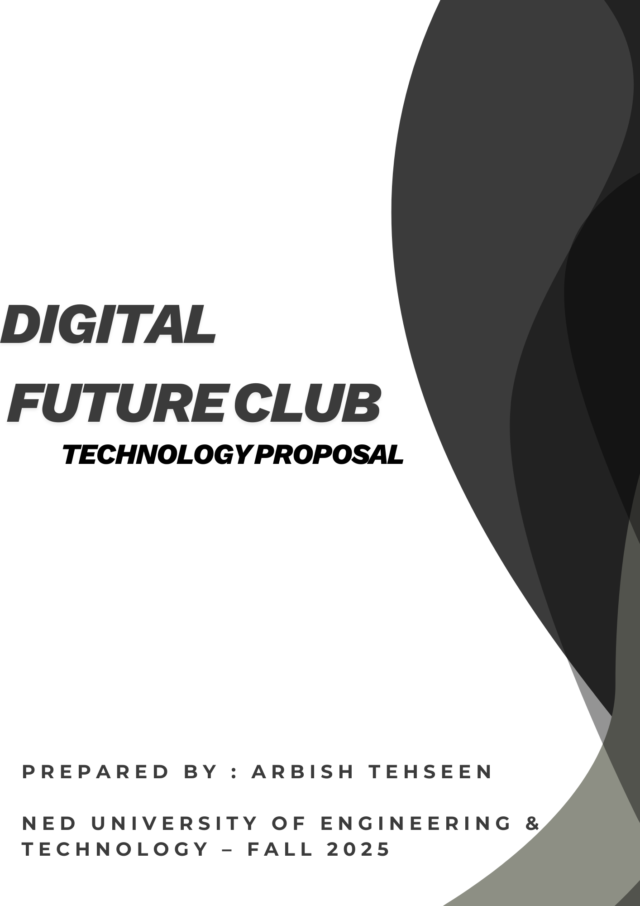

ARa

OUR VISION

The Digital Futures Club aims to empower NED students with modern digital tools and a collaborative workspace. With the right technology, we can design websites, build mobile apps, run workshops, and bring creative ideas to life. This proposal outlines the essential equipment we need to start strong and unlock the club’s full potential.



WHAT WE NEED? (SHOPPING LIST)

Recommended Devices.

Laptop (2 units) – HP 15s (i5)
Specs:
- Intel Core i5-1235U
- 8GB RAM
- 512GB SSD
- 15.6" FHD
- Price: $630 each. 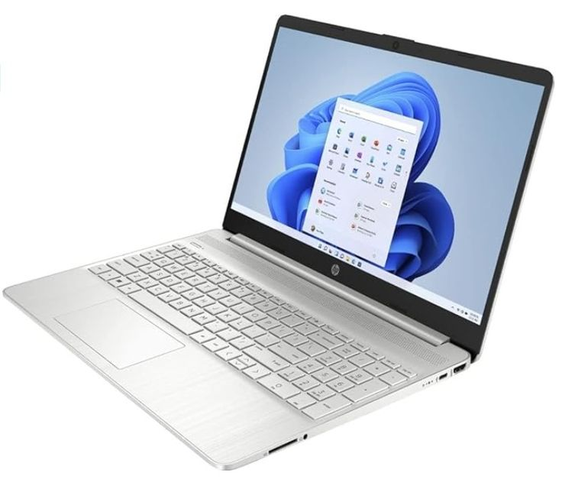

Desktop (1 unit) – Dell OptiPlex Tower
Specs:
- Intel Core i5-12400
- 16GB RAM
- 512GB SSD
- 24" FHD Monitor
- Price: $750 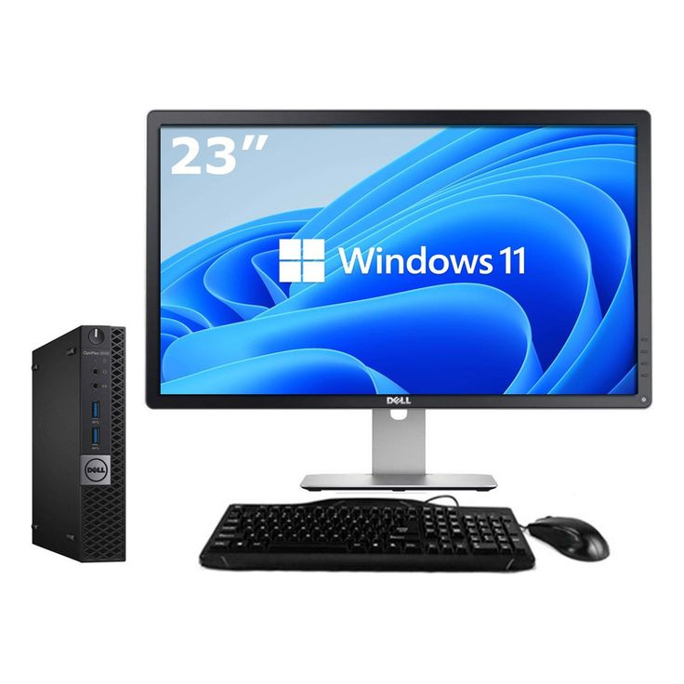

Printer – HP LaserJet 107w
Price: $150

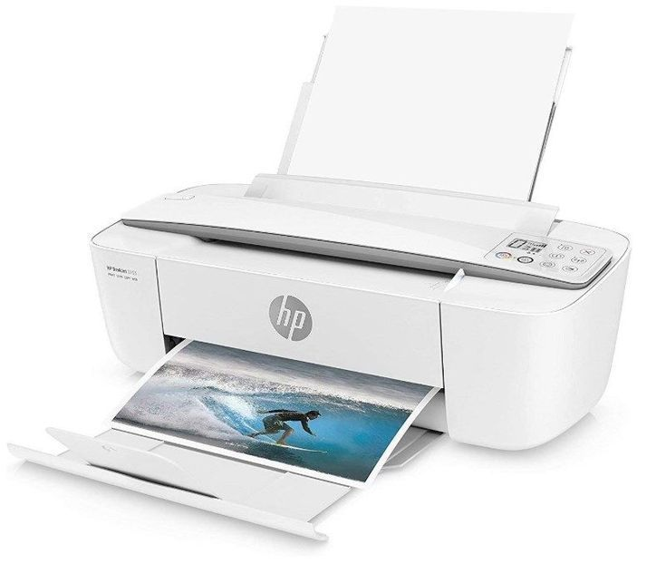

Backup Solution – 200GB Google One Cloud Plan

Price: $25/year 

Software
- Windows 11: $120
- MS Office Student Edition: $70
- VS Code: Free
- Antivirus: $25
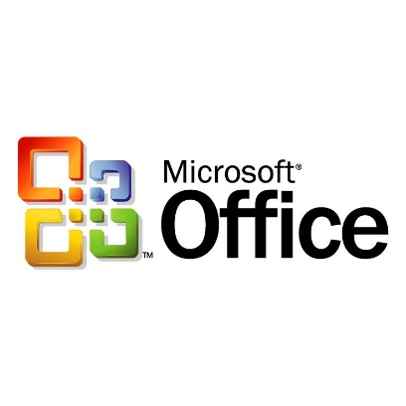

BUDGET TABLE
- Digital Future Club

Item | Model / Specs | Unit Price | Qty | Total Price
Laptop | HP 15s – i5-1235U, 8GB RAM, 512GB SSD, 15.6" FHD | $630 | 2 | $1,260
Desktop Computer | Dell OptiPlex i5-12400, 16GB RAM, 512GB SSD, 24" Monitor | $750 | 1 | $750
Printer | HP LaserJet 107w | $150 | 1 | $150
Software Package | Windows 11 + MS Office + Antivirus | $215 | 1 | $215
Cloud Backup | Google One 200GB Plan | $25 | 1 | $25
 |  |  | Grand Total | $2,400

BUDGET BREAKDOWN

Software & Usage
:
- Windows 11: Operating system for all devices

- MS Office: Reports, budgeting, documentation

- Visual Studio Code: Coding, app development

- Google Drive: Cloud backup + team collaboration

- Antivirus: System protection

Total Budget Summary

TOTAL PROJECT BUDGET
Total Project Cost: $2,400
Budget Limit: $2,500
Status: ✔ Approved — Within Budget!

