1.1 Объединение таблиц с концентрациями выше среднего для Москвы, с концентрациями ниже среднего для Москвы, с концентрациями выше среднего для Курска, с концентрациями ниже среднего для Курска.

SELECT "Date", "Concentration", 'Over avg', "Acid_production"."City"

FROM "Acid_production"

WHERE "Acid_production"."City" = 1 AND "Concentration" > (SELECT AVG("Concentration") FROM "Acid_production")

UNION

SELECT "Date", "Concentration", 'Lower avg', "Acid_production"."City"

FROM "Acid_production"

WHERE "Acid_production"."City" = 1 AND "Concentration" < (SELECT AVG("Concentration") FROM "Acid_production")

UNION

SELECT "Date", "Concentration", 'Over avg', "Acid_production"."City"

FROM "Acid_production"

WHERE "Acid_production"."City" = 2 AND "Concentration" > (SELECT AVG("Concentration") FROM "Acid_production")

UNION

SELECT "Date", "Concentration", 'Lower avg', "Acid_production"."City"

FROM "Acid_production"

WHERE "Acid_production"."City" = 2 AND "Concentration" < (SELECT AVG("Concentration") FROM "Acid_production")

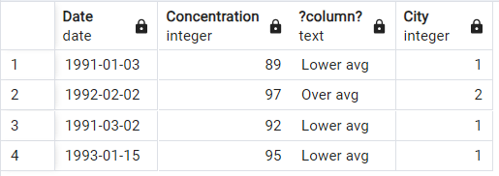

1.2. Вывод производства с максимальной, минимальной, не максимальных и не минимальных концентраций в Москве и Курске.

SELECT "Date", "Concentration", 'MAX', "Cities"."City"

FROM "Acid_production", "Cities"

WHERE "Cities"."City" = 'Москва'

AND "Concentration" = (SELECT MAX("Concentration")

FROM "Acid_production"

WHERE "Acid_production"."City" = 1

OR "Acid_production"."City" = 2)

AND "Cities"."ID_city" = "Acid_production"."City"

UNION

SELECT "Date", "Concentration", 'NORM', "Cities"."City"

FROM "Acid_production", "Cities"

WHERE "Cities"."City" = 'Москва'

AND "Concentration" < (SELECT MAX("Concentration")

FROM "Acid_production"

WHERE "Acid_production"."City" = 1

OR "Acid_production"."City" = 2)

AND "Concentration" > (SELECT MIN("Concentration")

FROM "Acid_production"

WHERE "Acid_production"."City" = 1

OR "Acid_production"."City" = 2)

AND "Cities"."ID_city" = "Acid_production"."City"

UNION

SELECT "Date", "Concentration", 'MIN', "Cities"."City"

FROM "Acid_production", "Cities"

WHERE "Cities"."City" = 'Москва'

AND "Concentration" = (SELECT MIN("Concentration")

FROM "Acid_production"

WHERE "Acid_production"."City" = 1

OR "Acid_production"."City" = 2)

AND "Cities"."ID_city" = "Acid_production"."City"

UNION

SELECT "Date", "Concentration", 'MAX', "Cities"."City"

FROM "Acid_production", "Cities"

WHERE "Cities"."City" = 'Курск'

AND "Concentration" = (SELECT MAX("Concentration")

FROM "Acid_production"

WHERE "Acid_production"."City" = 1

OR "Acid_production"."City" = 2)

AND "Cities"."ID_city" = "Acid_production"."City"

UNION

SELECT "Date", "Concentration", 'NORM', "Cities"."City"

FROM "Acid_production", "Cities"

WHERE "Cities"."City" = 'Курск'

AND "Concentration" < (SELECT MAX("Concentration")

FROM "Acid_production"

WHERE "Acid_production"."City" = 1

OR "Acid_production"."City" = 2)

AND "Concentration" > (SELECT MIN("Concentration")

FROM "Acid_production"

WHERE "Acid_production"."City" = 1

OR "Acid_production"."City" = 2)

AND "Cities"."ID_city" = "Acid_production"."City"

UNION

SELECT "Date", "Concentration", 'MIN', "Cities"."City"

FROM "Acid_production", "Cities"

WHERE "Cities"."City" = 'Курск'

AND "Concentration" = (SELECT MIN("Concentration")

FROM "Acid_production"

WHERE "Acid_production"."City" = 1

OR "Acid_production"."City" = 2)

AND "Cities"."ID_city" = "Acid_production"."City"

ORDER BY 4 DESC;

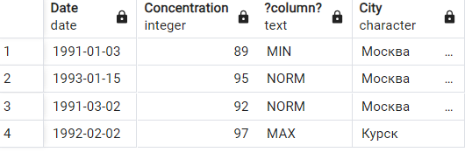

1.3 Внешние объединение. Объединение производств с Реактор2 и производств не с Реактор2.

SELECT "Concentration", "Reactors"."Reactor"

FROM "Acid_production", "Reactors"

WHERE "Acid_production"."Reactor" = "Reactors"."ID_reactor"

AND "Acid_production"."Reactor" = 2

UNION

SELECT "Concentration", CAST('Not reactor2' AS CHARACTER(20))

FROM "Acid_production"

WHERE "Acid_production"."Reactor" != 2

ORDER BY 2 DESC;

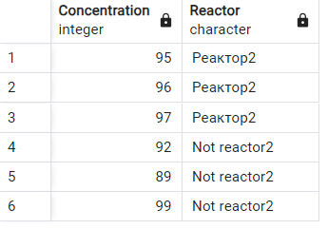

1.4 Пересечение производств, концентрация кислоты, у которых больше средней и производств находящихся в Курсе

SELECT "Concentration", "City"

FROM "Acid_production"

WHERE "Concentration" > (SELECT AVG("Concentration") FROM "Acid_production")

INTERSECT

SELECT "Concentration", "City"

FROM "Acid_production"

WHERE "City" = 2

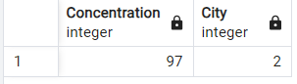

1.5 Производства с концентрацией кислоты выше средней и не находящихся в Курске

SELECT "Concentration", "City"

FROM "Acid_production"

WHERE "Concentration" > (SELECT AVG("Concentration") FROM "Acid_production")

EXCEPT

SELECT "Concentration", "City"

FROM "Acid_production"

WHERE "City" = 2

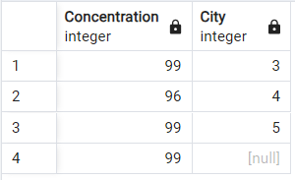

2.1 Создание представления производств с концентрацией кислоты > 90.

CREATE VIEW Over90

AS SELECT * FROM "Acid_production"

WHERE "Concentration" > 90

WITH CHECK OPTION

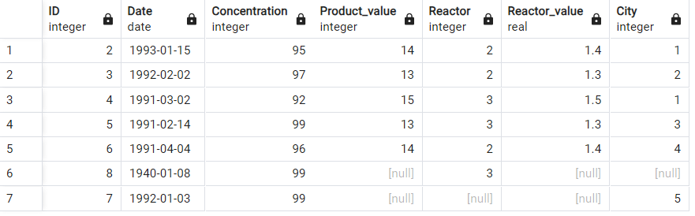

2.2 Представление. Итоговая таблица.

CREATE VIEW Itog_query

AS SELECT "Date", "Concentration", "Product_value", "Reactors"."Reactor", "Reactor_value", "Cities"."City"

FROM "Acid_production", "Reactors", "Cities"

WHERE "Acid_production"."Reactor" = "Reactors"."ID_reactor"

AND "Acid_production"."Reactor" = "Cities"."ID_city" 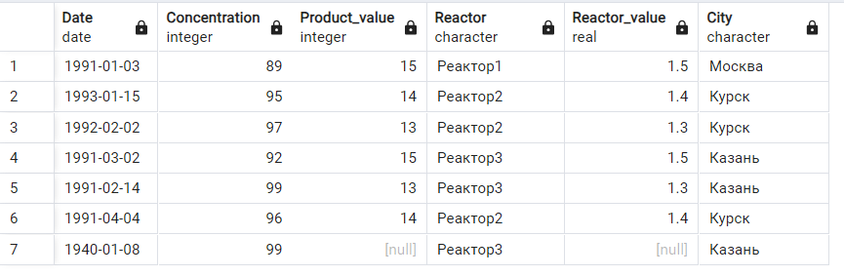

2.3Добавление значения реактора для поля равного NULL через представление.

UPDATE itog_query

SET "Reactor_value" = 1.5

WHERE "Reactor_value" = NULL;

Выполнение модификации представления невозможно по причине того, что представление состоит из нескольких таблиц.

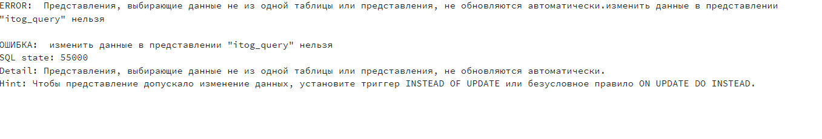

2.4 Модифицируемое представление с опцией проверки (WITH CHECK OPTION).

CREATE VIEW My_query_option

AS SELECT "Date", "Concentration", "Product_value"

FROM "Acid_production"

WITH CHECK OPTION

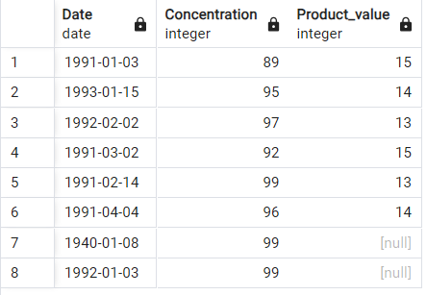

2.5 Создание представления городов с средними концентрациями по ним.

CREATE VIEW Avg_Sum

AS SELECT "Cities"."City", "Concentration", AVG("Concentration")

OVER(PARTITION BY "Acid_production"."City")

FROM "Acid_production", "Cities"

WHERE "Acid_production"."City" = "Cities"."ID_city" 