**Coronavirus Guide for F&B**

**What it is, why it’s bad—and how you can help**

What is coronavirus (aka COVID-19) and why does it matter?

* COVID-19, sometimes simply called coronavirus, is an illness that can affect your lungs and airways. It starts out like a cold or the flu but in some cases can make people very sick and sometimes kills them.
* You can have coronavirus without knowing it.
* Coronavirus spreads when your nose, mouth, or eyes come into direct contact with body fluid infected with the coronavirus—this can be from human contact, droplets in the air, or from infected body fluid on hands, hard and soft surfaces, cloths, aprons, and clothing.
* Older people and those who are already ill are at great risk of becoming extremely ill or dying if they are infected by coronavirus.
* Some people infected with coronavirus show no symptoms for many days. You can infect others even if you have no symptoms.
* People infected with coronavirus are probably most infectious starting when they begin to show symptoms (which are similar to symptoms of colds and flu).
* If coronavirus infections become widespread, this is likely to cause healthcare systems to break down. This has already happened in Italy and China. This makes it difficult or impossible for people who might healthcare for other reasons to get the care they need. This may cause a long economic recession, if not a depression.

Why does coronavirus matter for the food and beverage industry?

* Restaurants, bars, coffeeshops, and pubs are places where it is especially easy for coronavirus to spread—both to your staff and to your customers. Your actions could save many lives, even if you're not likely to become infected yourself.
* Coronavirus can remain active on surfaces for many hours (we still don’t know for sure how long). These surfaces include counters, cloths, clothing, dishes, glasses, cutlery, storage containers, packing boxes, doorknobs/handles, faucets/taps, credit cards, credit card terminals, POS systems, keyboards and mice, tablets, cellphones, and money.
* Even if you are strictly following regular sanitation practices, you need to take special precautions to reduce the risk of coronavirus infection.
* There’s always the risk that one of your staff or customers will get sick from the coronavirus, unless you shut down the business temporarily. There is no other way to completely eliminate the risk that coronavirus will spread through your business—but you can and should take steps to reduce that risk.

What can you do to reduce coronavirus risk in your business?

If you have no time right now to read further, just doing these three things will be enormously helpful in slowing the spread of coronavirus.

1. Ask your staff to dramatically increase frequency of handwashing.
2. Schedule much more frequent and intense cleaning and sanitizing of all equipment and surfaces in your establishment
3. Remember: What you and your staff do will make a difference—washing hands and cleaning more often can literally save lives.

If you do have time to read on, there are many things you can do to reduce the risk of your staff accidentally getting coronavirus, or accidentally giving a customer coronavirus.

The most important takeaways

1. A restaurant/bar/café/pub can accidentally make a lot of people sick.
2. Stop sick staff from coming in to work.
3. Make sure regular hygiene and sanitization practices are strictly upheld—and make them even stricter if you can. (Many suggestions below.)
4. Remind your staff to be conscious of not touching things unnecessarily, including their own face, their cellphone, their clothing, cutlery, plates.
5. Train all staff in proper handwash procedure.
6. Remind all staff to wash or sanitize their hands as often as possible, ideally every 10-15 minutes or after touching a surface which might be contaminated (including cellphones, clothing, POS/payment machines, door or equipment handles, used plates/cutlery, used napkins/serviettes, and other people)
7. Do your best to move your business as much to takeout/delivery as possible.

For many more low/no-cost things

you can do to reduce coronavirus risk,

please read on.

To translate this guide, download an editable version at: [bit.ly/CGTranslate](http://bit.ly/CGTranslate)

This work is licensed under the Creative Commons Attribution-NonCommercial 4.0 International License. To view a copy of this license, visit

[creativecommons.org/licenses/by-nc/4.0/](http://creativecommons.org/licenses/by-nc/4.0/)

Do once

* Ensure that all food safety, hygiene and COSHH documents are updated and that all staff are informed and trained as necessary.
* Make and share a plan for staff wages so people don’t feel undue financial pressure to work when they are sick. If you are able to, guarantee basic pay for hourly staff who cannot work because they are ill.
  + In the UK: Statutory Sick Pay (SSP) will be available from Day 1 for those unable to work because they are diagnosed with coronavirus, or self-isolating according to Government guidelines.
* Find out if you have a local or national coronavirus reporting hotline number. If yes, post it prominently in the restaurant, and make sure all staff know it.
  + In the UK, report to NHS 111.
* Issue all staff with an inexpensive thermometer.
* Remind staff not to hug, fistbump, shake hands, or high-five—if possible, not even to elbow-bump. Instead find non-contact ways to show the love.
* Put up a clearly visible sign at the entrance and on your website asking people who are ill or elderly not to enter.
* Check laundry processes for all service linens. This includes chef jackets, uniforms, towels, cloths, aprons, table linens.
  + Call your linen service to verify that it is complying with sanitation regulations for service linens.
  + If you launder service linens on-site, use water above 160F/70C (add bleach at the label recommended concentration to be extra-sure). If laundry water temperature is below 160F/70C, you must use hypochlorite bleach or another disinfecting product at the label recommended concentration.
* Check all cleaning and sanitation products to make sure they are antiviral—soap, alcohol, food service sanitation sprays, bleach, and hydrogen peroxide solutions should be effective. Unfortunately some natural or low-toxicity cleaning products such as vinegar or essential oils may not be antiviral.
  + In the US, the EPA has a list of products effective against coronavirus here: <http://bit.ly/2Ucecbw>
* Check cleaning and sanitation products and spray bottles to make sure they are at label recommended dilution.
* Change how your team handles clean glass, crockery, and cutlery to reduce to the absolute minimum the number of times each piece is touched. Polishing cloths are really easy to contaminate.
  + Stop polishing cutlery and glassware altogether.
  + If you absolutely must polish, ensure that staff wash their hands before and after touching items, and that cloths are replaced between each use
  + Move cutlery only once between cleaning and using for service.
* Change how cooks plate so they only use spoons and tweezers (no use of hands, whether gloved or not).
* Install pump-dispenser alcohol gel sanitizer bottles at kitchen and FOH stations (make sure the gel is at least 60% ethanol).
* Move to contactless payments if possible.
* Provide service stations with antiviral sanitizer wipes for use on cellphones, POS, payment terminals, keyboards/mice, and tablets.
* Most people don’t know how to thoroughly wash their hands and wrists. Near staff and customer sinks, post a handwash notice with a diagram showing how to wash hands properly:
  + Download a printable 2-page PDF with a handwash notice and WHO recommended handwash methods at: <http://bit.ly/2U4odHr>
  + These are the most often-missed areas when washing hands:

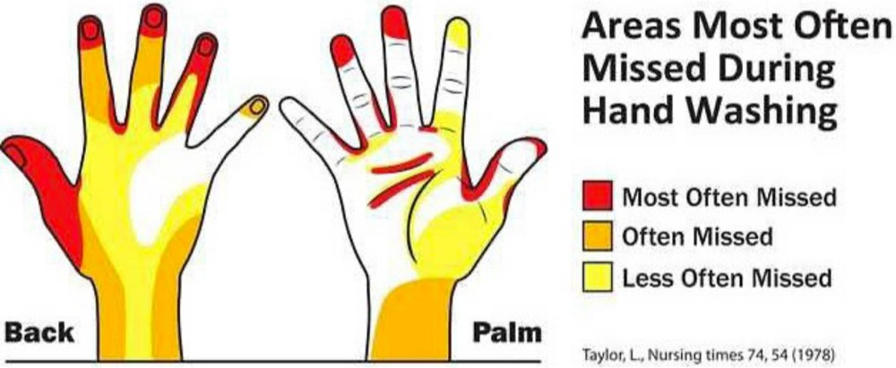

* + Handwash instructions from the WHO:
* 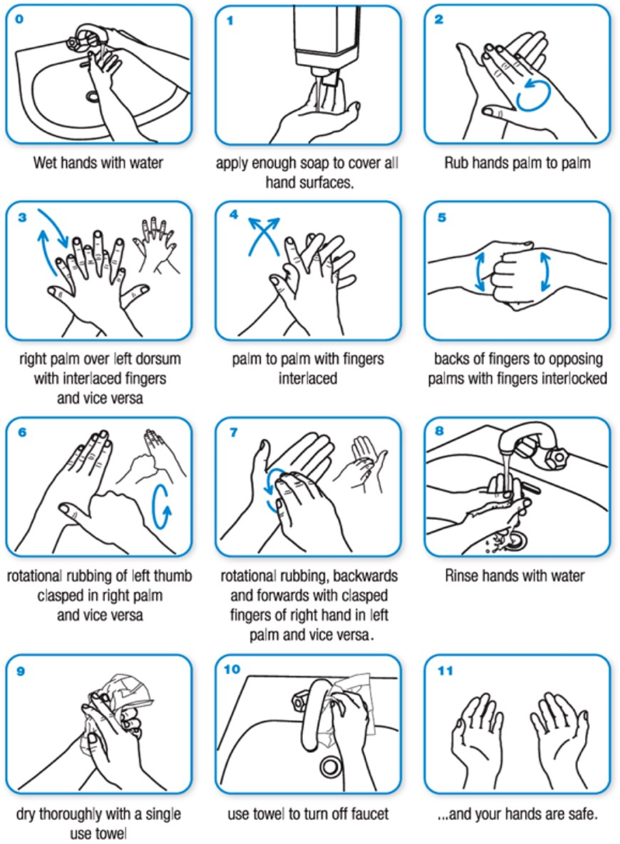

Do every week

* Remind all staff to clip their nails and wash their hands for at least 20 seconds as often as possible and at least every 10-15 minutes during service.
* Train (via demonstration) all staff to wash hands correctly: <http://bit.ly/2wUHovt>
* Remind all staff members to measure their temperature every day. They should call in sick if they are.
* Remind all staff to stay home and report (by phone) if they have very mild fever (even a few tenths of a degree C/F above normal body temperature of 37C/98.6F), other cold and flu symptoms, or have had any direct contact with someone known or suspected to have coronavirus.

Do every day

* **Remind all staff members to check their temperature every day and report even very mild cold and flu symptoms (including slight fever), and to stay home.**
* Check your dishwash system to ensure it is working correctly, running at the correct temperature, and that there are sufficient sanitizer chemicals loaded.
* Remind staff:
  + To call out all face-touching.
  + Not to hug, fistbump, shake hands, or high-five. Find non-contact ways of showing the love instead.
  + To wash hands after accidentally touching someone else.
  + To wash hands as often as possible and at least every 10-15 minutes during service, and before and after handling cutlery, glassware, or table linens.

Do before every service

* Do a pre-service reminder for all staff to:
  + **Wipe down cellphones every 10-15 minutes with an antiviral sanitizer wipe. Even better, provide a secure, locked box for staff to (voluntarily) put their cellphones in at the beginning of service.**
  + Wash hands frequently,
  + Touch only handles when laying cutlery on tables,
  + Avoid face-touching,
  + Remind co-workers (discreetly) if they see them touching their face
  + Change side towels more often than usual; every 10-15 minutes if possible

Do before and after every service

* **Use an antiviral sanitizer to thoroughly disinfect all key surfaces frequently touched by staff or customers—faucets, toilet seats, door handles, toilet flush handles, table tops, chair backs, POS system, keyboards and mice, tablets, card machine, menus.**

Do as often as practical during service

* Use an antiviral sanitizer to wipe down key surfaces in dining room, kitchen, and bathroom — faucets, toilet seats, door handles, toilet flush handles, POS system, keyboards/mice, tablets, card machines. This should be done as often as possible and not less than once an hour.

Changing how your FOH team does service

* **Where you can, prop doors open so staff and customers don’t have to touch handles to enter and exit.**
* Rearrange products (especially unpackaged products, and products which may be eaten uncooked) to prevent customers from reaching or handling them.
* Use tongs to handle products which are not wrapped and which will be eaten uncooked (e.g. breakfast pastries, confectionery, pieces of fruit).
* Remove tasters/samplers/sample bottles from retail displays.
* Change how menus are presented so customers handle them less or not at all—for instance, a menu board posted in a clearly visible place, or on a stand on the table, or on a portable board brought to the table by a server.
* Replace menus with laminated sheets if original menu material is hard to sanitize.
* Proactively indicate where customers can wash their hands before eating, and ask if they want sharing plates and sharing utensils.
* Offer hand sanitizer at the table.
* For sharing plates, use serving spoons that look different from regular ones—this is so that customers don’t accidentally confuse serving spoons with their own spoon.
* During booking confirmation calls, remind guests that they can cancel at any time, even up to the reservation, if they have symptoms of cold and flu. Provide a dedicated number, or email address, to reduce load on reservations during service.
* Reduce bookings and limit walk-ins as much as you can to prevent crowding.
* Proactively manage the seating plan to seat guests further from each other.
* If customers bring their own items, such as reusable coffee cups, ensure that the item is sanitized before use.

Changing how your beverage program works

* Consider using a juice commissary or cold-press company for juices, instead of creating an extra contamination point by taking FOH time to juice.
* Sterilize any bottle used for bar ingredients that isn’t the original bottle those ingredients came in. This is especially important for bottles used for non-alcoholic liquids (syrups and juices).
* For bulk cold beverages (e.g. iced tea), sterilize pitchers and hands immediately before preparation. Consider making lemonade to order rather than batching.
* Use garnish tongs for all garnishes, including two sets of tongs for expressing citrus peels (in the manner required for International Bartending Association contests).
* Pre-cut citrus peels for service.

Changing your menu and how your kitchen operates

* Minimize, eliminate, or rethink serving style for things designed to be shared at the table—e.g., large cuts of meat, whole fish/poultry, communal bowls of rice/pasta.
* Minimize, eliminate or change serving style for dishes to be eaten with hands instead of cutlery—e.g., bread, sharing platters, chicken wings, finger foods (like nuggets/croquettes), shellfish, sandwiches. Consider pre-slicing, changing plating, providing additional cutlery, and offering hand sanitizer with the dish.
* Consider adding or expanding options for delivery and takeaway, to minimize the number of customers on site at any one time.
* Use tasting spoons only once—after each use, send the spoon to the dishpit.

Planning for prolonged shutdowns or limitations on eat-in dining

* **Plan to convert most or all of your business to takeout or delivery**
  + Re-evaluate your menu for producing takeout-suitable foods (delicious and safe to eat even after several hours of storage)
  + Find suppliers of takeout packaging and purchase stocks
  + Talk to your front-of-house staff to see if they want to do deliveries of food
* Know what government resources are available for coronavirus-affected businesses.
  + In the UK: http://bit.ly/38LH67j
* Make a plan to reduce wage costs temporarily without laying off staff:
  + Reduce hours-per-person for hourly staff
  + Open later or close earlier
  + Close on your lightest day/s of the week
* Create a gift certificate program so your customers can give you some cash in hand.
* Create a “buy a meal for someone who needs it” program so customers can pay you to prepare takeout that can be collected for free by someone who needs it.
* Get in touch with local organizations that distribute food to those in need—such as food banks, churches, temples, shelters—to check if you can supply them. They may have budgets to pay you for these meals as well.