BasicModel Architecture Decomposition
Static modules, meronymic towers, grammar/truth machinery, and dynamic learning loops
This brief decomposes BasicModel into roughly two dozen architectural blocks, then expands those blocks into the concrete Model, Space, Layer, grammar, truth, codebook, and taxonomy modules present in the codebase. It distinguishes extension learning over codebooks from intension learning through TruthLayer and Taxonomy.

1. Static Architecture
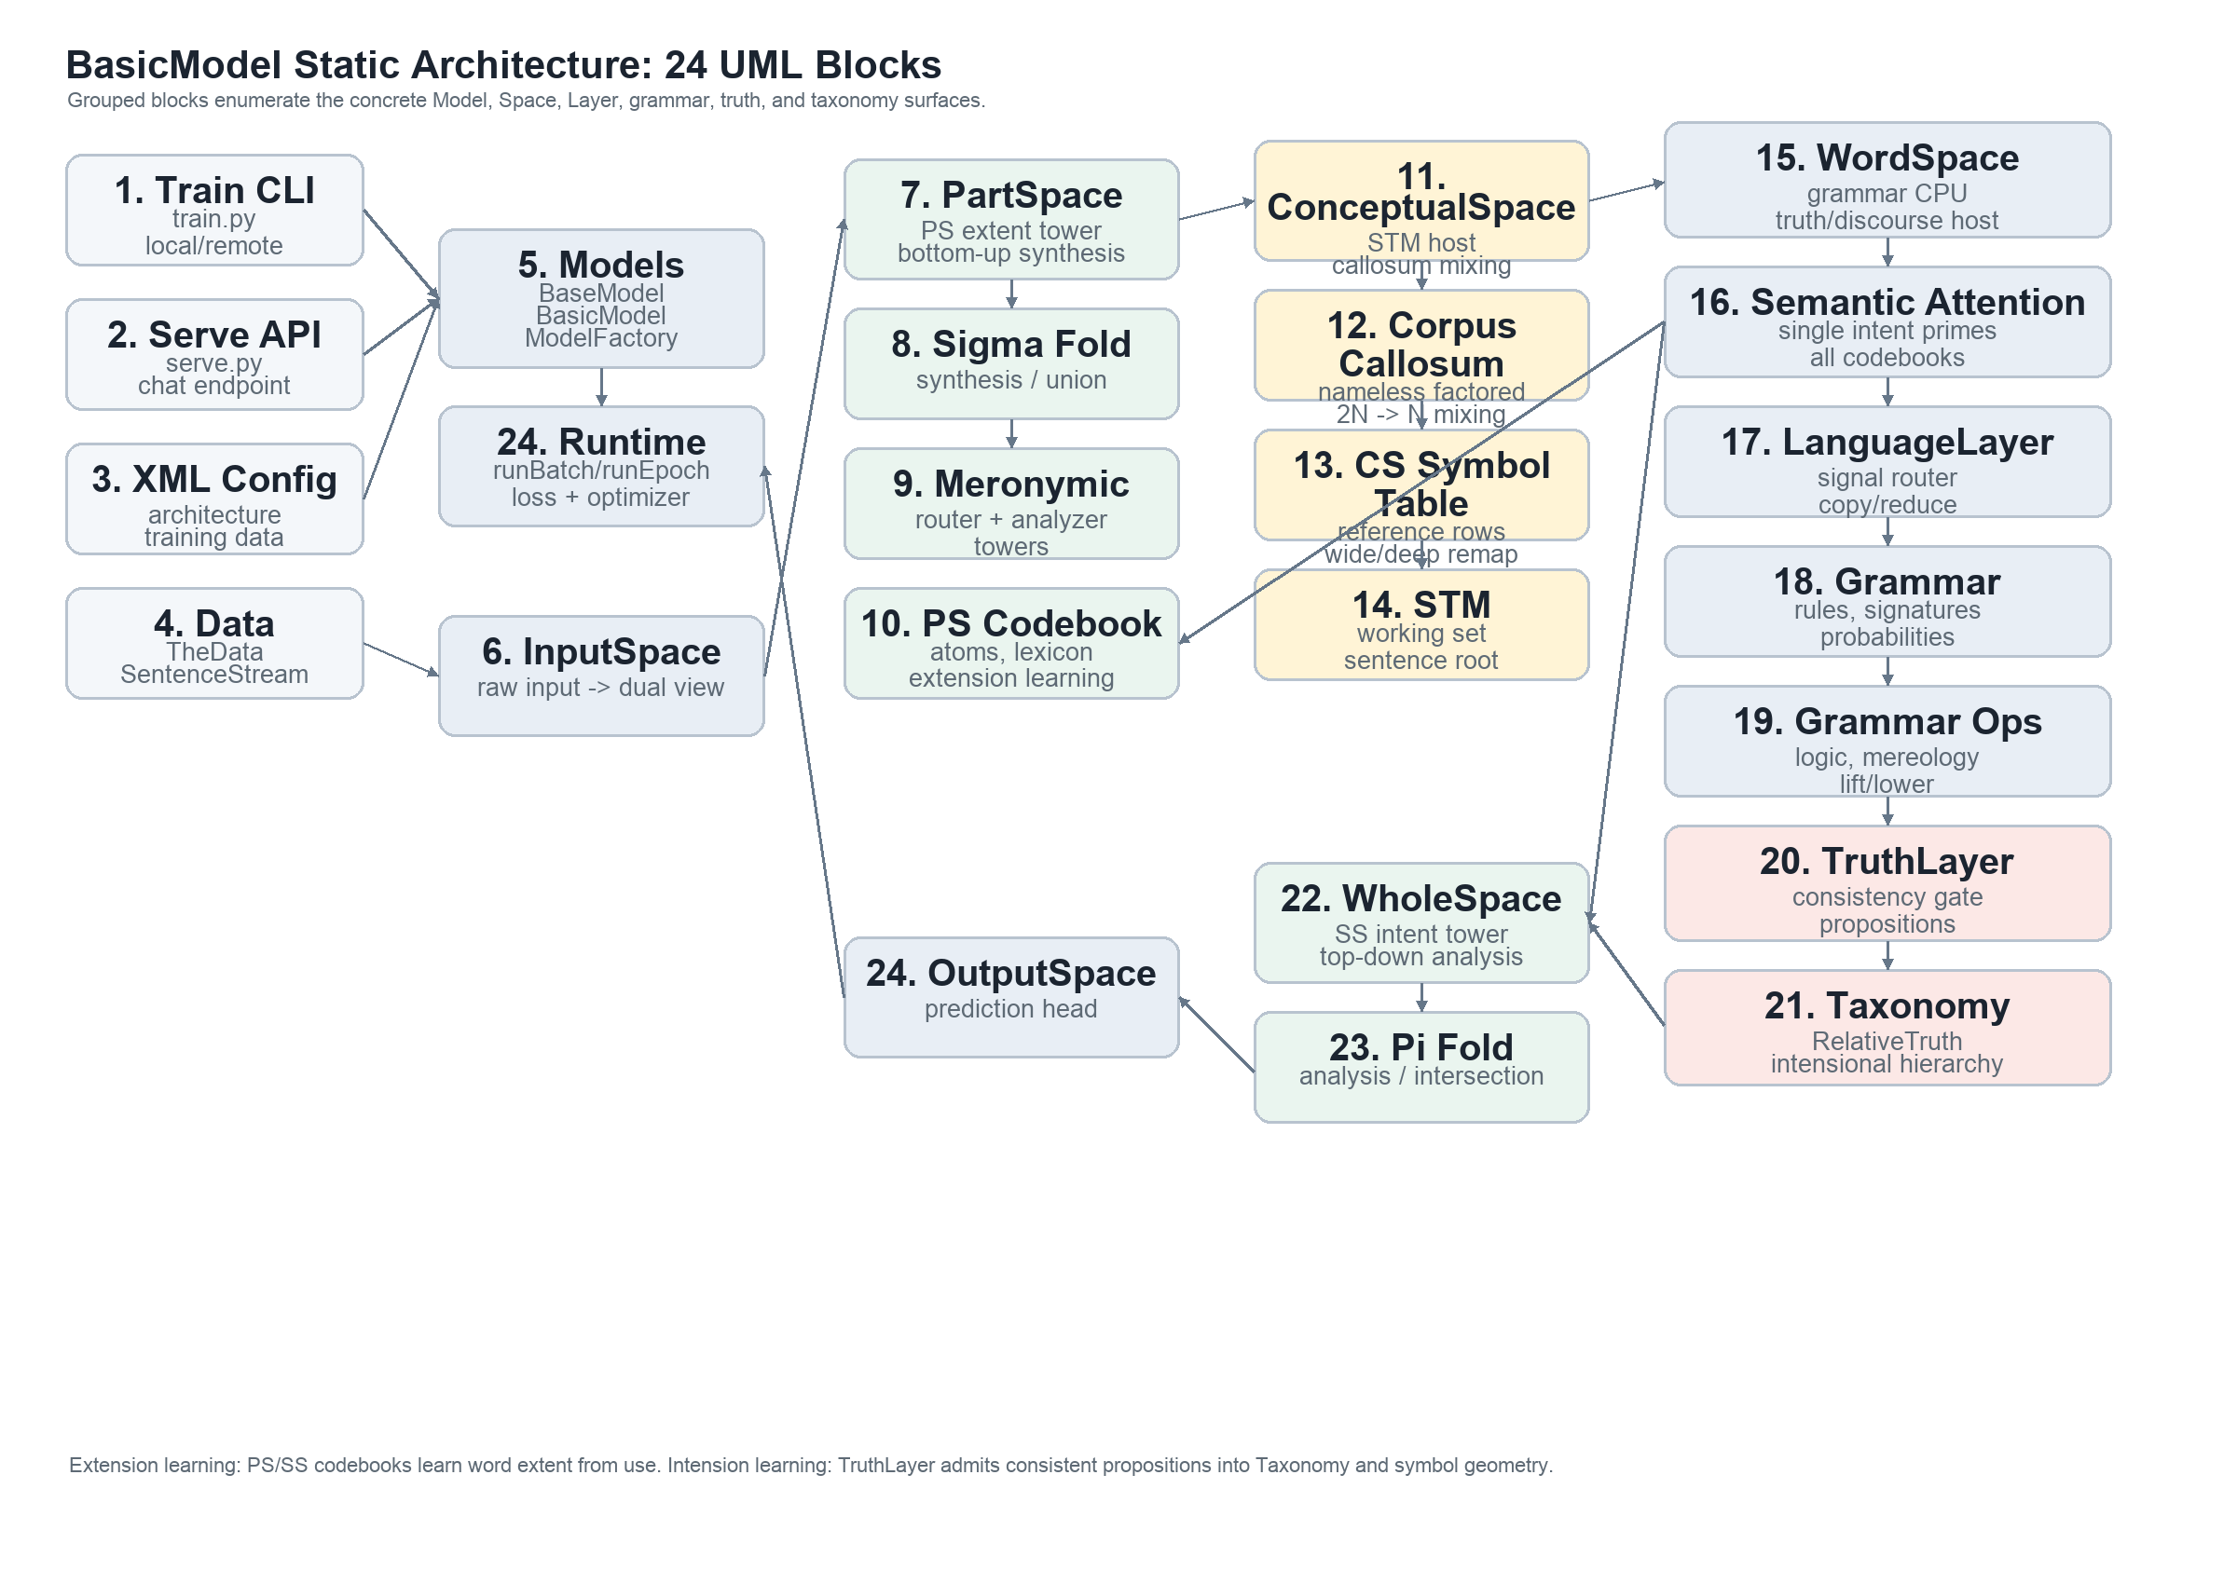
Figure 1. Static decomposition: entrypoints, model factory/runtime, five-space body, WordSpace grammar/truth host, codebook towers, and training runtime.
Pipeline. InputSpace -> PartSpace -> ConceptualSpace -> WholeSpace -> OutputSpace.
The WordSpace/WordSubSpace sidecar owns the grammar CPU, semantic attention, truth admission, taxonomy, and discourse prediction that act on the STM and codebook towers.

2. Modules and Responsibilities
- Models: BaseModel owns configuration hydration, training, persistence, and inference scaffolding; BasicModel assembles the space pipeline; ModelFactory validates XML and drives train/eval runs.
- InputSpace: converts raw input into the dual view used by the part/whole split: atom-side percepts and unity/concept evidence.
- PartSpace: bottom-up synthesis tower. It owns Sigma, surface-keyed lexicon/MPHF front ends, and the extent/object codebook used for extension learning.
- ConceptualSpace: working conceptual interface. It hosts STM, corpus-callosum mixing, and the symbol-table/re-reference machinery that lets nameless percepts cross into reference-bearing symbols.
- WholeSpace: top-down analysis tower. It owns Pi, the unified word/symbol codebook, paired orthographic/semantic rows, and codebook-write grammar operations.
- WordSpace: grammar and truth host. LanguageLayer scores copy/reduce routes over STM; Grammar provides rules and signatures; GrammarLayer ops perform logic, mereology, lift/lower, and grammatical transformations.
- Attention: a single intent code, produced by the parallel parse, primes all relevant codebooks. It biases recognition and retrieval over PS/SS towers without changing grammar-rule dispatch.
- Truth and Taxonomy: TruthLayer checks propositions for consistency before admission. AbsoluteTruth is encoded as symbolic truth; RelativeTruth is stored as a taxonomic relation and reflected geometrically as part/whole structure over symbols.
- Training runtime: runBatch/runEpoch implement the compute brick, losses, optimizer step, checkpointing, and optional compiled-step path.

3. Dynamic Algorithms
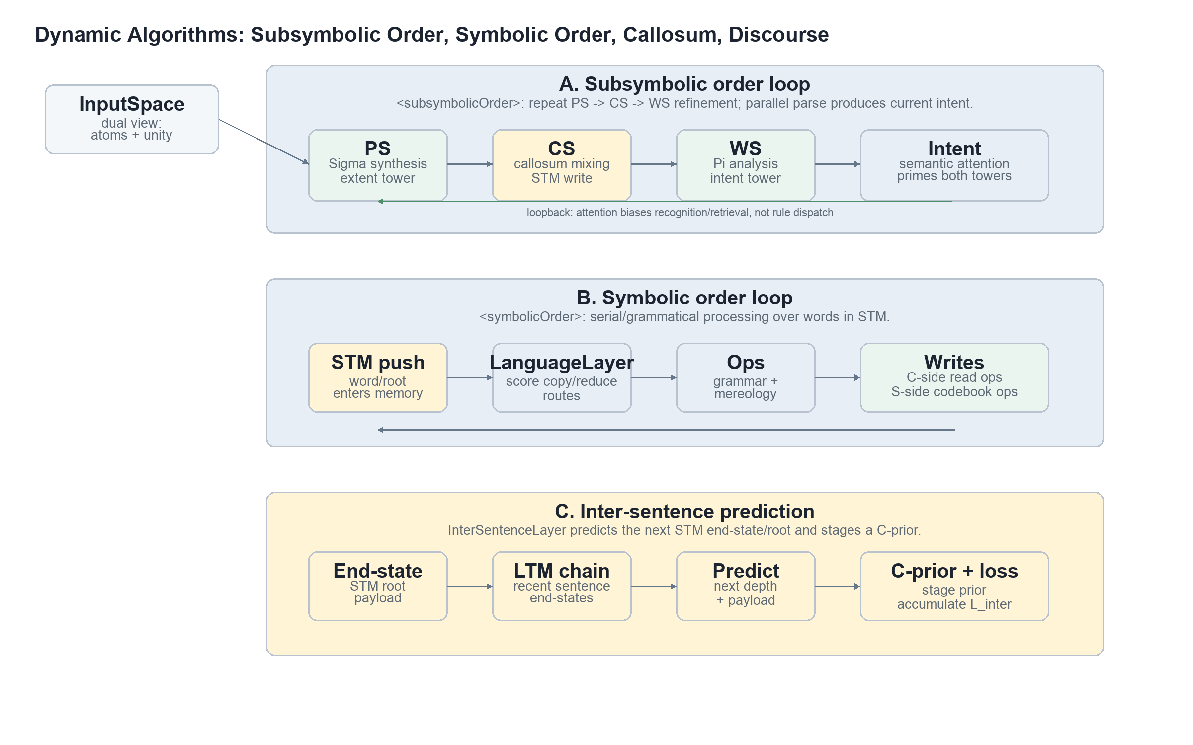
Figure 2. Dynamic loops: subsymbolic order refines the towers, symbolic order routes grammar over STM, and inter-sentence prediction feeds a future C-prior.
- Subsymbolic order repeats PS -> CS -> WS refinement. The parallel parse produces an intent representation that primes codebook attention across both meronymic towers.
- Symbolic order is the serial/grammatical loop. Each word or symbol enters STM, LanguageLayer scores copy/reduce routes, and GrammarLayer operators transform or write symbolic structure.
- Corpus callosum mixing is ConceptualSpace-side: percepts cross nameless and factored. Parallel mode uses the explicit 2N -> N mixer; serial mode folds fusion into STM shift/write behavior.
- InterSentenceLayer predicts the next STM end-state/root from the LTM chain, stages a C-prior for the next sentence, and contributes L_inter when the prediction is observed.
- Training combines output, reconstruction/infill, truth, intra-sentence, inter-sentence, and regularization terms through ModelLoss/Error before the optimizer step.

4. Truth, Intension, and Token Promotion
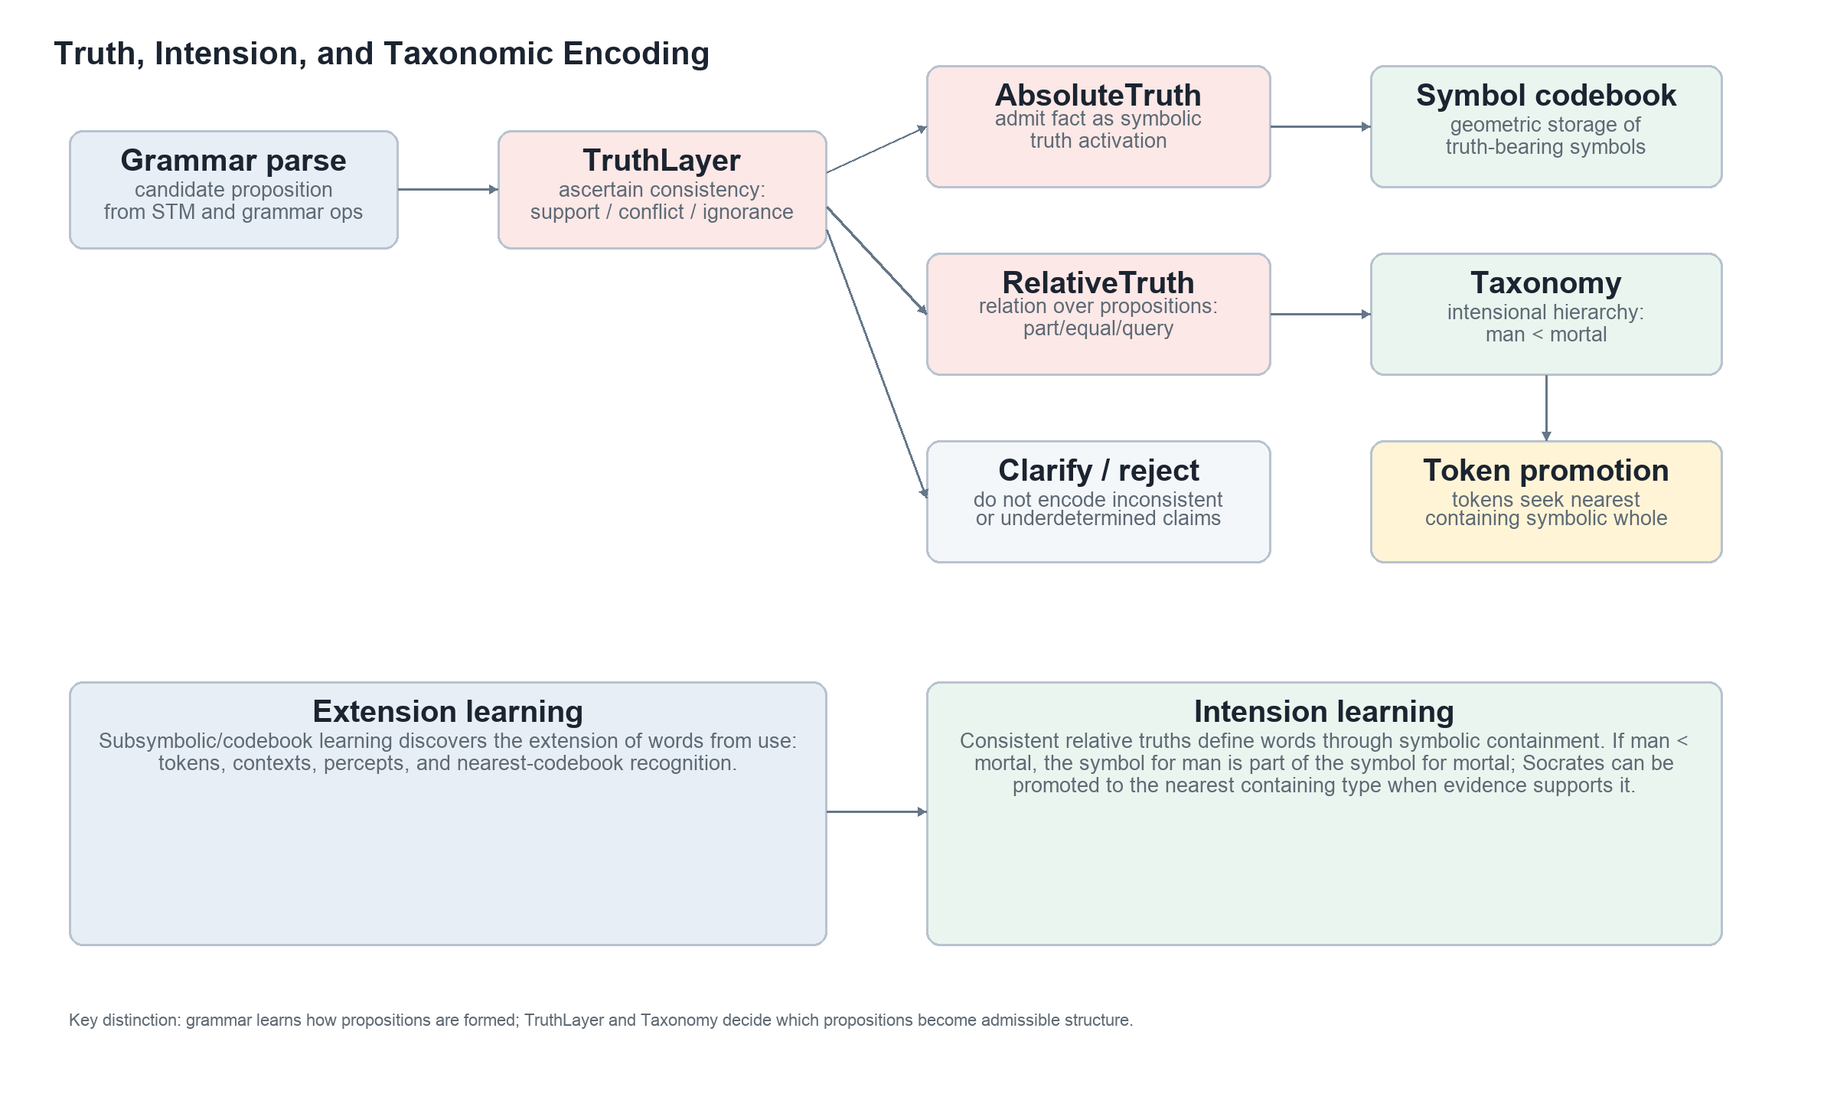
Figure 3. TruthLayer admits consistent propositions; RelativeTruth populates Taxonomy and part/whole symbol geometry; tokens promote to nearest containing types.
Extension learning asks which observations fall under a word. It is learned by the subsymbolic/codebook system from usage, token contexts, perceptual similarity, and nearest-row recognition.
Intension learning asks what a word means by virtue of its relations to other propositions and types. A consistent RelativeTruth such as man < mortal becomes a taxonomic containment relation. Geometrically, the symbol for man is part of the symbol for mortal, meaning the equivalence class of man is a subset of the equivalence class of mortal.
Token promotion follows containment. If Socrates is categorized as mortal, the taxonomy and codebook geometry should let the system locate the nearest containing symbolic whole, then promote or bind Socrates to the most specific supported type such as man when the evidence warrants it.

5. Concrete Class Inventory
The inventory below lists the concrete classes that make up the Model, Space, Layer, grammar, and meronymic surfaces. It is intentionally grouped by module rather than drawn as one unreadable inheritance tree.

Models.py
ReverseAdapter, CachePoint, GrammarMergeGlue, Normalizer, BaseModel, BasicModel, ModelFactory

Spaces.py
Encoding, QuadratureEncoding, ActiveEncoding, WhereEncoding, WhenRangeEncoding, WordEncoding,
WhatEncoding, EventEncoding, Basis, Tensor, Codebook, ProjectionBasis, Embedding, SubSpace,
_ShortTermMemory_PlaceholderRemoved, Space, InputSpace, PerceptualSpace, PartSpace, ModalSpace,
ConceptualSpace, WholeSpace, OutputSpace

Layers.py
Lexicon, Layer, ErgodicLayer, LinearLayer, NonNegativeLinearLayer, InvertibleLinearLayer,
ConceptualCombine, NonNegativeInvertibleLinearLayer, ContractiveInvertibleLinearLayer,
SurfaceSchema, GrammarLayer, SigmaLayer, NegationLayer, EqualLayer, TrueLayer, FalseLayer,
SwapLayer, CopyLayer, AreaLayer, LuminosityLayer, IsaPartLayer, PiLayer, PiLayer2, SigmaLayer2,
MeronymicFoldAdapter, MapppingLayer, SortingLayer, DecisionBoundaryLayer, AttentionLayer,
AssociationLayer, LiftingLayer, LoweringLayer, SparsityRegLayer, SmoothingRegLayer,
ImpenetrableLayer, TruthLayer, RelativeTruthStore, InterSentenceLayer, IntraSentenceLayer,
ChunkLayer, _RadixNode, RadixTrie, BytesFallbackEncoder, RadixLayer, BPEGpuLayer, MPHFGpuLayer,
SymbolLearningLayer, _RuleScorer, ShortTermMemory, Ops, Loss, ModelLoss, Error,
CertaintyWeightedMAELoss, CertaintyWeightedMSELoss, CertaintyWeightedCrossEntropy, Mem, ZOHMem,
StateMem, RLSMem, ProbMem, MeanMem, GammaMem, ExponentialMem, CorrMem, VectorQuantize,
_OpHandle

Language.py grammar/word classes
Grammar, NotLayer, NonLayer, IntersectionLayer, UnionLayer, LiftLayer, LowerLayer,
PrepositionLayer, ContextualBindLayer, TenseLayer, AspectLayer, MorphologyLayer,
SymbolizeLayer, ConjunctionLayer, DisjunctionLayer, IsEqualLayer, IsPartLayer, PartLayer,
AssertPartLayer, QueryLayer, QueryPartLayer, QueryEqualLayer, ExistLayer, RuleCodebook,
LanguageLayer, NeuralToolUser, BinaryStructuredReductionLayer, UnaryStructuredLayer,
SyntacticLayer, Taxonomy, ObjectSubSpace, WordSubSpace

perceptual_analyzer.py
EndpointSumWhere, MeronymicRouter, MeronymicAnalyzer

6. Algorithm Notes
- XML-driven construction: config resolves dimensions, codebook modes, training knobs, grammar settings, and symbolic/subsymbolic order before BasicModel builds the spaces.
- Masked/infill inference: the live within-sentence path is IR-style masked prediction; sentence-level generation is delegated to discourse prediction rather than AR token stepping inside the body.
- Meronymic analysis/synthesis: PartSpace synthesizes atoms into wholes with Sigma; WholeSpace analyzes wholes into parts with Pi; MeronymicFoldAdapter binds the membership kernel at those tower slots.
- Grammar dispatch: LanguageLayer treats STM as a slab, scores unary copy and binary reduce candidates, then dispatches GrammarLayer operations such as intersection, union, part, equal, query, lift, lower, tense, aspect, and morphology.
- Truth admission: grammar may form candidate propositions, but TruthLayer decides whether they are consistent enough to encode. RelativeTruth writes taxonomic structure; AbsoluteTruth writes symbolic truth activations.
- Attention over codebooks: semantic relevance is implemented as row-priming over codebook selection/retrieval. It guides focus in the towers while preserving syntactic rule selection as syntactic.
- Inter-sentence learning: the sentence root/end-state is appended to an LTM chain; the predictor estimates the next end-state shape and root and scores the estimate against the next observed sentence.

