**Omnicell Diagram Creator Help**

**Welcome to the Omnicell Diagram Creator**

This guide provides comprehensive help and documentation for the latest version (3.0) of the Omnicell Diagram Creator. Published and released on July 16, 2021, Omnicell Diagram Creator 3.0 allows for users to automatically generate diagrams to represent data flows and network architecture based on customer-specific hardware.

**Overview**

Omnicell Diagram Creator 3.0 automates network architecture/data flow diagrams in MS Visio. This program allows user to select diagram type and options for hardware/diagram components.

After submitting the related form, the script prints a new Visio diagram, loads stencils, and adds the shapes to a vsd file, saved to "C:\Omnicell_Customer_Diagrams\" under related subfolder (based on diagram type).

**User Guide**

**Installing the Diagram Creator**

As of v3.0, the Omnicell Diagram Creator will be distributed as a zip file: “Omnicell Diagram Creator.zip”. Users should save and unzip this on their primary hard drive of their device (C drive). This will open two folders on the C drive, labeled as follows:

* Omnicell Diagram Creator
  + Batch files
  + Uninstall files
  + “Files” folder
    - Includes PowerShell scripts, Visio templates and stencils, text files, and
* Omnicell_Customer_Diagrams
  + Directory for storing saved outputs from the Diagram Creator Tool
  + Includes folders for the following categories
    - Architecture Diagrams
    - Current State by Facility (not used)
    - Data Flow Diagrams
    - Future State by Facility (not used)
    - Transition State by Facility (not used)

Users then can copy and create a shortcut to the batch file on the desktop. Selecting the shortcut will then run the batch file, which in turn runs the corresponding PowerShell script.

**Opening the Diagram Creator**

Running the script will bring up the first window labeled “Diagram Creator Welcome Form.” This window serves as a starting point for the application and offers three key items:

* The welcome form, including an introduction and brief overview of the tool
* OK Button – leads to the main form
* Help Button – opens this document for review by the user

**Welcome Form**

**Using the Main Form**

Clicking the “OK” button from the “Diagram Creator Welcome Form” leads to the main form, labeled “Select Omnicell Diagram Type.” From here, the user can select one of three sets of diagram types and move on to the options available under each of those categories. Carrying out these procedures involves the three controls available on the main form:

* Drop-down menu – lists the three categories of diagram types available in this version of the tool
* Submit Button – upon selecting a category, this button then opens the form providing the options for that specific category
* Cancel Button – clears the combo box if a category has been selected

**Main Form**

**Using the Architecture Form**

This form prompts the user to enter CSN and name of the customer in question, select the hardware implemented by that customer, select whether to print port information, and select the type of diagram to print. Filling out the CSN and customer name fields also fills in the CSN and customer name within the file name when the diagrams is saved. To avoid conflict with saving/overwriting files, users must ensure that this information is specified within the following text fields:

* CSN field – enter customer CSN
* Customer Name field – enter customer name

The form also offers the following controls/options:

* Product options – hardware/products checklist, each item corresponds to an optional item within the Omnicell portfolio of products
* “Select All” Button – checks all items within the product options checklist
* “Deselect All” Button – unchecks all items within the product options checklist
* “Print port information” option – prints shapes with port specifics for selected hardware
* “Omnicell Architecture” option – prints diagram in “Omnicell Architecture” format
* “Network Topology” option – prints diagram in “Network Topology” format

The submit button then opens a Visio diagram template and adds the shapes related to the selected hardware along with the corresponding frames, connectors, default shapes, and Omnicell labels to that Visio drawing. Then the tool saves the diagram under “C:\Omnicell Customer Diagrams\Architecture Diagrams\Omnicell Architecture\” or “C:\Omnicell Customer Diagrams\Architecture Diagrams\Network Topology\” depending on the diagram type selected.

**Architecture Form**

**Omnicell Architecture**

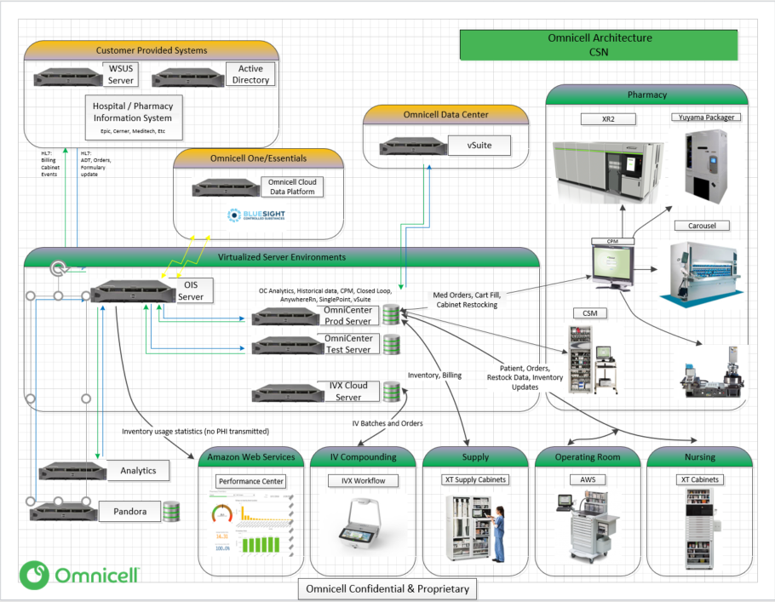

**Network Topology**

**Using the Data Flow Form**

This form prompts the user to enter CSN and name of the customer in question and select the type of diagram to print. Filling out the CSN and customer name fields also fills in the CSN and customer name within the file name when the diagrams is saved. To avoid conflict with saving/overwriting files, users must ensure that this information is specified within the following text fields:

* CSN field – enter customer CSN
* Customer Name field – enter customer name

The form also offers the following controls/options:

* “Cloud Data Platform” option – leads navigation to Cloud Data Platform form
* “E-R Diagram” option – leads navigation to E-R Diagram form
* “Submit” Button – opens the form selected above
* “Cancel” Button – clears information and selections within text fields and checkboxes

**Data Flow Form**

**Using the Cloud Data Platform Form**

The purpose of this diagram type is to demonstrate the interaction among entities on the Omnicell Cloud Data Platform, including pharmacy information systems and Omnicell systems within environments managed by both the customer and Omnicell. Using this form, users can include the Enterprise Medication Manager and Connect-Rx or Central Pharmacy Manager. Other than those options, no product specifics are included.

The submit button then prints and saves a Visio diagram under “C:\Omnicell Customer Diagrams\Data Flow Diagrams\CDP\Diagrams\”.

**Cloud Data Platform Form**

**Cloud Data Platform Data Flow Diagram**

**Using the E-R Diagram Form**

The Entity Relationship diagram gives a high-level overview of how products and services within the Omnicell portfolio of products interact with one another. This form allows the user to select hardware specifics for representation in an E-R diagram, like those implemented in database design and unified modeling language applications.

The submit button then prints and saves the diagram under “C:\Omnicell Customer Diagrams\Data Flow Diagrams\E-R Diagrams\”.

**E-R Diagram Form**

**E-R Diagram**

**V2 Architecture**

This form prompts the user to enter CSN and name of the customer in question, select the hardware implemented by that customer, select whether to print port information, and select the type of diagram to print. Filling out the CSN and customer name fields also fills in the CSN and customer name within the file name when the diagrams is saved. To avoid conflict with saving/overwriting files, users must ensure that this information is specified within the following text fields:

* CSN field – enter customer CSN
* Customer Name field – enter customer name

The form also offers the following controls/options:

* Product options – hardware/products checklist, each item corresponds to an optional item within the Omnicell portfolio of products
* “Select All” Button – checks all items within the product options checklist
* “Deselect All” Button – unchecks all items within the product options checklist
* “Print port information” option – prints shapes with port specifics for selected hardware

The submit button then opens a Visio diagram template and adds the shapes related to the selected hardware along with the corresponding frames, connectors, default shapes, and Omnicell labels to that Visio drawing.The diagram is then saved under “C:\Omnicell Customer Diagrams\Architecture Diagrams\v2 Architecture\”.

**V2 Architecture Form**

**V2 Architecture Diagram**

**When Using this Tool**

* **CSN and Customer Name**

Users must fill out the CSN and Customer Name text fields when creating a diagram. Doing so will ensure that diagrams are saved with the appropriate CSN and Customer Name in the file name. Failure to do so will result in duplicate/overwritten files. Appropriate labelling will eliminate problems with file organization within the system drive.

* **Form Navigation**

As of the current version, the close (X) button on the forms does not end the program. It only closes the current window, as PowerShell relies on the script, not the form, to execute code. Fix for this issue is currently under review.

**Help/Support/Comments**

For questions/comments related to the Omnicell Diagram Creator, contact us:

Email: [brad.walker@omnicell.com](mailto:brad.walker@omnicell.com)

Slack: brad.walker

**Design Team/Authors**

Rich Kirsch – Manager, Technical Sales

Craig Hamilton – Technical Sales Engineer

Brad Walker – Intern, Technical Sales