**Linux & Python Project No.1 SDA Academy**

Title: Report for the SDA.vm and the automation process of enumeration and password cracking with Python.

Group members:

Klevis

Arbri

Argjent

**Topology of the Lab**

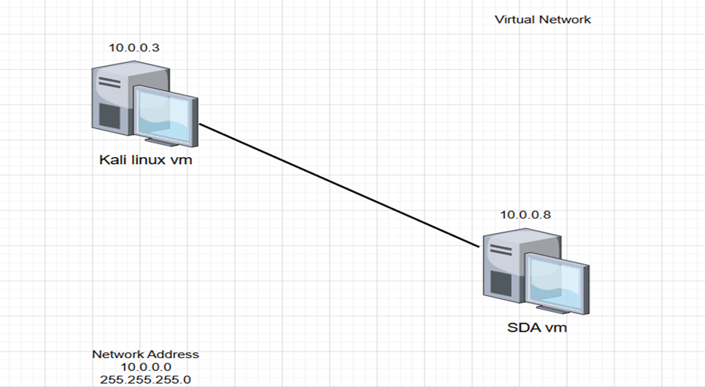

We are going to work with different hypervisor platforms to “hack” the

SDA.vm manually first and then automate it.

**Recon & Enumeration Phase**

* **Nmap** Scan (Checking for open ports and service versions)

Command:

**sudo nmap** -sS -sV -p- -T4 192.168.1.6

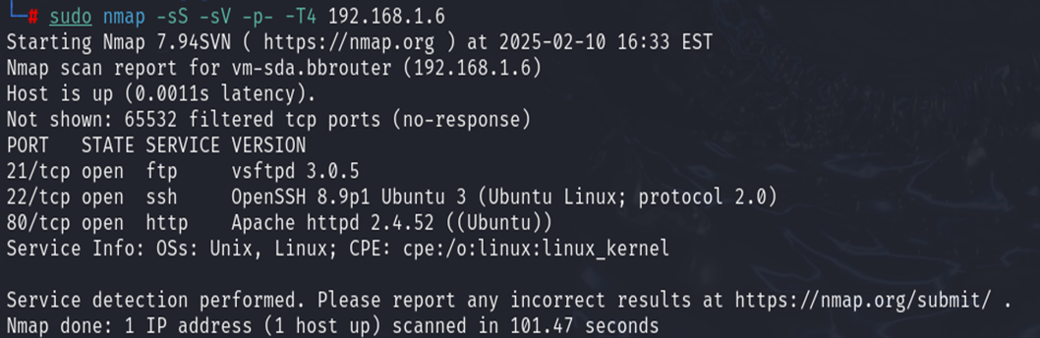

We have 3 open ports. The last one port 80 (Apache) or Web application is perfect way. It may have misconfigurations or some other kind of webapp vulnerabilities.

Also we are going to give the below command to see if there are any frameworks.

**whatweb** 192.168.1.6



After that I gave the **curl** command to view the page source code for comments or functions.

**curl** 192.168.1.6

We found a base 64 encoded. The best way is to decode it with online site such as <https://www.base64decode.org/>

Message gives us details on how to enumerate the webapp.

We proceeded to download the list and used **gobuster** to look for directories.

* **GoBuster brute-forcing Directories**

**gobuster** dir -u http://192.168.1.6 -w directory-list-lowercase-2.3-medium.txt

For us the most interesting directory was **/requests**.

**urgent.txt**

The user has as username a planet name. We are going to make a list of planets using ChatGPT then put them on a list and use hydra to Brute-Force on the SSH service. Based on urgent.txt, we should use rockyou-10 passwords list.

* **Brute-Forcing SSH Logins using Hydra**

hydra -L planets.txt -P rockyou-10.txt ssh://192.168.1.6 -t 4

**Credentials**

uranus: butterfly

Now we’re going to login with SSH and see for possible privilege escalation ways to get into root.

We logged in on uranus user and found the first flag: **user.txt**

* **Flag**: flag{h4ck3r}
* **Privilege Escalation to root user**

Now that we are logged in we’re going to see what permissions as uranus user we have using **sudo -l** command.

We don’t have permissions to run sudo command with uranus. Now, let's try to see the last commands they’ve executed on the machine.

Accessing the **.bash_history** file

We got another Base64 message, We are going to decode it and see what it says.

Decoding Base64 found from **.bash_history**

The root user has a 3-digit code. Crunch is a tool that generate a list of 3-digit codes from 000 to 999. We should use hydra tool to brute-force root user.

**Using crunch to generate 3-digit codes**

**crunch** 3 3 -t %%% -o codes.txt

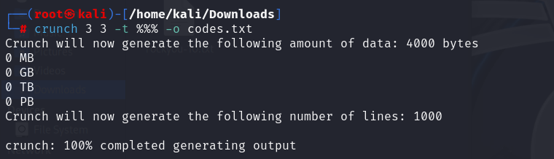

Now we’re going to use hydra again to brute-force root user.

**hydra** -l root -P codes.txt ssh://192.168.1.6 -t 4

root:666

Accessing root user with found credentials

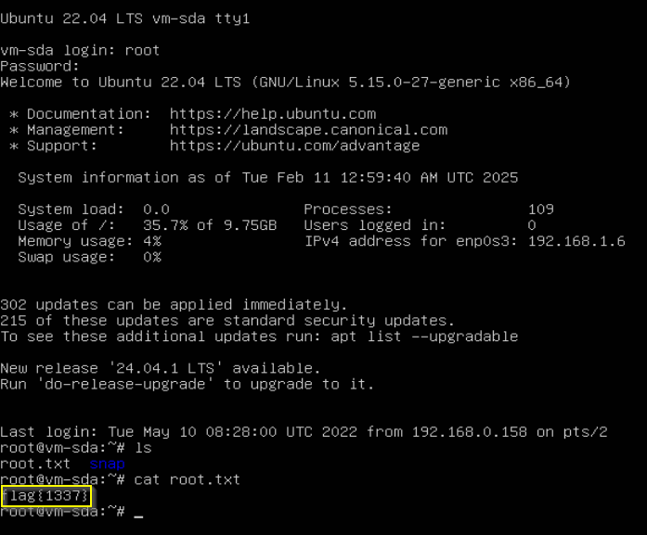

* **Flag** flag{1337}

Another topic is the automation of tasks using Python3 and Scapy. The script will be uploaded on a GitHub repo..