Aleksander Bruske

CS362

Assignment 1

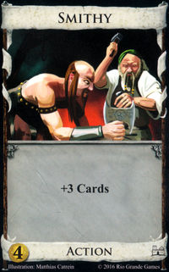

Smithy is an Action card from the Base set. Although the card does not provide any real +Action, it allows the player to draw +3 cards from the player’s library, and it uses up the player’s one action for their turn. This card costs 4 copper to add to your deck of cards.

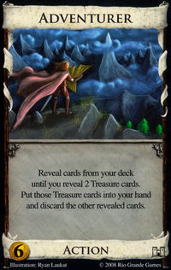

Like the Smithy card, the Adventurer card is an Action card of the Base set. Considering a player starts a game with 7 copper coins, the adventurer is very expensive at a cost of 6 coins. Moreover, this Action card reveals cards from the player’s deck until two treasure cards are revealed. These two treasure cards are put into the player’s hand, then the rest of their cards are discarded.

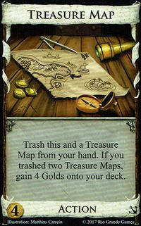

The Treasure Map is an Action card from Seaside. The card costs 4 coins to use as the action for the player’s turn. When used it is trashed from the player’s hand. If a player trashes two Treasure Maps, the player acquires 4 gold coins.

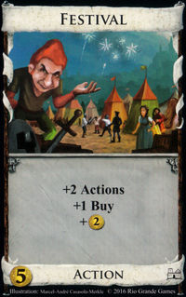

Like the Smithy and Adventurer cards, the Festival card is an Action card of the Base set. It is a rather expensive card to use as it costs 5 coins; however, it is very valuable as it gives a player two additional Action cards, a +Buy, and +2 coins.

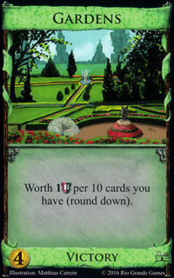

The Gardens card is a Victory card of the Base set, and it costs 4 coins to use. This card can be very powerful when a player has many cards in their deck because when used it produces 1 Victory point for every 10 cards a player has in their deck. For example, if the player has 2 Gardens cards and 27 cards in their deck, they will receive 4 Victory points.