PROBEX SCHOOL INC.

WORK IMMERSION PORTFOLIO

(Bioplastics: Alternative Packaging Materials As Candy Wrapper)

Prepared by: DM A. ADANZA

GR.12 STEM

2021-2022

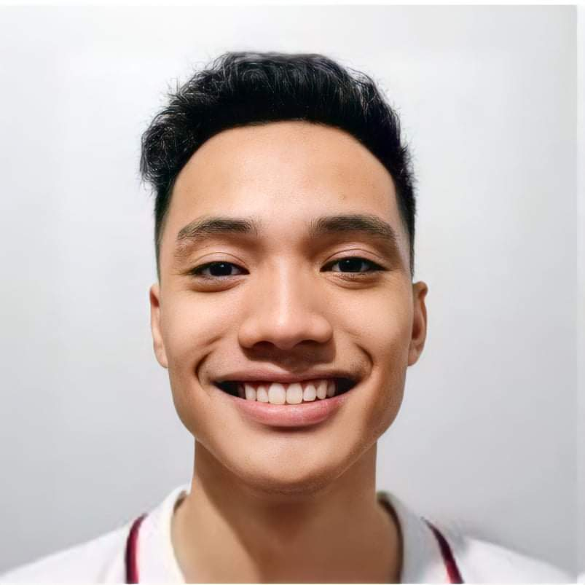STUDENT INFORMATION SHEET

NAME : DM A. Adanza

DATE OF BIRTH : Oct. 13,2004____________________________________________

PLACE OF BIRTH : Manila____________________________________________

PARENT’S/GUARDIAN’S NAME: Darne E. Adanza______________________________________

EMAIL ADDRESS :dm.adanza@probexschool.edu.ph____________________________________________

CELLPHONE NUMBER :09218569314____________________________________________

RELIGION :PROTESTANT___________________________________________________________

HEALTH ISSUES/ ALLERGIES: Handsomeness____________________________________________________

HOBBIES/PAST TIME ACTIVITIES: Basketball,Cycling,Video Games,Creating Contents____________________

SKILLS/TALENTS :Singing and Acting_______________________________________________________

EXTRA-CURRICULAR ACTIVITIES IN SCHOOL: Former Varsity Player(Basketball)________________________

LIST YOUR FAVOURITES: Dogs, Neutral Colors, Pizza, Windbreaker__________________________________

ONE WORD OR OBJECT THAT DESCRIBES YOURSELF: Peach-Mango Pie______________________________

HOW DO YOU FEEL ABOUT SCHOOL ENVIRONMENT? : mysterious___________________________________

_________________________________________________________________________________________

WHAT ARE YOUR MOST MEMORABLE SUBJECTS / CLASSES? WHY? /: All of them, because they are all difficult in different ways but it’s fun, exciting and full of memories at the same time.___________________________

WHAT ARE YOUR PLANS AFTER SENIOR HIGHSCHOOL? : Going to college and do my best to be one of varsity players in basketball and I’m planning to be a celebrity.­­­____________________________________________

WHAT IS YOUR CHOSEN CAREER PATH? : I’m planning to study computer.____________________________

_________________________________________________________________________________________

WHAT IS YOUR PHILOSOPHY IN LIFE? : Just ride the tide until the sun rises again because it always does, and when it does tas nandyan ka pa rin.. you’re in for a lot of surprises.___________________________________

DO YOU HAVE PLANS TO GO ABROAD? IF YES, WHERE AND WHY? : yes, if it is my world tour concert or trip around the world just to chill._________________________________________________________________

WHAT ARE YOUR DREAMS AND AMBITIONS? : make my parents happy, I want to became an actor and a recording artist or became a professional basketball player._________________________________________

HOW DO YOU PLAN TO ACHIEVE YOUR AMBITIONS AND GOALS IN LIFE? : Work hard, taking risks not giving up easily._________________________________________________________________________________

WHAT ARE YOUR EXPECTATIONS AND APPREHENSIONS FOR RESEARCH PROJECT? : I expected it to be finish _________________________________________________________________________________________

**Your bio**:

“Who you are as a person and as a researcher?”

As a person I’m kind of person who’s go with the flow, funny guy but responsible at the same time. I just want to be genuinely happy. As a researcher, if the lead says what they want me to do, I’ll do my best to satisfy my fellow researchers and members.

**Weekly Log (WEEK 1)**

* What are my expectations in creating our research project? I expect it to be successful and has a successful product.
* How did we come up with our research problem? The product won’t harden just like we expect.
* Why is this a problem? We need it to be moldable and harden in able to become a bottle.
* What is/ are my background knowledge about our chosen problem? Maybe we need ingredient or ingredients in able to be stiff when it is completely dry.
* **Reflections:**

**Not everything that we plan will always go as we wanted too, sometimes we need to fail at first in able to grow.**

Documentation**:(Show your outputs)**

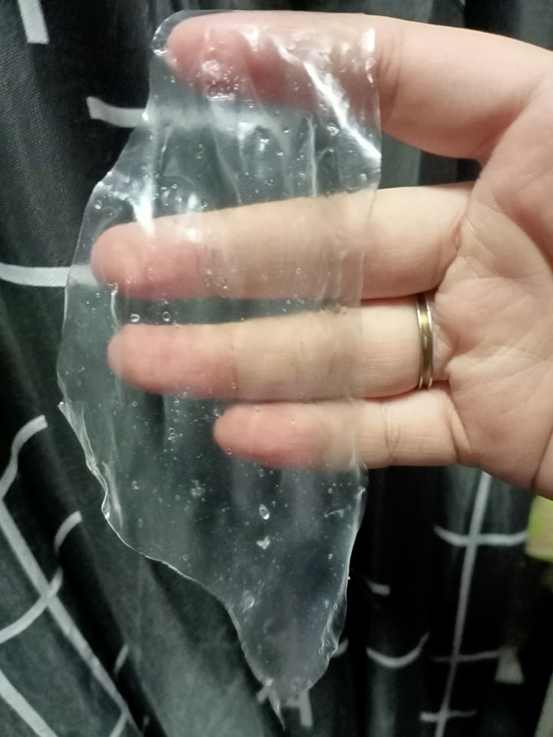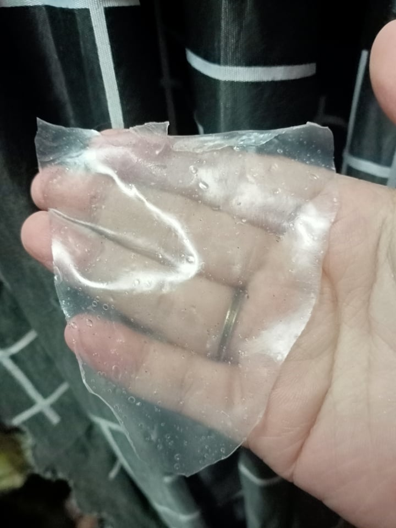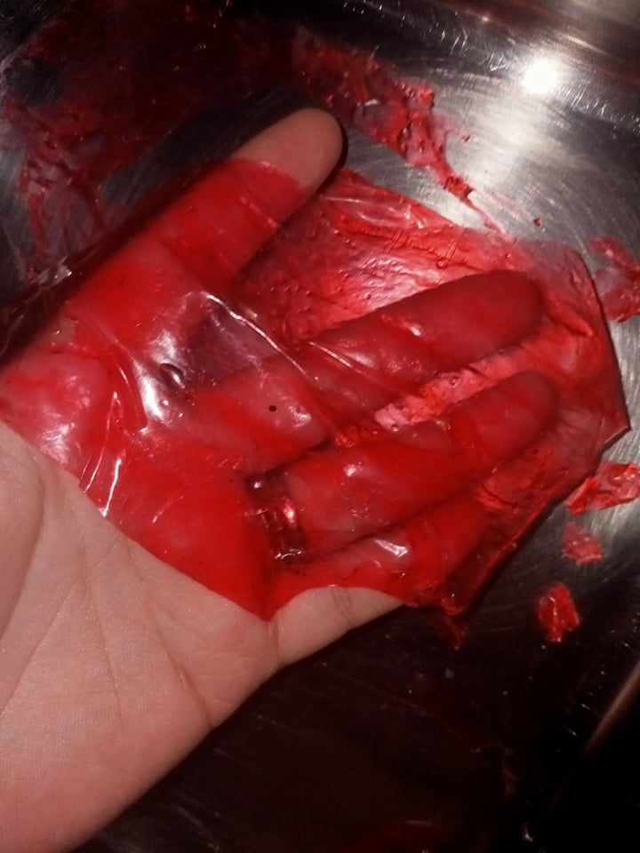

**Weekly Log (WEEK 2)**

* What is my role in our research project? I gather some informations where my lead assigned me to do.
* What skills and qualities I explicitly shown in creating our research project? Not being short temper and I became more responsible.
* Which one best demonstrate my/ our approach to design problems?

We had a change of heart and desided to change our product. Because we cannot force something if it’s not meant for that.

* Where have I/ our group made mistakes or had to adjust my/ our process?

The product, we need to change our product because no matter what we do it always fail. It doesn’t become stiff and it dissolves fast.

* What are the ways I’ve/ our group’s way/s done to overcome that mistake/s or adjustment/s during the creation of our research project?

We overcome it by accepting the fact that we need to revise some or most of our research in able to be compatible to our new product.

* Write a list of my past projects that I show my listed skills and qualities.

I do actions right after I got something to do.  
I response if someone asked me something.

* Documentation**: (Show your outputs)  
    
  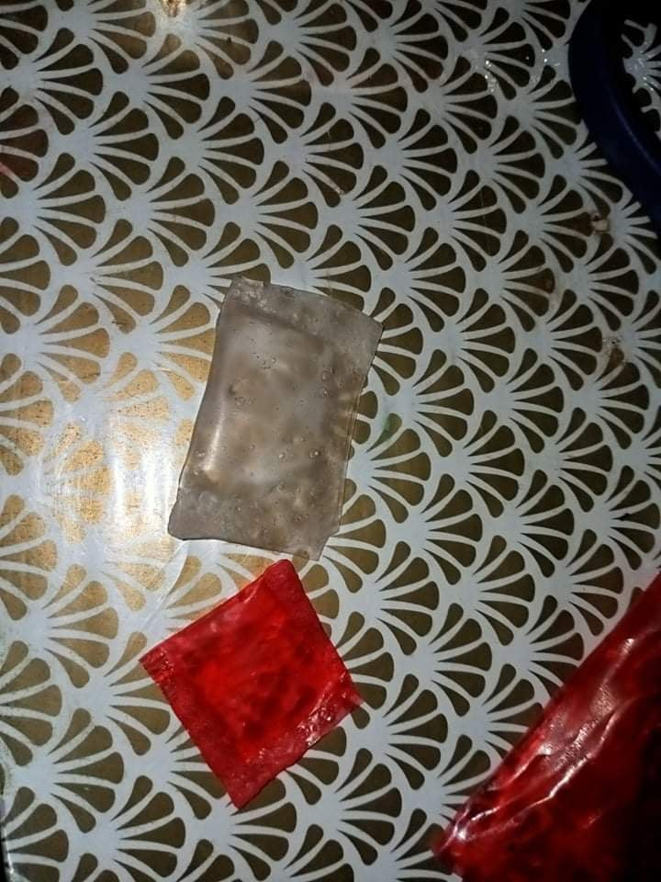 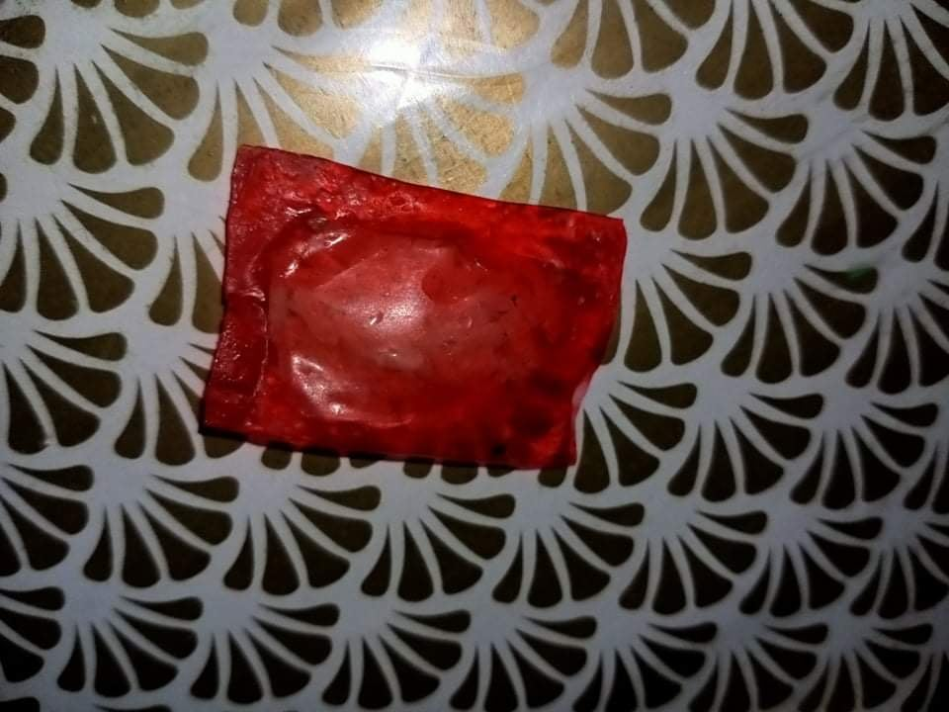**

**Weekly Log (WEEK 3)**

* What are the methods that I/ we used in creating our research project? Explain in details.

In paper works, we always check if the site was legitimate and we gather informations as a group. In product making we mixed all the dry ingredients first then we add the liquid materials, mixed till the dry ingredients dissolves and become one with liquid material. Then we pour it into our molding trey and let it dry.

* How I/ we validated or unvalidated our hypothesis?

We assume that it will go well but in creating our product we didn’t expect it to be so difficult.

* At what point, did I/ we decide I/ weneed those method/s I/ weused?

To the point that we need some output because the panelist need some products.

* Demonstrate my/ our research process.

The research went like a rollercoaster. Mixed emotions and lots of trials and errors.

* Documentation**: (Show your outputs)**

