|  |
| --- |
| **LTE OTA Test Report**  **Report No.:** **AF1ApplyNumber**  **Test Plan: CTIA Test Plan for Wireless Device Over-the-**  **Air Performance, Revision 3.7.1**  **Applicant Name:** **AF1ApplicantName**  **Manufacturer Name:** **AF1MaufactureName**  **Product Name:** **AF1ProductName**  **Model Name:** **AF1ModelName**  **Measurements performed at**  **SGS Taiwan Ltd.**  **WuKu District, Taiwan** Issued Date: |

|  |  |  |  |  |
| --- | --- | --- | --- | --- |
|  | Name | Date & Signature |  | Distribution |
| Prepared by: |  |  |  |  |
| Approved by: |  |  |  |  |



**Revision Version**

|  |  |  |  |
| --- | --- | --- | --- |
| **Report Number** | **Revision** | **Date** | **Memo** |
| RV1ReportNumber | RV1Revision | RV1Date | RV1Memo |
|  |  |  |  |
|  |  |  |  |
|  |  |  |  |
|  |  |  |  |
|  |  |  |  |
|  |  |  |  |
|  |  |  |  |
|  |  |  |  |
|  |  |  |  |

**This test report contains a reference to the previous version test report that it replaces.**

Table of contents

1. Measurement System Information 4

1.1 General Information 4

1.2 List of Equipment 9

2. Range Reference Measurement 10

2.1 Reference Measurement Procedure 10

3. Test Procedure 10

4. Measurement Uncertainty 10

5. Summation Test Reports 11

5.1 TRP Test Report 11

5.2 TIS Test Report & Intermediate Channels 12

6. Free Space & SAM Measurements 24

6.1 Test Setup (FS & BHHL & BHHR & HL & HR) 24

6.2 Coordinate System 27

# Measurement System Information

## General Information

# Testing Condition:

* Temperature: 25±3˚C
* Humidity: <80%

# 

# Measurement Facility:

* + Measurement Chamber: ETS-Lindgren 3D fully anechoic chamber and its measuring system (AMS-8500)
  + Base Station Simulator: Agilent E5515C (or R&S CMU200)
  + ETS-Lindgren EMCO-2090 Auxiliary Ports RF Relay Switches
  + Spectrum Analyzer: Agilent N9010A

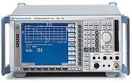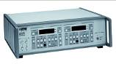

Fiber Optics for MAPS system

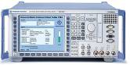

Measurement Antenna

GPIB-Bus



Spectrum Analyzer



Universal Radio Communication Tester

MAPS Controller

Communication Antenna on ceiling

Communication Antenna on MAPS

Mobile Phone

RF Relay Switch

Control PC

Limiting Amplifier

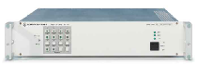

Measurements are performed in a ETS-Lindgren AMS-8500 3D fully anechoic test system. The test system includes a high-performance RF-shielded, rectangular anechoic chamber, a Multi-Axis Positioning System (MAPS), and *EMQuestTMEMQ-100* data acquisition and analysis software. The geometry of the setup is specified below for reference.

**Typical Setup for ETS-Lindgren AMS-8500:**

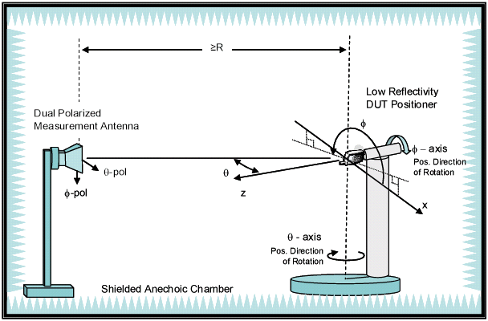

**Instruments View Inside View**

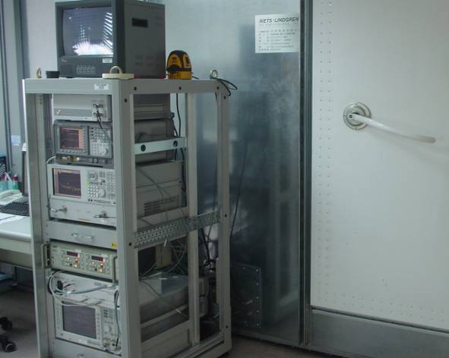 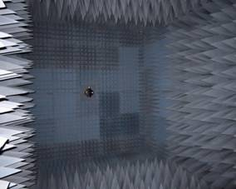

**Head and Hand Phantom Selection Process**

Customers, or carriers, at their option, may ask for additional testing with alternate hand phantoms. In such cases, normal measurement procedures apply, and the resulting

supplemental data can be included in the report. The test report shall clearly identify the supplemental data.

|  |  |  |  |  |  |
| --- | --- | --- | --- | --- | --- |
| **Brand** | **Grip** | **Right Hand No.** | **Spacer No.** | **Talk / Data** | **S/N** |
| SPEAG | Monoblock | QD LOH 001 | N/A | Talk | 5303 |
| SPEAG | Fold | QD LOH 030 | N/A | Talk | 15313 |
| SPEAG | Narrow Data | QD LOH 060 | N/A | Data | 35287 |
| SPEAG | PDA | QD LOH 050 | N/A | Talk & Data | 25318 |
| SPEAG | Wide Grip | QD LOH 480 | N/A | Talk & Data | 7024 |

|  |  |  |  |  |  |
| --- | --- | --- | --- | --- | --- |
| **Brand** | **Grip** | **Left Hand No.** | **Spacer No.** | **Talk / Data** | **S/N** |
| SPEAG | Monoblock | QD LOH 020 | N/A | Talk | 1181 |
| SPEAG | Fold | QD LOH 040 | N/A | Talk | 11159 |
| SPEAG | Narrow Data | QD LOH 070 | N/A | Data | 30189 |
| SPEAG | PDA | QD LOH 080 | N/A | Talk & Data | 20217 |
| SPEAG | Wide Grip | QD LOH 460 | N/A | Talk & Data | 6016 |

**The Definitions of Two Receiving Antennas**

The better antenna between the two receiving antennas is always identified as the primary antenna, and the weaker antenna is the secondary antenna. The manufacturer shall identify one antenna as “a” and the other antenna as “b”. When either the “a” or “b” antennas is activated dynamically, then the manufacturer must identify this antenna as being active dynamically and include this information in the test report. Antenna “a” or “b” shall be identified as the primary antenna for all test cases having a primary and secondary antenna.

The antenna used for transmitting shall be identified as “a”, “b” or “other”.

**Testing Laboratory: Identification of the Responsible Test Laboratory.**

* **OTA Laboratory:**

**SGS Taiwan Ltd. Electronics & Communication Laboratory**

No.134, Wu Kung Road, New Taipei Industrial Park, Wuku District, New Taipei City,

Taiwan 24803.

Telephone: +886 2 2299 3279

Fax: +886 2 2298 0488

Internet: <http://www.tw.sgs.com>

* **Testing Location:**

No.134, Wu Kung Road, New Taipei Industrial Park, Wuku District, New Taipei City,

Taiwan 24803.

**Details of Applicant:**

|  |  |
| --- | --- |
| **Applicant’s name:** |  |
| **Applicant’s address:** | AF1ApplicantAddr |
| **Contact person:** | AF1ContactPerson |
| **Telephone:** | AF1Telephone |
| **Fax:** | AF1Fax |
| **E-mail:** | AF1Email |

**Details of Manufacturer:**

|  |  |
| --- | --- |
| **Applicant’s name:** | AF1MauAppName |
| **Applicant’s address:** | AF1MauAppAddr |
| **Contact person:** | AF1MauContactMan |
| **Telephone:** | AF1MauTelephone |
| **Fax:** | AF1MauFax |
| **E-mail:** | AF1MauEmail |

**Details of EUT:**

|  |  |
| --- | --- |
| **Device Description:** | **AF1DeviceDescrip** |
| **Device Manufacturer:** | **AF1DeviceManu** |
| **Model Name:** |  |
| **CTIA Request #** | **AF1CTIARequest** |
| **Hardware Version:** | **AF1HardwareVersion** |
| **Software Version:** | **AF1SoftwareVersion** |
| **IMEI:** | **AF1MEDI** |
| **FCC ID:** | **AF1FCCID** |
| **Device Power Class:** | **AF1DevicePwrClass** |
| **Configuration of Primary Mechanical Mode:** | **AF1Contfiguration** |

**Duration of Tests:**

|  |  |
| --- | --- |
| **Sample Receive Date:** | **AF1SampleRevDate** |
| **Test Starting Date:** | **AF1TestStartDate** |
| **Test Ending Date:** | **AF1TestEndingDate** |
| **Report Issued Date:** | **AF1ReportIssuDate** |

**Photographs of EUT:**

|  |  |
| --- | --- |
| **PE1PhotoTag** |  |
| **PE1PhotoData** |  |

## List of Equipment

|  |  |  |  |  |
| --- | --- | --- | --- | --- |
| Equipment Summary Sheet | | | | |
|  | | | | |
| **Equipment Description** | **Manufacturer** | **Identification no.** | **Current calibration date** | **Next calibration date** |
| AE1EquipmentName | AE1Manufacturer | AE1IdentifyNo | AE1CurrCalibratDT | AE1NextCalibratDT |

# 2. Range Reference Measurement

Range reference measurement is performed in order to determine the system losses and gains so that they may be normalized out of the EUT measurement data. A calibrated horn antenna is used as the EUT, a signal generator as the source, and a spectrum analyzer as the receiver.

## 2.1 Reference Measurement Procedure

The reference measurement procedure is described in SGS Working Instruction WI-TESP-EO-003 for CTIA OTA service, and Satimo Support Document “SG24 active measurements user manual”, and follow **CTIA Test Plan for Wireless Device Over-the-Air Performance, Revision 3.7.1.**

# Test Procedure

Testing is performed according to the ***CTIA Test Plan for Wireless Device Over-the-Air Performance, Revision 3.7.1.*** Detailed test procedures are described in SGS Working Instruction WI-TESP-EO-117 for CTIA OTA service.

# Measurement Uncertainty

**Expanded Uncertainty (dB)**

|  |  |  |  |  |  |  |  |  |  |
| --- | --- | --- | --- | --- | --- | --- | --- | --- | --- |
| **Item** |  | **LTE-**  **700** | **Cellular** | **GPS** | **AWS-1**  **TX** | **PCS** | **AWS-1**  **RX** | **LTE-**  **2300~2800** | **CTIA**  **Limits** |
| **MU1Item** | **MU2SubItem** | **MU2LTE700** | **MU2Cellular** | **MU2GPS** | **MU2AWS1TX** | **MU2PCS** | **MU2AWS1RX** | **MU2LTE23002800** | **MU2CTIALimits** |
|  |  |  |  |  |  |  |  |  |

# 5. Summation Test Reports

## 5.1 TRP Test Report

### 5.1.1 CTIA TRP Summation Test Report

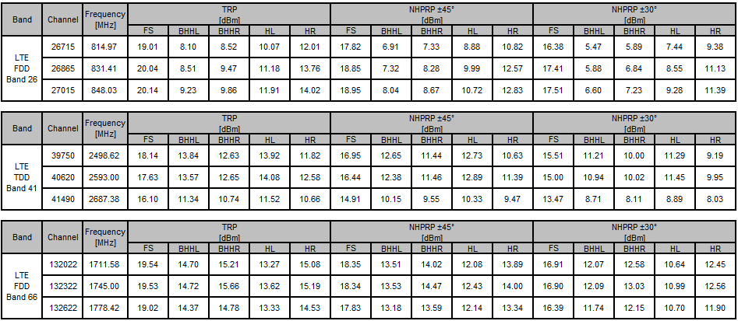

## 5.2 TIS Test Report & Intermediate Channels

### 5.2.1 CTIA TIS Summation Test Report

**TIS – Primary Antenna**

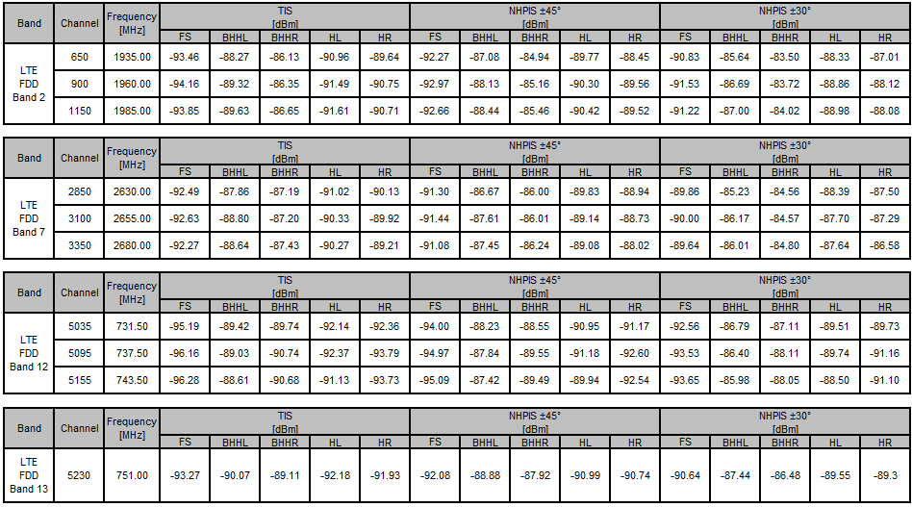

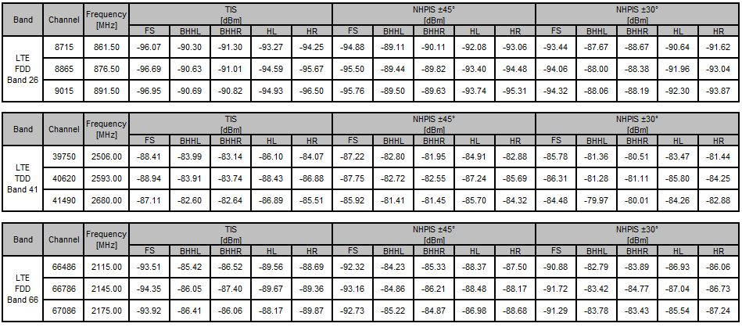

**Secondary Antenna**

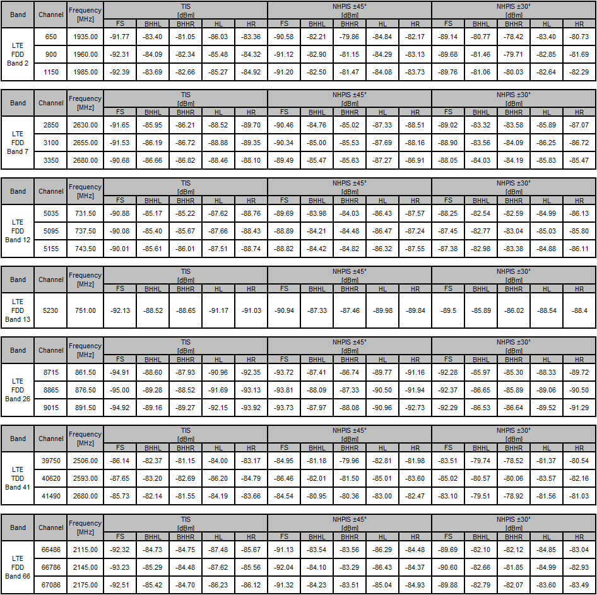

* + 1. **BPD– Branch Power Difference**

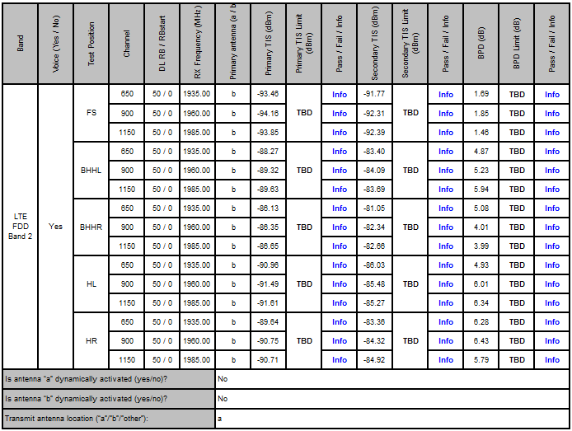

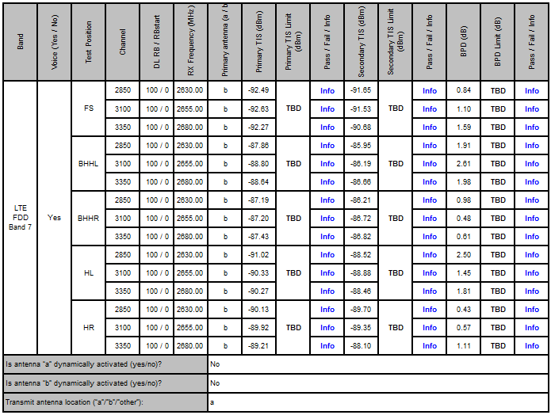

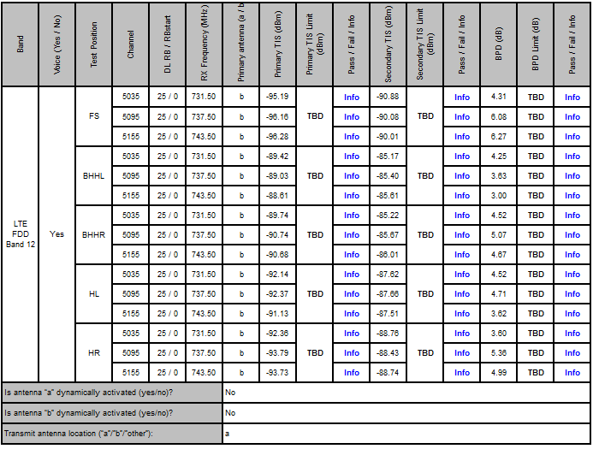

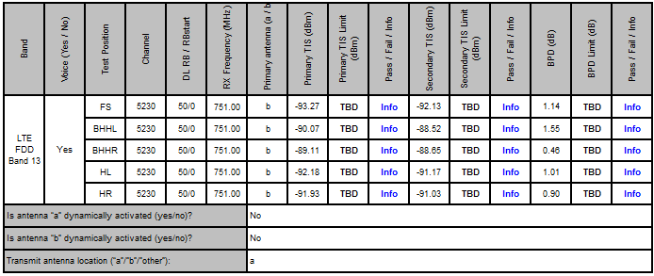

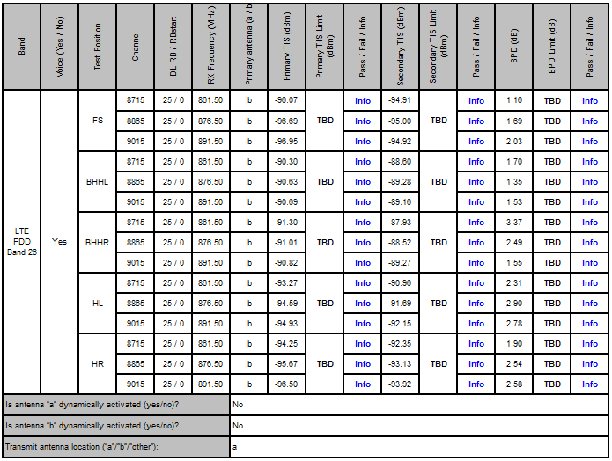

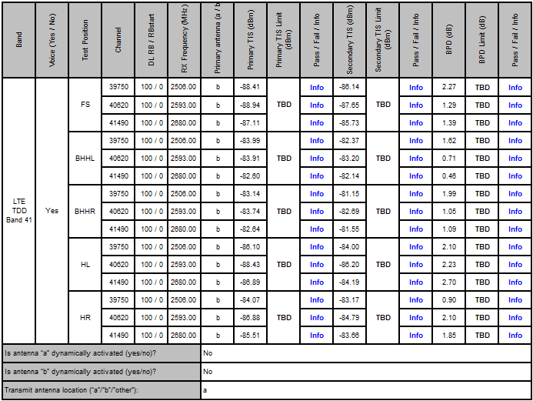

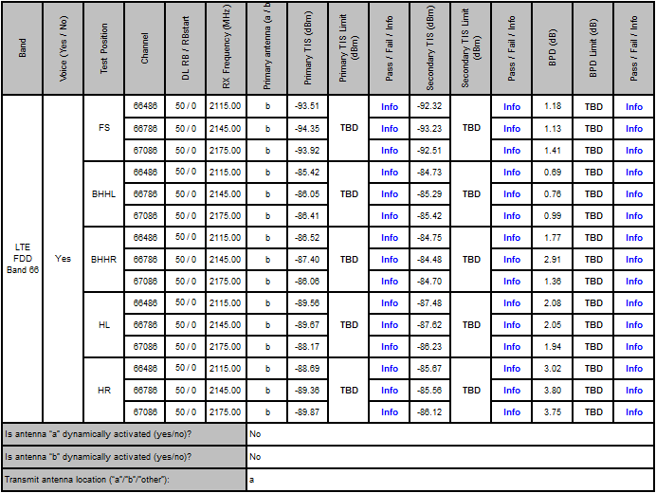

### Relative Sensitivity on Intermediate Channels

**RS1TestStage**

|  |  |  |  |  |  |
| --- | --- | --- | --- | --- | --- |
| **Band** | **Channel Bandwidth (MHz)** | **Frequency (MHz)** | **Channel** | **FS EIS (dBm)** | **BHHR EIS (dBm)** |
| **RS2Band** | **RS2Bandwidth** | **RS2Fequence** | **RS2Channel** | **RS2FSEIS** | **RS2BHHREIS** |
|  |  |  |  |  |  |
|  |  |  |  |  |  |

### Summation Test Report Plot Matrix

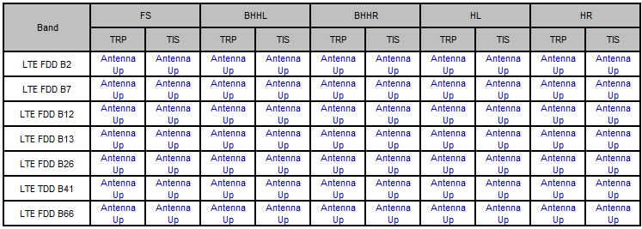



## Free Space & SAM Measurements

## 6.1 Test Setup (FS & BHHL & BHHR & HL & HR)

**Free Space (FS):**

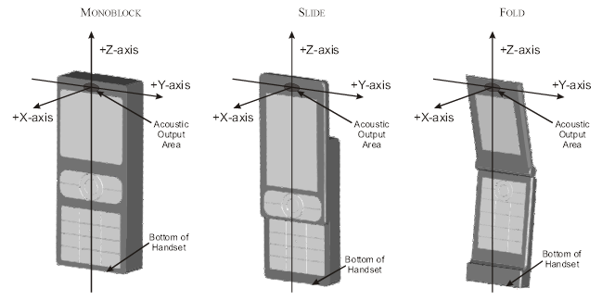

**Beside Head & Hand Left (BHHL):**

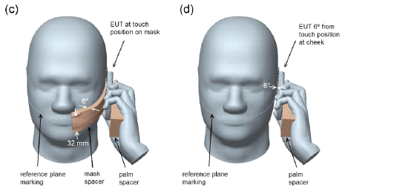

**Beside Head & Hand Right (BHHR):**

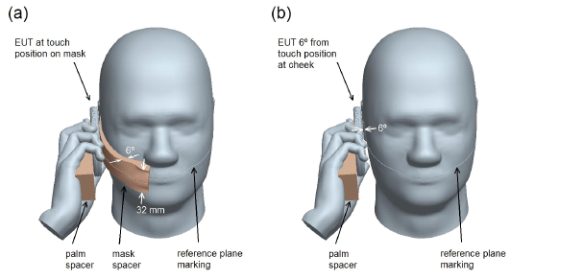

**Hand Left / Right (HL / HR):**

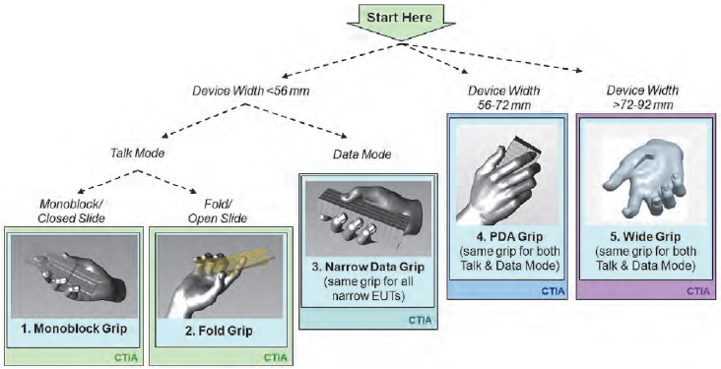

**FS BHHL BHHR**

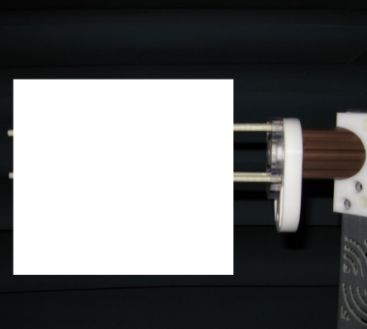  

**HL HR**

** **

**Remark:**

Most devices will fit nicely in to the decision tree. Customers, or carriers, at their option, may ask for additional testing with alternate hand phantoms. In such cases, normal measurement procedures apply, and the resulting supplemental data can be included in the report.



## Coordinate System

**FS**

The coordinate system is centered on the receiver of the phone, with the **+X-axis** pointing front side of the phone (out of the picture), the **+Y-axis** pointing right side of the phone (top side of the picture), and the **+Z-axis** pointing top side of the phone (left side of the picture).

## BHHL / BHHR

The coordinate system is centered on the ear of the SAM phantom, with the **+X-axis** pointing front side of the phantom (out of the picture), the **+Y-axis** pointing right side of the phantom (right side of the picture), and the **+Z-axis** pointing top side of the phantom (top side of the picture).

## HL / HR

The coordinate system is centered on the display of the phone, with the **+X-axis** pointing front side of the phone (out of the picture), the **+Y-axis** pointing right side of the phone (top side of the picture), and the **+Z-axis** pointing top side of the phone (left side of the picture).

* **Transmitting radios:**
  + WWAN - **On**
  + WLAN(Wireless Local Area Network) - **Off**
  + Bluetooth™ - **Off**
  + WiMAX™ – **Off**
  + UWB(Ultra Wideband) – **Off**
  + All other embedded transmitting radios that are not being tested – **Off**
* **RX Diversity – Enabled**
* **Power Management Settings:** 
  + Screensaver – **None**
  + Turn Off Display - **Enable**
  + Turn Off Hard Drive - **Enable**
  + System Hibernate - **Enable**
  + System Standby - **Enable**
* **Display (LCD) Backlight - Off**
  + Ambient light sensor - **Disabled**
* **Keyboard Backlight - Off**
  + Ambient light sensor - **Disabled**
* **Powered by the battery (standard battery only)**

**End of Report**