Sample Paragraph Post. This is a sample Paragraph post. Sample Paragraph text is being cut and pasted again and again. This is a sample Paragraph post. peru-duellmans-poison-dart-frog.  
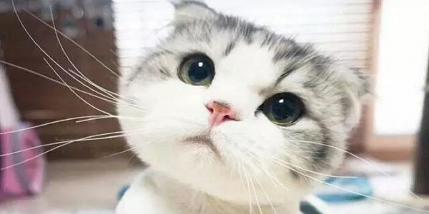  
Sample Paragraph Post. This is a sample Paragraph post. Sample Paragraph text is being cut and pasted again and again. This is a sample Paragraph post. peru-duellmans-poison-dart-frog.  
