**Exercise 1**

1. The IP address of the website www.koala.com.au is 104.21.45.210 and 172.67.219.46. Multiple IP’s may be used for DNS load balancing. This distributes incoming network traffic across multiple servers. In case another server goes down, there will also be other ones that are still up.
2. The name of the IP address 127.0.0.1. is ‘localhost’. This IP address allows the machine to connect to and communicate with itself.

**Exercise 2**

* [www.google.com.au](http://www.google.com.au) yes
* [www.stanford.edu](http://www.stanford.edu) yes
* [www.wikipedia.org](http://www.wikipedia.org) yes
* [ec.ho](http://ec.ho/) no, not reachable through web browser. Does not exist.
* [pin.gs](http://pin.gs/) no, not reachable through web browser. Does not exist.
* [nasa.gov](http://nasa.gov/) no, reachable through web browser. Since it is a government website they want to stop people accessing their IPs. For example, they might get DDOS attacked.
* [yes.no](http://yes.no/) yes
* [one.one.one.one](http://one.one.one.one/) yes
* [theguardian.com](http://theguardian.com/) yes
* [xn--i-7iq.ws](http://xn--i-7iq.ws/) yes

**Exercise 3**

* How many routers are there between your workstation and [www.tu-berlin.de](http://www.tu-berlin.de)?

15

* How many routers along the path are part of the UNSW network?

5

* Which router is the first router outside of Australia?

et-2-0-5.bdr1.sing.sin.aarnet.net.au. Router number 7 It is in Singapore.

* Which router is the first router in Europe?

ae9.mx1.ams.nl.geant.net

1. 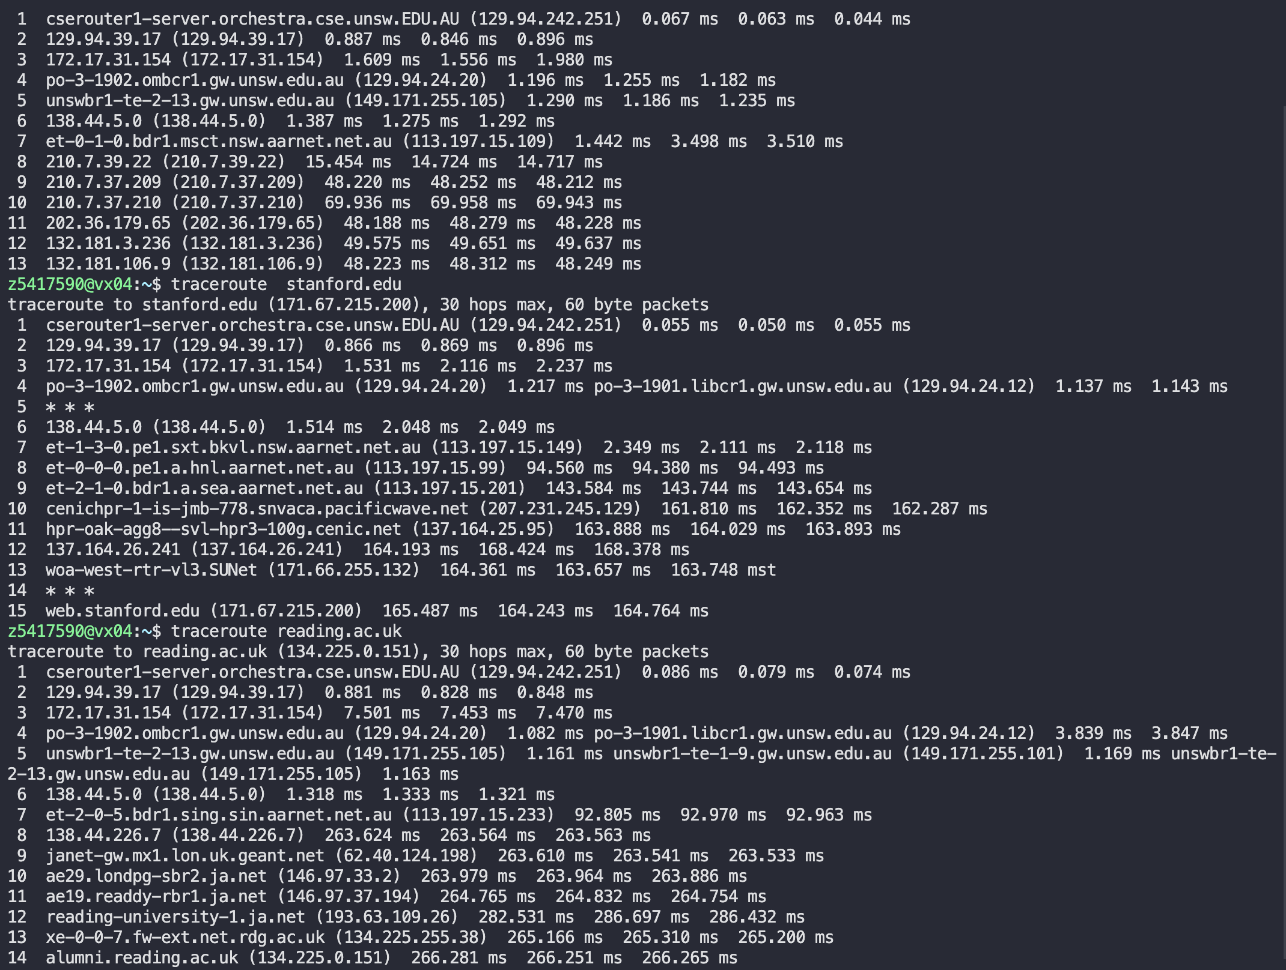

The last common router is 138.44.5.0 (138.44.5.0).

Router - Australian Academic and Research Network

The number of hops in a traceroute is not necessarily proportional to physical distance. It is primarily influenced by the network routing decisions made by various routers along the path.

reading.ac.uk 14 hops – 17071km

web.stanford.edu 15 – 11960km

canterbury.ac.nz 13 – 2156 km

As we can see the number of hops is not proportional to physical distance

1. 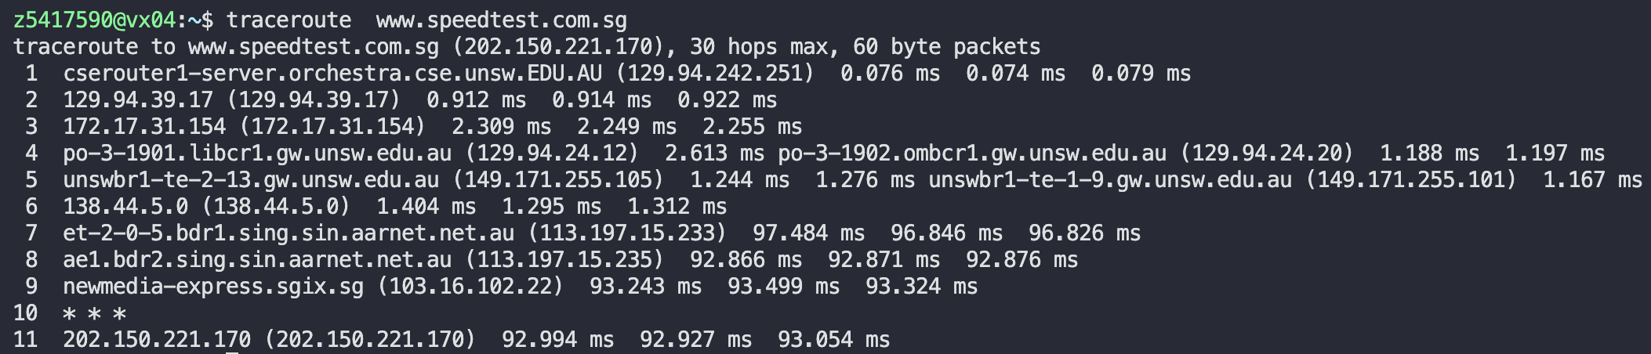 Traceroute from home to [www.speedtest.com.sg](http://www.speedtest.com.sg) 11 hops

Traceroute from [www.speedtest.com.sg](http://www.speedtest.com.sg) to home 6 hops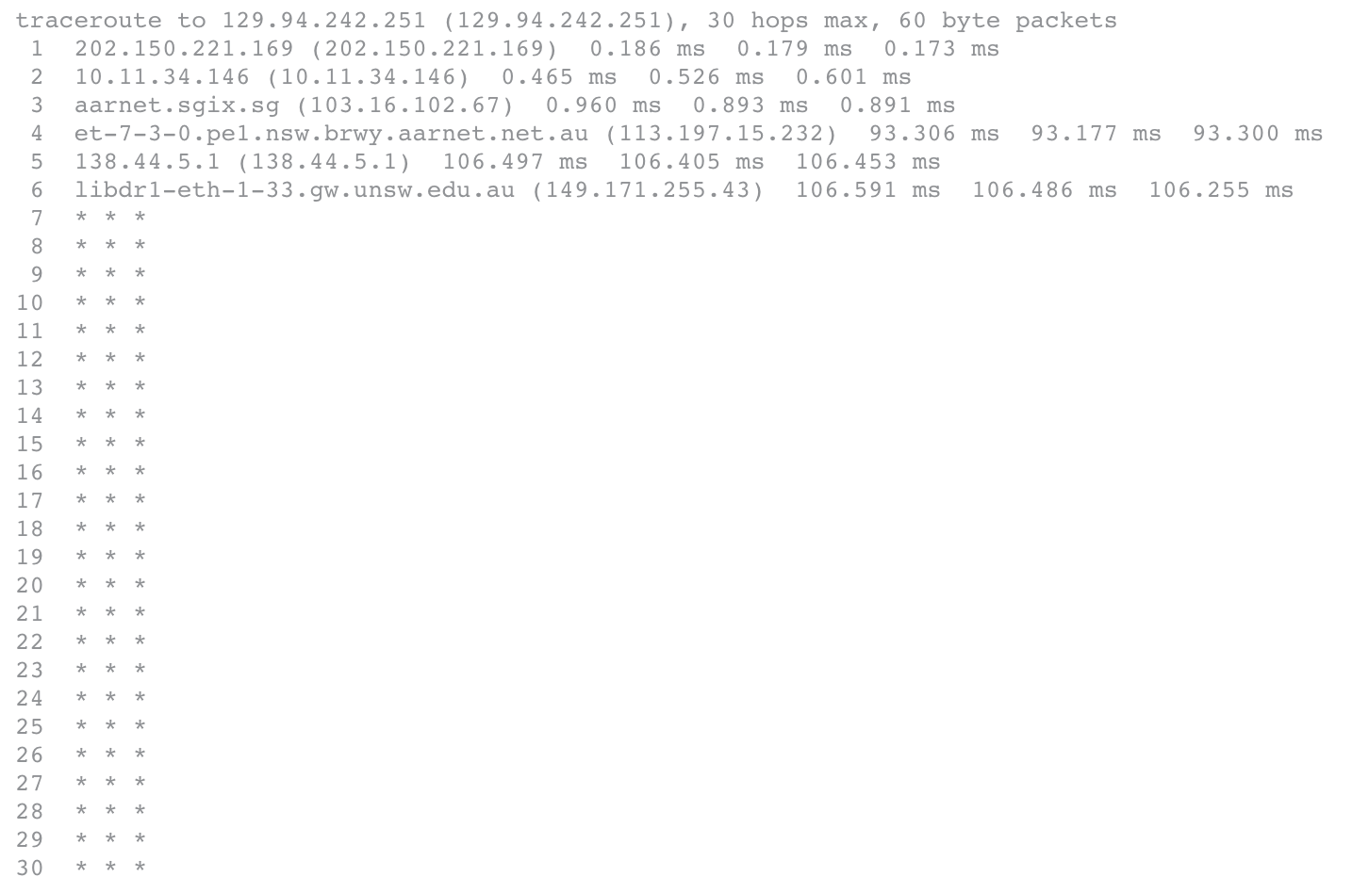

Traceroute from home to [www.as13030.net](http://www.as13030.net) 24 hops.

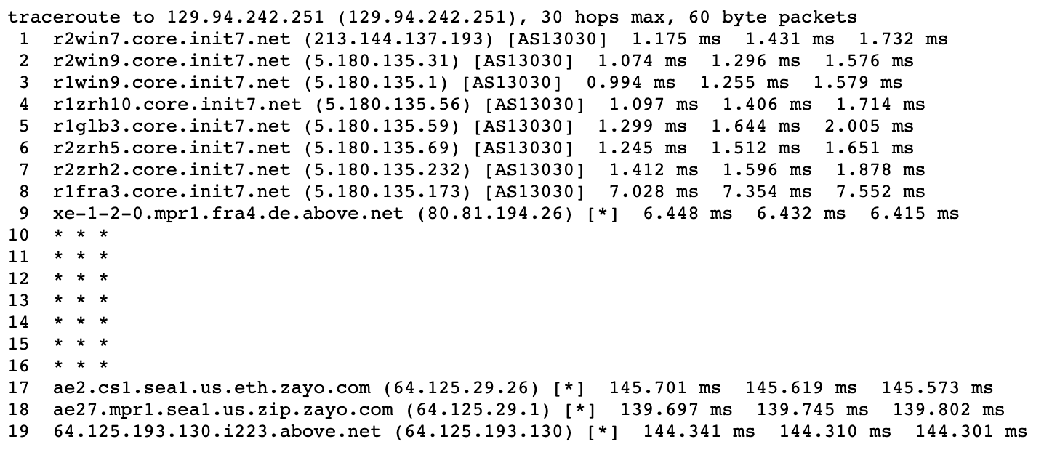Traceroute from [www.as13030.net](http://www.as13030.net) to home 19 hops

As shown above, the reverse path does not go through the same paths as the forward path. Every route would have its own rules, so the path forward is not the same as the path home.

**Exercise 4**

|  |  |  |
| --- | --- | --- |
| Location | Delay | Scatter |
| Flinders University |  |  |
| University of Philippines |  |  |
| University of Oslo |  |  |

|  |  |
| --- | --- |
| Location | Delay Values |
| Flinders University |  |
| University of Philippines |  |
| University of Oslo |  |

The speed of light = 300 000 km/second

|  |  |  |  |
| --- | --- | --- | --- |
| Location | Distance(km) | Shortest time(seconds) | RTT(ms) |
| Flinders University | 1163.48 | T = 1163.48/300000 = 0.00387 | 23.393 |
| University of Philippines | 6270.06 | T = 6270.06/300000 = 0.0209 | 121.033 |
| University of Oslo | 15939.09 | T =15939.09/300000 = 0.0531 | 315.729 |

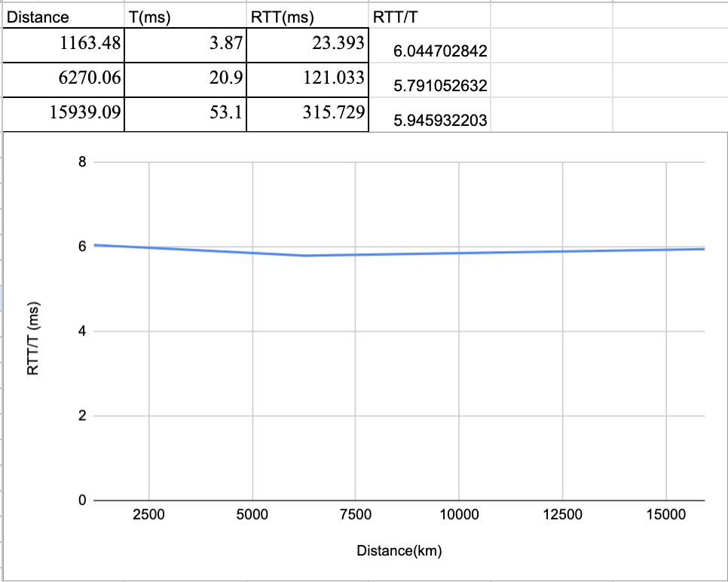

Round-trip time(RTT) is the time it takes for a packet to be sent from the source to destination and for a response to be received from the destination back to the source, whereas T is the shortest time to reach the destination. Therefore, RTT will be at least two time T because it has to travel back and forth between source and destination whilst T is only from source to destination. Thus, the Y axis value will be greater than 2. Furthermore, the value is greater than 2.

Another reason is that there are other delays to consider such as queueing, transmission and processing delays which add more time.

1. Delays to the destinations are not constant over time. As you can see in the graphs above the delays with the different packet sizes vary. One example that may be affecting the delays are increased queueing delays from the packet sizes.
2. Transmission delay and processing delay depend on packet size whilst propagation and queuing delay do not. Propagation delay depends on the length of the physical link, whilst queueing delay depends on time waiting at the output link for transmission.