**Exercise 3**

**Question 1: What is the status code and phrase returned from the server to the client browser?**

HTTP/1.1 200 OK\r\n

Status code: 200

Phrase: OK

**Question 2: When was the HTML file the browser retrieves last modified at the server? Does the response also contain a DATE header? How are these two fields different?**

Last-Modified: Tue, 23 Sep 2003 05:29:00 GMT\r\n.

Yes, the response also contains a DATE header.

Date: Tue, 23 Sep 2003 05:29:50 GMT\r\n.

Date and Last Modified are different, as date is the date and time that the response was generated, whilst last modified is the time and date that the requested object was last modified.

**Question 3: Is the connection established between the browser and the server persistent or non-persistent? How can you infer this?**

The connection established between the browser and the server is persistent. This can be inferred from the connection field being “Keep-Alive”. A persistent connection means that multiple requests and responses can sent over the same connection.

**Question 4: How many bytes of content are being returned to the browser?**

File Data: 73 bytes

**Question 5: What is the data contained inside the HTTP response packet?**

Text and html data.

**Exercise 4**

**Question 1: Inspect the contents of the first HTTP GET request from the browser to the server. Do you see an “IF-MODIFIED-SINCE” line in the HTTP GET?**

There is not an “IF-MODIFIED-SINCE” line in the first HTTP GET.

**Question 2: Does the HTTP response from the server indicate the last time that the requested file was modified?**

Last-Modified: Tue, 23 Sep 2003 05:35:00 GMT\r\n.

**Question 3: Now inspect the contents of the second HTTP GET request from the browser to the server. Do you see the “IF-MODIFIED-SINCE:” and “IF-NONE-MATCH” lines in the HTTP GET? If so, what information is contained in these header lines?**

If-Modified-Since: Tue, 23 Sep 2003 05:35:00 GMT\r\n.

If-None-Match: "1bfef-173-8f4ae900"\r\n.

If-Modified-Since contains a date and time that the browsers resources were last modified or received. If-None-Match contains an e-tag value linked to the browsers resources.

**Question 4: What is the HTTP status code and phrase returned from the server in response to this second HTTP GET? Did the server explicitly return the file's contents? Explain**.

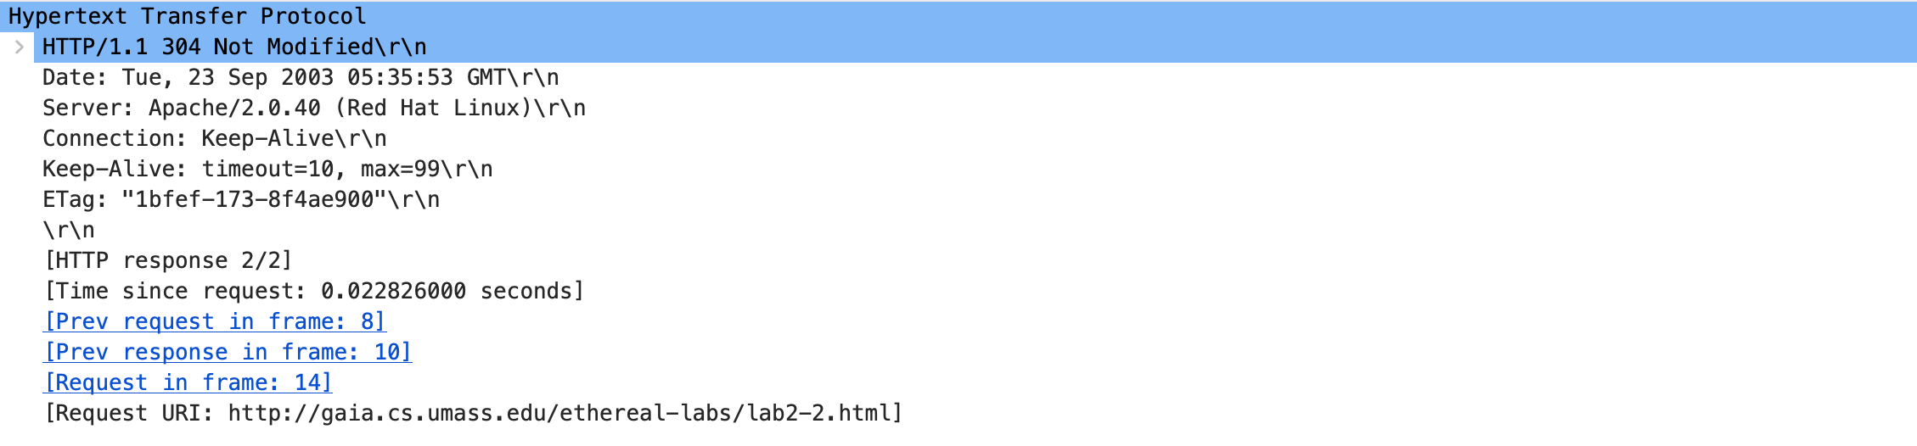

HTTP/1.1 304 Not Modified\r\n

Status code: 304

Phrase: Not Modified

The server has not explicitly returned the file’s contents. The status code informs the browser that the requested resources has not been modified as the Etag from the “IF-NONE-MATCH” is the same as the GET request. This saves resources as the server does not have to send the entire resource every time, as the locally cached version that the browser has is appropriate as no resources have been changed.

**Question 5: What is the value of the Etag field in the 2nd response message, and how is it used? Is the Etag value the same as in the 1 stresponse?**

ETag: "1bfef-173-8f4ae900"\r\n

The ETag value is used for web cache validation. If it matches ETag value with the ETag value in the GET request, it means the resource has not been modified.

**Exercise 5**

