AUTOMATED TEMPERATURE CONTROL SYSTEM

PROOF OF CONCEPT IMPLEMENTATION REPORT

TEAM MEMBERS | UNIVERSITY
MWESIGA TEGAMBWAGE | UDSM
NANCY HIZA | UDSM
WALIDI KOWERO | UDSM
CHELSEA GIDEON | UDSM

SUPERVISOR : DR. EVA SHAYO
TECHNICAL SUPERVISOR : MR. ADRIAN KAMOYE



ACKNOWLEDGMENT
The Team would like to acknowledge the financial and technical support they received from the university of Dar es Salaam (UDSM) and Youth Team Up through DVE program. The team would like to extend their gratitude to Dr. Fatahi Omid, Mr. Solomon and Ms. Pardis Youth Team Up coordinators for their guidance on a wealthy information and vast experiences in project implementations.
A heartfelt appreciation and acknowledgment also goes to Mr Adrian Kamoye and Dr. Eva Shayo for their supervision in both technical and financial support. They are the pillars towards the implementation of this project because they ensured an excellent working relationship from the onset of the pilot project till its completion.
In conclusion, a profound appreciation is extended to the team members, who worked tirelessly throughout the implementation of this Automated Temperature Control System Proof of Concept.

Thank you,

Mwesiga Tegambwage - Project Manager and Lead System Designer
Nancy Hiza - Lead Hardware System Engineer
Walidi Kowero - Lead Electronics and Hardware Programming
Chelsea Gideon

TABLE OF CONTENTS
ACKNOWLEDGMENT i
TABLE OF CONTENTS ii
LIST OF FIGURES iii
LIST OF TABLES iv
EXECUTIVE SUMMARY v
CHAPTER I 1
INTRODUCTION 1
1.1 BACKGROUND 1
1.2 PROBLEM STATEMENT 2
1.3 SOLUTION 2
1.4 OBJECTIVES 2
1.5 SUSTAINABLE DEVELOPMENT GOALS (SDGs) ALIGNMENT 3
1.6 LIMITATIONS 3
CHAPTER II 4
METHODOLOGY 4
2.1 ENGINEERING DEVELOPMENT APPROACH 4
2.2 PROJECT DEVELOPMENT APPROACHES 5
CHAPTER III 7
RESOURCES AND MATERIALS 7
3.1 HUMAN RESOURCES 7
3.2 TECHNICAL RESOURCES 11
3.3 BUDGET AND FINANCIAL RESOURCES 13
3.4 RESOURCE MOBILIZATION 14
CHAPTER IV 16
SYSTEM DESIGN 16
4.1 SYSTEM REQUIREMENTS 16
4.2 IoT ARCHITECTURE 17
4.3 HIGH LEVEL SYSTEM DESIGN 17
4.4 COOLING SYSTEM DESIGN 19
CHAPTER V 21
SYSTEM IMPLEMENTATION 21
5.1 CONTROL LOGIC AND PCB IMPLEMENTATION 21
5.2 COOLING SUBSYSTEM IMPLEMENTATION 22
5.3 SYSTEM INTEGRATION 23
5.4 RESULTS 24
CONCLUSION 25
REFERENCES 26
APPENDIX A 27
PROJECT TIMELINE 27
APPENDIX B 28
PROJECT LEAN CANVAS MODEL 28

LIST OF FIGURES
Figure 1: Bottom-Up Approach 4
Figure 2: Iterative Waterfall Methodology 6
Figure 3: Project’s Task Distribution Chart 10
Figure 4: High-Level Block Diagram 18
Figure 5: Schematic Design 19
Figure 6: PCB Implementation 21
Figure 7: Cooling System Implementation 22
Figure 8: System Integration 23
Figure 9: Project Schedule 27
Figure 10: Lean Canvas Model 28

LIST OF TABLES
Table 1: Project Development Approach 5
Table 2: Task Allocation to Team Members 9
Table 3: Cost Estimation For Actual Device 13

EXECUTIVE SUMMARY
The "Automated Temperature Control System" project, initiated from April to June during DVE Exchange program, aims to provide a comprehensive solution for residential comfort by offering both cooling and heating functionalities ensuring an optimal indoor environment regardless of external weather conditions. By leveraging innovative technologies, the project addresses key sustainability goals, particularly SDG 7 (Affordable and Clean Energy) and SDG 11 (Sustainable Cities and Communities).
In the initial phase during April, the project focused on detailed planning and design. The design specifications for the cooling and heating subsystems were finalized, and necessary resources were secured, some included a rotary compressor, R22 refrigerant, quarter-inch copper tubes for the condenser and evaporator, air filters, capillary tubes, and Nichrome wire for the heating element, micro-controllers and other electronics materials.
The implementation phase in June saw the assembly and initial testing of both subsystems. The cooling subsystem was constructed using the rotary compressor and R22 refrigerant, with quarter-inch copper tubes designed for efficient condensation and evaporation. Air filters and capillary tubes were incorporated to optimize performance. Concurrently, the heating subsystem was assembled using nichrome wire as the primary heating element. The subsystems were then integrated into a cohesive unit capable of automated temperature regulation by multidisciplinary team, comprising engineers, technicians, to ensure a seamless execution of the project.
Overall, the Automated Temperature Control System represents a significant advancement in residential comfort and energy efficiency. The successful proof of concept implementation not only enhances the quality of life for residents in Tanzania but also sets the stage for broader adoption across Tanzania. By aligning with global sustainability goals, this project contributes to creating sustainable and energy-efficient living environments, ultimately supporting the broader objectives of affordable and clean energy and sustainable urban development.

CHAPTER I

INTRODUCTION

1.1 BACKGROUND
In The "Automated Temperature Control System" project emerges in response to the growing need for efficient and sustainable solutions to manage indoor climates, particularly in regions with challenging weather conditions like Dar es Salaam, Tanzania. Located just a few degrees south of the equator, Tanzania experiences a tropical climate characterized by high temperatures and humidity, particularly in its coastal regions. These climatic conditions can lead to significant discomfort for residents and high energy consumption due to the constant need for cooling. Traditional air conditioning systems, while effective, are often energy-intensive and not tailored to the specific needs of each household, leading to inefficiencies and increased utility costs.
Recognizing these challenges, the project aims to develop an automated system that not only regulates indoor temperatures more effectively but also optimizes energy use. The system incorporates advanced technologies for both cooling and heating, making it versatile enough to provide comfort year-round. The cooling subsystem utilizes a rotary compressor with R22 refrigerant and quarter-inch copper tubes for the condenser and evaporator, along with air filters and a capillary tube to ensure efficient operation. The heating subsystem employs Nichrome wire, a material known for its reliability and efficiency in heating applications. This dual approach ensures that the system can maintain comfortable indoor temperatures regardless of external weather conditions.
The project's focus on Dar es Salaam is strategic, given the city's unique climate and the potential impact of an efficient temperature control system on its residents. Dar es Salaam, as the largest city in Tanzania, faces significant energy demands, particularly for cooling. By piloting the system in this region, the project aims to demonstrate its effectiveness in reducing energy consumption while enhancing indoor comfort. The successful implementation of proof of concept serve as a model for showcasing the benefits of integrating advanced temperature control technologies in home residents.

1.2 PROBLEM STATEMENT
In this modern life, air conditioning system is an essential system that needs to be energy efficient and to provide a comfortable room temperature environment. Most of these state-of-the-art systems, which are generally expensive, equip many high-precision sensors and can achieve high energy efficiency and high comfortableness.
Due to budget, many home as well as apartment owners often have to use traditional cooling systems characterized by low incurring cost such as standing fans or ceiling fans, which are of low-performance in the control ability. However, such systems are of low energy efficiency and cannot always reasonably provide a comfortable environment. Further, for a large room with many people or workers, the difference between the ideal performance and the actual one would be large because they are not well equipped with sensors as well as means to overcome disturbances.

1.3 SOLUTION
We propose an automated temperature control system based on user preferences. The purpose is to realize the control system that improves the low-performance cooling systems in terms of energy efficiency and comfortableness.
The system will employ the use of digital controller that maintains the temperature of the room while also taking into account temperature interference such as temperature change due to heat exchange between the room and the outside environment. Thus, making sure the right temperature is maintained not only by dealing with disturbances but also by providing a comfortable condition to the users (i.e., cool environment during the day and warm environment during the night) by keeping these in its memory.

1.4 OBJECTIVES
Main Objective:
Develop and deploy an automated temperature control system proof of concept to be tailored for residential use in the Dar es Salaam region to enhance energy efficiency and comfort.
Specific Objectives:
- To establish requirements for developing proof of concept for an Automated Temperature Control System Proof of Concept prototype.
- To design and develop the system, control logic, electronics assembly and installation of a cooling system.
- To evaluate the usability of the system.

1.5 SUSTAINABLE DEVELOPMENT GOALS (SDGs) ALIGNMENT
SDG 7: Affordable and Clean Energy:
- By precisely monitoring and regulating the indoor temperature, the system minimizes energy usage since it only operate when necessary and at optimal levels.
- Cost Savings: By reducing unnecessary energy consumption, this project lowers utility bills for homeowners and tenants, making energy more affordable.
SDG 11: Sustainable Cities and Communities
- Incorporating advanced technology in home temperature control supports the broader concept of smart cities, where digital solutions enhance quality of urban life.
- Resilience: By ensuring reliable temperature control, the system helps homes withstand extreme weather conditions, enhancing the resilience of to climate variations.

1.6 LIMITATIONS
The following are the possible limitations that could hinder the full performance of the desired product specification:
- Cost: High initial cost of installation and raw materials necessary to bring the idea to life which can be mitigated by seeking funding, subsidies, or partnerships to offset costs.
- Technical Challenges: Potential technical issues with integrating the two subsystems into a single system altogether.

CHAPTER II

METHODOLOGY

2.1 ENGINEERING DEVELOPMENT APPROACH
The Development Approach implemented in this project is Bottom-up Approach. The bottom-up approach works by starting with individual components and building up to the larger system. This approach is characterized by:
- Breaking down a large problem or project into smaller, more manageable tasks;
- Starting with the details and working toward the bigger picture
- Focus on implementation of each individual task, rather than abstract planning.
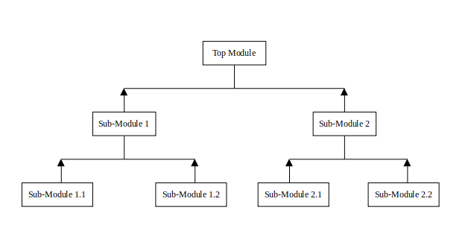
Figure 1: Bottom-Up Approach
As illustrated in the figure above, the development begins with the lowest-level components of the system towards higher-level components providing us with the following advantages:
- Flexibility: Bottom-up approach allows for changes to be made at any stage of the process;
- Empowerment: It gives individuals and smaller groups the power to make decisions;
- Robustness: Each component can be thoroughly tested and debugged.

2.2 PROJECT DEVELOPMENT APPROACHES
For successful implementation of the main objective different approaches and methodologies will be used upon achieving the success of each specific objective of the project as shown in the table below:
Table 1: Project Development Approach
S/N | SPECIFIC OBJECTIVES | PROPOSED APPROACH or METHODOLOGY
1 | To establish requirements for developing e-payment system for enhancing food ordering work-flow in cafeteria | - Literature Review
2 | To design and develop the system, control logic, electronics assembly and installation of a cooling system. | - Iterative Waterfall  - Bottom-Up Approach
3 | To integrate cooling and heating subsystem and assess the usability of the integrated system. | - Questionnaires  - Discussion

SYSTEM REQUIREMENT ESTABLISHMENT
System Requirement Establishment involves the process of searching, gathering, collecting and analyzing all the necessary information that will be used for the completion of the project. Ensure that the requirements are analyzed, defined, complete, consistent, stable, and verifiable, as well as consistent with the software development life cycle to be used.
This project aims to use secondary data to establish the system requirements for successful design and implementation of the project, where collection of requirements that were collected by other authors or developers for a purpose rather than the task at hand allowing engineers and developers to enhance the quality and accuracy of their insights via the existing Journals, Books, blogs and websites.
SYSTEM IMPLEMENTATION
Iterative Waterfall Methodology is a software development approach that combine sequential steps of the traditional Waterfall Model with the flexibility of iterative design to allow for improvements and changes to be made at each stage of the development process, instead of waiting until the end of the project. This methodology will be employed to implement the system control logic successfully.
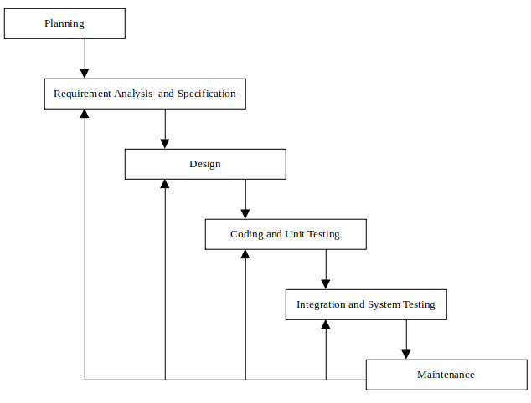
Figure 2: Iterative Waterfall Methodology
When errors are detected at some later phase, these feedback paths allow for correcting errors committed during some phase. It tends to reduces the effort and time required to correct the errors. It’s advantage lies in simplicity of use, well organized, ease of management and cost effective while changing requirements of project.

CHAPTER III

RESOURCES AND MATERIALS

3.1 HUMAN RESOURCES
Initially, the core team tasked with implementing the GIP proof of concept comprised three members: Mwesiga Tegambwage, Nancy Hiza, and Chelsea Gideon. To ensure a seamless project implementation, we recognized the need for additional expertise, particularly in electronics and programming. Thus, we sought the assistance of our colleague Walidi Kowero from UDSM CoICT, who brought specialized skills to enhance implementation of project.
The expanded team's blend of technical and soft skills was crucial to achieving the project's goals. Each member played a pivotal roles. These diverse skill set defined below enabled us to tackle the project's challenges effectively and work collaboratively towards a successful implementation.
Mwesiga Tegambwage - Project Manager and Lead System Designer
Technical skills
- Mobile application development | - IoT and Embedded Systems
- Machine learning and AI | - System Design
- Research | - Project Management
Soft skills
- Teamwork | - Leadership skills
- Ability to work under pressure | - Problem Solving
- Good communication skills | - Proactive and willing to learn

Nancy Hiza - Lead Electronics and Hardware Engineer
Technical Skills
- IoT and Embedded Systems Development
- Electronics Circuit Design, Prototyping, And Testing.
- Equipment maintenance
- Computer Aided Drawing Software
Soft Skills
- Teamwork | - Leadership skills
- Good communication skills | - Proactive and willing to learn
- Attention to detail | - Enthusiastic
Walidi Kowero - Lead Electronics and Hardware Programming
Technical Skills
- Programming in C, C++ and Python
- Electronics Design, PCB Design PCB Assembly
- Graphics Design and Computer Aided Drawing Software
- Embedded Systems in Designing, Installing, Troubleshooting and Safety Skills
Soft Skills
- Teamwork | - Leadership skills
- Ability to work under pressure | - Time management
- Good communication skills | - Proactive and willing to learn

Chelsea Gideon
Technical Skills
- IoT and embedded systems | - Project planning and management
Soft Skills
- Design Thinking skills | - Time management
- Teamwork | - Communication

The Customized Automated Temperature Control System (CATCS) project basically requires certain skills set to achieve its goal and vision. Basing on these skills set, each one of us will show our values and contribution to the project respectively. The skills set both technical and non-technical required for the project are elaborated below;
Table 2: Task Allocation to Team Members
S/N | Tasks | Allocated person
1 | Project Planning and Management | Mwesiga
2 | Design Thinking and Innovation | Mwesiga, Nancy
3 | Risk Management | Mwesiga
4 | Identifying Targets | Mwesiga, Nancy
5 | Time and Resource Management | Mwesiga
6 | Requirement Gathering | Mwesiga
7 | Requirement Analysis | Mwesiga, Walidi
8 | Documentation and Reporting | Mwesiga, Nancy
9 | Concept Design | Mwesiga, Walidi
10 | System Design | Nancy, Walidi
11 | Material Specification and Ordering | Mwesiga, Walidi
12 | Hardware Simulation Design | Nancy, Walidi
13 | Cooling System Implementation | Mwesiga
14 | Heating System Implementation | Nancy, Walidi
15 | PCB Implementation | Nancy, Walidi
16 | PCB Troubleshooting and Testing | Nancy, Walidi, Chelsea
17 | System Integration and Testing | Nancy, Walidi
18 | Budgeting Report | Mwesiga
19 | System Documentation | Mwesiga
The value of skills and distribution of work that each person brings to the project is shown in the metrics below
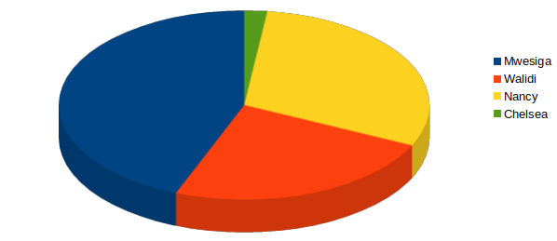
Figure 3: Project’s Task Distribution Chart

3.2 TECHNICAL RESOURCES
The implementation of the Automated Temperature Control System requires a comprehensive array of technical resources, which can be categorized into hardware, software, and additional materials and tools.
Sensors, Actuators and Micro-controller:
- Sensors: The system utilizes DHT11 temperature sensors to monitor the indoor climate accurately.
- Relay: Acts as a switch to control the power flow to the heating elements.
- Control Unit: An Atmega328 micro-controller serves as the core processing unit, managing inputs from sensors and controlling the heating and cooling subsystems.
Heating Subsystem:
- Nichrome Wire: Provides the primary heating element.
Cooling Subsystem:
- Refrigerant: Essential for the cooling cycle, facilitating heat exchange.
- Rotary Compressor: Compresses the refrigerant to enable effective cooling.
- Radiators: Utilized for both the condenser and evaporator to maximize heat exchange efficiency.
- Filter: Ensures the purity and efficiency of the refrigerant cycle.
- Expansion Tube: Regulates the flow of refrigerant into the evaporator.
- Suction Copper Tubes: Used for efficient refrigerant transportation between components.
Other Electronics Equipments:
- Power Supply: Ensures consistent power delivery to the heating components.
- Display Unit:
- LCD or OLED Display: Provides real-time data and system status to the user.
- Buttons: Allow user interaction and control over the system settings.
Software:
- Arduino IDE: An integrated development environment used for programming the Atmega328 micro-controller.
- C Programming Language: The primary language used to code the system's functionalities.
- Proteus CAD: A computer-aided design software used for simulating and designing the electronic circuits.
Other Resources:
- Construction Materials:
- Enclosure: Houses the system components, providing protection and structural integrity.
- Mounting Brackets: Securely fix components within the enclosure.
Tools:
- Soldering Iron: Used for assembling electronic components.
- Screwdrivers: Essential for assembling and disassembling hardware.
- Wire Cutters: Used for cutting and stripping wires during assembly.
- Jumpers and Wires: Facilitate connections between components within the system.
This detailed inventory of technical resources ensures that every aspect of the Automated Temperature Control System is well-supported, from initial design and development to final deployment and operation.

3.3 BUDGET AND FINANCIAL RESOURCES
Refer to the funds, capital, and monetary assets available for project implementation. These resources are essential for covering the costs associated with planning, executing, monitoring, and completing the project.
Estimated Cost of Proposed Solution Prototype: The total cost estimation of the product prototype design is as detailed in Table 2, listing all required components for the complete design of the product prototype for proof of concept for the whole design implementation.
Table 3: Cost Estimation For Actual Device
Cost Expenses Estimation
Item Name | Item Description | Quantity | Tshs / Quantity | Total
Power Adapter | 230v ac to 24v/12v dc and power cable | 1 | 20,000 | 20,000
Voltage Regulator | LM317T, 5v Regulator  LM317T, 12v Regulator | 1  1 | 2,500  3000 | 5,500
Relay | 12V 30A 250W 2 Channel Relay | 1 | 10,000 | 10,000
Buttons | Push Buttons/keypad | 10 | 500 | 5,000
Jumpers and Wires |  | 25 | 100 | 2,500
Power MOSFET | IRF540 | 3 | 5,000 | 15,000
Peripherals | Diode:  Electrolytic Capacitor: | 4  3 | 500  1,000 | 7,000
PCB Designing | PCB Board  Connectors  Power Jacks | 1  5  5 | 15,000  1,000  1,000 | 25,000
Heating Subsystem:
Nichrome Wire or PTC | Heating element | 1 | 40,000 | 40,000
Cooling Subsystem:
Refrigerant | R22, quantity | 1kg | 20,000 | 20,000
Rotary Compressor | Rotary Air Conditioning Compressor | 1 | 150,000 | 150,000
Filter | Copper filter ac drier | 1 | 5,000 | 5,000
Capillary Copper Tube | Diameter 1.3mm | 4 ft | 1,500 | 6,000
Copper tubes | Diameter 18mm | 24ft | 2,500 | 60,000
Fan | Cooling Axial Ac Fan | 2 | 15,000 | 30,000
Display Unit:
LCD Display |  | 1 | 30,000 | 30,000
Construction Materials:
Enclosure | PVC, or Aluminum sheet |  |  | 40,000
Subtotal |  |  |  | 471,000
Contingency |  |  |  | 129,000
Total Cost of Project Prototype |  |  |  | 600,000

3.4 RESOURCE MOBILIZATION
To ensure the successful implementation of the Automated Temperature Control System, we identified reliable sources for all necessary electronic components, cooling system components, and heating elements. Below is a detailed plan highlighting where each type of resource will be sourced, along with the added value these suppliers bring to our project.

Electronics Resources and PCB Printing:
Suppliers: Makumbusho Electronics Store and Bafredo Electronics Store.
Description: These stores will provide all the required electronic components and PCB printing services. Bafredo Electronics Store is particularly valued for its extensive inventory of high-quality electronic parts and its expertise in PCB fabrication, ensuring that we have access to reliable and precise electronic components for our system.
Cooling System Components:
Suppliers: Specialized suppliers located in Magomeni.
Description: These suppliers focus on cooling solutions and are known for their specialized knowledge and high-quality cooling components. This ensures that the cooling subsystem of our project will be built with components that are both efficient and durable.
Heating Elements:
Suppliers: Suppliers in Kariakoo.
Description: Kariakoo is recognized for providing high-quality heating elements. By sourcing our heating elements from this area, we are ensuring that we obtain reliable and efficient components necessary for the heating subsystem of our system.
Added Values:
- Comprehensive Inventory: We have access to a wide range of components and materials necessary for the project, which facilitates a smooth and uninterrupted implementation process.
- Cost Efficiency: The suppliers offer competitive pricing and bulk purchase options, enabling us to mobilize resources cost-effectively and stay within our budget.
- Specialization and Expertise: Our suppliers are specialized in their respective fields (electronics, cooling, heating), ensuring that we use the best-suited components for each part of the system. This specialization enhances the overall quality and performance of the Automated Temperature Control System.

CHAPTER IV

SYSTEM DESIGN

4.1 SYSTEM REQUIREMENTS
The implementation of the Automated Temperature Control System involves a comprehensive set of requirements that ensure the system operates efficiently, reliably, and meets user needs. The requirements can be categorized into functional and non-functional with each category addresses different aspects of the system.
Functional Requirements:
- System must be able to monitor indoor temperature in real-time;
- System must control a rotary compressor for cooling based on temperature readings;
- System must activate either heating or cooling subsystem based on temperature readings;
- System must allow users to set desired temperature ranges;
- System must store data on temperature variations for analysis and optimization;
- System must provide remote monitoring and control capabilities through a connected application or interface.
Non-Functional Requirements:
- System must respond to temperature changes within 30 seconds;
- The system must operate continuously with minimal downtime;
- System must be secure, protecting data from unauthorized access;
- System must be user-friendly, with an intuitive interface and easy-to-understand controls.

4.2 IoT ARCHITECTURE
The Internet of Things (IoT) architecture plays a crucial role in the design and implementation of modern automated systems, such as the Automated Temperature Control System. A well-structured IoT architecture ensures seamless integration, efficient data management, and enhanced system performance. One of the most significant advancements in IoT architecture is the shift towards centralized architectures facilitated by cloud computing.
As IoT gained traction and more devices were integrated into networks, the demand for a centralized architecture became apparent. In a centralized IoT architecture, devices collect data and transmit it to the cloud, where it is stored and analyzed.
The benefits of this centralized architecture are manifold. Firstly, it allows for real-time monitoring and remote control of IoT devices, enabling users to manage and optimize their systems from any location. This is particularly beneficial for applications such as the Automated Temperature Control System, where constant monitoring and quick adjustments are crucial for maintaining comfort and efficiency. Secondly, in project further implementation the centralized storage and processing facilitate advanced data analytics, providing insights that lead to informed decision-making. By analyzing data trends and patterns, the system can predict and respond to environmental changes proactively, ensuring optimal performance and energy efficiency.

4.3 HIGH LEVEL SYSTEM DESIGN
The high-level design defines the project level architecture of the system. This architecture defines the sub-systems to be built, internal and external interfaces to be developed, and interface standards identified. The high level design is where the sub-system requirements are developed and is illustrated below.
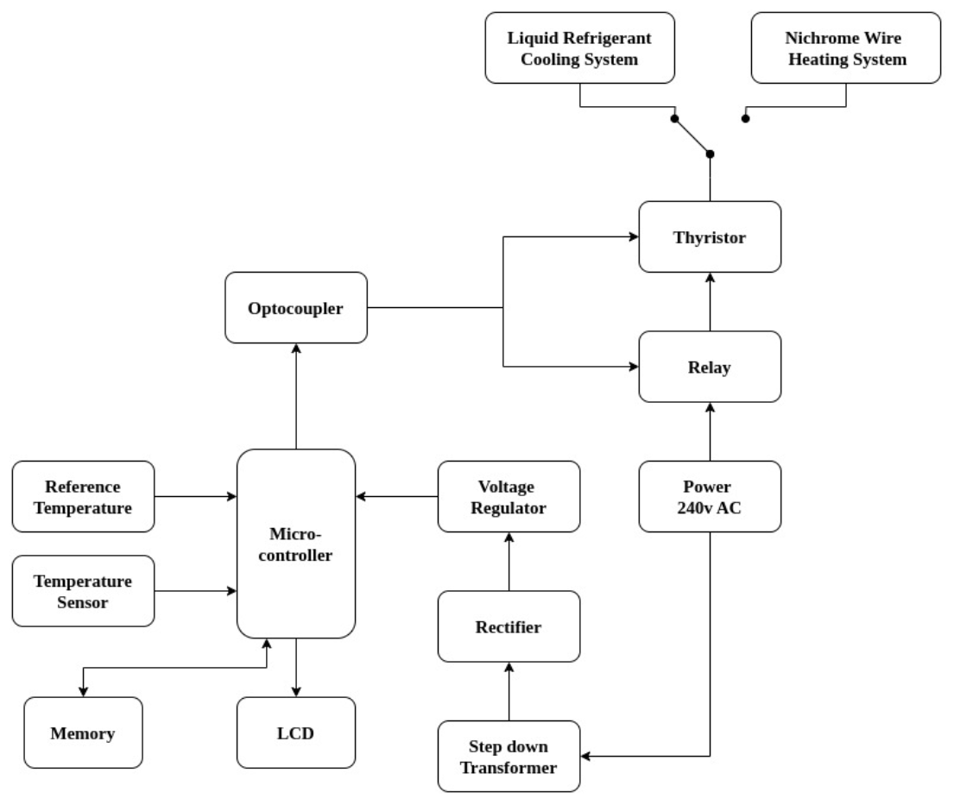Figure 4: High-Level Block Diagram
The circuit is using a micro-controller to control the fan and cooling system based on the temperature variations. The system measure the temperature using sensors, for a more efficient system both humidity and temperature sensors will be used to provide input to micro-controller.
Using LoraWAN technology equipped within the microcontroller, the data collected will be sent to the gateway cloud, then Micro-controller provide the signal based on the comparison between the reference input and the measured inputs from the sensors to automatically maintain the temperature of the room within the required range.
The schematic design showing placement of the electronics equipments and their connection is as shown in the figure below:
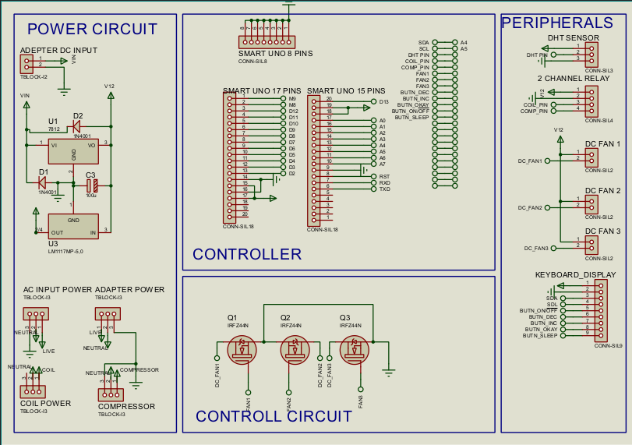
Figure 5: Schematic Design

4.4 COOLING SYSTEM DESIGN
While heating subsystem comprised of nickel heating element does not require any calculation since all you need is to power the subsystem with an ac power to function properly. The cooling subsystem on the other hand require careful calculations and planning for efficient implementation of the system prototype.
Now Consider:
Compressor Type : Rotary compressor suitable for the application.
Refrigerant : Compatible with R22.
Capacity : 1.25kg

Calculated Surface Area and Length
First, let's confirm the total surface area available with 30ft of ¼inch (0.00635m) diameter copper tube which makes an equivalent of 9.144m.
Total Surface Area = π * 𝐷 * 𝐿
= π * 0.00635m * 9.144m ≈ 0.182m²
We need total surface area of 1.25 m² to handle the heat load of 3202.63 BTU/hr (0.939 kW).
New System Capacity
Scaling Factor = 0.182m² /1.25m² ≈ 0.146
Thus, the new cooling capacity:
= 0.939kW * 0.146 ≈ 0.137kW
= 0.137kW * 3412.14BTU/hr ≈ 467.46 BTU/hr
Refrigerant Charge
Original Charge = 1.25kg
New Charge = 1.25kg * 0.146 ≈ 0.1825kg = 182.5g
Lengths for Each Component
Assuming equal split between condenser and evaporator:
Condenser Length ≈ Evaporator Length
≈ 9.144m / 2 ≈ 4.572m (15ft each)
Capillary Tube Sizing
The capillary tube plays a critical role in controlling the flow of refrigerant from the high-pressure side (condenser) to the low-pressure side (evaporator).
Inner Diameter : 0.031 inches (0.79 mm)
Length : 1.5 meters (approximately 5 feet)

CHAPTER V

SYSTEM IMPLEMENTATION

5.1 CONTROL LOGIC AND PCB IMPLEMENTATION
Once the design was completed, the control logic for proper micro-controller task execution was implemented. During which, we adhered to modular code design and thorough documentation that facilitated easier troubleshooting, maintainability and scalability of code accessed at;
https://github.com/arc1o1/Automated_Temperature_Control_System.
Implementation was then followed by carefully soldering electronics components onto the PCB, with special attention given to the placement and orientation to avoid any potential issues during operation as illustrated in the figure below.
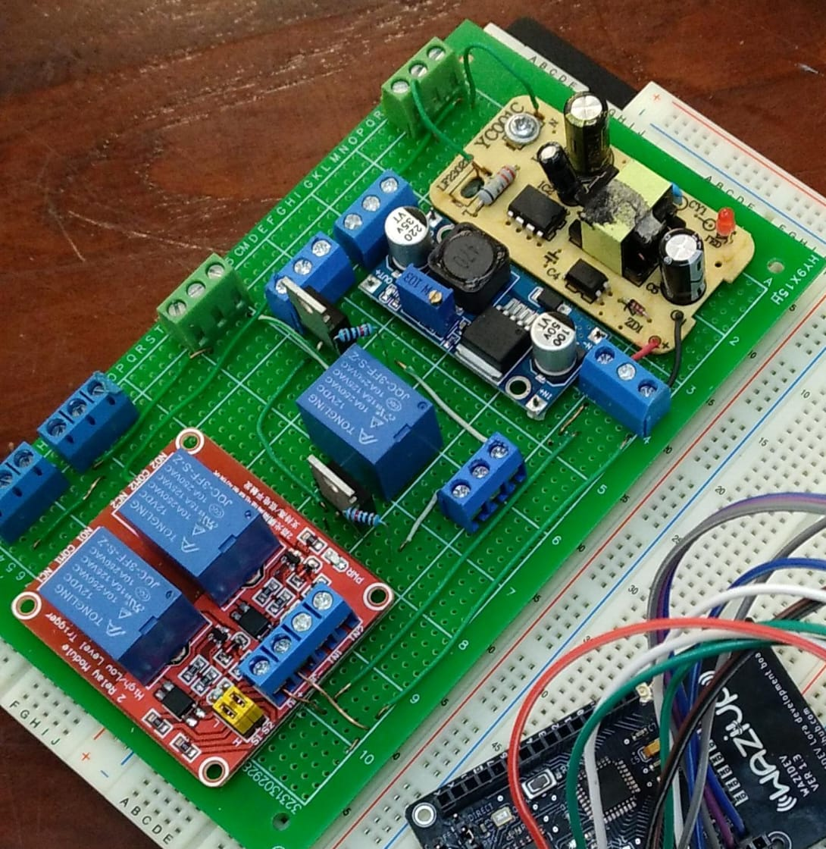
Figure 6: PCB Implementation

5.2 COOLING SUBSYSTEM IMPLEMENTATION
As Illustrated in the figure below, the cooling system components were integrated to create a closed-loop system capable of efficient heat exchange. The copper tubes were arranged in a helical configuration to maximize surface area and improve heat dissipation. The rotary compressor was connected to the evaporator and condenser through the copper tubing, with the capillary tube regulating the flow of refrigerant.
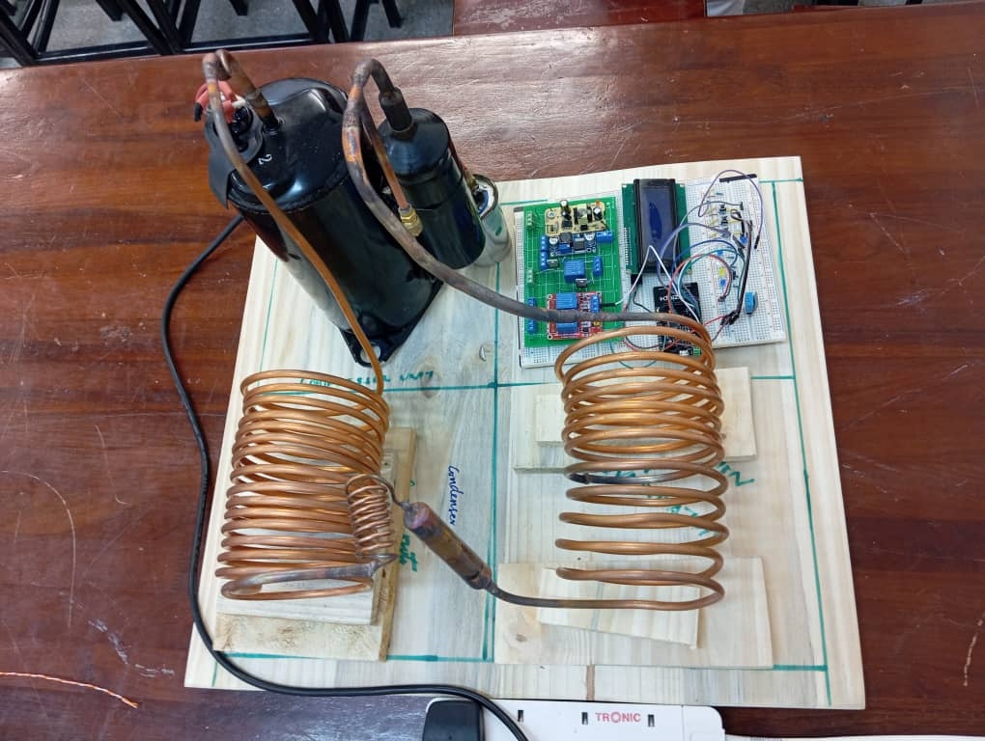
Figure 7: Cooling System Implementation

5.3 SYSTEM INTEGRATION
The final stage of the project involved the integration of all subsystems into a cohesive and fully functional Automated Temperature Control System. This integration process required careful coordination to ensure that the heating subsystem, cooling subsystem, and control electronics worked seamlessly together, during which each subsystem was connected to the central control unit, and comprehensive testing was conducted to verify system functionality.
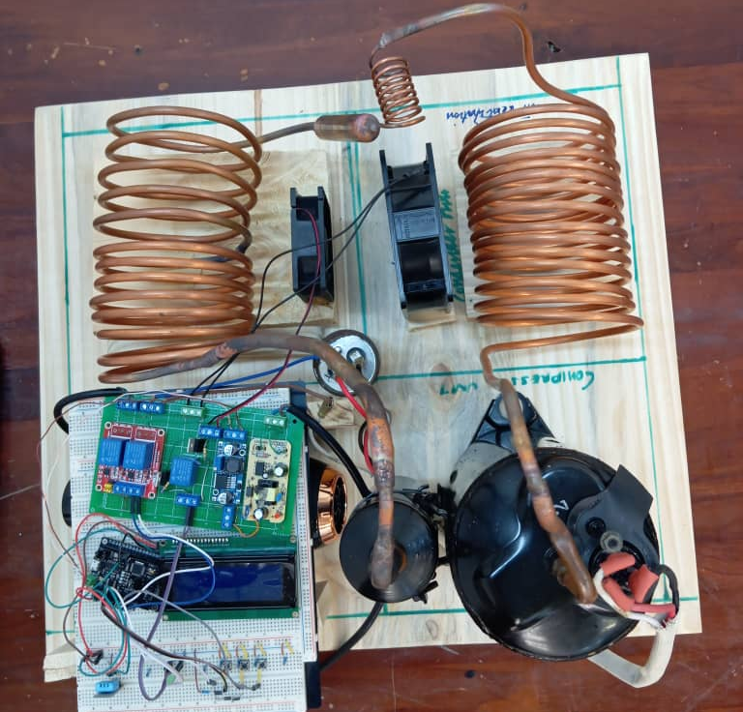Figure 8: System Integration

5.4 RESULTS
During the testing phase, the Automated Temperature Control System demonstrated promising results, achieving approximately 70% of the expected functionality. The system effectively monitored temperature changes and activated the heating and cooling subsystems accordingly.
However, several issues were identified that need to be addressed to ensure the system meets the specified requirements. The most notable issue was the system's startup sequence, where all subsystems erroneously activated simultaneously instead of remaining off until initiated accordingly.
The issue indicates a need for further debugging and refinement of the control logic. This will involve detailed examination of the control unit's programming and the interaction between different components. Additionally, further testing under various environmental conditions is necessary to ensure the system's robustness and reliability. By simulating different scenarios, potential weaknesses can be identified and corrected, leading to a more resilient system.

CONCLUSION
The Automated Temperature Control System project has successfully advanced through the critical stages of design, and implementation. The project achieved several milestones, including the successful implementation of the circuit board (PCB), the assembly of the cooling subsystem, and the integration of the heating and cooling components with the control electronics.
These accomplishments demonstrate the technical feasibility of the system and its potential to provide effective temperature regulation in residential environments. The collaborative efforts of the project team, combined with their commitment in planning and execution, provided a strong foundation for the system's completion.
However, the project faced several challenges that highlighted areas for improvement and learning such as, ensuring the precise integration of the various subsystems (synchronizing the operations of the heating and cooling components with the control unit) and sourcing high-quality materials and components required extensive research and coordination with suppliers.
Despite these obstacles, the project has shown promising results and potential for future success. The team's ability to overcome technical difficulties and adapt to unforeseen issues has been a testament to their resilience and problem-solving skills. Moving forward, addressing the identified challenges and optimizing the system's performance will be crucial for achieving the project's goals. The insights gained from this phase of the project will inform future improvements and ensure the system's reliability and efficiency.

REFERENCES
- Z. I. Rizman, K. H. Yeap, N. Ismail, N. Mohamad and N. H. Husin. 2013. Design an automatic temperature control system for smart electric fan using PIC. International Journal of Science and Research. 2(9): 1-4.
- Jaafar L. B. 2013. Automatic room temperature control. Master thesis, University of Tun Hussein Onn Malaysia.
- A. Pimpalgaonkar, M. Jha, N. Shukla and K. Asthana. 2013. A precision temperature controller using embedded system. International Journal of Scientific and Research Publications.3 (12): 1-3.
- Li W., Li Y. and Xiao F. 2010. The design and implementation of digital temperature measurement and automatic control system. In: IEEE International Conference on Computer Application and System Modeling.pp. 407-409.
- Pimpalgaonkar, A., Jha, M., Shukla, N., & Asthana, K., (2013). A precision temperature Controller using embedded system, Int. J. Sci. Res. Publ. 3 (12), pp. 1-3.
- Ludwig,S. & Pritchard,J. (2010).10 principles of sustainable, cost-effective design: building a safer, more efficient machine, in: Control Engineering Magazine, October 2010.
- Levine, M.R., (2013). Automatic temperature adjusting system for air conditioner Room. China Patent CN103335385 A.

APPENDIX A

PROJECT TIMELINE
In order to establish a realistic and achievable timeline for project activities, this project timeline is estimated as illustrated in the figure below.
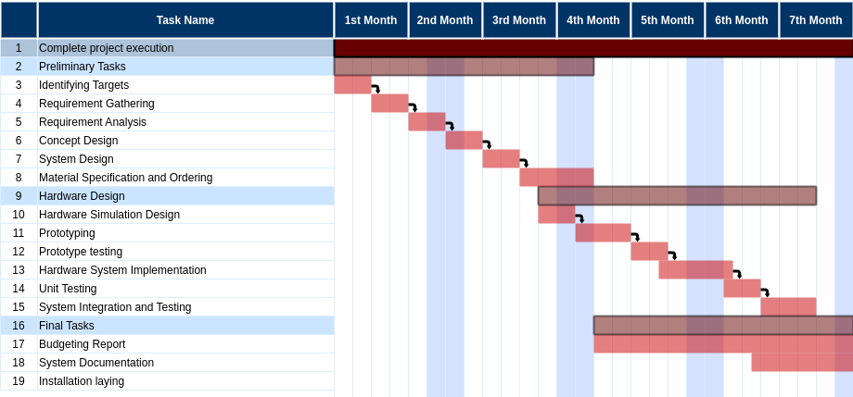
Figure 9: Project Schedule

APPENDIX B

PROJECT LEAN CANVAS MODEL
To identify who is the customer, competition and market entry strategy a lean business model canvas was employed as a straight forward business plan that gets to deliver products to customers faster and determine whether or not the business model itself is viable.
The market plan for this project is as illustrated in the figure below:
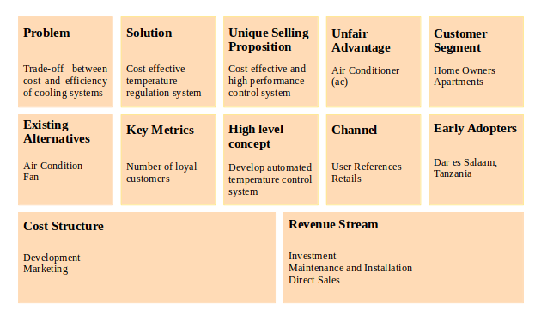
Figure 10: Lean Canvas Model

