**LOG-IN PAGE INFORMATION**

Client’s name Anan Nawar, Address 48/4545 Sahathep Phahonyothin14 Bangkok 10220

Email address Viicheck@outlook.com Mbp: 081-546-5179 ID card 1-1824-01877-87-6

Motocycle Brand……………….Series……….colour…………………Year…………….Mileage…..km.

⃝ News & Promotion ⃝ Allow Service information

-------------------------------

Piaggio Vespa SXL 125, Black, 125 cc, 2015 INSURANCE

Engine No. MNTAC2D23Z0723, MZS 7299 BKK TH AIA 2+ PLUS, 7 Feb 18

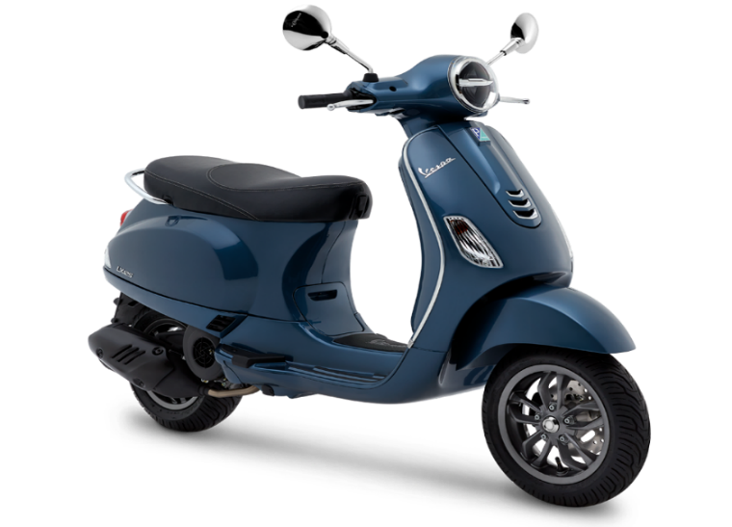

Remarks. ………………………………………………………………………………………………………………………

………………………………………………………………………………………………………………………………………

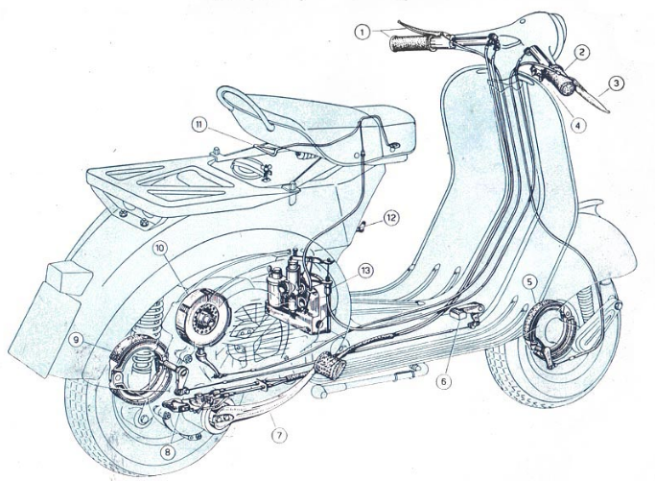

INSPECTION FORM

QUOTATION FORM

**INSPECTION FORM**

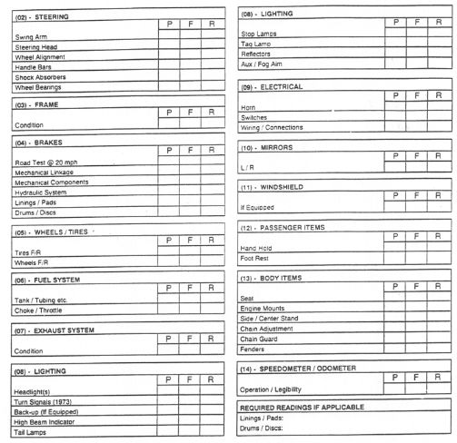

**QUOTATION FORM**

|  |  |  |  |  |
| --- | --- | --- | --- | --- |
| ลำดับ  No | รายการ  Description | จำนวน  Total | หน่วยละ  Unit price | จำนวนเงิน  ฿ Amount |
|  |  |  |  |  |
|  |  |  |  |  |
|  |  |  |  |  |
|  |  |  |  |  |
|  |  |  |  |  |
|  |  |  |  |  |
|  |  |  |  |  |
|  |  |  |  |  |
|  |  |  |  |  |
|  |  |  |  |  |
|  |  |  |  |  |
|  |  |  |  |  |
|  |  |  |  |  |
|  |  |  |  |  |
|  |  |  |  |  |
|  |  |  |  |  |
|  |  |  |  |  |
|  |  |  |  |  |
|  |  |  |  |  |
|  | | | รวม  Total | |
|  |  |  |  | |
| GARAGE INFO. 28/415 XXXXX, XXXXXXXXXXXX, XXXX  ..................................., …………………………, ………………….. | | | Mr.ALADIN  (POSITION) | |
| **APPROVE PLEASE PRESS… YES…** | | | | |