**Question 1 -** The Breadth First Search algorithm has been implemented using the queue data structure. One possible order of visiting the nodes of the following graph is -

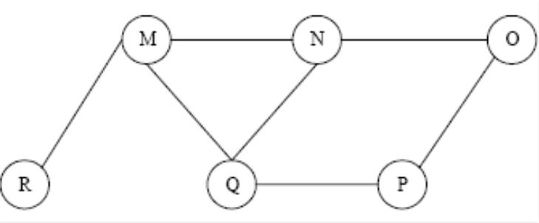

**(A)** MNOPQR

**(B)** NQMPOR

**(C)** QMNPRO

**(D)** QMNPOR

**Question 2 -** Which of the following statements is/are TRUE for an undirected graph?

P: Number of odd degree vertices is even

Q: Sum of degrees of all vertices is even

A) P Only

B) Q Only

C) Both P and Q

D) Neither P nor Q

**Question 3 -** Time Complexity of DFS is? (V – number of vertices, E – number of edges)

a) O(V + E)

b) O(V)

c) O(E)

d) O(V*E)

**Question 4 -** Traversal of a graph is somewhat different from the tree because

**(A)** There can be a loop in a graph, so we must maintain a visited flag for every vertex

**(B)** DFS of a graph uses the stack, but the inorder traversal of a tree is recursive

**(C)** BFS of a graph uses a queue, but a time-efficient BFS of a tree is recursive.

**(D)** All of the above

**Question 5 -**Consider the following graph -

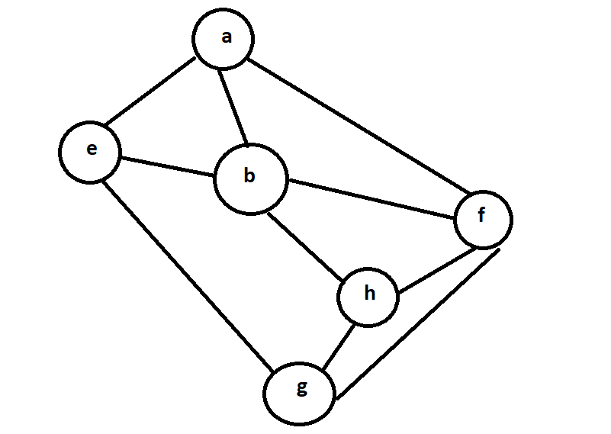

Among the following sequences:

(I) a b e g h f

(II) a b f e h g

(III) a b f h g e

(IV) a f g h b e

Which are the depth-first traversals of the above graph?

**(A)** I, II, and IV only

**(B)** I and IV only

**(C)** II, III, and IV only

**(D)** I, III, and IV only

**Question 6 -** If G is an directed graph with 20 vertices, how many boolean values will be needed to represent G using an adjacency matrix?

1. 20
2. 40
3. 200
4. 400

**Question 7 -**What is the expected number of operations needed to loop through all the edges terminating at a particular vertex given an adjacency matrix representation of the graph? (Assume n vertices are in the graph and m edges terminate at the desired node.)

1. O(m)
2. O(n)
3. O(m²)
4. O(n²)

**Question 8 -**What is the expected number of operations needed to loop through all the edges terminating at a particular vertex given an adjacency list representation of the graph? (Assume n vertices are in the graph and m edges terminate at the desired node.)

1. O(m)
2. O(n)
3. O(m²)
4. O(n²)

**Question 9 -** A person wants to visit some places. He starts from a vertex and then wants to visit

every vertex till it finishes from one vertex, backtracks and then explore other vertex

from same vertex. What algorithm he should use?

a) Depth First Search

b) Breadth First Search

c) Trim’s algorithm

d) Kruskal’s Algorithm

**Question 10 -** Consider an undirected unweighted graph G. Let a breadth-first traversal of G be done starting from a node r. Let d(r, u) and d(r, v) be the lengths of the shortest paths from r to u and v respectively, in G. lf u is visited before v during the breadth-first traversal, which of the following statements is correct?

|  |  |
| --- | --- |
| Cross | 1. d(r, u) <d(r, v) |
|  | 1. d(r, u) > d(r, v) |
| Tick | 1. d(r, u) <= d (r, v) |
|  | 1. None of the above |

**Answers**

**1) C**

**2) A**

**3) B**

**4) A**

**5) D**

**6) D**

**7) D**

**8) A**

**9) A**

**10) A**