
Game version: 1.0 – Manual version: 1.0.8

You can find an up-to-date digital copy of this manual, FAQs, videos, and more stuff on how to play Stampadia at https://kesiev.com/stampadia/learn.html

Discover Stampadia!

The reign of Stampadia had thousands of years of history of dangerous places and brave mercenaries before disappearing mysteriously from our globe. But Stampadia monks, generation after generation, managed to document relentlessly the adventures of every single adventurer, the map of every single dungeon, and the clue of every single mystery in a huge tome called Chronicles Of Stampadia.

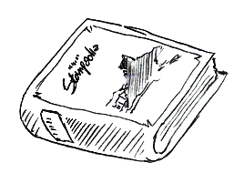
We managed to find a damaged copy in an abandoned basement and it looks like that the book is imbued with some kind of magic: the reader can live every page of its story with just two dice, an eraser, and a small token! We’re recovering, translating, and digitalizing a new adventure sheet of this book daily at https://kesiev.com/stampadia. Go there, download the daily page, and bring back to life the story of a brave Stampadian!

Setup

Print the adventure sheet, pick 2 dice, a pencil, an eraser, the Hero Token (you can use a small button, thimble, or a cube taken from another board game), and you're ready to go!

Your memory

Adventure sheets may ask you to learn and forget specific keywords. You’ve to keep them and on any adventure you’re going to play next, even if you’re playing the same and past adventure sheets again! Moreover, keywords are not lost when your hero dies. Stampadians had a very good memory but we suggest you to track them on a sheet instead and use it every time you play. Keeping this list may help you to uncover future secrets but you may still play most of the Stampadia with no memory, starting with no keywords and noting them on the adventure sheet borders – just remember to keep them if you’re playing that adventure sheet again.

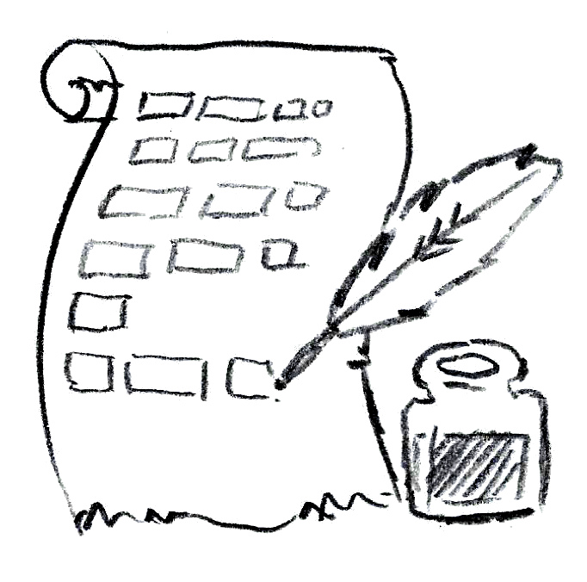
How to read the Map

It’s a grid that shows where rooms, enemies, treasures, and traps are. When your adventure starts only the walls of the starting room are visible (the squared black outline with a stairs symbol in the middle) but you’ll soon discover more rooms as your hero will start exploring.

Calculating distances and ranges

Sometimes you’ll need to check the distance between two cells on the map. To calculate it, count the number of cells crossed by the shortest path from these two cells, moving orthogonally and counting the destination cell too. This path can cross any cell and door but can't cross room walls.

How to read the Rooms Table

The Rooms Table shows which rooms your dungeon has, where they are, and how they work. Try avoiding spoilers and read this table just when needed!
The first column indicates the room number and has a checkbox on it: the game will instruct you how to use these during the adventure.
The second column indicates where the room is on the map and you will use this information to draw them as your hero explores the dungeon.
The third column shows the Room Instructions, which describe how that specific room works. When your hero will be in that room you will follow that room’s rules.

How to read the Inventory

The Inventory lists your hero equipment (the Equipment Scroll) and gold (the Gold Bar). The Gold Bar also tracks your time left and your end-game score!
Spending gold (- xG)

Spend gold (- xG) ticking x circles from the Gold Bar. If you don't have enough empty circles in the Gold Bar to act, that action cannot be performed.

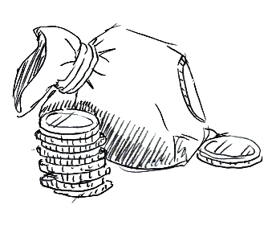
Time is Gold!

The game uses gold to track your time left too: 1 gold is spent every time the Hero Token crosses a door when exploring and fighting. If you can't afford that, your time is up and your hero is lost in the dungeon. You've to leave him to his terrible fate and your game ends.

Gaining gold (+x G)

Gain gold (+x G) erasing ticks from the Gold Bar. If you don't have enough ticked circles on the Gold Bar, use the ones you have and the remaining gained gold is lost. If your quest ends successfully, the gold left is your score so try to manage it as better as you can!

Using items

At any time during your adventure, you can use the items listed in the Equipment Scroll that have an unticked box on the left of its name. The brackets following the item name instruct you on how to use it and are read the same way as room instructions (see “How to read room instructions”). To use an item, read the text in the brackets, check the condition before the » symbol and, if it’s verified, tick the item box and apply the item effect.
Once an item box has been ticked, there is no way to gain or use it again, so use them wisely!

Losing an item (lose x)

Using an item isn’t the only way to lose it: your hero may trade it for other goods… or lose it getting into trouble. When the game instructs you to lose an item, tick the item box if any in the Equipment Scroll without applying its effects.

Getting an item (get x)

Some items in the Equipment Scrolls don’t have any box on the left its name. These are the items you don’t have and you can’t use that may be somewhere in the dungeon. When the game instructs you to get an item, find it in the Equipment Scroll and draw a small box on the left of its name: you’ll be able to use it (or lose it) checking this box later.

How to read the Hero Sheet

The Hero Sheet shows your hero stats: there is a row of defense bonuses (+x DEF), a row of groups of HP boxes that tracks the hero health points (HP), a row of pairs of abilities the hero will use in battle, and a row of groups of XP boxes that track the hero experience points (XP).
When your adventure starts, only the first column of stats is enabled and the other columns are ignored, but you will unlock more columns as your hero gains XPs: when a group of XP boxes is completed, the relative column will be enabled, giving your hero more defense bonuses, HP, and abilities to use!
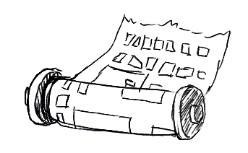
Gaining XP (+x XP)

Your hero will gain XP (+x XP) killing enemies. Tick as many XP boxes as the gained XP starting from the leftmost group with at least one unchecked box.
As you tick all of the XP boxes of a group, your hero will enable the abilities and bonuses of the relative column, becoming stronger!

Losing hero's XP (-x XP)

Experience is a very valuable resource and the Stampadians rogues and gods know it very well. In the rare case your hero must lose his experience points (-x XP), erase as many boxes as the experience points your hero lost starting from the leftmost ticked XP box. If a group of XP boxes is no longer completed, your hero loses its column bonuses and you’ve to erase all the ticks of that column HP boxes.
Gaining hero's HP (+x HP)

Some items or special events may give your hero some health back (+x HP). Starting from the rightmost ticked HP box of the Hero Sheet, erase as many ticks as the HP your hero gained. If you don't have any ticked HP box available, the cure is lost.

Losing hero's HP (-x HP)

Your hero may lose his health (-x HP) in fights or falling into traps. Starting from the leftmost available unticked HP box, tick as many boxes as the damages your hero got. If you have to tick an HP box and there aren’t any that’s available and unticked, your hero is dead!

Gaining hero's ability (gain hero ability)

In the Hero Sheet, there may be ability boxes with no text inside: that ability has no effect but you can learn a new powerful one in your adventure! When the game tells you to gain a new ability (gain hero ability “x”), select any empty ability box and write the text in quotes. Now you can use that new ability in battle! But remember: if your Hero Sheet has no empty ability boxes, any new ability is lost!

When your hero dies...

Check the Equipment Scroll of the Inventory: if you have the Resurrection item still unused (i.e. with its box unticked) and at least 5 gold left, you may tick its box, tick 5 gold from the Gold Bar, remove all the ticks from the HP boxes, move your Hero Token back to the cell with the stairs symbol, and continue your adventure. But beware: you can use an item only once so use it carefully!
If you don't have any resurrection item, you don't have enough gold to use it, or you don’t want to use it your game ends.
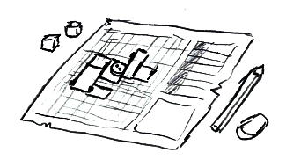
How to read the Enemy Sheet

The Enemy Sheet shows all of your enemies stats: there is a row of defense bonuses (+x DEF), a set of symbols to show which columns are enabled for specific enemies, a row of pairs of abilities the enemy will use in battle, and the XP bonus your hero will gain killing that enemy in battle (+x XP).
When dealing with an enemy, only the first column (ALL) and the columns matching that enemy shape are enabled, the other columns are ignored. Enemies that don't match any column just have the first column enabled.
Enemy’s health is tracked directly by its symbol on the map: when an enemy loses HP tick a white circle on its symbol and when there is no white circle available, cross the entire cell on the map, marking the enemy’s death.

Starting the game

Write down your hero name in the space on the top left of the adventure sheet. Try something evocative!
Place the Hero Token on the stairs cell of the map, find the starting room on the Room table (the row with the stairs symbol on the second column), read the stairs room instructions, and you're ready to start your adventure!
The starting room contains no enemy, so keep reading the next paragraph.

When there are no enemies...

When the Hero Token is in a room with no enemies (the gray circles with horns) you can move the Hero Token orthogonally by one space multiple times. Things may happen while you're moving your hero in rooms, so follow the room instructions of the Rooms Table to manage special conditions, like when moving the Hero Token over grayed numbered cells. Any entirely crossed cell is considered a cell with no symbol on it. The Hero Token can't cross room walls but it may leave a room crossing a door, marked by a rectangle along the room walls: stop the Hero Token outside the door and spend 1 gold. Then, if the Hero Token is no longer inside a room, you've discovered a new one: sum the black number under the Hero Token with that cell's column and row numbers, and follow the next paragraph instructions.

Discovering a new room

The second column of the Rooms Table explains where the room is on the map.
First, draw the room walls: the first pair of numbers tell in which column and row the top-left cell of the room is on the map (i.e. 3,5 means that the top-left cell of the room is at column 3 row 5), and the second pair of numbers tells how many cells the room is large and tall (i.e. 4x3 means that the room has a width of 4 cells and a height of 3 cells). Find the top-left cell of the discovered room and draw the room rectangle on the map. Remember that the top-left cell of the first pair of numbers will end inside the room. You can note the room number anywhere inside the room, so you can use it to find the room instructions later easily.
The room walls may cross tiny rectangles already printed on the sheet: these are the room doors your hero may use to leave the room.
Finally, if your Hero Token is inside this new room, read and follow the room instructions on the third column.

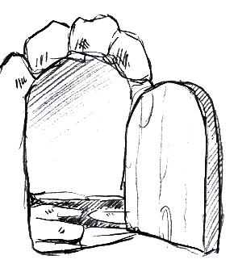
How to read room instructions

Find the room number on the first column of the Rooms Table and read the text on that row third column. You're going to read the room instructions and apply it mostly when you discover a new room, but some conditions may keep applying during the game (i.e. how to manage the grayed numbered cells in the room or what happens after a battle).
Room instructions contain up to two lines of text per room, that must be read sequentially and may contain trigger and action lines. Some lines may contain the | symbol to split a line into multiple autonomous lines.
A trigger line has the » symbol on it: the left side is the condition, which activates the consequent action on the right side every time it is satisfied. Conditions may be composed of multiple parts divided by a & symbol: all of its parts must be verified to trigger the linked actions. Conditions parts may contain symbols for common actions:

x1: Room 1 on the Rooms Table must be ticked.
not x1: Room 1 on the Rooms Table must be not ticked.
pay 5G: You may decide to -5G to verify this condition part. You must own the full amount of the required resource. The required resource may vary (i.e. “pay 5HP” requires you to -5HP, “pay 5XP” requires you to -5XP).
“Let’s go!”: You may decide to have your hero say “Let’s go!” to verify this condition part.
pay Resurrection: You may decide to lose your Resurrection item from the Equipment Scroll to verify this condition part. The item must be available and still unused (i.e. with an unticked box on the left of its name).
move [1]: You moved your Hero Token on the 1 square in this room.
no foes: All enemies in the room must have been killed (i.e. has been crossed out in the map).
killed last foe: You have just killed this room last enemy.
know ‘Sword’: You learned the keyword Sword. You must have this keyword noted.
forget ‘Sword’: You learned the keyword Sword and you may decide to forget it to verify this condition part. You must have this keyword noted and erase it.
forget any ‘Golem…’: You learned at least one keyword that starts with ‘Golem’ (i.e. ‘Golem 1’ or ‘Golem Spell’) and you may decide to forget one of them to verify this condition part
forget any ‘Golem…’ + G to reach >=3: You learned at least one keyword that starts with ‘Golem’ (i.e. ‘Golem 1’) and you may decide to forget one of them and, starting from the keyword number, pay the missing gold to reach 3 to verify this condition part. (i.e. you may forget ‘Golem 1’ and pay 2G or forget ‘Golem 3’ or ‘Golem 4’ and pay no gold).

Action lines don't contain any » symbol and are executed only once, and when they are read for the first time. Actions may contain symbols too:

x1: Tick the room 1 box on the Rooms Table.
x[1]: Cross entirely the grayed cell inside this room that has a 1 on it.
no escape: You can’t leave the room until all enemies have been killed.
room is empty: Ignore all of the enemies and grayed cells in this room.
stop reading: Ignore the next lines in this room description.
discover room 35: Draw the room walls of room 35. Your hero doesn’t move there, so no room effect applies.
draw [1] in room 35: Draw a 1 in any empty cell of room 35. It will act as a grayed numbered cell.
learn ‘Sword’: You’ve learned the keyword Sword. If you’re tracking your memory on a sheet and it wasn’t already noted, you must note this word.
forget ‘Sword’: You’ve to forget the keyword Sword. If you’re tracking your memory on a sheet and if it was noted, you must erase this keyword.

Upside-down text?

A trigger line may have an action with partial or full upside-down text. You’ve to read the upside-down part as a continuation of the action line once you’ve triggered its condition. It’s a way to hide some of the consequences of your choices: while the upright part may give you a hint of what could happen next, you’ve to resist not to read the upside-down part! Will you be brave enough to walk on that suspicious tile?

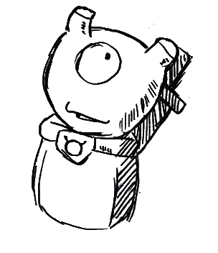
When there are enemies…

When the Hero Token is in a room with enemies (the gray circles with horns) a battle round starts. All of the enemies in the room are considered active and will play an enemy turn in this round. Your hero goes first.

Battle round — the hero turn

Roll two dice and remove all the dice that rolled a 1: for this turn, you won’t play these. Then place the available dice on the ability spaces of the Hero Sheet to activate them, but following these rules: you can use not empty enabled abilities only (have a look at the "How to read the Hero Sheet" for more), the dice must be placed on different rows and columns, and in descending order (i.e. the die on the right must be lower or equal to the die on the left). You may use just one die instead and place it on any enabled ability, or play no dice at all and pass to the enemies’ turn. Then you have to activate the covered abilities from left to right one by one using the covering die value as activation value.
(pay 1G): This ability takes more time to be performed so you’ve -1G first. If you don’t have enough gold, the whole ability is not performed.
Move: Move the Hero Token orthogonally up to the number of spaces by the activation value. A modifier may change the activation value (i.e. Move -1 subtracts 1 from the movement). Follow the usual movement rules but you can't move over cells containing a living enemy. Note that some rooms may prevent you from leaving until all enemies have been eliminated. Also, remember to spend 1 gold when crossing a door.
ATK/RNG: Attack one enemy that's distant at most RNG squares from your Hero Token by the activation value strength. If RNG has an equal symbol (i.e. RNG =2) the enemy must be at that exact distance. A modifier may change the activation value (i.e. ATK -1 subtracts 1 from the strength). Subtract the attacked enemy defense (the enabled defense bonuses from the Enemy Sheet and the gained defense from that enemy’s previous turn). If the resulting value is greater than 0, the enemy loses 1 HP: tick one circle from his icon on the map to reduce his health or, if there are no circles available, cross its cell entirely to mark his death. Killing enemies this way makes your hero stronger: your hero will gain all of the enabled XP bonuses of that enemy.
ATK/ALL: Perform a single ATK/RNG on all enemies in range.
DEF: Set the defense by the activation value. A modifier may change the activation value (i.e. DEF -1 subtracts 1 from the defense). Defense value is set and not increased, so multiple defenses can't be stacked.
Gain HP: Gain hero’s HP by the activation value. A modifier may change the activation value (i.e. Gain HP -5 subtracts 5 from the gained HP). Your hero can’t lose HP this way: if you gain negative HP by using this ability it doesn’t have any effect.
Copy: Select a single enabled enemy ability that shares the same row on the Enemy Sheet and activates it using your activation value. A modifier may change the activation value before the copied ability activation (i.e. COPY -1 subtracts 1 from the copied ability activation value).
Lock: If the activation power is greater than 0, keep the die on this ability for the next enemy turns of this round. If you've locked one die, all enemies will play their turns with just the remaining die. If you've locked both dice, enemies don't have any die to play in their turn and they must pass. If this ability has been activated without a die, it has no effect. All locked dice are unlocked when the battle round ends.

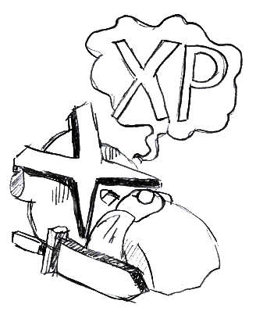
At the end of the hero turn, sum the defense set by abilities if any to the enabled defense bonuses on the Hero Sheet and limit the result to a maximum of 6 to get your hero final defense. You will use it to parry enemies’ attacks. Now all active enemies will play an enemy turn, starting from the nearest to the farthest — the player decides the ties.

Battle round — the enemy turn

Roll two dice, remove all the dice that rolled a 1, and place them on the not empty ability spaces of the Enemy Sheet to activate them, following the same rules of the hero turn. The enabled columns of the Enemy Sheet are the ALL column and the one matching the printed enemy symbol — so only up to two columns per enemy are enabled each turn. The enemy may play his dice up to 4 ways: using the highest dice on a single ability, using both dice in one of the two valid combinations (the higher dice on the upper ability of the ALL column and the lower dice on the lower ability of the second available column or the higher dice on the lower ability of the ALL column and the lower dice on the upper ability of the second available column) or skipping their turn. Starting from the highest to the lowest, play the dice one at a time activating the leftmost valid ability that satisfies one of these conditions in priority order: deal as much damage as possible, move the Hero Token within the range of the most of available attacks (the player decides on multiple paths), finally raise defense. If no more dice can be played or any priority can be satisfied, the enemy passes.

Move: Attract the Hero Token toward the shorter path to the enemy up to the number of spaces indicated by the dice, following the Hero turn MOVE rules. 1 gold is still spent every time the Hero Token crosses a door. A modifier may change the dice value (i.e. Move -1 subtracts 1 from the movement).
ATK/RNG: Attack the hero if the Hero Token is distant at most RNG squares from the enemy with the strength indicated by the dice. A modifier may change the dice value (i.e. ATK -1 subtracts 1 from the strength). Subtract the Hero defense and, if the resulting value is greater than 0, your hero loses 1 HP.
DEF: Set the defense by the value of the dice. A modifier may change the dice value (i.e. DEF -1 subtracts 1 from the defense). Defense value is set by abilities and cannot be increased by multiple defenses.

At the end of the enemy turn, sum the defense set by abilities if any to the enabled defense bonuses on the Enemy Sheet and limit the result to a maximum of 6 to get the enemy final defense. It will use it to parry your hero attacks on the next battle round. Now play the next active enemy turn until all active enemies played their turn.

Battle round – round end

After all of the enemies played their turn, the battle round ends. If the Hero Token is still in a room with enemies, start a new battle round. If the Hero Token is in a room with no enemies instead, because all enemies are dead or your hero managed to escape, all of the defense is lost and your hero will act as described in "When there are no enemies...".

Ending the game

If your hero has all of his HP boxes checked and must lose HPs and can't resuscitate (or you don't want to do that) or if you lose all of your gold, you lost the game and your final score is 0. Victory conditions may vary from adventure to adventure and are often described by the starting room instructions. You can play again erasing all the markings. If you’re playing with no memory don’t erase your keywords list.
If your quest ended successfully, congratulations! Your gold left is your score. Compare scores with friends who played the same adventure and discover who’s the best adventurer!

CoS is an open-source project: https://github.com/kesiev/stampadia. Huge thanks to Bianca, her father Sergio, Stampadia Discord, and BGG travelers for sharing their effort and ideas!

Variants

Once you have mastered the basics of the game, you can decide to play your adventures using one or more of these variants.

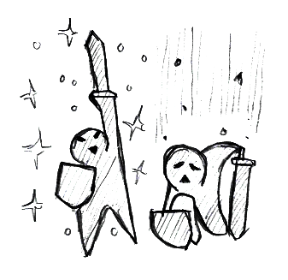
The Apprentice Monk

For Stampadia monks any information was gold. Every time you have to gain an XP and you don’t have any empty XP box to tick, add a tick on a side of the adventure sheet. These extra ticks can’t be lost or spent as XPs in your adventure. At the end of your adventure, sum your gold left, your HP left (i.e. the count of blank enabled XP boxes), the ticks you’ve collected on the adventure sheet side, the number of discovered rooms on the Map, the number of crossed cells in the Map, and the number of ticks on the Rooms Table to get your Monk Score.

The Premonition

When your hero dies, erase all the markings on the adventure sheet except for the rooms’ walls. If you’re playing with no memory don’t erase your keywords list. Then count the rooms on the map and divide that number by 2 rounded up: you can spend that much gold to start the adventure over. Your hero had a strange dream that day and reached the starting room late. Was that... a premonition?

Vs. Campaign

Collect some adventure sheets day by day, print them, start with no keywords, play them in sequence, and then sum the points gained in each adventure. Compare the overall score with friends that played the same sheets and crown the best adventurer of Stampadia! This way you can challenge a far friend!

