MarkyMark

Aaron R. Caldwell

2021-06-28

# Headings

# One hash for main headings

## Two has for secondary headings

### Three has for tertiary headings

#### I think you get the idea…

# Bold and Italics

You can modify the display of text with asterisks

**I want this to be bold**

*I want italics*

I want to show *asterisks*

# Bullet points with dashes

* Dash one
* Dash two
* Dash away all!

There must be a space after the dash to get bullets.

# Quotes

Now get quotes with a >

“Rmarkdown was a major motiviation of mine to switch all of my data workflow to R.” - Aaron Caldwell

# Links

All you need is brackets for the text and paratheses with the URL

[find Rmd resources here](https://github.com/jenrichmond/RMarkdownThrowdown)

# Images

Images are similar you just set a ! before the brackets and then the file path.



File path is a link to my website

# Embed a tweet

Here is a good articlet to read on ggplot2!

So @emilynordmann said we could have celebratory drinks after this preprint was downloaded 1000 times. There’s less than 50 to go, so if you’ve ever wanted a gentle intro to #rstats through #dataviz, I encourage you to download it 😉🥂https://t.co/L3Bl1kzpBQ

— Lisa DeBruine 🏳️‍🌈 (@LisaDeBruine) June 26, 2021

# What about Code?

R markdown is nice because you can incorporate your code and get the output you want in a tidy fashion.

Mac: alt-command-I Windows: alt-control-I

Remember, you can suppress messages and warnings in the header of the chunks.

library(tidyverse)  
# I can set the options globally with the following code  
# This way I don't have to do it with every chunk  
# But I can override it if I want  
knitr::opts_chunk$set(echo = TRUE,   
 message = FALSE,  
 warning = FALSE)  
library(here)  
library(janitor)

#Import beaches  
beaches <- read_csv(here("data","sydneybeaches.csv"))

Now that we have data we can modify with our code from basics.R

cleanbeaches = beaches %>%  
 clean_names() %>% # clean columns  
 rename(beachbugs = enterococci_cfu_100ml) %>%  
 separate(date, c("day","month","year"),  
 remove = FALSE) %>%  
 #unite(council_site,council:site) %>%  
 mutate(logbeachbugs = log(beachbugs),  
 beachbugsdiff = beachbugs - lag(beachbugs),  
 buggier = beachbugs > mean(beachbugs, na.rm=TRUE))

Then we can create neat data summaries and clean them up using knitr.

cleanbeaches %>%  
 group_by(site) %>%  
 summarize(meanbugs = mean(beachbugs,na.rm=TRUE)) %>%  
 knitr::kable()

|  |  |
| --- | --- |
| site | meanbugs |
| Bondi Beach | 18.77545 |
| Bronte Beach | 31.42090 |
| Clovelly Beach | 10.21856 |
| Coogee Beach | 39.37758 |
| Gordons Bay (East) | 24.90062 |
| Little Bay Beach | 45.61012 |
| Malabar Beach | 68.11437 |
| Maroubra Beach | 20.17910 |
| South Maroubra Beach | 15.70536 |
| South Maroubra Rockpool | 63.89809 |
| Tamarama Beach | 35.72836 |

Or we can plot the results.

cleanbeaches %>%  
 group_by(site) %>%  
 summarize(meanbugs = mean(beachbugs,na.rm=TRUE)) %>%  
 ggplot(aes(x=site,y=meanbugs)) +  
 geom_col() +  
 coord_flip() +  
 theme_classic()

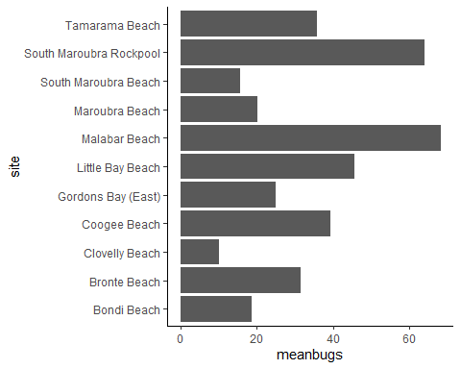

# Output

There are a multiple of output types to choose from.

* Rstudio guide: <https://rmarkdown.rstudio.com/lesson-9.html>
* Yihui guide: <https://bookdown.org/yihui/rmarkdown/output-formats.html>

Sometimes they will require extra installations. For example, pdf documents are rendering using LaTex so you will need to have the tinytex R package installed.

The header of the document will need to be modified in order to change output styles. Though RStudio will allow you to use the knit button to select the output style.

