Week 5: Correlations, t-tests, ANOVAs, oh my!

Aaron R. Caldwell

6/28/2021

knitr::opts_chunk$set(echo = TRUE,  
 message = FALSE,  
 warning = FALSE)  
library(tidyverse)

# Week 5 Answers

This week’s instructions were written in R now that everyone is aware of how to use Rmarkdown.

Now we get down to what R was created for: statistics.

# Useful Packages

# statistics pacakges  
# functions simliar to tidyverse  
# install.packages("easystats", repos = "https://easystats.r-universe.dev")  
library(easystats)  
  
# For ANOVAs  
library(afex)  
  
# For equivalence testing  
# Download the developmental version  
# devtools::install_github("arcaldwell49/TOSTER")  
library(TOSTER)

Now, let’s import the data we need for this week!

data("sleep")  
data("ChickWeight")  
data("iris")

# Correlations

Let’s assume you are a botanist and are interested in the relationship between different measures of flower size. You are going to use the iris dataset to determine the correlation between 4 different meaures: sepal length, sepal width, petal length, and petal width.

This process isn’t too difficult with the correlation package, but we could just as easily use the base version function cor or cor.test.

# First remove the species column  
iris2 = iris %>%  
 select(-Species)  
  
correlation(iris2,  
 method = "Pearson") %>%  
 knitr::kable(caption = "Correlation: Pearson Coefficient")

Correlation: Pearson Coefficient

|  |  |  |  |  |  |  |  |  |  |  |
| --- | --- | --- | --- | --- | --- | --- | --- | --- | --- | --- |
| Parameter1 | Parameter2 | r | CI | CI_low | CI_high | t | df_error | p | Method | n_Obs |
| Sepal.Length | Sepal.Width | -0.1175698 | 0.95 | -0.2726932 | 0.0435116 | -1.440287 | 148 | 0.1518983 | Pearson correlation | 150 |
| Sepal.Length | Petal.Length | 0.8717538 | 0.95 | 0.8270363 | 0.9055080 | 21.646019 | 148 | 0.0000000 | Pearson correlation | 150 |
| Sepal.Length | Petal.Width | 0.8179411 | 0.95 | 0.7568971 | 0.8648361 | 17.296454 | 148 | 0.0000000 | Pearson correlation | 150 |
| Sepal.Width | Petal.Length | -0.4284401 | 0.95 | -0.5508771 | -0.2879499 | -5.768449 | 148 | 0.0000001 | Pearson correlation | 150 |
| Sepal.Width | Petal.Width | -0.3661259 | 0.95 | -0.4972130 | -0.2186966 | -4.786461 | 148 | 0.0000081 | Pearson correlation | 150 |
| Petal.Length | Petal.Width | 0.9628654 | 0.95 | 0.9490525 | 0.9729853 | 43.387237 | 148 | 0.0000000 | Pearson correlation | 150 |

correlation(iris2,  
 method = "Spearman") %>%  
 knitr::kable(caption = "Correlation: Spearman Coefficient")

Correlation: Spearman Coefficient

|  |  |  |  |  |  |  |  |  |  |
| --- | --- | --- | --- | --- | --- | --- | --- | --- | --- |
| Parameter1 | Parameter2 | rho | CI | CI_low | CI_high | S | p | Method | n_Obs |
| Sepal.Length | Sepal.Width | -0.1667777 | 0.95 | -0.3228132 | -0.0019162 | 656283.26 | 0.0413680 | Spearman correlation | 150 |
| Sepal.Length | Petal.Length | 0.8818981 | 0.95 | 0.8390070 | 0.9138974 | 66429.35 | 0.0000000 | Spearman correlation | 150 |
| Sepal.Length | Petal.Width | 0.8342888 | 0.95 | 0.7761639 | 0.8783537 | 93208.42 | 0.0000000 | Spearman correlation | 150 |
| Sepal.Width | Petal.Length | -0.3096351 | 0.95 | -0.4514945 | -0.1525085 | 736637.00 | 0.0003462 | Spearman correlation | 150 |
| Sepal.Width | Petal.Width | -0.2890317 | 0.95 | -0.4332929 | -0.1303298 | 725048.13 | 0.0006686 | Spearman correlation | 150 |
| Petal.Length | Petal.Width | 0.9376668 | 0.95 | 0.9141048 | 0.9549177 | 35060.85 | 0.0000000 | Spearman correlation | 150 |

We can also plot the results to visualize the relationship.

correlation(iris2,  
 method = "Spearman") %>%  
 summary()%>%  
 plot(show_values = TRUE, show_p = TRUE, show_legend = FALSE)

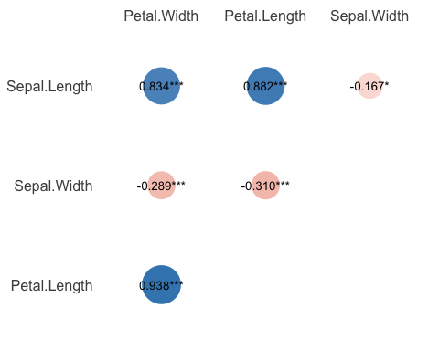

Fun note: you can even plot the *partial* correlations.

# You will need ggpraph  
library(ggraph)  
correlation(iris2,  
 partial = TRUE) %>%  
 plot()

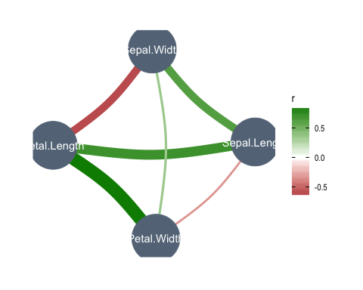

## Base R approach

As I mentioned before you can use the cor.test is there is a particular correlation you want to test. This is useful if you do not want to create a matrix of results.

As an example, let’s use cor.test to test the relationship between sepal length and petal length.

test1 = cor.test(iris$Sepal.Length,iris$Petal.Length)  
# Now we can print the result  
test1

##   
## Pearson's product-moment correlation  
##   
## data: iris$Sepal.Length and iris$Petal.Length  
## t = 21.646, df = 148, p-value < 2.2e-16  
## alternative hypothesis: true correlation is not equal to 0  
## 95 percent confidence interval:  
## 0.8270363 0.9055080  
## sample estimates:  
## cor   
## 0.8717538

However, we can also use the report package to get a summary of the result.

report(test1)

## Effect sizes were labelled following Funder's (2019) recommendations.  
##   
## The Pearson's product-moment correlation between iris$Sepal.Length and iris$Petal.Length is positive, statistically significant, and very large (r = 0.87, 95% CI [0.83, 0.91], t(148) = 21.65, p < .001)

Effect sizes were labelled following Funder’s (2019) recommendations.

The Pearson’s product-moment correlation between iris $Sepal.Lengthandiris$ Petal.Length is positive, statistically significant, and very large (r = 0.87, 95% CI [0.83, 0.91], t(148) = 21.65, p < .001)

# t-test

# ANOVA