Zaccheus Sia

17032467

Construct a Mamdani style fuzzy expert system with the inputs of

* temperature of the room,
* number of people in the room, and
* ambient temperature (temperature outside the room)

and the output of cooling speed of an air conditioner.

Then perform an inference for temperature of the room of 30℃, 20 people in the room, with ambient temperature of 33℃.

You only need to implement step 1 to 3 of the process of building a fuzzy expert system.

Input = Room Temperature, People, Ambient Temperature

Output: Cooling Speed

|  |  |
| --- | --- |
| Room temperature | |
| Linguistic Value | **Numerical Range** |
| Cold | 20 – 24 |
| Regular | 22 – 27 |
| Hot | 26 – 36 |

|  |  |
| --- | --- |
| People | |
| Linguistic Value | **Numerical Range** |
| Few | 4 – 10 |
| Normal | 8 – 15 |
| Many | 14 – 28 |

|  |  |
| --- | --- |
| Ambient temperature | |
| Linguistic Value | **Numerical Range** |
| Cold | 22 – 28 |
| Regular | 26 – 32 |
| Hot | 29 – 40 |

|  |  |
| --- | --- |
| Cooling speed | |
| Linguistic Value | **Numerical Range** |
| Slow | 50 – 100 |
| Average | 75 – 150 |
| Fast | 125 – 300 |

Fuzzy sets

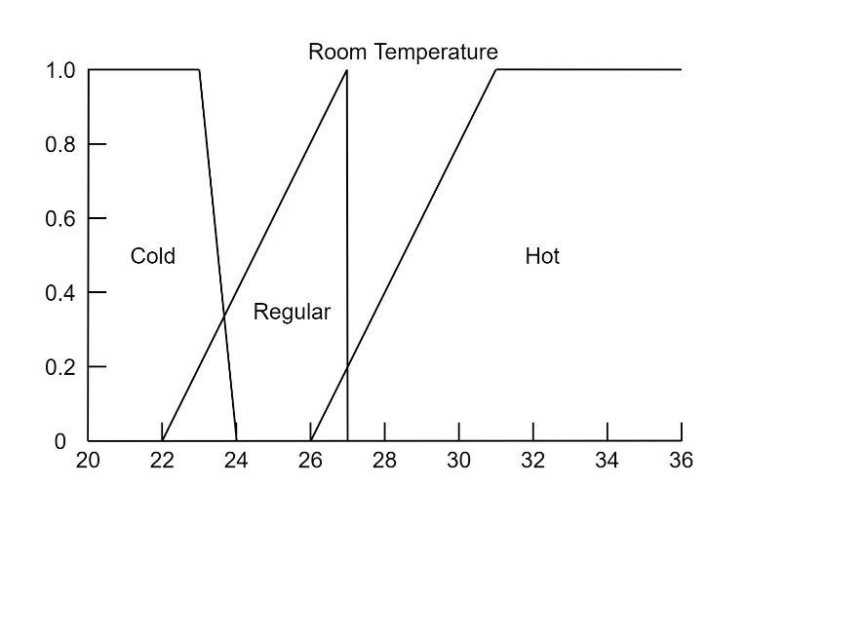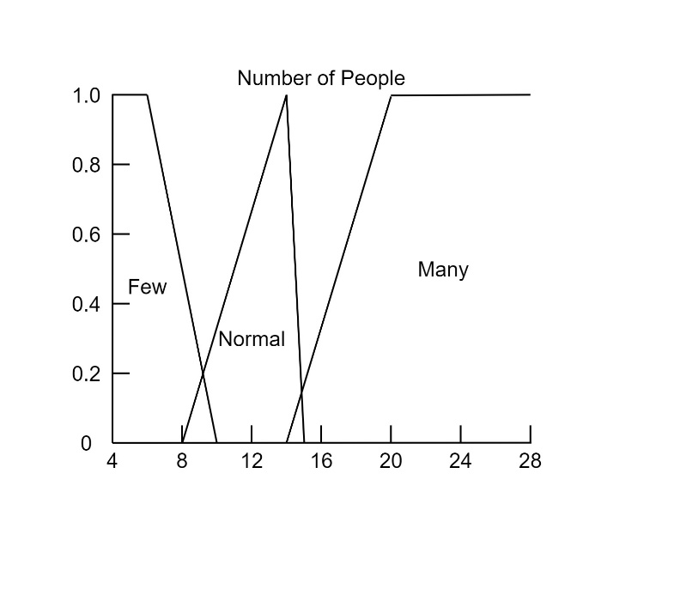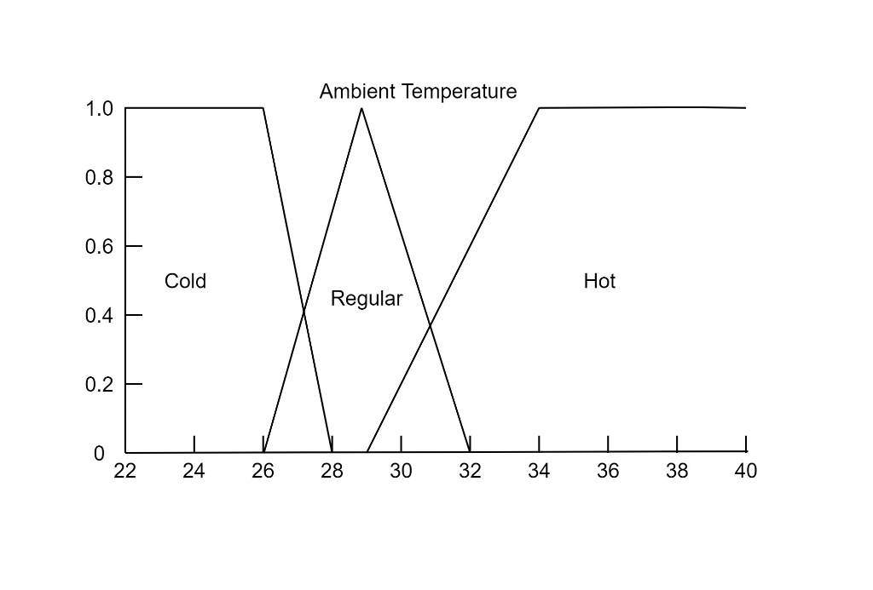

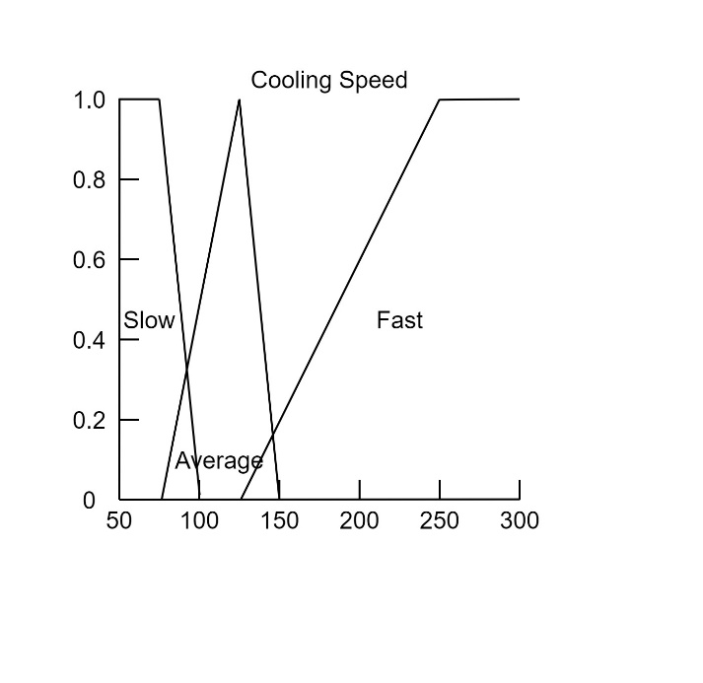

3x3x3 Cube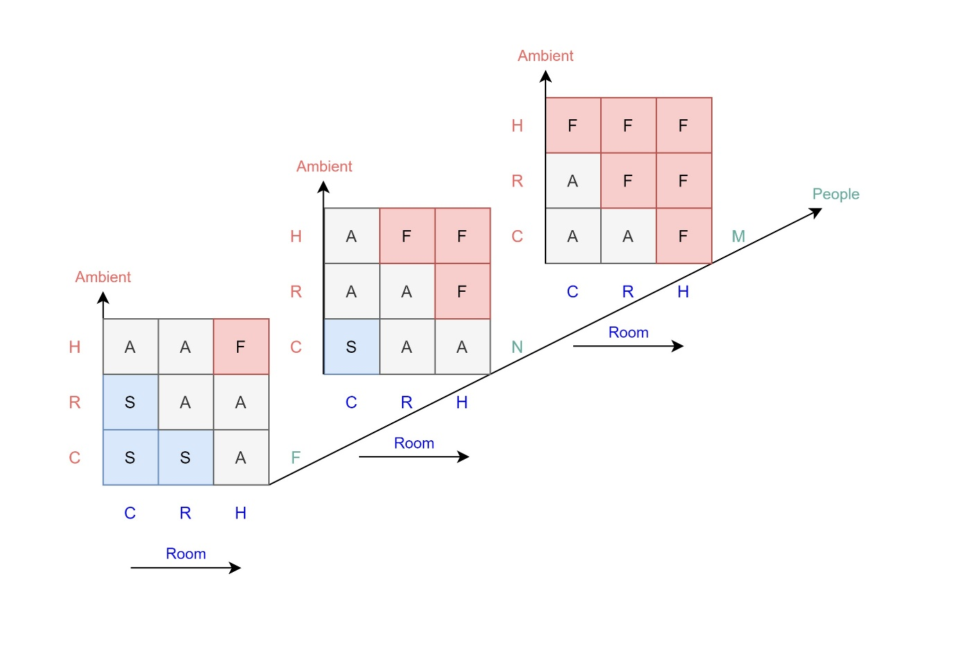

From my understanding I need to calculate for 27 rules so I’ll skip this part.