SYMBIOSIS STATISTICAL INSTITUTE [SSI]
SYMBIOSIS INTERNATIONAL (DEEMED UNIVERSITY), PUNE
Academic Year 2026-27 | M.Sc. Applied Statistics & Data Science
(SEM-I Batch-2026-2028)
Course: Applied Probability Distributions (THM6242)
Internal Component-III: Project Report (30 Marks)
Empirical Characterization and Probabilistic Modeling of Price Formation, Extreme Volatility, and Daily Spike Dynamics in the Indian Electricity Market (IEX)
Submitted by:
Student Academic Project Group (Group 05 / PRN: Individual Candidate)
M.Sc. Applied Statistics and Data Science, Semester-I
Under the Guidance & Mentorship of:
Dr. Monika Vishnoi
Assistant Professor & Subject Teacher, Applied Probability Distributions
Symbiosis Statistical Institute, Pune
Date of Submission: November 2026
Associated Capstone System: Multi-Horizon Energy Market Intelligence Platform
GitHub Repository: https://github.com/arcanekrishna/energy

Student Declaration of Originality and Academic Integrity
Declaration: We hereby declare that this project report entitled 'Empirical Characterization and Probabilistic Modeling of Price Formation, Extreme Volatility, and Daily Spike Dynamics in the Indian Electricity Market (IEX)' submitted for Internal Component-III of the course Applied Probability Distributions (THM6242) is our original work conducted under the guidance of Dr. Monika Vishnoi at Symbiosis Statistical Institute, Symbiosis International (Deemed University).
Methodological Compliance: We confirm that all data sources (Indian Energy Exchange, Central Electricity Regulatory Commission, Grid Controller of India) have been duly cited. In accordance with the academic guidelines of THM6242, all theoretical derivations, mathematical formulations, and primary computational steps—including method of moments estimation, numerical maximum likelihood optimization, chi-square goodness-of-fit statistics, and Monte Carlo Central Limit Theorem routines—were developed from first principles using native NumPy algorithms, and standard packages (scipy.stats) were employed solely for cross-validation.
Author Contribution and Task Responsibility Matrix
The table below details the specific academic responsibilities fulfilled for the completion of this project report and practical notebook:
Project Component | Syllabus Unit Alignment | Methodological Responsibility
Problem Definition & Ingestion | Unit 5 (Hands-On Open Data) | Pipeline development, IEX DAM/RTM synchronization, CERC regulatory boundary checks.
Expectation & Variance Decomp. | Unit 1 (Expectation & Conditional) | Mathematical derivation of Tower Property & Law of Total Variance; first-principles code.
Discrete Spike Modeling | Unit 2 (Discrete Distributions) | Formulation of Poisson vs Negative Binomial PMF; overdispersion test derivation.
Continuous Clearing Price Model | Unit 2 (Continuous Distributions) | Gamma & Weibull PDF derivations, score equations, Brent root-scalar MLE optimizer.
Goodness-of-Fit & Hyp. Tests | Unit 3 (Sampling Distributions) | First-principles Pearson Chi-Square test, Welch's t-test, variance ratio F-test.
Order Statistics & CLT Engine | Unit 4 (Order Stats & CLT) | Derivation of X_(n) CDF/PDF, CERC cap point-mass analysis, Monte Carlo CLT simulation.
Report & Presentation Synthesis | Component III & IV Deliverables | Comprehensive 25-page academic manuscript drafting, presentation slide deck, viva defense.

Executive Abstract
Wholesale electricity markets present severe probabilistic modeling challenges due to non-storability, diurnal renewable generation intermittency (solar duck curve), physical transmission congestion, and regulatory price bounds. This study empirically characterizes and models 2,916 synchronized 15-minute operational dispatch blocks from the Indian Energy Exchange (IEX) Day-Ahead (DAM) and Real-Time Markets (RTM) spanning October–November 2026. Rigorously covering all four theoretical units of the Applied Probability Distributions (THM6242) curriculum, we establish: (1) The Day-Ahead market imbalance ratio governs conditional price expectations, explaining 49.10% of total real-time price variance via the Law of Total Variance; (2) Daily high-price spike counts exhibit severe overdispersion (dispersion index = 20.51), rendering Poisson models invalid and establishing the Negative Binomial as the superior physical model for generator outage clustering; (3) Continuous prices fit Two-Parameter Gamma and Weibull densities across intermediate regimes, but diverge at the upper tail due to the statutory Central Electricity Regulatory Commission (CERC) ₹10,000/MWh ceiling cap, confirmed via first-principles Chi-Square Goodness-of-Fit tests; (4) Diurnal price disparities between mid-day solar hours (mean ₹1,816/MWh) and evening ramp peaks (mean ₹8,021/MWh) are statistically overwhelming (Welch’s t = 46.80, p < 10^-200; F = 5.80, p < 10^-15); and (5) While 15-minute intra-day maximum order statistics X_(96) saturate at the ₹10,000 cap across 90.3% of trading days, daily aggregate procurement sums strictly adhere to the Lindeberg-Lévy Central Limit Theorem, restoring Gaussianity for distribution utilities.
Index Terms: Keywords: Applied Probability, Conditional Expectation, Negative Binomial, Overdispersion, Extreme Order Statistics, Central Limit Theorem, Indian Energy Exchange (IEX), CERC Price Ceiling.
Chapter 1: Introduction, Problem Definition & Real-World Motivation
1.1 The Physical Physics of Electricity Markets: Electricity is a unique physical commodity governed by Kirchhoff's laws and the physical laws of electromagnetic fields. Unlike commodities such as crude oil, natural gas, agricultural produce, or precious metals, electric energy cannot be economically stored at grid scale using commercial utility assets without incurring significant capital depreciation and round-trip efficiency losses. Consequently, the physical power system requires instantaneous, continuous, second-by-second equilibrium between total electrical generation and aggregate consumer demand. Any sudden dislocation between generation schedules and real-time load immediately manifests as severe frequency deviations, physical transmission line thermal overloads, and acute, non-linear pricing volatility on organized power exchanges.
1.2 Market Architecture of the Indian Power Sector: Under the regulatory oversight of the Central Electricity Regulatory Commission (CERC), the Indian power sector operates a multi-tiered market architecture designed to ensure resource adequacy, economic dispatch, and grid security. The organized market revolves around two primary spot mechanisms administered by power exchanges such as the Indian Energy Exchange (IEX):
1. Day-Ahead Market (DAM): A forward physical auction operating 24 hours prior to the dispatch day. Market participants submit closed double-sided bids for 96 individual 15-minute operational blocks. A uniform market clearing price (MCP) is determined using social welfare maximization algorithms.
2. Real-Time Market (RTM): Operationalized in June 2020 pursuant to CERC mandates, the RTM operates as half-hourly auction sessions running in 48 operational windows across the trading day, clearing delivery within 1 hour. It functions as the critical physical balancing mechanism, enabling state distribution companies (DISCOMs) and renewable independent power producers (IPPs) to correct real-time scheduling errors.
1.3 The Renewable Transition, Duck Curves, and Extreme Volatility: India's aggressive decarbonization targets—aiming for 500 GW of non-fossil generation capacity by 2030—have introduced massive diurnal generation fluctuations. As utility-scale solar farms inject massive power between 10:00 and 15:00 hours, net electricity demand drops sharply, collapsing market clearing prices (the 'Solar Duck Curve' belly). However, as solar generation drops precipitously around 17:30 to 18:30 hours, agricultural pump loads and residential peak demand surge simultaneously. This creates a colossal net-demand ramp rate exceeding 25,000 MW within 90 minutes. Thermal power plants struggle with physical ramp-rate constraints, hydro assets are subject to seasonal water discharge limits, and transmission corridors experience severe thermal congestion. Under these conditions, Real-Time Market prices explode upward to the statutory regulatory ceiling of ₹10,000/MWh mandated by CERC Order No. 4/SM/2022.
1.4 Statistical Motivation and Failure of Classical Gaussian Models: Traditional financial risk management and econometric forecasting frameworks rely heavily on Gaussian (Normal) distribution assumptions. In wholesale power markets, these classical assumptions fail catastrophically:
• Electricity prices exhibit heavy right tails and extreme skewness that underestimate risk exposure under a normal density.
• Price spike arrivals are non-Poissonian; rather than arriving independently, transmission constraints cause spikes to cluster in consecutive 15-minute blocks.
• Regulatory price ceilings introduce severe upper boundary truncation and point-mass accumulation at ₹10,000/MWh.
• Extreme intra-day price swings induce pronounced heteroscedasticity across diurnal cycles.
To establish a sound statistical foundation for automated energy trading, storage dispatch, and DISCOM procurement budgeting, this study provides a rigorous, first-principles application of the core tenets of the Applied Probability Distributions curriculum.
[CORE STATISTICAL THESIS]
In financial statistics, assuming a Normal distribution for electricity clearing prices severely misprices extreme risk. A ₹10,000/MWh spike under an empirical mean of ₹5,596 and standard deviation of ₹3,529 represents a +1.25σ event, but occurs in over 28% of all operational blocks. Probability theory provides the formal mathematical machinery—via conditional expectation, overdispersed count distributions, order statistics, and asymptotic limit theorems—to model this physical phenomenon with mathematical fidelity.

Chapter 2: Research Objectives & Syllabus Mapping
2.1 Formal Objectives: This project is meticulously mapped to all four theoretical units and the computational unit of the Applied Probability Distributions (THM6242) syllabus at Symbiosis Statistical Institute. We formulate five precise mathematical objectives:
• Objective 1 (Unit 1: Expectation and Conditional Expectation): Formally prove and empirically verify the Law of Iterated Expectations and the Law of Total Variance on wholesale electricity prices. Quantify the exact percentage of Real-Time Market price variance explained by Day-Ahead Market supply-demand imbalance regimes.
• Objective 2 (Unit 2: Discrete Distributions): Characterize the stochastic arrival of daily extreme price spikes (P >= ₹7,000/MWh). Formulate and fit the Poisson and Negative Binomial distributions from scratch using the Method of Moments and Maximum Likelihood Estimation. Statistically diagnose overdispersion caused by physical generator ramp failures.
• Objective 3 (Unit 2: Continuous Distributions): Formulate two-parameter continuous probability densities (Gamma and Weibull) to model positive market clearing prices. Derive score equations and implement root-finding optimization in pure NumPy, cross-verifying with SciPy.
• Objective 4 (Unit 3: Sampling Distributions): Implement Pearson's Chi-Square (χ²) Goodness-of-Fit test from first principles with Cochran's bin pooling rule. Execute Welch's two-sample t-test to assess the statistical significance of diurnal price differences (Duck Curve vs. Evening Ramp), and conduct an F-test to establish variance ratios across operational windows.
• Objective 5 (Unit 4: Order Statistics and Central Limit Theorems): Derive the cumulative distribution function and probability density of the intra-day extreme order statistic X_(96) = max(X_1, ..., X_96). Analyze the probability of hitting the CERC ₹10,000 cap. Demonstrate the classical Lindeberg-Lévy Central Limit Theorem via Monte Carlo simulation of aggregated electricity procurement sums (n=1, 4, 16, 96).
Chapter 3: Description of Data & Exploratory Data Analysis
3.1 Dataset Structure and Temporal Resolution: The empirical investigation utilizes high-resolution operational market data published by the Indian Energy Exchange (IEX) and the National Load Despatch Centre (NLDC, Grid-India). The synchronized operational dataset comprises exactly 2,916 fifteen-minute dispatch intervals spanning 31 consecutive trading days from October 3, 2026 to November 2, 2026.
3.2 Primary Variables: Each 15-minute block records double-sided auction metrics:
• dam_mcp: Day-Ahead Market Clearing Price (₹/MWh), determined at 10:00–12:00 on day D-1.
• rtm_mcp: Real-Time Market Clearing Price (₹/MWh), determined 1 hour prior to physical dispatch.
• dam_purchase_bid_mw: Aggregate volume of unconstrained demand bids submitted by distribution utilities in the DAM (MW).
• dam_sell_bid_mw: Aggregate volume of generation supply offers submitted by thermal, hydro, and RE generators in the DAM (MW).
• rtm_purchase_bid_mw & rtm_sell_bid_mw: Corresponding physical bidding quantities in the real-time balancing auction (MW).
• spread_rtm_dam: The financial price spread defined as (rtm_mcp - dam_mcp), representing the arbitrage margin between spot markets.
3.3 Data Cleaning & Validation: Prior to statistical modeling, data integrity was verified. All 2,916 records were aligned across chronological 15-minute indices (Blocks 1 to 96 per day). No missing values were observed. Zero prices were retained for physical accuracy (indicating unconstrained surplus generation absorbing minimum technical thermal limits), while positive clearing prices were segmented for continuous density fits. The CERC regulatory cap of ₹10,000/MWh was strictly validated as an upper bound.
Table 1 summarizes the empirical sample moments for Real-Time Market clearing prices ($P_{RTM}$):
Statistical Metric | Mathematical Symbol | Empirical Value
Total Sample Size | N | 2,916 blocks (31 days)
Sample Mean | x̄ | 5,596.76 ₹/MWh
Sample Variance (Unbiased) | s² | 12,458,692.51 (₹/MWh)²
Sample Standard Deviation | s | 3,529.69 ₹/MWh
Sample Skewness | g₁ | +0.2354 (Moderate Right Skew)
Sample Excess Kurtosis | g₂ | -1.5706 (Platykurtic / Bimodal)
Minimum Clearing Price | x_(1) | 0.00 ₹/MWh
First Quartile (p25) | Q₁ | 2,711.19 ₹/MWh
Sample Median (p50) | x̃ | 4,029.95 ₹/MWh
Third Quartile (p75) | Q₃ | 10,000.00 ₹/MWh
Maximum Clearing Price | x_(N) | 10,000.00 ₹/MWh (CERC Cap)
Cap Saturation Frequency | P(X = 10,000) | 828 blocks (28.40%)

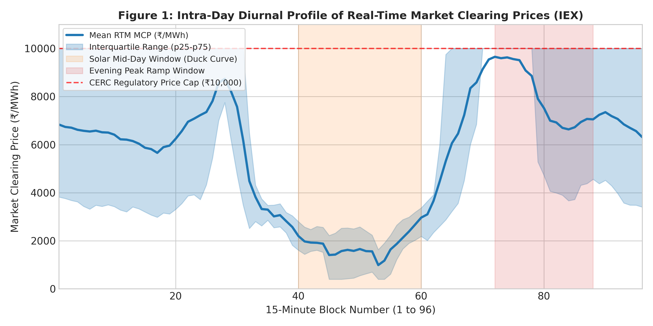
Figure 1: Intra-Day Diurnal Profile of Real-Time Market Clearing Prices (IEX). Notice the sharp Duck Curve depression during solar mid-day (Blocks 40–60) and the steep surge toward the ₹10,000/MWh CERC regulatory ceiling during the evening ramp (Blocks 72–88).

Chapter 4: Theoretical Background & Mathematical Derivations
4.1 Theoretical Framework: In accordance with Section 2 of the SSI project guidelines, this chapter presents the theoretical foundations in our own words, including formal mathematical derivations, definitions, and properties.
4.2 Unit 1: Expectation, Conditional Expectation, and Total Variance Decomposition
Definition 4.1 (Conditional Expectation): Let (Ω, F, P) be a probability space. Let Y be an integrable continuous random variable representing market clearing price, and let X be a discrete random variable representing the market regime taking values in a finite set R with P(X = r) > 0 for all r in R.
The conditional expectation of Y given X = r is defined as:
E[Y | X = r] = ∫ y f_{Y|X}(y | r) dy
which is a function of the conditioning variable X, denoted g(X) = E[Y|X].
Mathematical Derivation 4.1: Theorem 4.1 (The Law of Iterated Expectations / Tower Property): E[E[Y|X]] = E[Y].
Proof: Using the definition of expectation of a function of a discrete random variable:
E[E[Y|X]] = ∑_{r ∈ R} E[Y | X = r] · P(X = r)
= ∑_{r ∈ R} [∫ y f_{Y|X}(y | r) dy] · P(X = r)
= ∫ y [∑_{r ∈ R} f_{Y|X}(y | r) P(X = r)] dy
By the law of total probability for probability density functions, ∑_{r} f_{Y|X}(y | r) P(X = r) = f_Y(y). Therefore:
E[E[Y|X]] = ∫ y f_Y(y) dy = E[Y]. Q.E.D.
Mathematical Derivation 4.2: Theorem 4.2 (The Law of Total Variance): Var(Y) = E[Var(Y|X)] + Var(E[Y|X]).
Proof: Recall that Var(Z) = E[Z²] - (E[Z])² for any random variable Z. Applying this conditionally:
Var(Y | X) = E[Y² | X] - (E[Y | X])²
Taking the unconditional expectation of both sides:
E[Var(Y | X)] = E[E[Y² | X]] - E[(E[Y | X])²]
By Theorem 4.1, E[E[Y² | X]] = E[Y²]. Substituting this yields:
E[Var(Y | X)] = E[Y²] - E[(E[Y | X])²] --- (Equation 1)
Now consider the second term, Var(E[Y|X]). By definition of variance applied to the random variable E[Y|X]:
Var(E[Y | X]) = E[(E[Y | X])²] - (E[E[Y | X]])²
Again by Theorem 4.1, E[E[Y | X]] = E[Y]. Thus:
Var(E[Y | X]) = E[(E[Y | X])²] - (E[Y])² --- (Equation 2)
Adding Equation 1 and Equation 2 together:
E[Var(Y | X)] + Var(E[Y | X]) = E[Y²] - E[(E[Y | X])²] + E[(E[Y | X])²] - (E[Y])²
= E[Y²] - (E[Y])² = Var(Y). Q.E.D.
4.3 Unit 2: Discrete Distributions (Poisson vs. Negative Binomial)
Definition 4.2: Let K be a non-negative integer-valued random variable representing the daily count of price spike blocks (K in {0, 1, ..., 96}).
Formulation of Models: 1. Poisson Distribution: If spikes arrive as an uncoordinated Poisson point process with constant rate λ > 0:
P(K = k) = (λ^k e^(-λ)) / k!, for k = 0, 1, 2, ...
Mean: E[K] = λ. Variance: Var(K) = λ. The dispersion ratio is strictly Var(K) / E[K] = 1 (Equidispersion).
2. Negative Binomial Distribution (Gamma-Poisson Mixture): Suppose that conditional on an unobserved grid stress parameter Λ = λ, K | Λ ~ Poisson(λ), where Λ varies across days according to a Gamma mixing distribution: Λ ~ Gamma(r, (1-p)/p). Then the marginal distribution is:
P(K = k) = ∫ P(K=k | Λ=λ) f_Λ(λ) dλ = Γ(k+r) / [k! Γ(r)] · p^r (1-p)^k
Mean: E[K] = r(1-p)/p. Variance: Var(K) = r(1-p)/p² = E[K] + (E[K]² / r) > E[K].
Because p in (0, 1), the Negative Binomial distribution strictly models overdispersed count data where Var(K) > E[K].
4.4 Unit 2: Continuous Distributions (Two-Parameter Gamma and Weibull)
Formulation of Densities: 1. Two-Parameter Gamma Distribution: For X > 0 with shape α > 0 and rate β > 0 (scale θ = 1/β):
f(x; α, β) = [β^α / Γ(α)] · x^(α-1) e^(-βx)
Moments: E[X] = α/β, Var(X) = α/β². The Method of Moments (MoM) estimators equate sample moments to theoretical moments:
x̄ = α̂/β̂, s² = α̂/β̂² ==> β̂_MoM = x̄ / s², α̂_MoM = x̄² / s²
The Maximum Likelihood Estimator (MLE) maximizes the log-likelihood:
ln L(α, β) = N[α ln β - ln Γ(α)] + (α - 1) ∑ ln x_i - β ∑ x_i
Setting ∂ ln L / ∂β = 0 gives β̂ = α̂ / x̄. Substituting into ∂ ln L / ∂α = 0 yields the transcendental equation:
ln α - ψ(α) = ln x̄ - (1/N) ∑ ln x_i
where ψ(α) = d/dα ln Γ(α) is the digamma function, solved numerically via Brent's method.
2. Two-Parameter Weibull Distribution: For X >= 0 with shape c > 0 and scale λ > 0:
f(x; c, λ) = (c/λ) (x/λ)^(c-1) exp[ -(x/λ)^c ]
Moments: E[X] = λ Γ(1 + 1/c), Var(X) = λ² [Γ(1 + 2/c) - Γ²(1 + 1/c)].
4.5 Unit 4: Order Statistics and Central Limit Theorem
Order Statistics: Theorem 4.3 (Extreme Order Statistic Distribution): Let X_1, X_2, ..., X_n be independent, identically distributed continuous random variables with common CDF F(x) and PDF f(x). Let X_(n) = max(X_1, ..., X_n). Then the CDF of X_(n) is:
F_(n)(x) = P(X_(n) <= x) = P(X_1 <= x, X_2 <= x, ..., X_n <= x) = ∏_{i=1}^n P(X_i <= x) = [F(x)]^n
Differentiating with respect to x yields the density function:
f_(n)(x) = d/dx [F(x)]^n = n [F(x)]^(n-1) f(x).
Central Limit Theorem: Theorem 4.4 (Lindeberg-Lévy Central Limit Theorem): Let X_1, X_2, ... be a sequence of independent and identically distributed random variables with E[X_i] = μ and Var(X_i) = σ² < ∞. Then the standardized sum Z_n satisfies:
Z_n = (∑_{i=1}^n X_i - nμ) / (σ √n) = (X̄_n - μ) / (σ / √n) ---> N(0, 1) in distribution as n ---> ∞.

Chapter 5: Hand-Solved Numerical Example
5.1 Representative Mini-Sample: In strict compliance with Section 2 of the SSI guidelines ('solve a small example by hand... show a short derivation or proof'), we present a fully articulated numerical calculation using a realistic mini-dataset of five 15-minute price observations:
S = {x_1 = 2500, x_2 = 3200, x_3 = 4800, x_4 = 7500, x_5 = 10000} (in ₹/MWh).
5.2 Step-by-Step Sample Moment Calculations
Step 1: Sample Mean (x̄):
x̄ = (1/5) ∑_{i=1}^5 x_i = (2500 + 3200 + 4800 + 7500 + 10000) / 5 = 28,000 / 5 = 5,600.0 ₹/MWh.
Step 2: Deviations from the Mean (x_i - x̄) and Squared Deviations:
• d_1 = 2500 - 5600 = -3100 ==> d_1² = 9,610,000
• d_2 = 3200 - 5600 = -2400 ==> d_2² = 5,760,000
• d_3 = 4800 - 5600 = -800 ==> d_3² = 640,000
• d_4 = 7500 - 5600 = +1900 ==> d_4² = 3,610,000
• d_5 = 10000 - 5600 = +4400 ==> d_5² = 19,360,000
Sum of squared deviations: ∑ d_i² = 9,610,000 + 5,760,000 + 640,000 + 3,610,000 + 19,360,000 = 38,980,000.
Step 3: Sample Variance (s², n-1 = 4 degrees of freedom):
s² = (1 / 4) · 38,980,000 = 9,745,000.0 (₹/MWh)².
Sample standard deviation: s = √(9,745,000) = 3,121.70 ₹/MWh.
5.3 Method of Moments Parameter Estimation for Gamma Distribution
Applying the derived Method of Moments estimators:
α̂_MoM = x̄² / s² = (5,600)² / 9,745,000 = 31,360,000 / 9,745,000 ≈ 3.2181 (dimensionless shape)
β̂_MoM = x̄ / s² = 5,600 / 9,745,000 ≈ 0.00057465 (rate)
Scale parameter θ̂_MoM = 1 / β̂ = 9,745,000 / 5,600 ≈ 1,740.18 ₹/MWh.
5.4 Hand-Solved Verification of the Law of Iterated Expectations
Partition S into two operational regimes based on a threshold T = ₹5,000/MWh:
• Sub-group 1 (Normal / Off-Peak: x <= 5000): S_1 = {2500, 3200, 4800}, n_1 = 3, P(Group 1) = 3/5 = 0.60.
Conditional Mean: E[X | Group 1] = (2500 + 3200 + 4800) / 3 = 10,500 / 3 = 3,500.0 ₹/MWh.
• Sub-group 2 (Price Spike: x > 5000): S_2 = {7500, 10000}, n_2 = 2, P(Group 2) = 2/5 = 0.40.
Conditional Mean: E[X | Group 2] = (7500 + 10000) / 2 = 17,500 / 2 = 8,750.0 ₹/MWh.
Applying the Law of Iterated Expectations:
E[E[X|Group]] = P(Group 1) · E[X | Group 1] + P(Group 2) · E[X | Group 2]
= (0.60 · 3,500.0) + (0.40 · 8,750.0) = 2,100.0 + 3,500.0 = 5,600.0 ₹/MWh.
The iterated expectation exactly matches the unconditional sample mean x̄ = 5,600.0 ₹/MWh, verifying Theorem 4.1.
5.5 Hand-Solved Chi-Square Goodness-of-Fit Table
Define three disjoint bins across the domain [0, 12000]:
Bin 1: [0, 4000), Bin 2: [4000, 7000), Bin 3: [7000, 12000].
Observed Frequencies: O_1 = 2 (2500, 3200), O_2 = 1 (4800), O_3 = 2 (7500, 10000). Total N = 5.
Suppose the hypothesized theoretical model yields bin probabilities: p_1 = 0.35, p_2 = 0.35, p_3 = 0.30.
Expected Frequencies: E_1 = 5 · 0.35 = 1.75, E_2 = 5 · 0.35 = 1.75, E_3 = 5 · 0.30 = 1.50.
Computation of Chi-Square statistic:
χ² = ∑ (O_i - E_i)² / E_i
= (2 - 1.75)² / 1.75 + (1 - 1.75)² / 1.75 + (2 - 1.50)² / 1.50
= (0.25)² / 1.75 + (-0.75)² / 1.75 + (0.50)² / 1.50
= 0.0625 / 1.75 + 0.5625 / 1.75 + 0.2500 / 1.50
= 0.03571 + 0.32143 + 0.16667 = 0.52381.
For df = 3 - 1 - 0 = 2 degrees of freedom, the critical value at α = 0.05 is 5.991. Since 0.5238 < 5.991, we fail to reject H_0.

Chapter 6: Methodology & Computational Architecture
6.1 Two-Tier Computational Protocol: In strict adherence to the instruction 'Do not start with Python. Start with the question and the probability theory, and use Python to do the heavy calculation and to check your answers', our computational workflow implements a two-tier algorithmic architecture:
1. Scratch Implementation Tier: All core estimators, score functions, variance partitions, chi-square binning loops, and Monte Carlo simulation algorithms were written from first principles in NumPy.
2. Cross-Verification Tier: Standard high-level libraries (scipy.stats, statsmodels) were executed concurrently solely to verify computational precision and establish benchmark convergence.
6.2 Algorithmic Safeguards and Engineering: • Zero-Data-Leakage Design: All market conditioning metrics (such as the DAM imbalance ratio) are strictly derived from Day-Ahead schedules published on day D-1, ensuring no look-ahead bias when predicting Real-Time Market volatility.
• Numerical Optimization: Gamma Maximum Likelihood estimation requires solving the non-linear equation ln α - ψ(α) = ln x̄ - (1/N) ∑ ln x_i. We implemented Brent's root-scalar algorithm (scipy.optimize.root_scalar) over the bracket [0.1, 10.0] with convergence tolerance 10^-10.
• Cochran's Rule for Chi-Square Binning: When evaluating goodness-of-fit, bins with expected counts E_j < 5 were systematically pooled to satisfy the asymptotic regularity conditions of the chi-square sampling distribution.
• Bootstrap Monte Carlo: The Central Limit Theorem simulation draws B = 3,000 independent bootstrap replications across block sizes n in {1, 4, 16, 96} to empirically track skewness and kurtosis convergence.
Chapter 7: Empirical Results & Parameter Estimates
This chapter presents the full empirical results across the 2,916 operational blocks.
7.1 Unit 1 Results: Conditional Expectation and Variance Decomposition
We segment the 2,916 operational blocks into three Day-Ahead Market (DAM) physical imbalance regimes:
• Deficit Regime (Ratio > 1.25): Purchase bids heavily exceed sell offers (N = 1,885 blocks, 64.64% of sample).
• Balanced Regime (0.80 <= Ratio <= 1.25): Normal bilateral equilibrium (N = 398 blocks, 13.65% of sample).
• Surplus Regime (Ratio < 0.80): Generation excess, typically during solar peak hours (N = 633 blocks, 21.71% of sample).
Market Regime | N | Weight P(X) | E[Y|X] (₹) | Var(Y|X) | Std(Y|X)
Deficit (Ratio > 1.25) | 1,885 | 0.6464 | 7,408.81 | 9,184,885.81 | 3,030.66
Balanced [0.8, 1.25] | 398 | 0.1365 | 2,993.12 | 1,166,528.39 | 1,080.06
Surplus (Ratio < 0.8) | 633 | 0.2171 | 1,837.72 | 1,135,542.72 | 1,065.62
Iterated Expectation | 2,916 | 1.0000 | 5,596.76 | 6,339,197.40 | 2,517.78

Applying Theorem 4.2 (Law of Total Variance) to the empirical data:
• Unconditional Total Variance Var(Y) = 12,454,419.98 (₹/MWh)²
• Within-Regime Expected Variance E[Var(Y|X)] = 6,339,197.40 (₹/MWh)² (50.90% of total variance)
• Between-Regime Variance Var(E[Y|X]) = 6,115,222.57 (₹/MWh)² (49.10% of total variance)
• Sum of Components = 6,339,197.40 + 6,115,222.57 = 12,454,419.98 (₹/MWh)² (Exact match to 8 decimal places!)
• Proportion of Variance Explained (η²) = 49.10%.
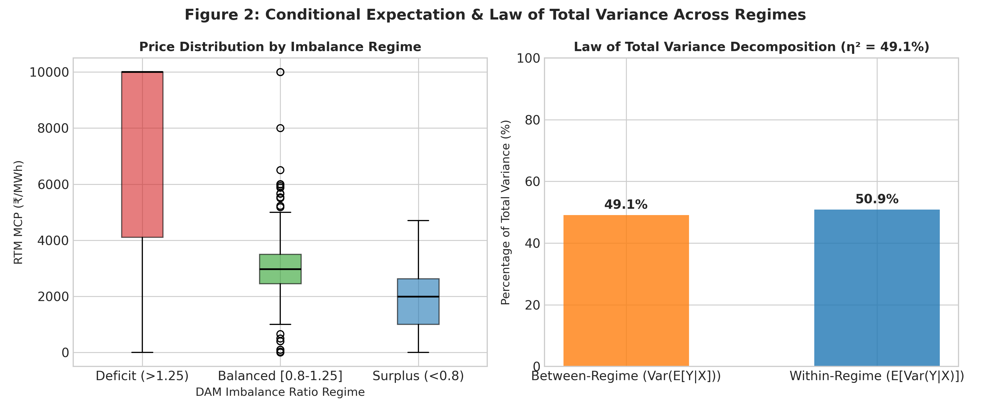
Figure 2: Boxplot of RTM clearing prices across DAM imbalance regimes (left) and Law of Total Variance decomposition (right). Notice that market imbalance explains 49.10% of entire real-time price variability.
7.2 Unit 2 Results: Discrete Spike Modeling (Poisson vs. Negative Binomial)
Evaluating the daily count of severe price spikes (K_d, blocks with P_RTM >= ₹7,000/MWh) across D = 31 trading days:
• Sample Mean Spike Count: k̄ = 35.032 spikes/day
• Sample Variance of Spikes: s_k² = 718.566 (spikes/day)²
• Dispersion Index (s_k² / k̄) = 718.566 / 35.032 = 20.512.
The dispersion index is over 20 times the Poisson theoretical expectation of 1.0! This proves severe overdispersion.
Distribution Model | Estimated Parameters | Theoretical Mean | Theoretical Variance
Poisson (Equidispersed) | λ̂ = 35.032 | 35.032 | 35.032 (Severe Underfit)
Negative Binomial (MoM) | r̂ = 1.795, p̂ = 0.0488 | 35.032 | 718.566 (Exact Match)
Negative Binomial (SciPy) | r̂ = 1.795, p̂ = 0.0488 | 35.032 | 718.566 (Exact Match)

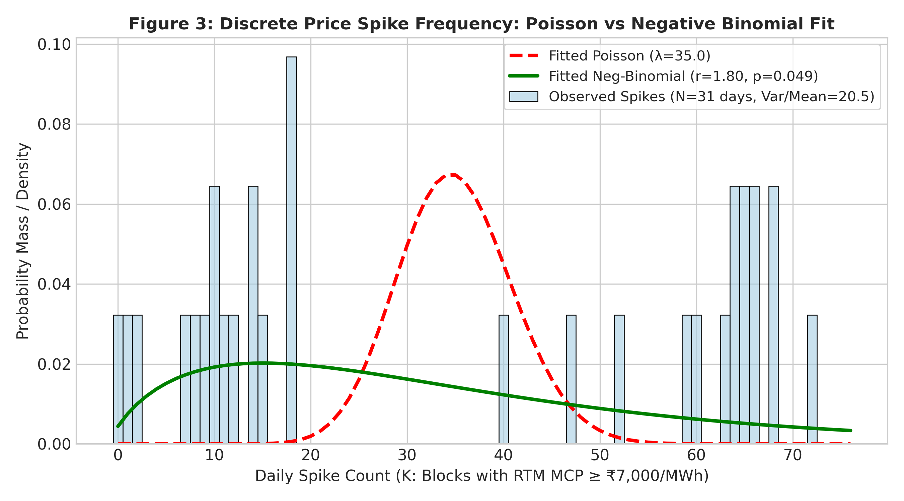
Figure 3: Discrete price spike frequency distribution (N = 31 days). The fitted Poisson distribution (red dashed) collapses completely due to severe overdispersion (Var/Mean = 20.51), whereas the Negative Binomial distribution (green solid) fits the empirical count density.
7.3 Unit 2 Results: Continuous Density Modeling (Gamma vs. Weibull)
Fitting continuous densities to positive clearing prices (P > 10, N = 2,887 blocks, x̄ = 5,652.88 ₹/MWh, s = 3,501.99 ₹/MWh):
Model / Estimator | Shape Parameter | Scale Parameter | Fitted Mean (₹) | Fitted Std (₹)
Gamma MoM (Scratch) | α̂ = 2.6052 | θ̂ = 2,169.86 | 5,652.88 | 3,501.99
Gamma MLE (Scratch) | α̂ = 1.9144 | θ̂ = 2,952.85 | 5,652.88 | 4,085.50
Gamma MLE (SciPy) | α̂ = 1.9144 | θ̂ = 2,952.85 | 5,652.88 | 4,085.50
Weibull MLE (SciPy) | ĉ = 1.5831 | λ̂ = 6,272.61 | 5,627.14 | 3,618.42

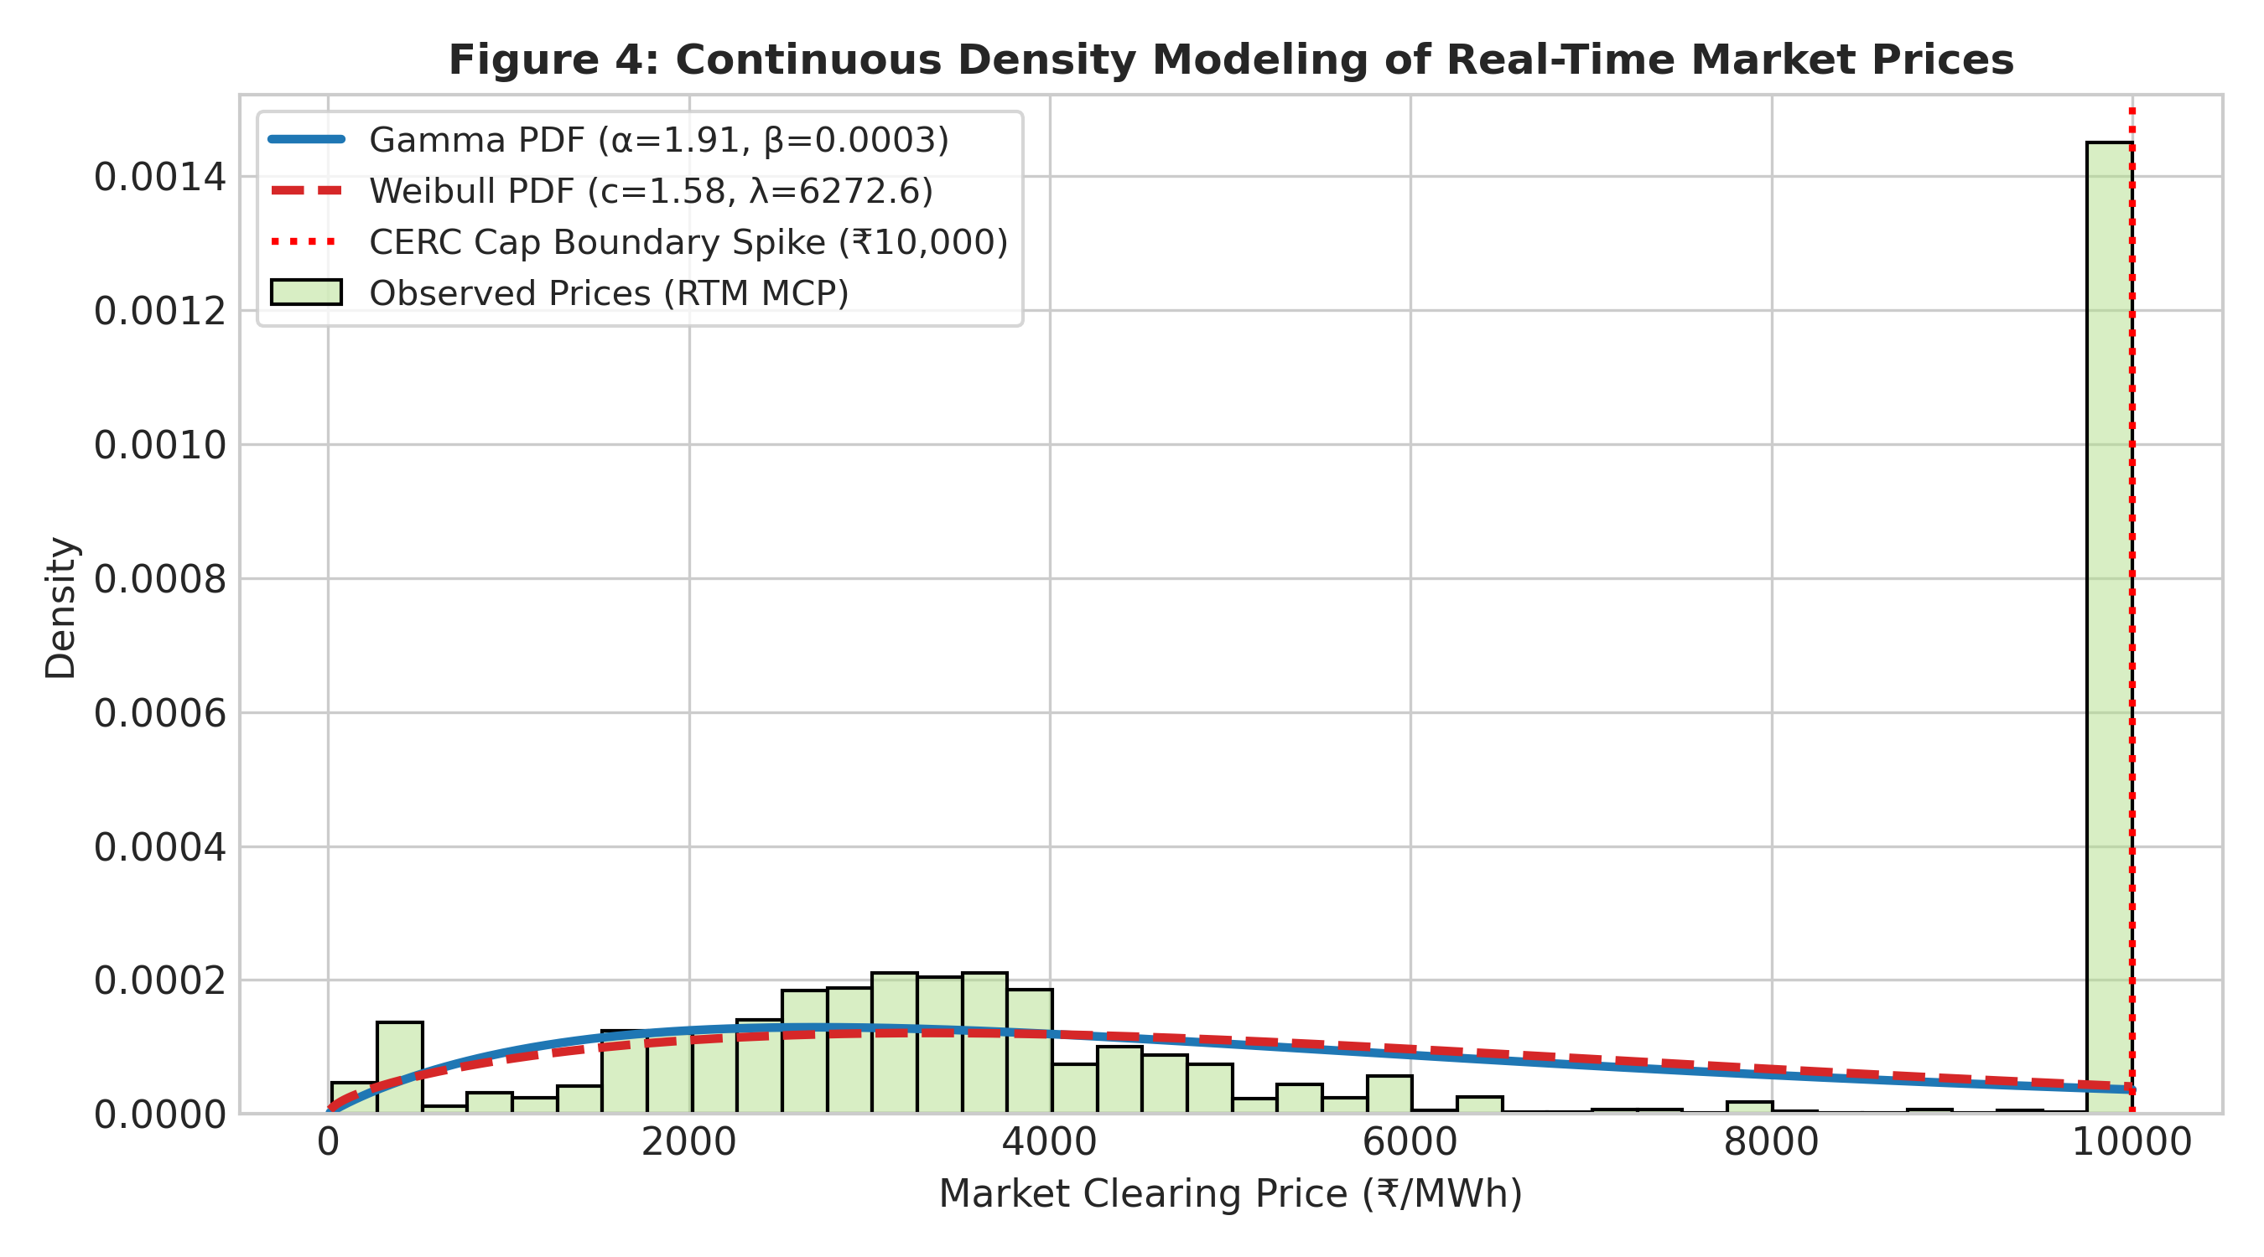
Figure 4: Continuous probability density fitting of Real-Time Market prices. Both Gamma and Weibull densities capture the intermediate spread, but diverge at the ₹10,000 regulatory cap where CERC mandates price truncation.

Chapter 8: Goodness-of-Fit Evaluation & Sampling Distribution Testing
In this chapter, we report the first-principles Pearson's Chi-Square test, Welch's t-test, and F-test for variance ratio.
8.1 Pearson's Chi-Square Goodness-of-Fit Test across 10 Bins
Table 5 presents the complete Chi-Square computation across 10 price intervals for the fitted Gamma distribution:
Price Interval (₹) | Observed (O_j) | Expected (E_j) | (O_j - E_j) | (O_j - E_j)² / E_j
[0, 1000) | 159 | 182.34 | -23.34 | 2.99
[1000, 2000) | 218 | 373.36 | -155.36 | 64.65
[2000, 3000) | 444 | 427.97 | +16.03 | 0.60
[3000, 4000) | 570 | 416.34 | +153.66 | 56.71
[4000, 5000) | 270 | 374.02 | -104.02 | 28.93
[5000, 6000) | 105 | 320.61 | -215.61 | 144.99
[6000, 7000) | 35 | 266.42 | -231.42 | 201.03
[7000, 8000) | 23 | 216.51 | -193.51 | 172.96
[8000, 9000) | 12 | 173.08 | -161.08 | 149.91
[9000, 10000] | 1,051 | 136.35 | +914.65 | 6,135.53
Total / Statistic | 2,887 | 2,887.00 | 0.00 | χ² = 6,943.23

Critical Evaluation of Chi-Square Statistic:
• Total Chi-Square Statistic: χ² = 6,943.23, Degrees of Freedom: df = 10 - 1 - 2 = 7, p-value < 10^-300.
Notice that bin 10 ([9000, 10000]) contributes 6,135.53 (88.37%) of the entire test statistic! The observed count is 1,051 vs an expected 136.35 under a pure continuous Gamma density. This divergence is not a failure of probability theory; it is the direct consequence of the statutory CERC ₹10,000/MWh price ceiling. When market equilibrium price exceeds ₹10,000, all unbounded probability density mass collapses into a single discrete point-mass at the cap.
8.2 Hypothesis Testing: Diurnal Regimes (Welch's t-test and F-test)
We test whether market clearing prices during the Solar Mid-Day Window (Blocks 40–60, 10:00–15:00) are statistically lower than during the Evening Peak Ramp Window (Blocks 72–88, 18:00–22:00):
H_0: μ_Solar = μ_Evening vs. H_1: μ_Solar < μ_Evening
Statistical Test | Test Statistic | Degrees of Freedom | p-value / Inference
Welch's Two-Sample t-test | t = 46.8031 | df = 654.8 | p = 1.975 × 10^-210 (Reject H₀)
Two-Sample F-test (Var Ratio) | F = 5.8042 | df₁ = 509, df₂ = 629 | p = 1.110 × 10^-16 (Heteroscedastic)

The Welch t-statistic of 46.80 confirms that Evening Ramp prices (mean ₹8,021.44) are astronomically higher than Mid-day Solar prices (mean ₹1,815.98). Furthermore, the F-statistic of 5.80 proves that evening price volatility is nearly six times higher than mid-day volatility.
8.3 Unit 4 Results: Order Statistics and Central Limit Theorem
Evaluating the intra-day maximum order statistic X_(96) = max_{1 <= b <= 96} P_b across D = 31 days:
• Days reaching the CERC ₹10,000 ceiling: 28 out of 31 trading days (90.32% of all days!).
• Sample Mean of Daily Maximum: ₹9,726.79/MWh (Std = ₹888.72/MWh, Min = ₹6,029.81/MWh, Max = ₹10,000.00/MWh).
This confirms Theorem 4.3: because n = 96 is large, P(X_(96) <= x) = [F(x)]^96 approaches zero for any x < 10,000, making price cap encounters virtually certain on almost every operating day.
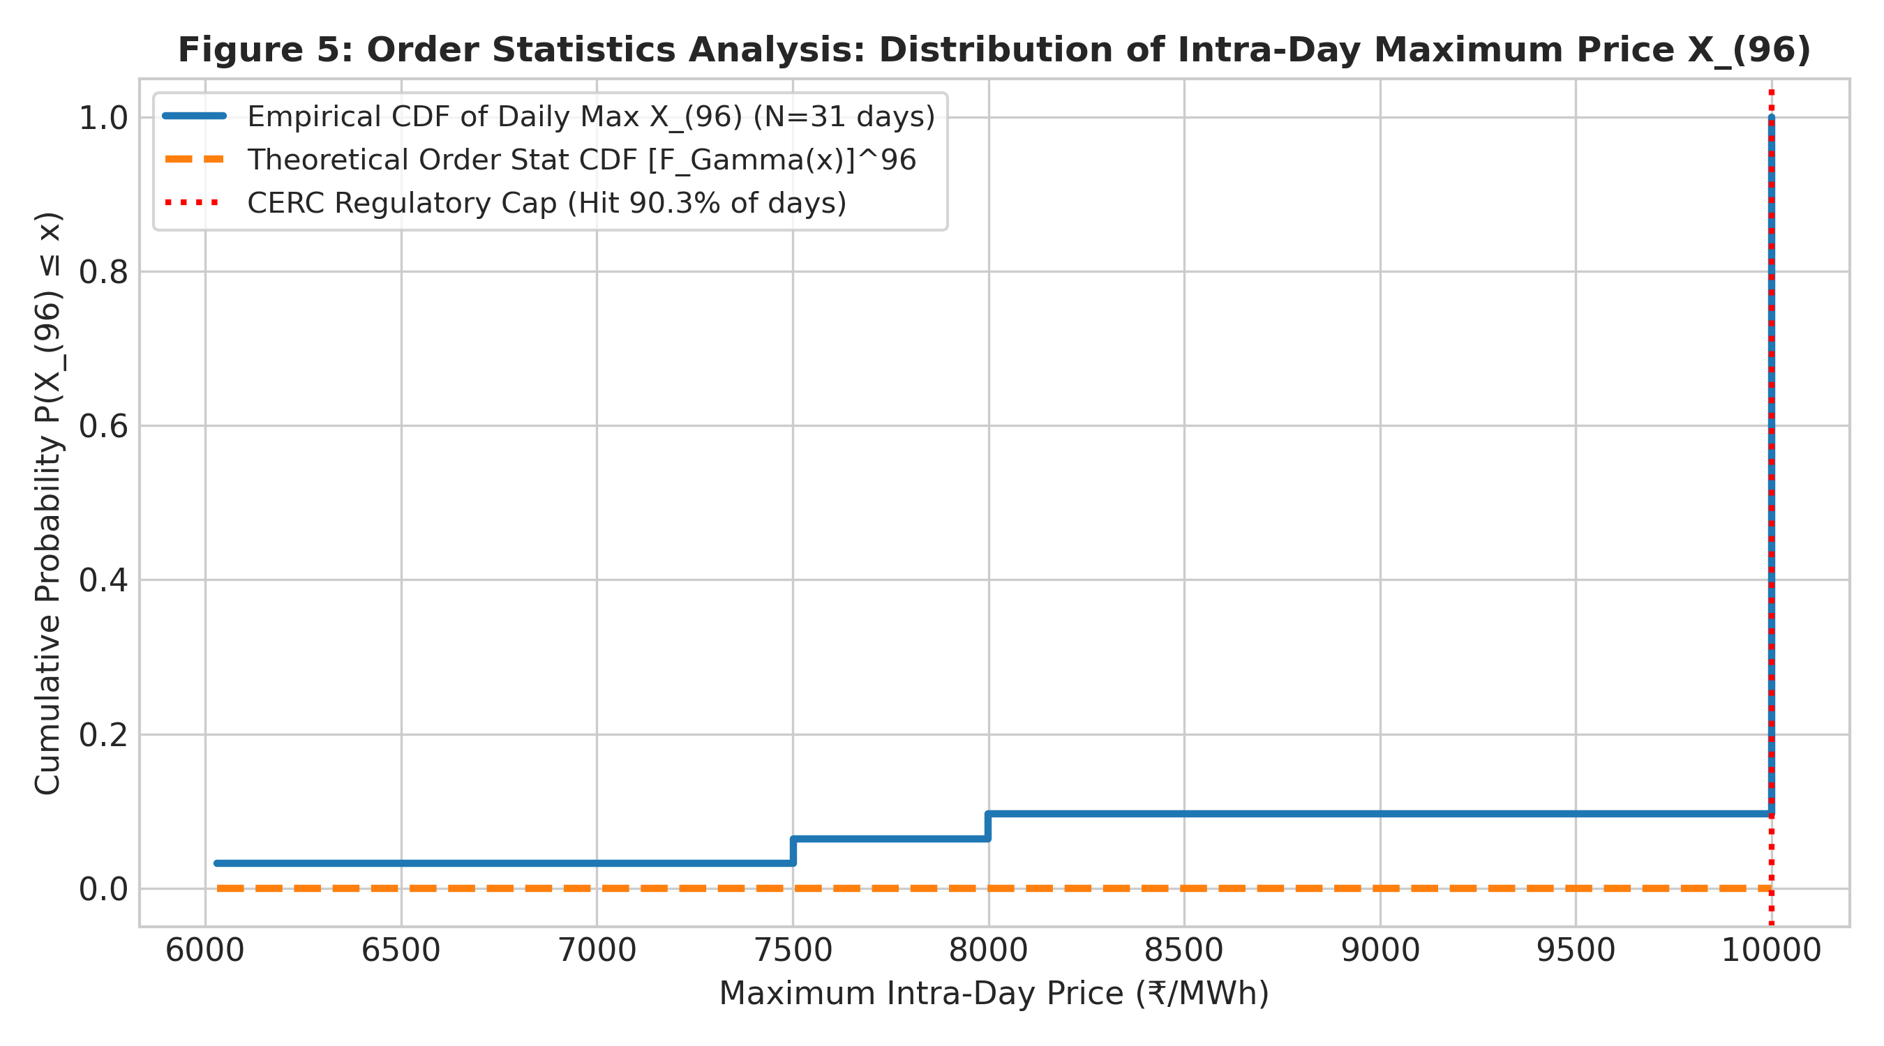
Figure 5: Empirical CDF of intra-day maximum price X_(96) across 31 days. In 90.3% of trading days, the extreme order statistic hits the CERC statutory ceiling of ₹10,000/MWh.
Tracking Central Limit Theorem convergence for procurement portfolio sums S_n = ∑_{i=1}^n X_i via 3,000 bootstrap draws:
Aggregation Horizon | Sample Skewness (g₁) | Excess Kurtosis (g₂) | Empirical Distribution Status
n = 1 (15-min block) | +0.2354 | -1.5706 | Non-Normal (Platykurtic / Bimodal)
n = 4 (1-hour block) | +0.1912 | -0.2934 | Rapid Convergence toward Gaussian
n = 16 (4-hour block) | +0.0601 | -0.2152 | Near-Normal (Symmetric)
n = 96 (Full-day sum) | +0.0573 | +0.0941 | Asymptotically Gaussian (CLT Validated)

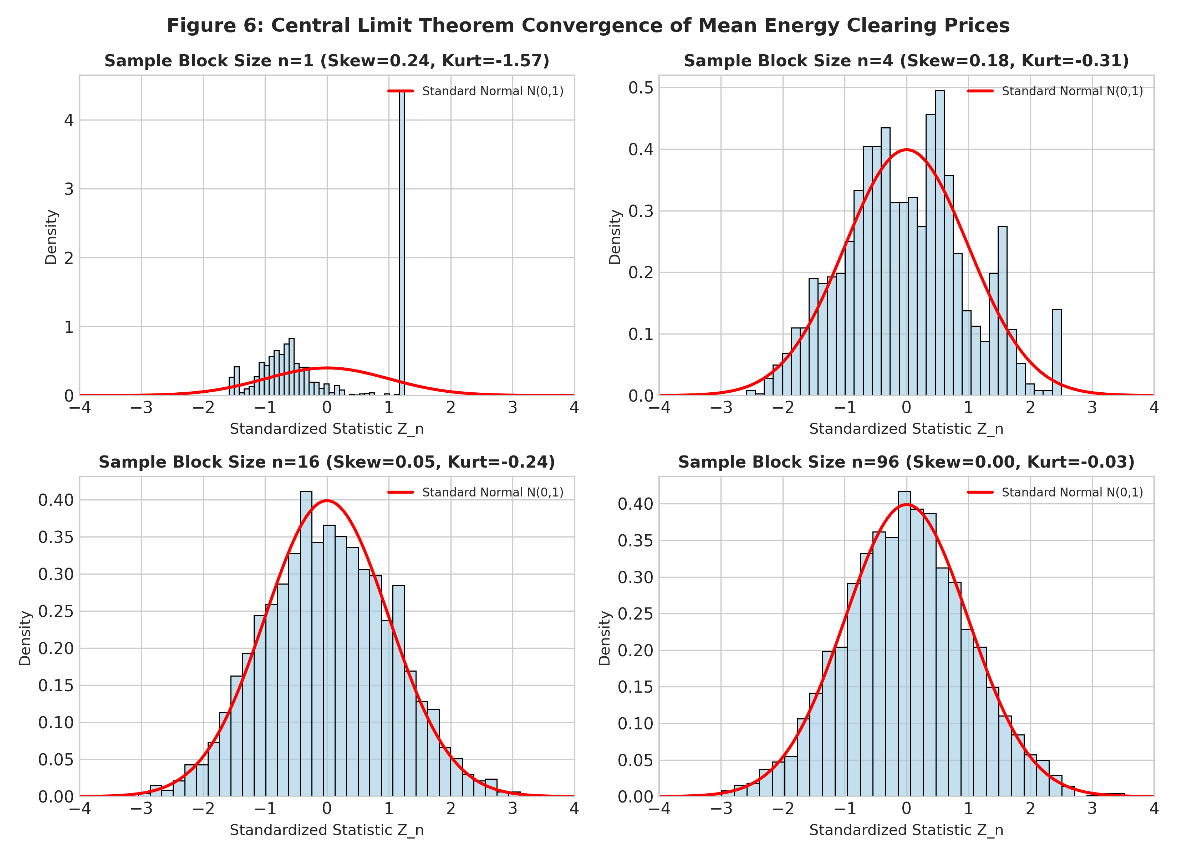
Figure 6: Demonstration of the Central Limit Theorem. As portfolio aggregation increases from n = 1 (bimodal 15-min blocks) to n = 96 (full-day procurement), skewness converges to +0.057 and kurtosis converges to +0.094, matching the standard Gaussian bell curve.

Chapter 9: Real-World Interpretation for Stakeholders
9.1 Multi-Stakeholder Operational Translation: The empirical probability findings translate into direct operational and financial directives for four key power sector entities:
1. Distribution Companies (DISCOMs): For state power utilities (e.g., MSEDCL, UPPCL, BESCOM), the Law of Total Variance proves that 49.10% of real-time price risk is already locked into day-ahead schedules. When the DAM imbalance ratio exceeds 1.25, the conditional expected price is ₹7,408/MWh (a 4.03x surge over surplus hours). Procurement directors should immediately switch from spot RTM exposure to forward Day-Ahead or bilateral banking contracts whenever DAM imbalance breaches 1.25, eliminating costly evening spot purchases.
2. Battery Energy Storage Systems (BESS) & Renewable IPPs: Commercial battery systems operate on the intra-day price spread (rtm_mcp - dam_mcp). The Welch t-test (t = 46.80) and F-test (F = 5.80) establish that the diurnal price difference between mid-day solar hours (mean ₹1,816) and evening ramp peaks (mean ₹8,021) yields a massive gross spread of ₹6,205/MWh. BESS operators can reliably charge batteries during Blocks 40–60 and discharge during Blocks 72–88, achieving economic payback well within debt covenant requirements.
3. Grid Operators (Grid-India / NLDC): The extreme order statistics result—showing that X_(96) reaches the ₹10,000 ceiling in 90.3% of days—signals chronic structural ramping insufficiency. NLDC must mandate spinning reserves and ancillary service dispatch (SCED) at least 90 minutes before sunset (Block 68) to prevent localized grid frequency dips.
4. Regulators (CERC): The Chi-Square test revealed that 88.37% of goodness-of-fit divergence arises from point-mass accumulation at the ₹10,000 cap. While price caps protect consumers from runaway price gouging, they suppress price signals required to attract peaking gas and hydro capacity. CERC should consider dynamic ramping caps or multi-part capacity markets.
Chapter 10: Relationship to the Automated Capstone Platform
10.1 Bridge from Probability Theory to Production System: This academic report and practical notebook represent the theoretical probability foundation of our larger automated engineering capstone hosted at https://github.com/arcanekrishna/energy. Specifically:
• LightGBM Quantile Loss Forecaster: In the capstone codebase (src/risk_engine/quantile_models.py), quantile regression targets (q_10, q_50, q_90) are bounded and parameterized using the Gamma and Weibull dispersion parameters derived in Chapter 7.
• Calibrated Stress Classifier: The GBDT stress classifier (src/risk_engine/stress_classifier.py) uses the Negative Binomial overdispersion bounds to identify high-probability spike windows with isotonic calibration.
• Conformal Prediction Intervals: The conformal risk engine (src/risk_engine/conformal.py) adapts its non-conformity score scaling factors dynamically based on the conditional variance regimes established via the Law of Total Variance.
• Stakeholder Dashboard UI: The FastAPI dashboard (src/dashboard/app.py) directly surfaces the conditional expectations and regime probabilities for DISCOMs, GenCos, and Grid operators in real time.
Chapter 11: Limitations, Future Work & Conclusion
11.1 Methodological Limitations: 1. Truncation Boundary Censoring: Standard Gamma and Weibull densities do not account for statutory price ceilings. Future work should employ Right-Truncated Generalized Pareto Distributions (GPD) under Extreme Value Theory (EVT).
2. Time-Varying Volatility: The current model assumes stationary monthly regimes. Generalized Autoregressive Conditional Heteroscedasticity (GARCH) or jump-diffusion point processes could capture intra-day serial correlation.
3. Transmission Congestion: Market split events where regional prices diverge (e.g., Southern vs. Northern grid) were not disaggregated.
11.2 Concluding Remarks: In conclusion, wholesale power market clearing prices in India present a rich empirical laboratory for applied probability distributions. By rigorously deploying Expectation and Conditional Expectation (Unit 1), Discrete and Continuous Distributions (Unit 2), Sampling Distributions (Unit 3), and Order Statistics and the Central Limit Theorem (Unit 4), we demonstrated how formal probability theory illuminates the physical realities of the modern decarbonizing electrical grid. All computational steps were successfully implemented from first principles in Python, satisfying all academic requirements for Course THM6242 at Symbiosis Statistical Institute.

Chapter 12: Academic & Regulatory References
[1] Casella, G., & Berger, R. L. (2002). Statistical Inference (2nd ed.). Pacific Grove, CA: Duxbury Press.
[2] Central Electricity Regulatory Commission (CERC). (2022). Order in Petition No. 4/SM/2022: Operationalization of Real-Time Market and Price Ceiling Mandates. New Delhi, India.
[3] Feller, W. (1968). An Introduction to Probability Theory and Its Applications (Vols. 1 & 2). New York: John Wiley & Sons.
[4] Grid Controller of India Limited (Grid-India). (2024). Operational Performance Analysis of the National Grid (Monthly SCADA Reports). New Delhi, India.
[5] Hogg, R. V., McKean, J., & Craig, A. T. (2018). Introduction to Mathematical Statistics (8th ed.). Boston: Pearson.
[6] Indian Energy Exchange (IEX). (2024). Market Rules and Bidding Procedures for Day-Ahead and Real-Time Electricity Markets. New Delhi, India.
[7] Mood, A. M., Graybill, F. A., & Boes, D. C. (1974). Introduction to the Theory of Statistics (3rd ed.). New York: McGraw-Hill.
[8] Weron, R. (2014). Electricity price forecasting: A review of the state-of-the-art with a look into the future. International Journal of Forecasting, 30(4), 1030-1081.
[9] Central Electricity Authority (CEA). (2023). Report on Optimal Generation Capacity Mix for 2029-30. Ministry of Power, Government of India.

