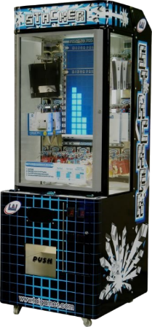Stack1e

The game is based on the popular arcade game **Stacker**, developed by LAI Games.

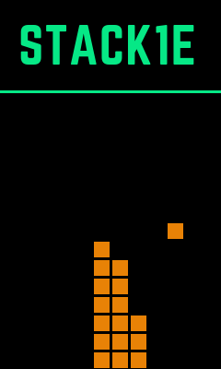Stack1e is made using the **PyGame** library, which is a free and open source python programming language library for making multimedia applications, such as games. In order to win the game, the player must stack 15 rows.

**Stack1e – The Ultimate Stacking Game**

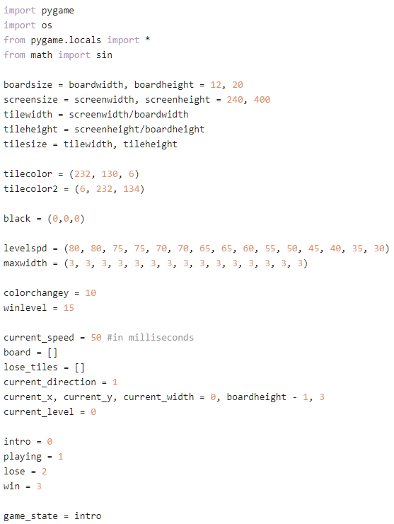

The variables are defined at the start, which includes all the parameters for the game, such as the speed of each row and color of the tiles.

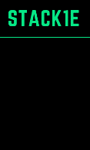

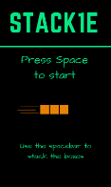

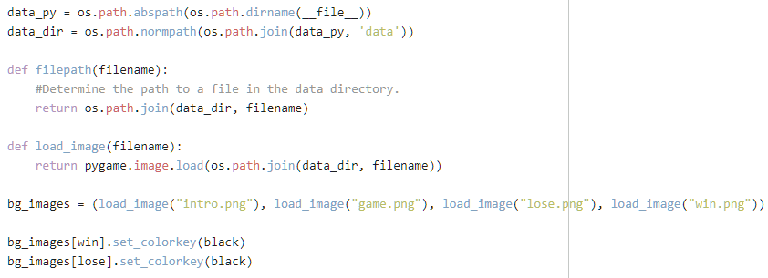

The background images for each game state are imported using pygame.

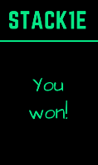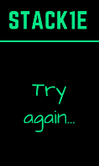

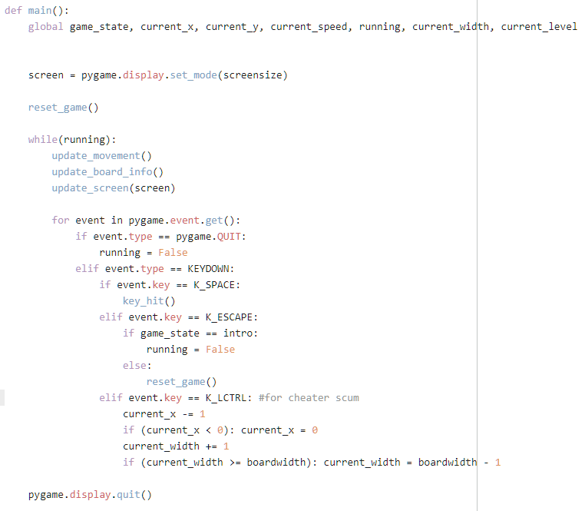

The main function which drives the entire game code. This includes checking for key presses and win/lose conditions.

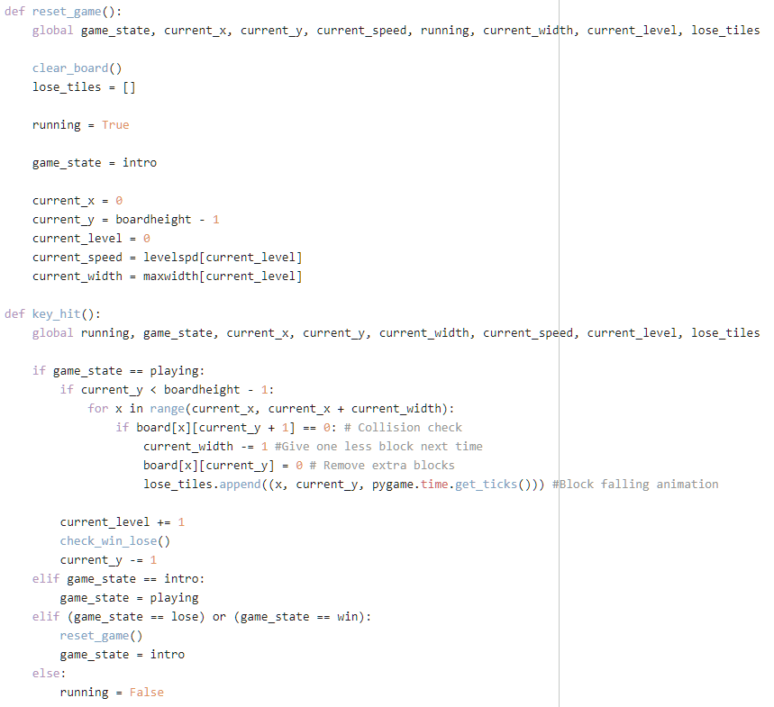

The reset_game function which is called to start the game again. It sets all the variables back to their default state.

The key_hit function which is called to stack the block. It checks for a collision with the bottom surface and stacks the block if it makes contact.

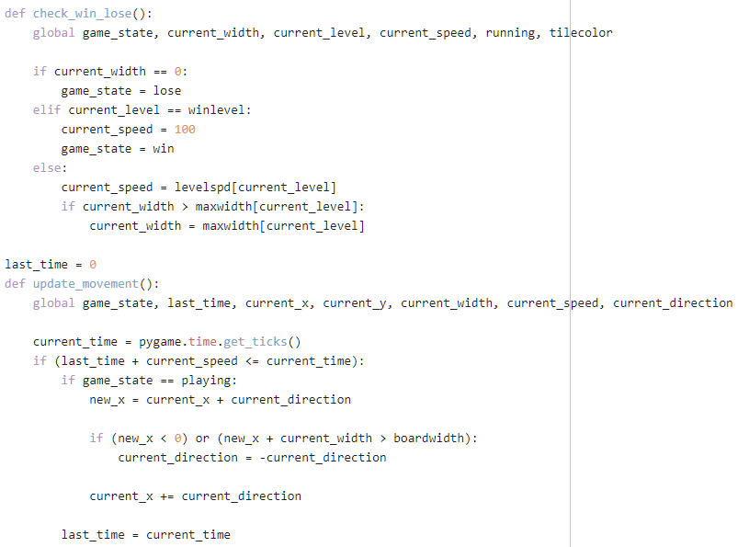

The win_lose function which checks whether the block no longer exists. It also determines whether the player has stacked 15 rows and continues the game if they haven’t.

The update_movement function updates the x and y positions of the block in real time.

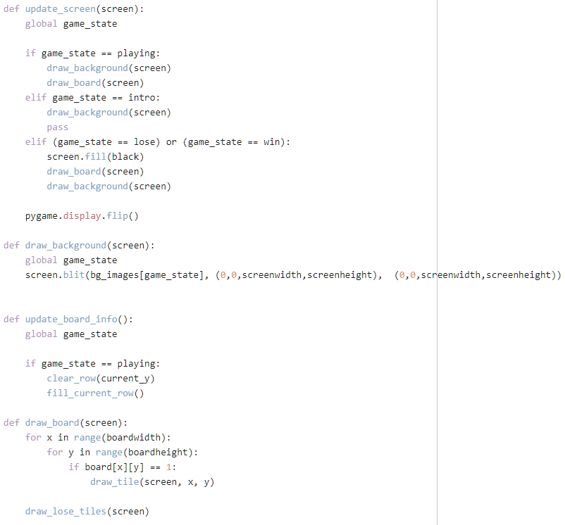

The update_screen function changes the background image according to the current game state.

These functions create a drawable area on the screen.

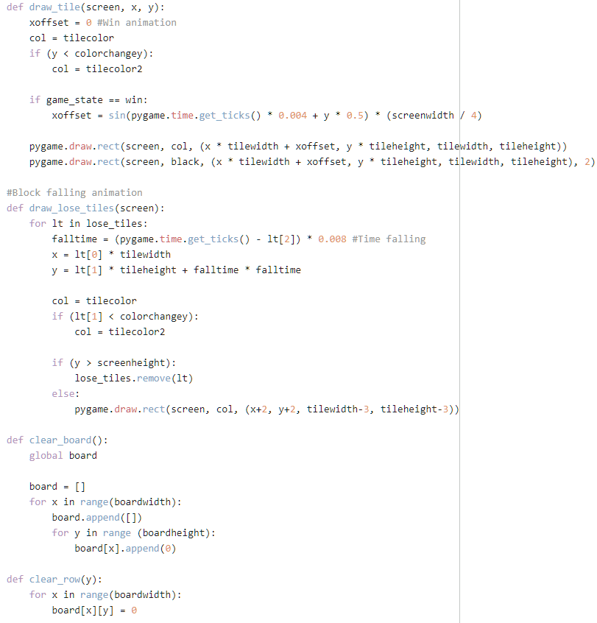

The draw_tile function draws the tiles on the screen and also draws a sine wave animation when the player wins.

The draw_lose_tiles function calculates the time taken for a tile to fall to the bottom of the screen and fades it out as it falls.

These functions are used in the reset_game function to clear the tiles off the screen.

