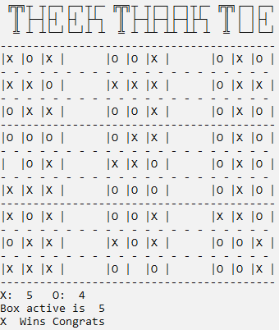TheekThaakToe

The game is a modification of the classic game tic tac toe.

The game involves a set of 9 nested tic tac toe games. The bigger as well as the smaller boxes are numbered from 1-9 like on your numpad.

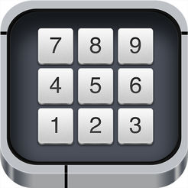

**Rules**

After a move the other player will have to play in the bigger box corresponding to the box where you played.

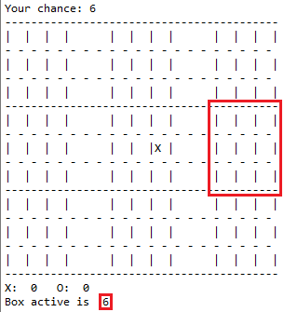

Eg: if you selected box 6 then then the opponent will have to play in the mid right box of the main grid.

**Win Condition:**

Either win 5 boxes or if there are no valid moves left then the person who has won more boxes wins.

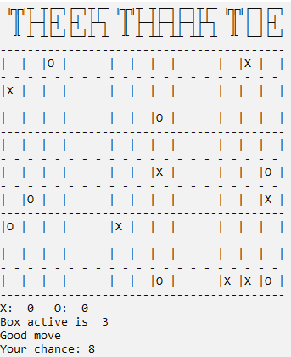

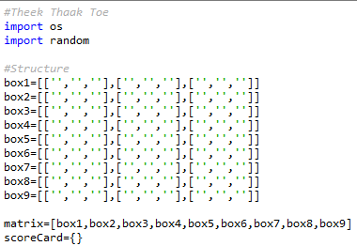

Defining basic structure.

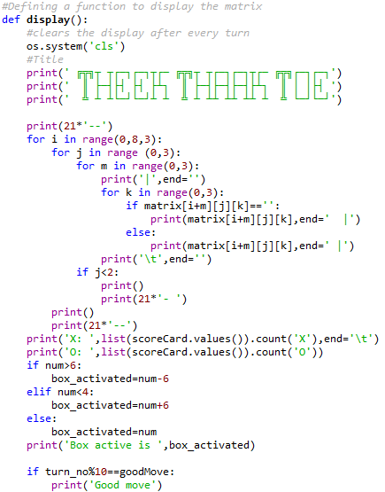

Defined a function to print everything.

Used nested loops to access each element of the list.

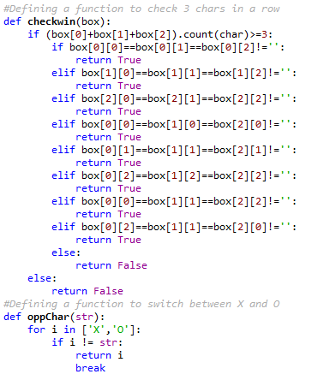

The checkwin function checks if the box is won by someone.

The oppChar function switches between X and O.

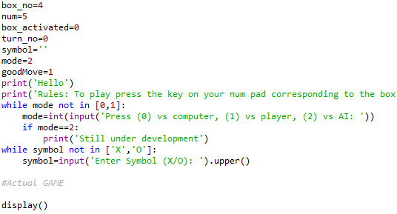

Variables are defined and a while loop for the user to choose the mode.

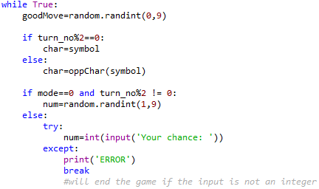

The main loop of the game.

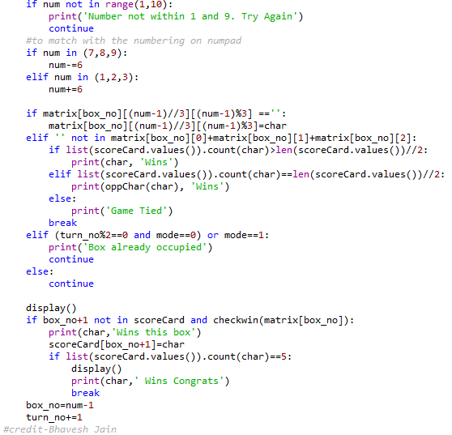

Checks if the box selected is already filled.