**remBoot: Random Encounter Modelling and bootstrapping for variance in R**

Caravaggi, A1

1 School of Biological Sciences, Queen’s University Belfast, Belfast BT9 7BL, UK

10-01-2017

**Paper DOI:**   
**Software Repository:** https://github.com/arcaravaggi/remBoot  
**Software Archive:** http://dx.doi.org/ 10.6084/m9.figshare.4536065

**Summary**

The Random Encounter Model (REM) allows researchers to calculate population densities from camera trap data for species which do no exhibit individually-identifiable markings (Rowcliffe *et al*., 2008) such as tapir (*Tapirus terrestris*; Oliveira-Santos et al. 2010), pine marten (*Martes martes*; Manzo et al. 2011), and hares (*Lepus* sp.; Caravaggi et al. 2016).. The REM is based on Brownian motion, and makes three assumptions: i) animal movements are random in the landscape; ii) detections are independent contacts between animals and cameras; and iii) the focal population is closed (Rowcliffe *et al*., 2008). Any study investigating wild populations will undoubtedly violate one or more of these assumptions. For example, wild populations are rarely closed, and animal movements are never truly random. The REM is relatively robust against certain violations, however (Rowcliffe *et al.* 2008; Manzo *et al.* 2011; Rowcliffe *et al*., 2012).

Density (D) is linearly scaled with trapping rate, based on two biological variables and two camera characteristics: *g* = average animal group size; *y* = number of detections; *t* = survey effort (i.e. camera hours); *v* = average distance travelled by the species in 24 hours; *r* = radial distance to the animal; and, *θ* = zone of detection (Fig. 1; Equation 1; Rowcliffe et al., 2008).

$$D= g\left(\frac{y}{t}\frac{π}{vr\left(2+θ\right)}\right)$$

Equation 1

remBoot is the first package to implement REM calculations in R. The package also contains functions which allow the calculation of variance (standard deviation [SD] and/or 95% confidence intervals [CI]). These calculations are computationally inexpensive and can be applied to datasets of considerable size. Densities and associated variances can be calculated for one or more sites concurrently, streamlining the analytical process.

**References**

Caravaggi, A., Zaccaroni, M., Riga, F., Schai‐Braun, S.C., Dick, J.T., Montgomery, W.I. and Reid, N. (2016). An invasive‐native mammalian species replacement process captured by camera trap survey random encounter models. *Rem Sens Ecol Cons*. 2, 45-58.

Manzo, E., Bartolommei, P., Rowcliffe, J.M. and Cozzolino, R. (2011). Estimation of population density of European pine marten in central Italy using camera trapping. *Acta Theriol*. 57, 165 – 172.

Oliveira-Santos, L.G.R., Zucco, C.A., Antunes, P.C. and Crawshaw, P.G. (2010). Is it possible to individually identify mammals with no natural markings using camera-traps? A controlled case-study with lowland tapirs. *Mamm Biol*. 75, 375 – 378.

Rowcliffe, J.M., Field, J., Turvey, S.T. and Carbone, C. (2008). Estimating animal density using camera traps without the need for individual recognition. *J Appl* Ecol. 45, 1228 – 1236.

Rowcliffe, J.M., Carbone, C. Kays, R., Kranstauber, B. and Jansen, P.A. (2012). Bias in estimating animal travel distance: the effect of sampling frequency. *Methods Ecol Evol*. 3, 653 – 662.

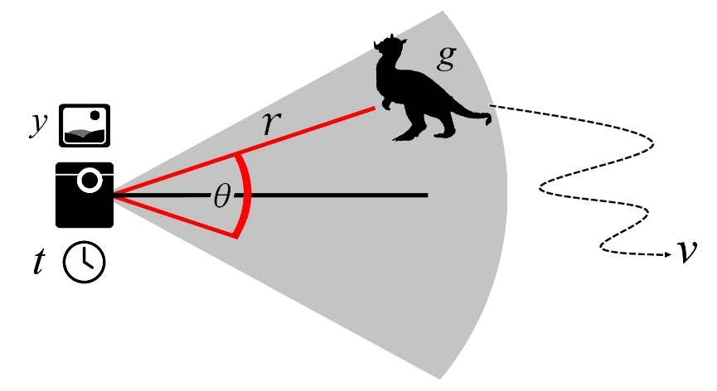

**Figure 1.** Data input (y and t) and parameters (r, θ and v) required for the calculation of population density estimates from camera trap data by the Random Encounter Model (REM). *g* = average animal group size; *y* = number of detections; *t* = survey effort (i.e. camera hours); *v* = distance travelled in 24 hours; *r* = radial distance to the target; and, *θ* = zone of detection.