SNAP SPECTRUM

A Report On Mini Project

BCA

in

Department of Computer Science

*by*

ANJANA PULIKKAL BAIJU (CCAXBCA001) ARCHANA J DEV (CCAXBCA043)

ARJUN S(CCAXBCA021)

ASMABI (CCAXBCA022)

Under the supervision of

Vandana T V



*to*

DEPARTMENT OF COMPUTER SCIENCE CHRIST COLLEGE(AUTONOMOUS), IRINJALAKUDA IRINJALAKUDA-680125, INDIA

*August 2024*

Abstract

This report details the development and implementation of Snap spectrum a website developed as part of our second-year mini project. The report outlines the project objectives, methodologies, design, implementation, and testing results. A platform called Snap Spectrum teaches photographers of various skill levels about photographic technology. It provides thorough in structions on a number of photography-related topics, such as composition, ISO, shutter speed, and aperture. The website offers an interesting learning environment with interactive components and high-quality photos to stim ulate creativity. With Snap Spectrum, we hope to create a community of photographers who are committed to learning from one another and improv ing their photographic techniques.

Contents

1 Introduction 3 1 Background . . . . . . . . . . . . . . . . . . . . . . . . . . . . 3 2 Objectives . . . . . . . . . . . . . . . . . . . . . . . . . . . . . 4 3 Scope . . . . . . . . . . . . . . . . . . . . . . . . . . . . . . . 4

2 Literature Review 5 1 Related Work . . . . . . . . . . . . . . . . . . . . . . . . . . . 5 2 Technologies Used . . . . . . . . . . . . . . . . . . . . . . . . . 5

3 System Design 7 1 Overview . . . . . . . . . . . . . . . . . . . . . . . . . . . . . . 7 2 Architecture . . . . . . . . . . . . . . . . . . . . . . . . . . . . 7 3 Module Descriptions . . . . . . . . . . . . . . . . . . . . . . . 7 4 User Interface Design . . . . . . . . . . . . . . . . . . . . . . . 9

4 Implementation 14 1 Development Tools . . . . . . . . . . . . . . . . . . . . . . . . 14 2 Coding Standards . . . . . . . . . . . . . . . . . . . . . . . . . 14 3 Code Implementation . . . . . . . . . . . . . . . . . . . . . . . 14

1

4 Challenges Faced . . . . . . . . . . . . . . . . . . . . . . . . . 15

5 Conclusion and Future Work 16 1 Conclusion . . . . . . . . . . . . . . . . . . . . . . . . . . . . . 16 2 Future Enhancements . . . . . . . . . . . . . . . . . . . . . . . 16

6 References 18

A Appendices 19 1 Appendix A: Source Code . . . . . . . . . . . . . . . . . . . . 19

2

Chapter 1

Introduction

Snap Spectrum is a cutting-edge photography education platform that pro vides in-depth explanations and high quality images to assist photographers of all skill levels improve. Snap Spectrum offers a visually stimulating and captivating learning experience with an emphasis on fundamental photogra phy skills such as aperture, shutter speed, ISO, and composition, which is intended to motivate and enable photographers.

1 Background

Although digital technology has increased the popularity of photography, it can be difficult to find resources that are all cohesive. In order to remedy this, Snap Spectrum provides a consolidated, approachable platform for learning photography methods.

3

2 Objectives

• Educate Photographers: Offer in-depth manuals to improve photo graphic abilities.

• Encourage Creativity: To inspire photographers, display excellent pho tos. Boost Your Photography Knowledge: Provide in-depth details on settings like ISO, aperture, shutter speed, and composition.

• Create a Photography Community: Promote a community where peo ple may exchange experiences and expertise.

3 Scope

• Aperture and depth of field:Examples are provided to illustrate the effects of aperture and depth of field on exposure and depth of field.

• Aperture and depth of field:Examples are provided to illustrate the effects of aperture and depth of field on exposure and depth of field.

• ISO: Effect on the quality of the image, particularly in dim light.

• Motion Blur and Shutter Speed: Motion capture and control tech niques.

• Composition and the Rule of Thirds: Using innovative approaches and composition guidelines, narrative is improved.

4

Chapter 2

Literature Review

1 Related Work

The linked publication, which focusses on enhancing image structure, pro vides a succinct summary of basic photographic composition concepts. It gives an explanation of the rule of thirds. To direct the viewer’s eye through the picture, leading lines are emphasised. Additionally covered is the signifi cance of symmetry and framing in the creation of eye-catching compositions. All things considered, the associated literature offers helpful advice, partic ularly for novices wishing to improve their photographic abilities.

2 Technologies Used

• Modern web technologies were used in the construction of Snap Spec trum to guarantee a smooth and interesting user experience.

• High-quality Visuals: Use of high-resolution images give users a hands 5

on learning experience.

• HTML and CSS: The foundational technologies used to create the structure and styling of the website.

6

Chapter 3

System Design

1 Overview

With its adaptable design, organized material, and interesting features, Snap Spectrum provides photographers with an interactive learning environment. Scalability and dynamic delivery are supported by its architecture.

2 Architecture

Frontend with CSS and HTML

3 Module Descriptions

• HOME PAGE:

Learn about Snap Spectrum

The heading ”Discover Snap Spectrum” features the subtitle ”The Art 7

of Photography.” Image Carousel: Showcases a selection of inspira tional words and eye-catching photos from each day’s Instagram stories. Footer Buttons: Contains navigational ”More Photos,” ”Explore,” and ”About Us” buttons.

• PHOTO GALLERY:

Header: Shows ”Photo Gallery” as the heading for this section. A ”Gallery” button that allows you to see the entire collection and the decsription about each photos. It also contains a ”Back to home” button.

Photo Thumbnails: Showcases a range of picturesque photos in a grid format.

• TECHNIQUES:

Acquire Knowledge of Photography Techniques

Header: ”SNAP SPECTRUM”; emphasises grasping photography meth ods.

Featured Image: An ”Explore Techniques” button draws attention to a picturesque picture.

Sections on Technique: enumerates common photographic methods, such as:

Techniques about aperture and depth of field, Insights and tips regard ing shutter speed and motion blur, Advanced lighting techniques using ISO and low light photography and Detailed explanation and examples on composition and the rule of thirds.

8

Contains a ”Back to home” button.

About Us: gives a quick overview of the Snap Spectrum group, high lighting their love of photography.

• ABOUT US:

Header: ”About Us” is bolded and highlighted in maroon text, centred at the top of the main content section. Principal Idea: An outline of Snap Spectrum’s goal to become the go-to resource for learning pho tography methods can be found in the main text. It states that Snap Spectrum provides tutorials on composition, lighting, exposure, and post-processing, among other important photography topics. The essay highlights how photography combines art and science, with the aim of assisting photographers in honing both their technical proficiency and creative vision.

Contains a ”Back to home” button.

Section of Newsletters: There is a section urging viewers to sign up for the Snap Spectrum newsletter beneath the main material. This sec tion has a call-to-action button for subscribing and is likewise coloured maroon.

Footer: A copyright notice is included in the footer section at the bottom of the page.

4 User Interface Design

The user interface is designed to be accessible, responsive, and intuitive. 9

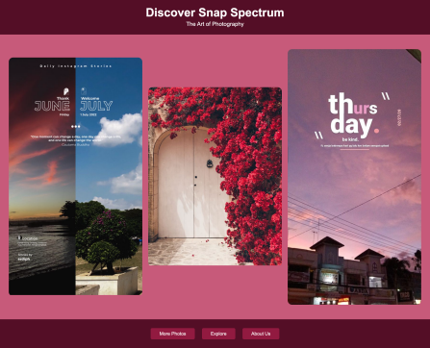Figure 3.1: HOME PAGE

10

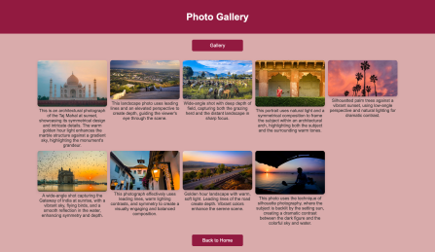Figure 3.2: PHOTO GALLERY

11

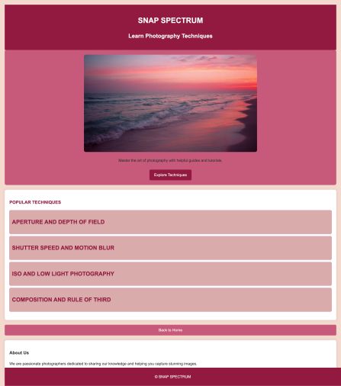Figure 3.3: TECHNIQUES

12

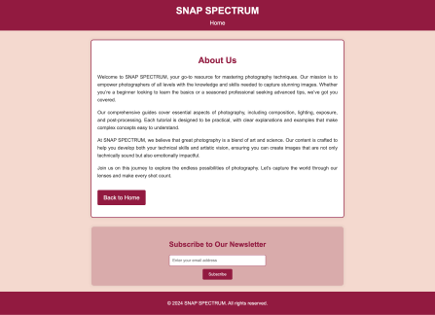Figure 3.4: ABOUT US

13

Chapter 4

Implementation

1 Development Tools

CSS, HTML, and front-end technologies.

2 Coding Standards

To improve readability and maintainability, logical organisation, consistent indentation, and descriptive nomenclature were used.

3 Code Implementation

• HTML Organisation:Employ semantic HTML elements to arrange con tent in a sensible manner. Provide sections on Aperture and Depth of Field, ISO, Shutter Speed and Motion Blur, and Composition and Rule of Thirds for each of the primary subjects.

14

• CSS Style:Create a responsive design by combining Flexbox with CSS Grid. Use CSS classes to apply uniform styling, and follow name con ventions such as BEM. To make sure the website looks well on all devices, use media queries.

• Designing with responsiveness:Make sure the website is responsive by utilising flexible graphics and fluid grids. Layout should be optimised for different screen sizes to ensure a consistent user experience. The Snap Spectrum website is guaranteed to be aesthetically pleasing, intu itive to use, and well-structured.Thanks to its implementation strategy.

4 Challenges Faced

• Cross browser compatibility:Providing consistent functionality across browsers is known as cross-browser compatibility.

• Responsive design:Layout adaptation for different devices is known as responsive design.

• Optimising Load Times: For quicker loading, smaller files are used. 15

Chapter 5

Conclusion and Future Work

1 Conclusion

To sum up, Snap Spectrum is an all-inclusive learning resource meant to im prove users’ photography abilities across the board. The website attempts to give a full learning experience by providing comprehensive instructions on im portant photography skills including aperture, ISO, shutter speed, and com position, combined with high-quality photographs and interactive aspects. Constructed using contemporary web technologies, Snap Spectrum guaran tees responsiveness, accessibility, and an intuitive user experience, cultivating a community of photography enthusiasts ready to advance and learn.

2 Future Enhancements

Advanced tutorials, community features, a mobile app, individualised learn ing routes, live workshops, photo challenges, and editing software integration

16

are some potential future improvements for Snap Spectrum. The enhance ments are intended to promote community involvement, improve user expe rience, and improve the platform’s educational offerings.

17

Chapter 6

References

• https://www.youtube.com/watch?v=PgAZ8KzfhO8 18

Appendix A

Appendices

1 Appendix A: Source Code

SNAP.HTML:

<!DOCTYPE html>

<html lang="en">

<head>

<meta charset="UTF-8">

<meta name="viewport" content="width=device-width, initial-scale=1.0"> <title>SNAP SPECTRUM</title>

<style>

body {

margin: 0;

font-family: Arial, sans-serif;

background-color: #921A40; /\* Dark Red from the palette \*/ color: #FFFFFF; /\* White for text \*/

19

}

header {

background-color: #540D26; /\* Darkest shade derived from the palette \*/

padding: 20px;

text-align: center;

}

.header-content h1 {

margin: 0;

font-size: 2.5em;

}

.header-content p {

margin: 5px 0;

font-size: 1.2em;

}

.gallery {

display: flex;

justify-content: space-around;

align-items: center;

20

padding: 40px 20px;

background-color: #C75B7A; /\* Medium Red from the palette \*/ }

.gallery-item {

flex: 1;

margin: 10px;

overflow: hidden;

border-radius: 15px;

transition: transform 0.3s ease;

}

.gallery-item img {

width: 100%;

height: auto;

transition: transform 0.3s ease;

}

.gallery-item:hover img {

transform: scale(1.1);

}

.links {

text-align: center;

padding: 20px;

21

background-color: #540D26; /\* Darkest shade derived from the palette \*/

}

.button {

text-decoration: none;

color: #FFFFFF;

background-color: #921A40; /\* Dark Red from the palette \*/ padding: 10px 30px;

border-radius: 5px;

margin: 10px;

display: inline-block;

font-size: 1em;

transition: background-color 0.3s ease;

}

.button:hover {

background-color: #C75B7A; /\* Medium Red on hover \*/

}

</style>

</head>

<body>

<header>

<div class="header-content">

<h1>Discover Snap Spectrum</h1>

22

<p>The Art of Photography</p>

</div>

</header>

<section class="gallery">

<div class="gallery-item">

<img src=

"/Users/venna/Downloads/d0fee2c589b91d8ccc3f81e61ccfef16.jpg" alt="Gallery Image 1">

</div>

<div class="gallery-item">

<img src=

"/Users/venna/Downloads/19d1beb10b8044be2a2263acd9db2241.jpg" alt="Gallery Image 2">

</div>

<div class="gallery-item">

<img src=

"/Users/venna/Downloads/9043493f21749459a01df460a5ec8166.jpg" alt="Gallery Image 3">

</div>

</section>

<section class="links">

<a href="PHOTO.HTML" class="button">More Photos</a>

<a href="HOME2.HTML" class="button">Explore</a>

23

<a href="ABOUTUS.HTML" class="button">About Us</a> </section>

</body>

</html>

24