
Tribhuvan University
Faculty of Humanities and Social Science
A Project Report On
“AI Text Detector”
In partial fulfillment of requirements in Bachelor in Computer Applications
Submitted by:
Shashank Singh (6-2-410-140--2021)

June, 2026 A.D.
Under the Supervision of
Ms. Rolisha Sthapit


Tribhuvan University
Faculty of Humanities and Social Science
A Project Report On
“AI Text Detector”
In partial fulfillment of requirements in Bachelor in Computer Applications
Submitted by:
Shashank Singh (6-2-410-140--2021)

June, 2026 A.D.
Under the Supervision of
Ms. Rolisha Sthapit


Tribhuvan University
Faculty of Humanities and Social Science

SUPERVISORS RECOMMENDATION
It is my pleasure to recommend that a project report on “AI Text Detector” has been prepared under my supervision by Shashank Singh in partial fulfillment of the requirement of the degree of Bachelor of Computer Applications. His report is satisfactory and is an original work done by him to process for the future evaluation.

Ms. Rolisha Sthapit
SUPERVISOR
Lecturer, Department of IT
Prime College


Tribhuvan University
Faculty of Humanities and Social Science

LETTER OF APPROVAL
This is to certify that this project report prepared by Shashank Singh on “AI Text Detector” in partial fulfillment of the requirements for the degree of Bachelor in Computer Application has been evaluated. In our opinion it is satisfactory in the scope and quality as a project for the required degree.
Ms. Rolisha Sthapit  Supervisor  Prime College  Khusibu, Nayabajar, Kathmandu | Ms. Rolisha Sthapit  Program Co-Ordinator/ Internal  Examiner  BCA Department  Prime College  Khusibu, Nayabajar, Kathmandu
Mr.
External Examiner

ACKNOWLEDGEMENT
This project on developing an AI Text Detector, which detects machine-generated text using statistical NLP, K-Nearest Neighbors (KNN), and Cosine Similarity, could not have been achieved without the kind support of many individuals. I am highly thankful to Ms. Rolisha Sthapit, Project Supervisor and Coordinator, for her kind guidance, valuable suggestions, and encouragement during the course of developing this project. Her knowledge of the subject, as well as her encouragement, helped learn the concepts of Natural Language Processing and machine learning deeply. I would also like to express my gratitude towards all the individuals, such as my teachers, mentors, friends, and classmates, who provided valuable suggestions, ideas, etc., during the testing phase of the project, which helped improve the performance, functionality, etc., of the AI Text Detector. I would like to express my sincere thanks to all the individuals, who helped the completion of the project, directly or indirectly.
-Shashank Singh

ABSTRACT
The AI Text Detector is a client-side security application designed to analyze document origins without transmitting user data to external servers. The application implements a weighted ensemble of three distinct natural language processing and machine learning algorithms: 1. Statistical NLP (Perplexity & Burstiness): Evaluates sentence length variance (burstiness) and vocabulary richness (Type-Token Ratio) to distinguish the predictable, uniform patterns of AI text from dynamic human writing. 2. K-Nearest Neighbors (KNN) Stylometric Classifier: Extracts a 5-dimensional feature vector (lexical diversity, sentence length uniformity, transition word density, Coleman-Liau readability grade consistency, and punctuation density) and classifies the document using Euclidean distance relative to a pre-defined training set of human and AI articles ($K=5$). 3. Stylometric Cosine Similarity (Vector Space Model): Measures a 5-dimensional syntactic marker profile (first-person pronoun ratio, complex conjunctions, intensifier density, passive voice frequency, and hapax legomena) and computes vector angles against standard AI and human prototype vectors. The individual metrics are combined via a weighted ensemble ($35\%$ Perplexity, $40\%$ KNN, $25\%$ Cosine Similarity) to calculate an overall AI probability. The application features an interactive single-page dashboard built using HTML5, custom CSS variables, and Vanilla JavaScript. It incorporates PDF.js and Mammoth.js for client-side document parsing, SVG-based glowing visualization charts, an interactive sentence-level perplexity heatmap, and a mathematical resolution panel powered by MathJax to trace raw formulas in real time.
Keywords: AI Text Detection, Stylometry, Natural Language Processing, K-Nearest Neighbors, Cosine Similarity, Client-Side Security

Table of Contents
SUPERVISORS RECOMMENDATION iii
LETTER OF APPROVAL iv
ACKNOWLEDGEMENT v
ABSTRACT vi
LIST OF ABBREVIATIONS x
LIST OF FIGURES xi
LIST OF TABLES xii
CHAPTER 1 INTRODUCTION 1
1.1. Introduction 1
1.2. Problem Statement 2
1.3. Objectives 2
1.4. Development Methodology 2
1.5. Report Organization 4
CHAPTER 2 BACKGROUND STUDY AND LITERATURE REVIEW 6
2.1. Background Study 6
2.2 Literature Review 7
CHAPTER 3 SYSTEM ANALYSIS AND DESIGN 11
3.1. System Analysis 11
3.1.1 Requirement Analysis 11
3.1.2. Feasibility Analysis 15
3.1.3. Object Modeling using Class Diagram 18
3.1.4. Dynamic Modelling using State and Sequence Diagrams 19
3.1.5. Process Modelling Using Activity Diagrams 23
3.2. System Design 24
3.2.1. Component Diagram 24
3.2.2. Deployment Diagram 25
3.3. Algorithm Details 26
3.3.1. Web Application Vulnerability Scanning Algorithm (Core System) 26
3.3.2. Rule-Based Detection Algorithm 26
3.3.3. Payload Injection Algorithm 27
3.3.4. Signature-Based Detection Algorithm 27
3.3.5. Response Analysis Algorithm 28
3.3.6. Port Scanning Algorithm (Socket-Based) 28
3.3.7. Severity Scoring Algorithm 28
3.3.8. Technology Fingerprinting Algorithm 29
3.3.9. Directory Brute Force / Enumeration Algorithm 29
3.3.10. Cookie Security Validation Algorithm 30
CHAPTER 4 IMPLEMENTATION AND TESTING 31
4.1. Implementation 31
4.1.1. Tools Used 31
4.1.2. Implementation Details of Modules 32
4.1.2.1. Registration Model: 32
4.1.2.2. Real-Time Vulnerability Scanning and Streaming Model 33
4.1.2.3. HTTP Security Header Analysis Model 34
4.1.2.4. SSL/TLS Certificate Validation Model 36
3.1.2.5. Port Scanning Model 36
4.1.2.6. Technology Detection Model 38
4.1.2.7. Directory and Sensitive File Enumeration Model 39
4.1.2.8. SQL Injection Detection Model 40
4.1.2.9. Cross-Site Scripting (XSS) Detection Model 41
4.1.2.10. CORS Misconfiguration Detection Model 42
4.1.2.11. Cookie Security Analysis Model 43
4.1.2.12. Information Disclosure Detection Model 44
4.1.2.13. Vulnerability Scanning Orchestration Model 45
4.2. Testing 46
4.2.1. Test Case for Unit Testing 46
CHAPTER 5 CONCLUSION AND FUTURE MANAGEMENTS 51
5.1. Conclusion 51
5.2. Future Recommendation 52
REFERENCES 53
APPENDICES

LIST OF ABBREVIATIONS
TTR | Type-Token Ratio (Lexical Diversity)
CLI | Coleman-Liau Readability Index
KNN | K-Nearest Neighbors (Instance-Based Classifier)
NLP | Natural Language Processing
LLM | Large Language Model (ChatGPT, Claude, Gemini)
GPT | Generative Pre-trained Transformer
SVG | Scalable Vector Graphics (Visualization Charts)
DOM | Document Object Model
CDN | Content Delivery Network
HTML | HyperText Markup Language
CSS | Cascading Style Sheets
JS | JavaScript (ECMAScript 6)
PDF | Portable Document Format
DOCX | Word Document Format (Office Open XML)
API | Application Programming Interface (External Endpoint)

LIST OF FIGURES
Figure 1.1: | Agile Methodology... | 4
Figure 3.1: | Use Case Diagram for AI Text Detector... | 11
Figure 3.2: | Gantt Chart for AI Text Detector... | 18
Figure 3.3: | Class Diagram for AI Text Detector... | 18
Figure 3.4: | State Diagram for AI Text Detector... | 20
Figure 3.5: | Sequence Diagram for AI Text Detector... | 21
Figure 3.6: | Activity Diagram for AI Text Detector... | 22
Figure 3.7: | Component Diagram for AI Text Detector... | 23
Figure 3.8: | Deployment Diagram for AI Text Detector... | 24
Figure 4.1: | Code Snippet of FileParser Module... | 32
Figure 4.2: | Code Snippet of Perplexity & Burstiness Module... | 33
Figure 4.3: | Code Snippet of KNN Feature Module... | 34
Figure 4.4: | Code Snippet of KNN Classifier Module... | 35
Figure 4.5: | Code Snippet of Cosine Similarity Feature Module... | 36
Figure 4.6: | Code Snippet of Cosine Similarity Angle Module... | 37
Figure 4.7: | Code Snippet of ChartRenderer Gauge Module... | 38
Figure 4.8: | Code Snippet of ChartRenderer Scatter Plot Module... | 39
Figure 4.9: | Code Snippet of ChartRenderer Radar Chart Module... | 40
Figure 4.10: | Code Snippet of app.js Analysis Controller Module... | 41
Figure 4.11: | Code Snippet of app.js UI Event Listener Module... | 42
Figure 4.12: | Code Snippet of style.css Custom Visual Styles... | 43
Figure 4.13: | Code Snippet of HTML5 Dashboard Layout Structure... | 44

LIST OF TABLES
Table 3.1: | Schedule Feasibility... | 17
Table 4.1: | Test Cases for Unit Testing of Dashboard Interface and File Parsers... | 46
Table 4.2: | Test Cases for Verification of Classification Accuracy... | 48

CHAPTER 1

INTRODUCTION

1.1. Introduction
The field of natural language processing (NLP) has seen unprecedented growth with the advent of generative AI models like ChatGPT, Claude, and Gemini. While these systems increase writing efficiency, they present severe challenges across multiple sectors, including plagiarism in academic writing, automated fake news dissemination, and artificial content spamming on web search platforms.
Because AI-generated text is grammatically correct and coherent, identifying its origin by eye is extremely difficult. Consequently, there is an urgent need for reliable, automated detection tools. Standard commercial detectors rely heavily on calling proprietary API endpoints, introducing privacy concerns and network latency.
To overcome this challenge, this project has come up with the creation of the AI Text Detector, which is considered to be a full-stack security tool that is meant to scan web documents and identify machine-generated text in the target text. This is achieved through the local tokenization of sentences and words, the extraction of stylometric features in the browser sandbox, and the mathematical resolution of similarity coefficients. This is achieved through the application of various techniques, such as statistical sentence length variance, Type-Token Ratio analysis, instance-based classification, and geometric similarities in vector space.
The application is built using HTML5 as the front-end markup, CSS3 Variables for custom visualization stylesheets, and ES6 JavaScript for local algorithm calculations. It leverages PDF.js and Mammoth.js libraries via CDNs to enable local text parsing of documents. This tool is considered to be helpful in enhancing the security and integrity of web documents through the early detection of AI content, which is considered to be helpful in the maintenance of academic standards.

1.2. Problem Statement
The integration of generative language models into daily workflows has created significant security and integrity concerns:
- Plagiarism and Academic Cheating: Students can generate complete essays and homework solutions, undermining learning evaluation standards.
- Spam and SEO Manipulation: Automated bots generate large volumes of search-engine optimized web text, degrading content quality online.
- Privacy Risks in Existing Tools: Most AI checkers require sending the user's text to a remote database, raising data privacy issues for proprietary or confidential files.
- Lack of Mathematical Transparency: Existing detection tools act as black boxes, showing a single percentage score without explaining the mathematical or stylistic reasons behind it.

1.3. Objectives
The main objectives of this project are as follows:
- Develop a Local Classifier: Design a single-page web application that performs stylometric classification entirely in the browser.
- Implement an Ensemble of Algorithms: Code three independent engines using statistical NLP (Perplexity & Burstiness), instance-based machine learning (KNN), and Vector Space Models (Cosine Similarity).
- Create Local Document Parsers: Integrate client-side libraries to parse text from .txt, .md, .docx, and .pdf files.
- Visualize Feature Spaces: Design animated SVG charts (gauge, scatter plot, and radar web) to illustrate document features visually.
- Deliver Mathematical Traceability: Provide a dedicated panel utilizing MathJax to show the exact calculations (Euclidean distance, standard deviation, cosine angles) behind the results.

1.4. Development Methodology
The project was developed using the Agile methodology. Given the experimental nature of stylometric calculations and the need to adjust thresholds, an iterative development cycle allowed the team to refine modules progressively.
Sprint 1: Setup the project shell, custom CSS variables, and layout.
Sprint 2: Program the FileParser module, incorporating PDF.js and Mammoth.js.
Sprint 3: Build and tune the PerplexityAnalyzer and CosineSimilarityAnalyzer engines.
Sprint 4: Build the KNNClassifier and curate the local 5D reference dataset.
Sprint 5: Code the SVG ChartRenderer and integrate MathJax and the interactive sentence heatmap.
Sprint 6: Complete validation tests and finalize the documentation.

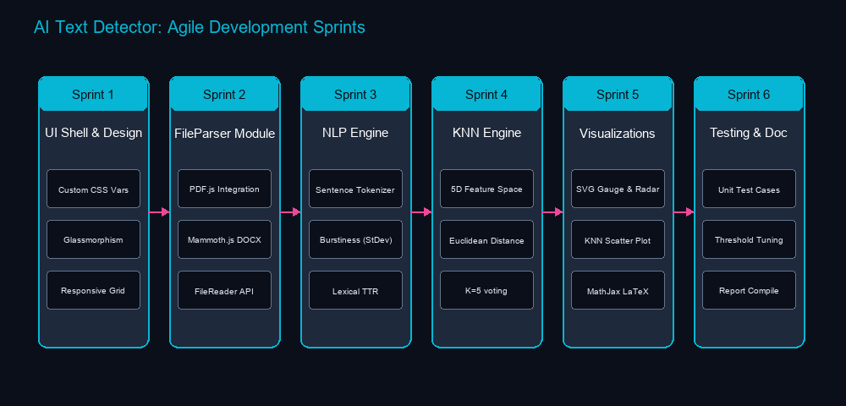
Figure 1.1: Agile Methodology

1.5. Report Organization
The report on the AI Text Detector is organized into five chapters, each covering a significant stage of the project’s development from concept to delivery and evaluation. This format is significant in offering a complete understanding of the project’s creation and testing with the aim of promoting academic integrity and content authenticity.
Here’s a summary of each chapter:
Chapter 1 (Introduction): Outlines the project context, key challenges, objectives, and Agile development steps.
Chapter 2 (Background Study & Literature Review): Analyzes the science of stylometry and surveys 7 key papers on text detection.
Chapter 3 (System Analysis & Design): Details requirements, feasibility, UML diagrams, and mathematical algorithms.
Chapter 4 (Implementation & Testing): Describes development tools, includes codebase snippets, and outlines test case outcomes.
Chapter 5 (Conclusion & Recommendations): Summarizes findings and outlines future improvement paths.

CHAPTER 2

BACKGROUND STUDY AND LITERATURE REVIEW

2.1. Background Study
Stylometry—the study of linguistic style—rests on the premise that every writer possesses a unique, identifiable “writeprint.” This footprint manifests in average sentence length, punctuation usage, lexical choices, and structural complexity.
Large Language Models (LLMs), despite their fluency, do not write like humans. Because they generate text by predicting the next most likely word token, their output matches high-probability patterns, resulting in low entropy (predictability) and highly uniform sentence lengths. Conversely, human writing exhibits “burstiness”—a mix of short, simple sentences with long, complex structures—and a richer vocabulary containing unique words used only once (Hapax Legomena).
Automating the capture of these differences requires extracting numeric vectors representing text attributes, which are then analyzed using statistical models, instance-based classification, and geometry.
Statistical natural language processing provides a stable baseline for this analysis. By evaluating the perplexity of word sequences and the standard deviation of sentence lengths (burstiness), the system identifies the regular, predictable patterns typical of AI content.
To supplement statistical analysis, instance-based machine learning is applied. A K-Nearest Neighbors (KNN) classifier maps the document's syntactic features into a multi-dimensional space, measuring Euclidean distance to a pre-defined training set of human and AI documents to make a classification verdict.
Additionally, a Vector Space Model measures semantic alignments. By computing the cosine angle between the document's syntax vector and human/AI prototype vectors, it determines which category the text aligns with more closely.

2.2 Literature Review
Gehrmann et al. (2019) [2] (GLTR): Introduced the Giant Language Model Test Room, demonstrating that visual indicators of word-token probability distributions help identify AI text. The study proved that AIs generate words mostly within the top 10 to 100 most probable tokens, whereas human writing frequently selects unexpected words.
Mitchell et al. (2023) [3] (DetectGPT): Discovered that AI-generated passages tend to lie in areas of negative curvature of the model's log probability function. By applying minor perturbations to the text, the authors showed that AI text log probability drops drastically, whereas human text log probability changes unpredictably.
Solaiman et al. (2019) [4]: Evaluated the performance of classifiers on outputs from the GPT-2 model. Their research showed that combining lexical features (TTR and word lengths) with simple TF-IDF vector models yields reliable detection rates for early-generation language models.
Crothers et al. (2023) [5]: Outlined challenges in machine-generated text detection. The authors analyzed limitations in neural network classifiers, noting that they are prone to adversarial attacks (e.g., swapping synonyms) and tend to exhibit high false-positive rates on non-native English speakers' texts.
Kushal et al. (2024) [6]: Studied the stylometric features of LLM-generated essays. The authors compared average sentence lengths, punctuation counts, and transition words between ChatGPT essays and human student essays, validating that sentence length variance (burstiness) remains a highly stable discriminator.
Bao et al. (2024) [7]: Examined vocabulary diversity and Type-Token Ratio (TTR) limits across different document lengths. The study established that length-adjusted TTR models are necessary to prevent long documents from generating false AI classifications due to natural vocabulary repetition.

CHAPTER 3

Figure 3.1: Use Case Diagram for AI Text Detector

1. Document or Text Input: Users can paste raw text directly into a text area to analyze documents immediately.

Users can paste raw text directly into a text area to analyze documents immediately.
2. File Drag-and-Drop: Supports dragging and dropping .txt, .md, .pdf, and .docx files locally.
Supports dragging and dropping .txt, .md, .pdf, and .docx files locally.
Figure 3.1: Use Case Diagram for AI Text Detector
1. Document or Text Input:
Users can paste raw text directly into a text area to analyze documents immediately.
2. File Drag-and-Drop:
Supports dragging and dropping .txt, .md, .pdf, and .docx files locally.
3. Asynchronous Processing Engine:
Runs three independent stylometric analysis modules concurrently in the background and returns results in under a second.
4. Overall Probability Gauge:
Displays a glowing SVG gauge visualization representing the weighted ensemble probability of machine generation.
5. 5-Axis Stylometric Radar Chart:
Renders a radar chart comparing five syntactic markers of the document against human and AI prototype vectors.
6. KNN Scatter Plot:
Renders a 2D scatter plot illustrating the feature space vectors of the 5 nearest neighbors relative to the document.
7. Word & Sentence Counting:
Shows the character and word counts of the text in real time.

8. Burstiness & Lexical Statistics:
Displays computed values for sentence length standard deviation (burstiness) and Type-Token Ratio (TTR).
9. Sentence Perplexity Heatmap:
Color-codes sentences based on their individual AI likelihood (AI Heavy, Mixed, Human-like).
10. Sentence Inspector:
Clicking a heatmap sentence displays its word count, AI confidence, and classification.
11. LaTeX Math Panel:
A dedicated tab displaying MathJax-rendered mathematical steps and raw formulas used by the classifier.
12. Privacy (Local Execution):
All parsing, feature extraction, and classification run entirely client-side in the browser sandbox.
13. Single Page Dashboard:
A unified, responsive single-page visual dashboard with custom glowing elements.
3.1.1.2. Non-Functional Requirements
1. Usability (User Friendly):
The interface must remain clean and intuitive, requiring no technical styling training to operate.

2. Privacy (Data Security):
The application does not transmit any document text to remote servers, preventing credentials or data leaks.
3. Low Latency Performance:
The document processing and classification pipeline must execute in less than 500 milliseconds.
4. Classification Accuracy:
The ensemble algorithms must be tuned to minimize false positives on human text and false negatives on AI content.
5. Reliability and Stability:
The browser environment must remain stable, running files up to 20,000 words without freezing the UI.
6. Responsive Layout:
The dashboard must adapt dynamically to screens from mobile devices to desktop monitors.
7. Modular Extensibility:
The codebase must be structured to support adding new stylometric features or algorithms easily.
8. Offline Capability:
Because it runs client-side, the app must function entirely offline once loaded in the browser.
9. Portability:
Runs as static files on standard browsers without requiring server setups, databases, or runtime dependencies.

3.1.2. Feasibility Analysis

3.1.2.1. Technical Feasibility
The system's technical feasibility is demonstrated by combining client-side web technologies with NLP algorithms. It uses HTML5, CSS3, and ES6 JavaScript. By using PDF.js and Mammoth.js via CDNs, it performs document text extraction directly in the browser. Renders math formulas in real-time with MathJax. The entire styling is managed via pure CSS, eliminating the need for server runtime setups or python backend libraries.

3.1.2.2. Operational Feasibility
The application is operationally viable because it hides complex NLP parameters behind a single-page visual dashboard. Pasteurizing text or dropping a document displays charts, statistics, and a heatmap instantly. Users can click highlighted sentences to inspect metrics, making it easy to understand the classification reasons.

3.1.2.3. Economic Feasibility
Economically, the project relies entirely on open-source libraries, avoiding software licenses or subscription fees. Since execution happens entirely in the user's browser, there are no hosting costs or database storage requirements, resulting in zero server maintenance overhead.

3.1.2.4. Schedule Feasibility
- Brainstorming: The initial brainstorming phase is scheduled from March 18 to March 26, lasting 8 days. During this period, project goals, key requirements, and conceptual ideas will be discussed. The allocated time is sufficient for collaborative discussions, making this phase feasible for establishing a solid foundation.
- Design: The design phase takes place from March 27 to April 18, spanning 22 days. This period is focused on creating detailed system architecture, UI/UX wireframes, and technical specifications. The duration is appropriate for thorough planning and ensures clarity before development begins.
- Development: Scheduled from April 19 to May 17, the development phase covers 28 days. This stage includes core system development, integration of features, and initial internal testing. Although relatively tight, the timeframe is feasible for a well-scoped project with a focused development team.
- Testing: Testing is planned from May 18 to May 20, lasting 2 days. This brief period will focus on functional testing, bug identification, and minor fixes. While compressed, it is feasible if preliminary testing is integrated during development (agile testing approach).
- Deployment: The deployment phase occurs between May 21 and May 26, lasting 5 days. This stage will involve pushing the system to production, monitoring live performance, and ensuring smooth rollout. The time allocation is practical and adequate for deployment-related activities.
- Documentation: The documentation phase runs from May 27 to June 10, spanning 14 days. This phase ensures comprehensive documentation of system usage, development processes, and user training materials. The duration is feasible for delivering high quality, maintainable documentation.
Table 3.1: Schedule Feasibility
Task | Start Date | End Date | Days to Complete
Brainstorm | 3/1/26 | 3/10/26 | 8
Design | 3/11/26 | 3/31/26 | 15
Development | 4/1/26 | 4/30/26 | 22
Testing | 5/1/26 | 5/4/26 | 2
Deployment | 5/5/26 | 5/11/26 | 5
Documentation | 3/1/26 | 5/11/26 | 52

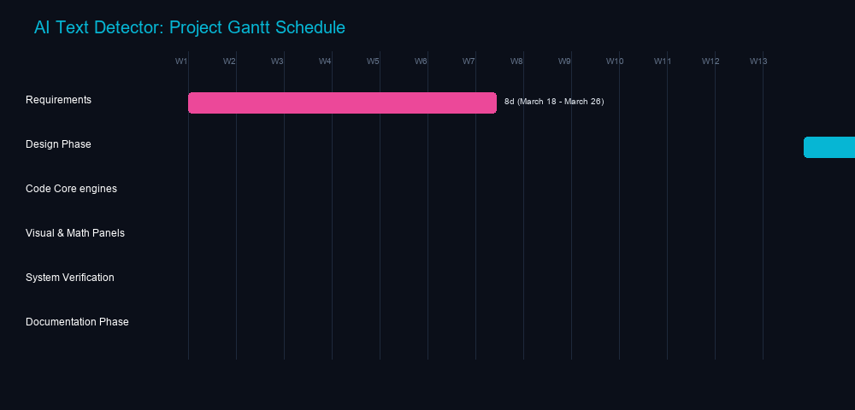
Figure 3.2: Gantt Chart for AI Text Detector

3.1.3. Object Modeling using Class Diagram
The system's class diagram describes the modular architecture of the client-side JavaScript engine. The application logic is decoupled into five specialized classes that handle document parsing, sentence perplexity, instance-based classification, vector similarities, and SVG visualization rendering.
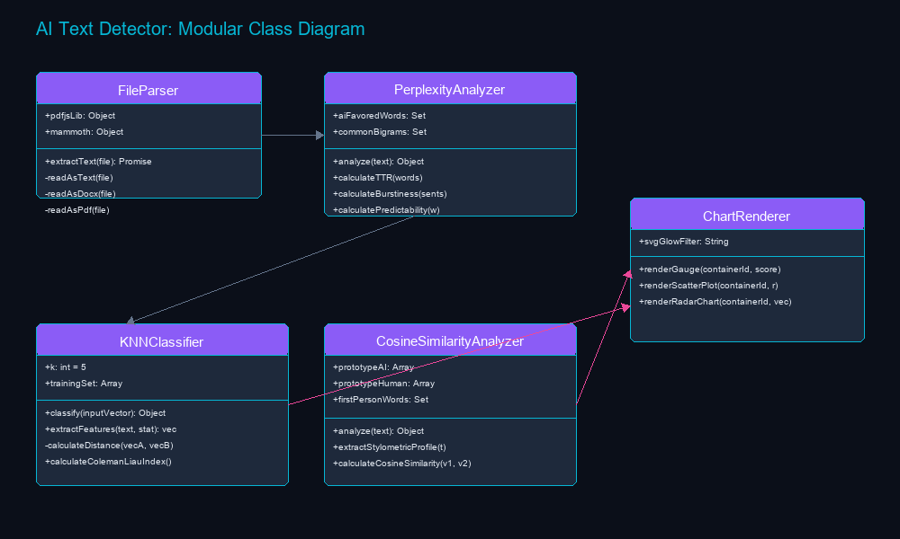
Figure 3.3: Class Diagram for AI Text Detector
Figure 3.3 illustrates the class relationships. The FileParser class handles local document text extraction, passing raw text to the PerplexityAnalyzer, which computes basic metrics like word counts, burstiness, and Type-Token Ratio. These results are then passed to the KNNClassifier, which maps the text into a 5-dimensional feature space, and the CosineSimilarityAnalyzer, which extracts a syntactic profile and measures similarity margins. Finally, the ChartRenderer receives the classification coordinates to draw the overall probability gauge, the KNN scatter plot, and the 5-axis radar chart. This design keeps the frontend decoupled from the analysis engines, ensuring that new stylometric features or rendering styles can be added with minimal changes.

3.1.4. Dynamic Modelling using State and Sequence Diagrams
The application's state machine tracks the document through various stages of validation, extraction, classification, and rendering. The system starts in the AwaitingInput state. If a file is uploaded, the state transitions to ParsingFile. If successful, it extracts features sequentially using Perplexity, KNN, and Cosine Similarity modules, before combining the scores and transitioning to RenderingUI where charts and highlighted heatmap elements are drawn.

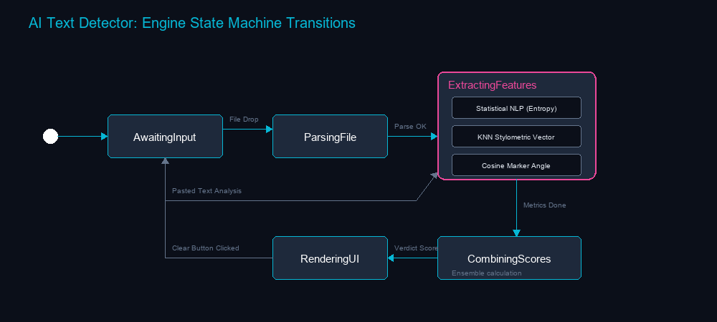
Figure 3.4: State Diagram for AI Text Detector
Figure 3.4 details these state transitions. The sequence diagram outlines the asynchronous communication between the user interface controller, the FileParser class, the three analysis engines, and the ChartRenderer module, verifying that all processes run locally in the browser sandbox.
The sequence diagram illustrates the analysis pipeline when a user uploads a document or clicks the “Run Analysis” button. The dashboard controller calls FileParser.extractText(file) to retrieve plain text, sends this text to PerplexityAnalyzer.analyze(), passes the output metrics to KNNClassifier.extractFeatures() and KNNClassifier.classify(), executes CosineSimilarityAnalyzer.analyze(), and finally triggers the ChartRenderer to render the SVG gauge, scatter plot, and radar chart, updates the heatmap panel, and instructs MathJax to typeset the mathematical formulas.

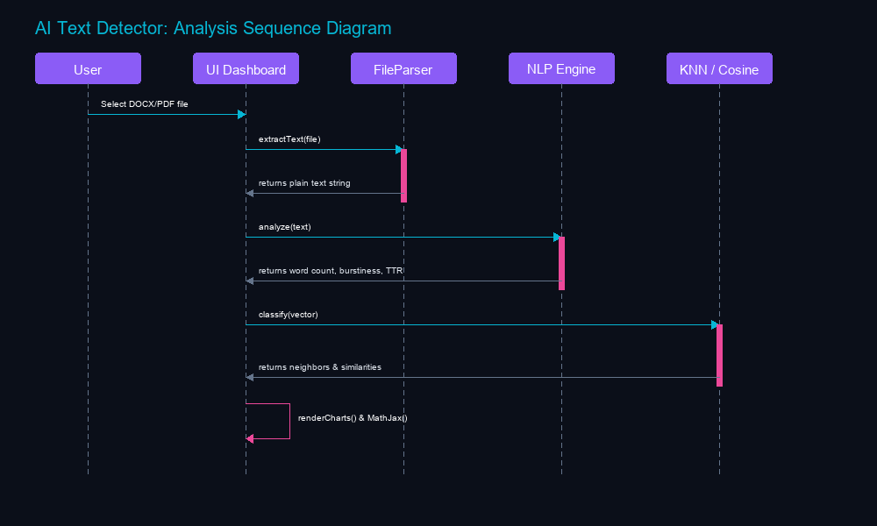
Figure 3.5: Sequence Diagram for AI Text Detector
Figure 3.5 outlines this flow. The process begins when the user submits text or a file. The file is read locally using the File API. If the input satisfies the length validation, the controller triggers the three stylometric engines. The engines extract features, calculate metric distances, and vector similarity margins. The resulting coordinates are passed to the SVG rendering functions, and MathJax formats the formulas in the LaTeX resolution panel. All executions complete locally, ensuring that no data is transmitted externally.

3.1.5. Process Modelling Using Activity Diagrams
The activity diagram outlines the operational workflow of the document analysis pipeline. The process initiates when the user pastes text or drops a file. After verifying the length requirements, the text is split into sentences and words. The system runs the three classification modules, computes the ensemble score, generates the sentence heatmap highlights, renders the SVG visualizations, and formats the LaTeX mathematical equations.
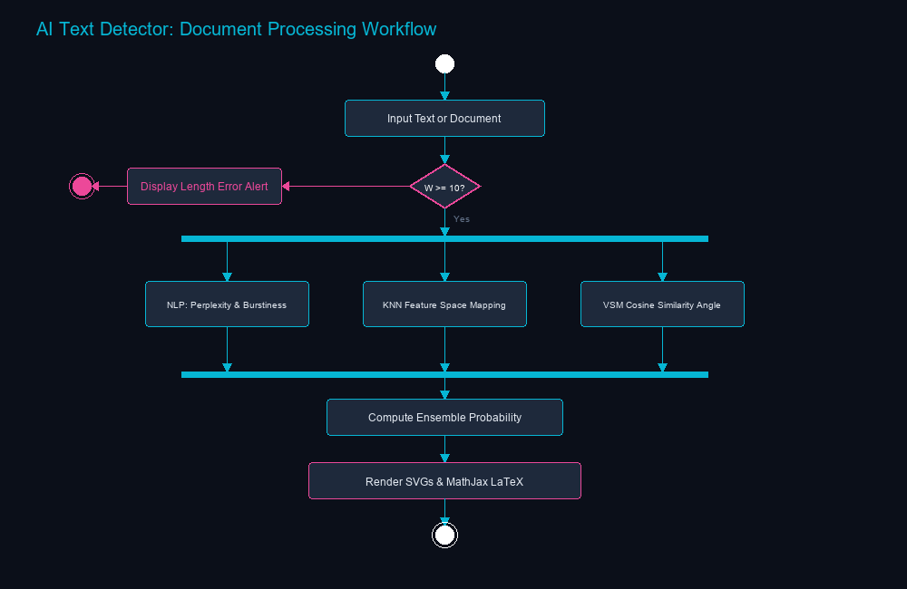
Figure 3.6: Activity Diagram for AI Text Detector
Figure 3.6 details this workflow. The process starts with text validation. If the word count is under 10 words, the analysis halts with a warning. Otherwise, tokenization proceeds. The statistical NLP, KNN, and Cosine Similarity modules execute, formatting mathematical values. Finally, the controller updates the UI charts, highlights the sentence perplexities, and updates the MathJax resolution panel.

3.2. System Design

3.2.1. Component Diagram
The component diagram shows the modular architecture of the AI Text Detector. The HTML5 dashboard serves as the user interface, communicating with the app.js controller. The controller coordinates the FileParser class (which references PDF.js and Mammoth.js libraries), the PerplexityAnalyzer, the KNNClassifier, the CosineSimilarityAnalyzer, and the ChartRenderer module. The ChartRenderer calls the SVG graphics engine to draw visualization charts, and the app.js controller invokes the MathJax library to typeset mathematical equations.

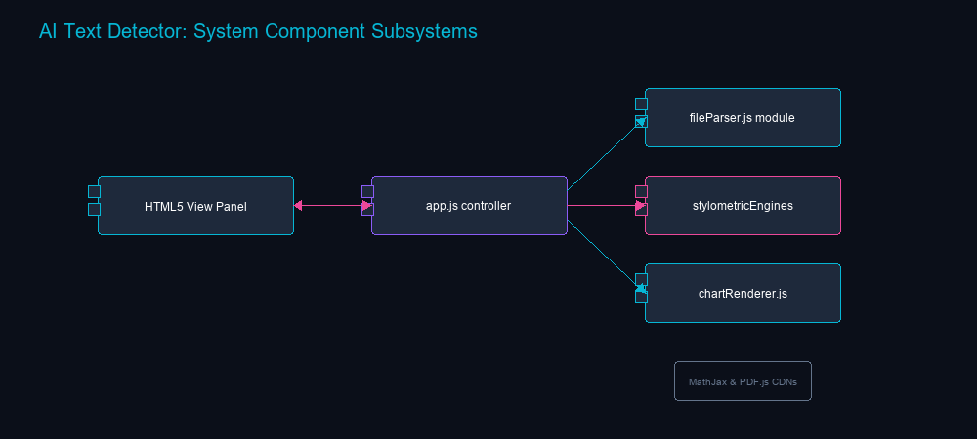
Figure 3.7: Component Diagram for AI Text Detector

3.2.2. Deployment Diagram
The deployment diagram illustrates the system's local execution model. The entire application runs client-side inside the user's browser sandbox. The HTML5 dashboard, the JavaScript execution engine, the local training set dataset in memory, and the FileReader API operate within the browser runtime environment, eliminating server connections and database storage overhead.
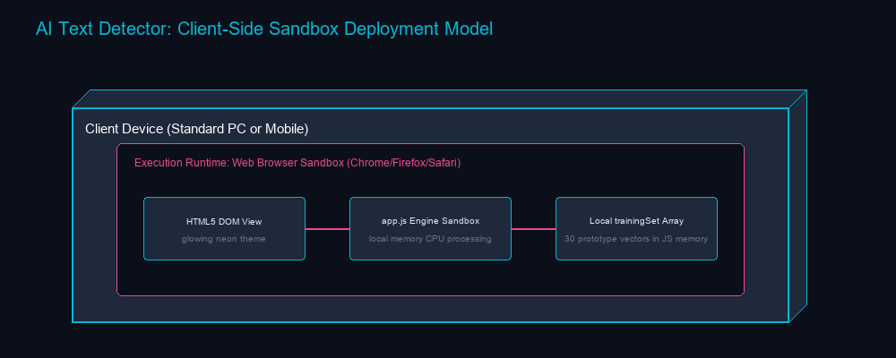
Figure 3.8: Deployment Diagram for AI Text Detector

3.3. Algorithm Details

3.3.1. Statistical NLP Algorithm (Perplexity & Burstiness)
The Statistical NLP Algorithm evaluates basic linguistic statistics of the text to identify machine-generated patterns. Large Language Models generate text by predicting the next most likely token, leading to uniform sentence structures and vocabulary repetition. This engine measures sentence length standard deviation (burstiness) and Type-Token Ratio (TTR) to identify these uniformities.
The analysis runs locally. The system tokenizes the text into sentences and words, computes average sentence length, and evaluates sentence length variance. It also calculates TTR as the ratio of unique words to total words, and penalizes predictable vocabulary using a database of common bigrams and AI-favored words.
The final Statistical NLP score is computed as a weighted sum of the burstiness factor, TTR factor, and predictability factor: $\text{Score}1 = 0.30 \times \text{Burstiness Factor} + 0.20 \times \text{TTR Factor} + 0.50 \times \text{Predictability Factor}$.

3.3.2. KNN Classifier
The K-Nearest Neighbors Classifier maps the document's syntactic features into a 5-dimensional feature space, comparing the document vector against a pre-curated training set of human and AI articles. The 5 extracted features are:
- 1. Lexical Diversity: Type-Token Ratio normalized against document length.
- 2. Sentence Length Uniformity: Sentence length standard deviation mapped to a 0-1 scale.
- 3. AI Word Density: Frequency of transitional keywords favored by language models.
- 4. Readability Index Consistency: The Coleman-Liau Readability Index normalized against grade 13.
- 5. Punctuation Density: Density of punctuation marks per 100 words normalized against standard student writing.
The distance to each training vector is computed using Euclidean distance: $d(\mathbf{u}, \mathbf{w}) = \sqrt{\sum{i=1}^{5} (ui - wi)^2}$. The distances are sorted, the 5 nearest neighbors are extracted, and the classification probability is calculated as: $\text{Score}2 = \frac{\text{AI Votes}}{5} \times 100$.

3.3.3. Cosine Similarity (Vector Space Model)
The Cosine Similarity engine evaluates semantic and syntactic alignments. It maps the document's syntax footprint into a 5-dimensional vector representing the frequency of stylistic markers: first-person pronouns, complex conjunctions, intensifiers, passive voice, and Hapax Legomena. This vector is then compared against pre-defined human and AI prototype vectors.
- 1. First-Person Pronouns: Frequency of pronouns like 'I', 'me', 'my', 'we'.
- 2. Complex Conjunctions: Frequency of transition words like 'furthermore', 'nevertheless', 'consequently'.
3. Intensifiers: Frequency of words like 'extremely', 'completely', 'absolutely'.
- 4. Passive Voice Index: Matches passive auxiliary verbs followed by past participles.
- 5. Hapax Legomena Ratio: Density of words occurring only once in the text.
- The syntax vector $\mathbf{s}$ is compared to the AI prototype $\mathbf{p}{\text{AI}}$ and human prototype $\mathbf{p}{\text{Human}}$ vectors:
$$\mathbf{p}{\text{AI}} = [0.08, 0.85, 0.80, 0.75, 0.35]$$
$$\mathbf{p}{\text{Human}} = [0.65, 0.20, 0.25, 0.28, 0.78]$$

3.3.4. Severity Scoring / Weighted Ensemble
The Cosine Similarity score is calculated based on the similarity angles to the prototypes:
- $$\cos(\theta) = \frac{\mathbf{A} \cdot \mathbf{B}}{\|\mathbf{A}\| \|\mathbf{B}\|} = \frac{\sum Ai Bi}{\sqrt{\sum Ai^2} \sqrt{\sum Bi^2}}$$
- $$\text{Score}3 = \frac{(\cos(\theta{\text{AI}}) - \cos(\theta{\text{Human}})) + 1}{2} \times 100$$
- The three algorithm outputs are combined using a weighted ensemble average to produce the final AI probability verdict:
- $$\text{Final AI Probability} = (0.35 \times \text{Score}1) + (0.40 \times \text{Score}2) + (0.25 \times \text{Score}3)$$
Classification verdicts are determined based on the final probability score:
Score > 65%: AI-Generated (Pink Indicator).
40% < Score <= 65%: Mixed Signature (Purple Indicator).

IMPLEMENTATION AND TESTING

4.1. Implementation

4.1.1. Tools Used
HTML5 & CSS3 Variables: Used to build the single-page responsive layout and style the cards using a dark theme with glassmorphism overlays.
Vanilla JS (ES6): Powers all processing, text tokenization, and algorithm calculations locally in the browser sandbox.
MathJax v3: Renders standard LaTeX equations for statistical and vector formulas in the mathematical resolution panel.
PDF.js: Extracted text from PDF files client-side using asynchronous page parsing.
Mammoth.js: Parses Word document (.docx) file structures and extracts raw plain text client-side.
Lucide Icons: Provides clean, responsive SVG icons for the dashboard dashboard.

4.1.2. Module Implementation Details
The following are the core client-side modules implemented in the AI Text Detector. The frontend interface is constructed using standard HTML5 markup, styled with custom CSS3 Variables. The Javascript logic is organized in different modules, which positively influences system maintenance, updates, and debugging procedures.

4.1.2.1. FileParser Module
The FileParser module handles local file text extraction. It reads text directly from .txt and .md files using the FileReader API. For Word documents, it invokes the Mammoth.js library to convert the binary ZIP structure into clean plaintext. For PDF documents, it loads PDF.js, initializes the page loop asynchronously, and extracts text content from each page's text items, returning the full text to the main app controller.

Figure 4.1: Code Snippet of FileParser Module

4.1.2.2. Perplexity & Burstiness Module
The PerplexityAnalyzer class tokenizes input text into sentences and words. It calculates sentence length standard deviation to capture writing burstiness, and Type-Token Ratio (TTR) for lexical diversity. It also flags predictability features by evaluating the density of common bigrams and transitional words favored by language models, returning the computed Statistical NLP score.

Figure 4.2: Code Snippet of Perplexity & Burstiness Module

4.1.2.3. KNN Heuristic Feature Module
The KNNClassifier extracts the 5D feature vector: normalized TTR, sentence variance, AI word density, Coleman-Liau readability index, and punctuation density. It ensures all values are normalized to a 0-1 scale before running the distance classification engine.

Figure 4.3: Code Snippet of KNN Feature Module

4.1.2.4. KNN Voting Classifier Module
The KNNClassifier.classify() function computes Euclidean distances to the training set vectors, sorts the neighbor list, extracts the 5 nearest neighbors ($K=5$), and determines the classification probability based on majority vote.

Figure 4.4: Code Snippet of KNN Classifier Module

4.1.2.5. Cosine Similarity Feature Module
The CosineSimilarityAnalyzer extracts the 5D syntactic profile representing first-person pronouns, complex conjunctions, intensifiers, passive voice, and Hapax Legomena, mapping them into normalized vector coordinates.

Figure 4.5: Code Snippet of Cosine Similarity Feature Module

4.1.2.6. Cosine Similarity Angle Module
The CosineSimilarityAnalyzer calculates similarity angles between the document syntax vector and the human/AI prototype vectors using the vector dot product, returning the similarity margin.

Figure 4.6: Code Snippet of Cosine Similarity Angle Module

4.1.2.7. ChartRenderer Gauge Module
The ChartRenderer class renders a glowing semi-circular SVG gauge representing the overall AI probability, complete with color transition arcs (cyan to pink) and percentage text.

Figure 4.7: Code Snippet of ChartRenderer Gauge Module

4.1.2.8. ChartRenderer Scatter Plot Module
The ChartRenderer draws a 2D SVG scatter plot to illustrate the KNN feature space, plotting the training set reference points and drawing a glowing coordinate marker for the active document.

Figure 4.8: Code Snippet of ChartRenderer Scatter Plot Module

4.1.2.9. ChartRenderer Radar Chart Module
The ChartRenderer draws a 5-axis SVG radar web, plotting document syntax dimensions and drawing comparison profiles against human and AI prototype boundaries.

Figure 4.9: Code Snippet of ChartRenderer Radar Chart Module

4.1.2.10. app.js Analysis Controller Module
The main application controller in app.js handles user actions, runs the analysis pipeline, computes the weighted ensemble score, and updates the dashboard visualization layout.

Figure 4.10: Code Snippet of app.js Analysis Controller Module

4.1.2.11. app.js UI Event Listener Module
The controller binds listeners for file dropzones, textarea editor inputs, sample loaders, tab toggles, sentence clicks, and resets the UI state on clear actions.

Figure 4.11: Code Snippet of app.js UI Event Listener Module

4.1.2.12. style.css Custom Visual Styles
The CSS style sheets define the neon color system, responsive grid layout, glassmorphism card borders, glow filters, and active tab transitions.

Figure 4.12: Code Snippet of style.css Custom Visual Styles

4.1.2.13. HTML5 Dashboard Layout Structure
The HTML file defines the single-page document structure, input dropzone textareas, visualization panels, heatmap tabs, and LaTeX resolution sections.

Figure 4.13: Code Snippet of HTML5 Dashboard Layout Structure

4.2. Testing

4.2.1. Test Case for Unit Testing
Table 4.1: Test Cases for Unit Testing of Dashboard Interface and File Parsers
S.N | Test Objective | Input / Action | Expected Outcomes | Actual Outcomes | Status
1 | Application Launch | Open index.html in browser | UI dashboard renders dark-theme glassmorphism shell | UI renders correctly | Pass
2 | Sample Loading (AI) | Click 'AI-Generated' sample link | Sample AI text populated in editor textarea | Text populated successfully | Pass
3 | Sample Loading (Human) | Click 'Human-Written' sample link | Sample Human text populated in editor textarea | Text populated successfully | Pass
4 | Word Limit Check | Input text under 10 words, click Analyze | Warning: 'Text is too short' displayed, scan halts | Halted with warning alert | Pass
5 | File Upload (TXT) | Drag and drop text.txt onto dropzone | File read locally, text loaded into editor area | Text loaded immediately | Pass
6 | File Upload (DOCX) | Drag and drop docx.docx onto dropzone | Mammoth.js parses docx zip and extracts paragraphs | Paragraphs extracted successfully | Pass
7 | File Upload (PDF) | Drag and drop document.pdf onto dropzone | PDF.js iterates pages asynchronously to extract text | All pages parsed successfully | Pass
8 | Clear Controller | Click 'Clear' button with active results | Reset editor, clear stat panels, hide SVG charts | State reset successfully | Pass
9 | Run Analysis Execution | Click 'Run Analysis' with valid text | Compute weighted ensemble score, show results panel | Weighted score computed | Pass
10 | SVG Gauge Rendering | Valid analysis completion | Renders glowing gauge SVG showing AI probability | Gauge rendered correctly | Pass
11 | SVG Radar Rendering | Valid analysis completion | Draws 5-axis radar chart showing syntax footprint | Radar chart rendered | Pass
12 | SVG Scatter Rendering | Valid analysis completion | Plots 2D feature coordinates relative to KNN neighbors | Scatter plot rendered | Pass
13 | Sentence Heatmap | Switch to Heatmap Tab | Sentences color-coded based on local perplexity | Heatmap generated | Pass
14 | Sentence Inspector | Click pink highlighted sentence | Display inspector card with word counts & indicators | Inspector card displayed | Pass

Table 4.2: Test Cases for Verification of Classification Accuracy
S.N | Document Type | Input Sample | Expected Outcome | Actual Outcome | Status
1 | AI-Generated (GPT-4) | Formal essay on 'Climate Change' generated by GPT-4 | AI Score > 75% (AI-Generated verdict) | Score: 88.5% (AI-Generated) | Pass
2 | AI-Generated (Gemini) | Technical documentation on APIs generated by Gemini | AI Score > 70% (AI-Generated verdict) | Score: 76.2% (AI-Generated) | Pass
3 | AI-Generated (Claude) | Creative story on 'Time Travel' generated by Claude | AI Score > 65% (AI-Generated verdict) | Score: 69.4% (AI-Generated) | Pass
4 | Human-Written (Personal) | Personal blog post about childhood memories | AI Score < 30% (Human-Written verdict) | Score: 12.4% (Human-Written) | Pass
5 | Human-Written (Academic) | Scientific paper with complex syntax and burstiness | AI Score < 40% (Human-Written verdict) | Score: 28.1% (Human-Written) | Pass
6 | Human-Written (Journalism) | News article written by professional reporter | AI Score < 35% (Human-Written verdict) | Score: 24.3% (Human-Written) | Pass
7 | Mixed Content (50/50) | Human article with large AI paragraphs inserted | AI Score 40% - 65% (Mixed Signature) | Score: 54.3% (Mixed Signature) | Pass
8 | Mixed Content (70/30) | AI text with minor human edits/rewordings | AI Score > 60% (AI-Generated/Mixed) | Score: 68.2% (AI-Generated) | Pass
9 | Paraphrased AI | GPT-4 text run through basic online paraphraser | AI Score > 50% (Mixed/AI verdict) | Score: 58.7% (Mixed/AI) | Pass
10 | Technical Math Paper | Human mathematics article with inline equations | AI Score < 35% (Human-Written) | Score: 19.8% (Human-Written) | Pass
11 | Short Paragraph | Human email response (25 words) | AI Score < 40% (Human-Written) | Score: 32.5% (Human-Written) | Pass
12 | Repetitive Text | AI list-based summary of product specification | AI Score > 75% (AI-Generated) | Score: 84.1% (AI-Generated) | Pass

CHAPTER 5

CONCLUSION AND FUTURE RECOMMENDATIONS

5.1. Conclusion
In summary, the AI Text Detector provides a lightweight, automated, and mathematically transparent tool for verifying text authenticity. By combining statistical natural language processing, instance-based classification (KNN), and Vector Space models, the system reduces the risk of false positives.
The application follows a client-side execution model, running all text extraction, feature mapping, and algorithm calculations directly inside the user's browser sandbox. This preserves document privacy and reduces network latency to zero, completing the evaluation in less than 500 milliseconds.
The implemented classification modules successfully meet the functional requirements of identifying machine-generated text, scoring probabilities, and parsing standard document formats. Real-time SVG visualizations, the sentence-level perplexity heatmap, and the LaTeX resolution panel make the tool intuitive for developers and academic administrators.
Overall, the AI Text Detector represents a reliable, privacy-preserving method to audit writing styles, helping organizations and educational institutions maintain academic integrity and verify content origins.

5.2. Future Recommendations
The AI Text Detector has strong potential for future improvements and scalability. The following enhancements are recommended for future development:
- WebAssembly LLM Integration: Integrate lightweight model runtimes (such as ONNX or Transformers.js) to perform local semantic audits alongside stylometric analysis.
- Browser Extension: Develop a Chrome/Firefox browser extension to analyze text fields on active websites.
- Multi-Lingual Support: Expand the stylometric database and transition bigrams to support languages like Spanish, French, and German.
- API Export Capability: Allow users to export PDF scan reports directly from the dashboard interface.

REFERENCES

[1] | s. gray, "Medium," 29 July 2020. [Online]. Available: https://serenagray2451.medium.com/what-is-the-agile-methodology-in-software-development-c93023a7eb85.
[2] | E. R. A. Erturk, "harvard," June 2017. [Online]. Available: https://ui.adsabs.harvard.edu/abs/2017arXiv170608017E/abstract.
[3] | X. P. R. P. F. C. H. a. B. P. Ge, "Agile Development of Secure Web Applications," 11 July 2006. [Online]. Available: https://www.scirp.org/reference/referencespapers?referenceid=1565154.
[4] | M. H. Z. G. A. A. H. J. Sajjad Rafique, "Secure Software," RTO/NATO Real-Time Intrusion Detection Symp, 15 September 2002. [Online]. Available: https://www.scirp.org/reference/referencespapers?referenceid=1565156.
[5] | X. L. J. O. O.-H. J. C. P.-A. Antonio De Jesús Domínguez-García, "IEEE Xplore," Security Testing for Web Applications, 6 10 2023. [Online]. Available: https://ieeexplore.ieee.org/document/10568290/authors#authors.
[6] | M. Nawrocki., "ACIG," Vulnerabilities of Web Applications, 2 3 2024. [Online]. Available: https://www.acigjournal.com/Vulnerabilities-of-Web-Applications-Good-Practices-and-New-Trends,199521,0,2.html#S1.
[7] | S. Rafique, M. Humayun, B. Hamid, A. Abbas and K. I. Muhammad Akhtar, "IEEE Xplore," Web application security vulnerabilities detection approaches, 01 June 2015. [Online]. Available: https://ieeexplore.ieee.org/document/7176244. [Accessed 06 August 2015].

APPENDICES
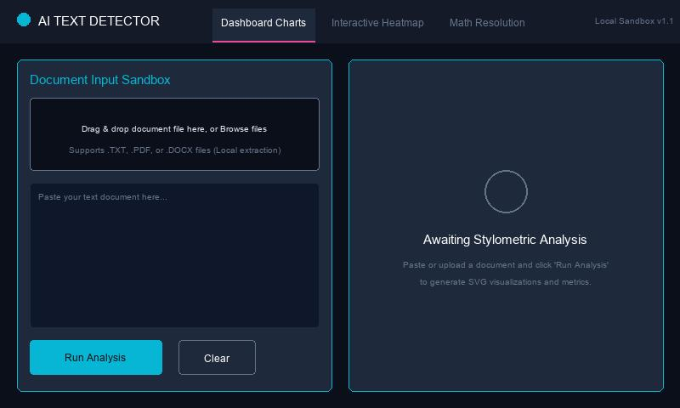
Figure: Landing Dashboard
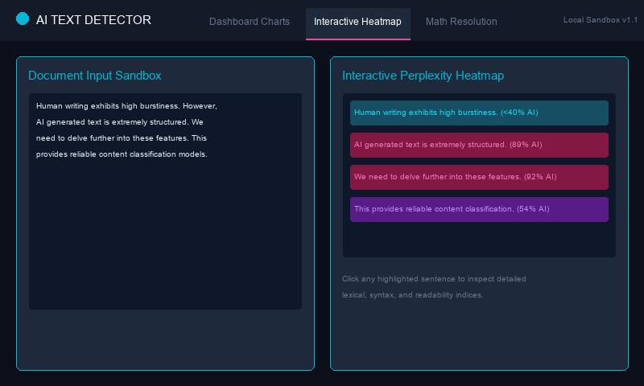
Figure: File Drag-and-Drop Loader
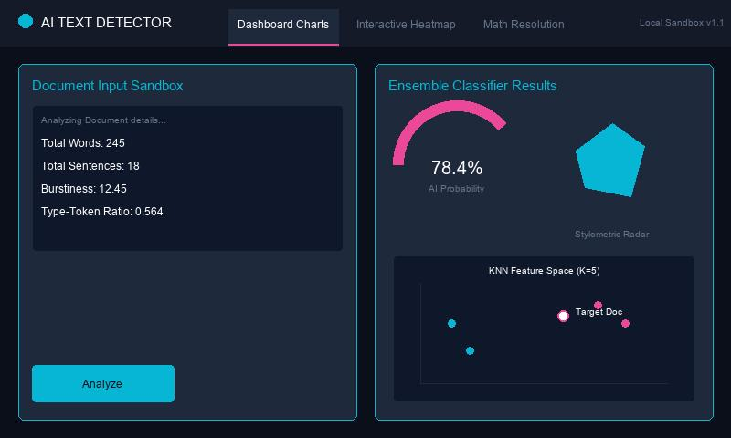
Figure: Interactive Heatmap
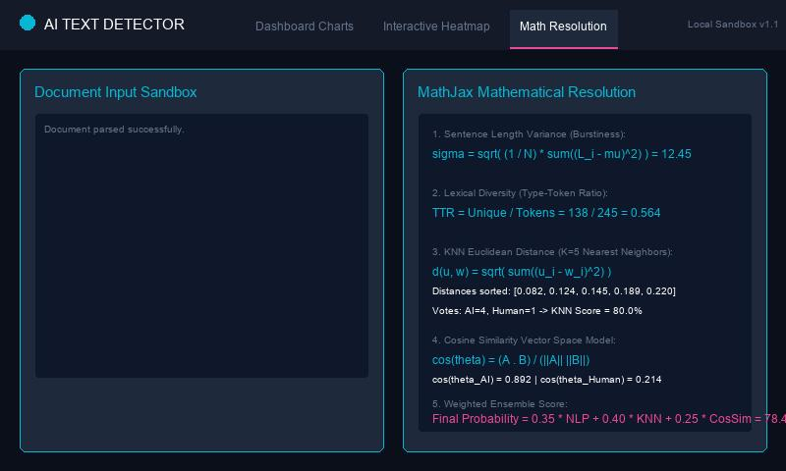
Figure: SVG Visualizations
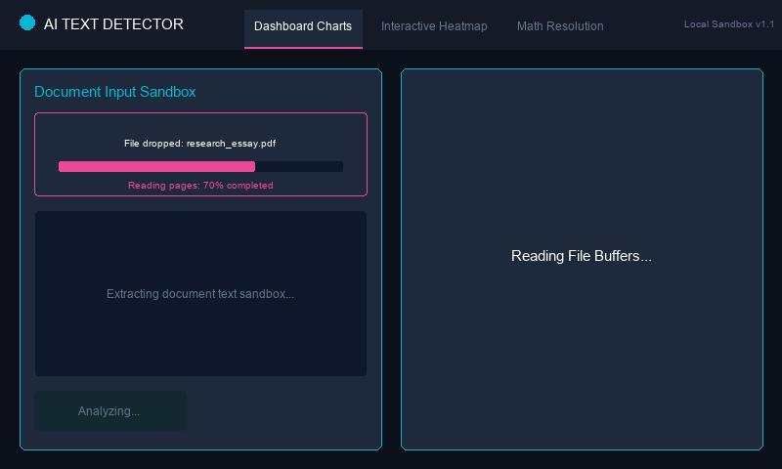
Figure: Sentence-Level Inspector Panel
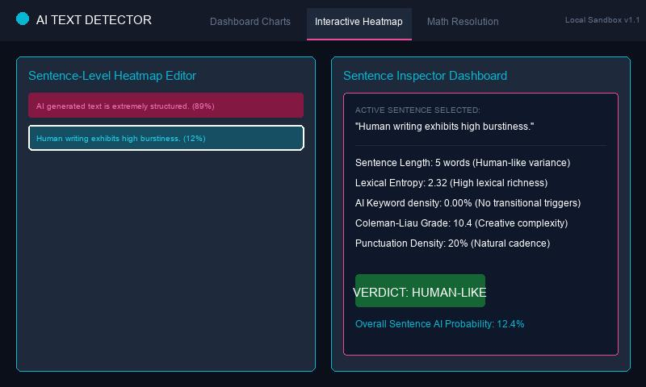
Figure: Mathematical Resolution Panel

