
Tribhuvan University
Faculty of Humanities and Social Science
A Project Report On
“Web Application Vulnerability Scanner”
In partial fulfillment of requirements in Bachelor in Computer Applications
Submitted by:
Shashank Singh (6-2-410-140--2021)

June, 2026 A.D.
Under the Supervision of
Ms. Rolisha Sthapit


Tribhuvan University
Faculty of Humanities and Social Science
A Project Report On
“Web Application Vulnerability Scanner”
In partial fulfillment of requirements in Bachelor in Computer Applications
Submitted by:
Shashank Singh (6-2-410-140--2021)

June, 2026 A.D.
Under the Supervision of
Ms. Rolisha Sthapit


Tribhuvan University
Faculty of Humanities and Social Science

SUPERVISORS RECOMMENDATION
I am pleased to recommend the project report on "Web Application Vulnerability Scanner" prepared by Shashank Singh under my supervision in partial fulfillment of the requirements for the degree of Bachelor of Computer Applications. His report is satisfactory, represents original work, and is ready for further evaluation.

Ms. Rolisha Sthapit
SUPERVISOR
Lecturer, Department of IT
Prime College


Tribhuvan University
Faculty of Humanities and Social Science

LETTER OF APPROVAL
This certifies that the project report on "Web Application Vulnerability Scanner" prepared by Shashank Singh in partial fulfillment of the requirements for the degree of Bachelor in Computer Application has been evaluated. In our opinion, it is satisfactory in scope and quality for the award of the required degree.
Ms. Rolisha Sthapit  Supervisor  Prime College  Khusibu, Nayabajar, Kathmandu | Ms. Rolisha Sthapit  Program Co-Ordinator/ Internal  Examiner  BCA Department  Prime College  Khusibu, Nayabajar, Kathmandu
Mr.
External Examiner

ACKNOWLEDGEMENT
Developing this Web Application Vulnerability Scanner, designed to identify flaws like SQL Injection, Cross-Site Scripting (XSS), Open Redirects, and missing security headers, would not have been possible without the guidance and support of many individuals. I express my gratitude to my project supervisor and coordinator, Ms. Rolisha Sthapit, for her mentorship, technical feedback, and continuous encouragement throughout this work. Her expertise in web application security was key to my understanding of the subject. I also thank my instructors, friends, and classmates for their suggestions and ideas during the testing phase, which helped refine the scanner's performance and design. Finally, I appreciate everyone who supported the completion of this project, directly or indirectly.
-Shashank Singh

ABSTRACT
Modern web applications are under constant threat. Because they manage everything from sensitive credentials to financial data, websites represent high-value targets for malicious actors. Vulnerabilities like SQL Injection, Cross-Site Scripting (XSS), and missing HTTP security headers act as dangerous security entry points. Left unaddressed, they expose database records and lead to severe financial or reputational damage. This project introduces an automated, client-side Web Application Vulnerability Scanner designed to uncover these common security gaps. The system crawls a target URL, identifies input forms, and tests fields using custom payloads. By analyzing server responses, status codes, and pattern anomalies, the scanner flags active vulnerabilities. It also integrates an OWASP-based risk assessment system that rates findings as Low, Medium, or High based on exploitability and impact. Built with React for the interactive dashboard and Python/Flask for the backend scanning engine, this tool provides developers with a local, lightweight method to audit their applications prior to deployment.
Keywords: Web Security, Vulnerability Scanner, SQL Injection, Cross Site Scripting (XSS), Open Redirect, OWASP Risk Assessment, Ethical Hacking

Table of Contents
SUPERVISORS RECOMMENDATION iii
LETTER OF APPROVAL iv
ACKNOWLEDGEMENT v
ABSTRACT vi
LIST OF ABBREVIATIONS x
LIST OF FIGURES xi
LIST OF TABLES xii
CHAPTER 1 INTRODUCTION 1
1.1. Introduction 1
1.2. Problem Statement 2
1.3. Objectives 2
1.4. Development Methodology 2
1.5. Report Organization 4
CHAPTER 2 BACKGROUND STUDY AND LITERATURE REVIEW 6
2.1. Background Study 6
2.2 Literature Review 7
CHAPTER 3 SYSTEM ANALYSIS AND DESIGN 11
3.1. System Analysis 11
3.1.1 Requirement Analysis 11
3.1.2. Feasibility Analysis 15
3.1.3. Object Modeling using Class Diagram 18
3.1.4. Dynamic Modelling using State and Sequence Diagrams 19
3.1.5. Process Modelling Using Activity Diagrams 23
3.2. System Design 24
3.2.1. Component Diagram 24
3.2.2. Deployment Diagram 25
3.3. Algorithm Details 26
3.3.1. Web Application Vulnerability Scanning Algorithm (Core System) 26
3.3.2. Rule-Based Detection Algorithm 26
3.3.3. Payload Injection Algorithm 27
3.3.4. Signature-Based Detection Algorithm 27
3.3.5. Response Analysis Algorithm 28
3.3.6. Port Scanning Algorithm (Socket-Based) 28
3.3.7. Severity Scoring Algorithm 28
3.3.8. Technology Fingerprinting Algorithm 29
3.3.9. Directory Brute Force / Enumeration Algorithm 29
3.3.10. Cookie Security Validation Algorithm 30
CHAPTER 4 IMPLEMENTATION AND TESTING 31
4.1. Implementation 31
4.1.1. Tools Used 31
4.1.2. Implementation Details of Modules 32
4.1.2.1. Registration Model: 32
4.1.2.2. Real-Time Vulnerability Scanning and Streaming Model 33
4.1.2.3. HTTP Security Header Analysis Model 34
4.1.2.4. SSL/TLS Certificate Validation Model 36
3.1.2.5. Port Scanning Model 36
4.1.2.6. Technology Detection Model 38
4.1.2.7. Directory and Sensitive File Enumeration Model 39
4.1.2.8. SQL Injection Detection Model 40
4.1.2.9. Cross-Site Scripting (XSS) Detection Model 41
4.1.2.10. CORS Misconfiguration Detection Model 42
4.1.2.11. Cookie Security Analysis Model 43
4.1.2.12. Information Disclosure Detection Model 44
4.1.2.13. Vulnerability Scanning Orchestration Model 45
4.2. Testing 46
4.2.1. Test Case for Unit Testing 46
CHAPTER 5 CONCLUSION AND FUTURE MANAGEMENTS 51
5.1. Conclusion 51
5.2. Future Recommendation 52
REFERENCES 53
APPENDICES

LIST OF ABBREVIATIONS
API | Application Programming Interface
CORS | Cross-Origin Resource Sharing
CSRF | Cross-Site Request Forgery
FTP | File Transfer Protocol
HTTP | HyperText Transfer Protocol
HTTPS | HyperText Transfer Protocol Secure
JSON | JavaScript Object Notation
OWASP | Open Worldwide Application Security Project
SQL | Structured Query Language
SSH | Secure Shell
SSL | Secure Sockets Layer
TLS | Transport Layer Security
URL | Uniform Resource Locator
XSS | Cross-Site Scripting
ZAP | Zed Attack Proxy

LIST OF FIGURES
Figure 1.1: | Agile Methodology……………………………………………………... | 4
Figure 3.1: | Use Case Diagram for Web Application Vulnerability Scanner………... | 11
Figure 3.2: | Gantt Chart for Web Application Vulnerability Scanner……………...... | 18
Figure 3.3: | Class Diagram for Web Application Vulnerability Scanner…………..... | 18
Figure 3.4: | State Diagram for Web Application Vulnerability Scanner…………...... | 20
Figure 3.5: | Sequence Diagram for Web Application Vulnerability Scanner………... | 22
Figure 3.6: | Activity Diagram for Web Application Vulnerability Scanner………..... | 23
Figure 3.7: | Component Diagram for Web Application Vulnerability Scanner……... | 25
Figure 3.8: | Deployment Diagram for Web Application Vulnerability Scanner…….. | 26
Figure 4.1: | Code Snippet of Registration Model…………………………………… | 33
Figure 4.2: | Code Snippet of Real-Time Vulnerability Scanning…………….……… | 34
Figure 4.3: | Code Snippet of HTTP Security Header Analysis Model…………….... | 35
Figure 4.4: | Code Snippet of SSL/TLS Certificate Validation Model………………. | 36
Figure 4.5: | Code Snippet of Port Scanning Model…………………………………. | 37
Figure 4.6: | Code Snippet of Technology Detection Model……………………….... | 38
Figure 4.7: | Code Snippet of Directory and Sensitive File Enumeration Model……. | 39
Figure 4.8: | Code Snippet of SQL Injection Detection Model…………………….... | 40
Figure 4.9: | Code Snippet of Cross-Site Scripting (XSS) Detection Model……….... | 41
Figure 4.10: | Code Snippet of CORS Misconfiguration Detection Model………….... | 42
Figure 4.11: | Code Snippet of Cookie Security Analysis Model……………………... | 43
Figure 4.12: | Code Snippet of Information Disclosure Detection Model…………….. | 44
Figure 4.13: | Code Snippet of Vulnerability Scanning Orchestration Mode…………. | 45

LIST OF TABLES
Figure 3.1: | Schedule Feasibility...……..………………………………...…………… | 17
Figure 4.1: | Test Case for Unit Testing of Web Vulnerability Scanner APIs……...….. | 46
Figure 4.2: | Test Cases for Unit Testing of Vulnerability Detection Modules………... | 48

CHAPTER 1

INTRODUCTION

1.1. Introduction
Web applications form the core infrastructure of modern digital services. From banking systems and retail portals to healthcare applications, academic databases, and government networks, web interfaces handle massive amounts of sensitive data daily.
However, this widespread reliance has made web applications prime targets for cyberattacks. A minor security flaw in an application's input handling can trigger severe consequences, exposing user databases and causing substantial financial losses. While manual penetration testing is highly thorough, it is also time-consuming, expensive, and prone to human oversight. Automated security scanners are therefore essential for continuous testing.
This project addresses these challenges by developing a full-stack Web Application Vulnerability Scanner. The scanner crawls target sites, maps active input fields, and injects test payloads to detect vulnerabilities like SQL Injection, XSS, and Open Redirects. It aggregates results into a visual dashboard built on React, backed by a Flask backend and MongoDB database, offering developers an accessible way to secure their code early in the development lifecycle.
The application utilizes React for the dashboard interface, Python/Flask for the backend REST APIs, and MongoDB for database persistence.

1.2. Problem Statement
Securing contemporary web applications is difficult. Organizations across all sectors use web interfaces that are continuously exposed to common vulnerabilities. Key problems addressed by this project include:
- Widespread Vulnerability Exposure: SQL Injection, XSS, and misconfigured HTTP headers remain prevalent security issues.
- High Risk of Compromise: Exploiting these gaps allows attackers to bypass authentication, leak databases, and compromise client sessions.
- Inefficient Manual Audits: Manual security testing is slow, expensive, and requires scarce cybersecurity expertise.
- Need for Developer-Centric Tools: Developers need a simple, lightweight tool to audit code locally during development without relying on complex, enterprise-grade software.

1.3. Objectives
The primary objectives of this project are:
- Automate Web Security Testing: Design a scanner to automatically identify standard vulnerabilities in web systems.
- Build Targeted Detection Modules: Write specific injection engines to test for SQL Injection (SQLi), Cross-Site Scripting (XSS), Open Redirects, and security header misconfigurations.
- Implement OWASP Severity Rating: Grade identified vulnerabilities using a standardized risk score based on exploitability and impact.
- Develop an Intuitive Dashboard: Create a frontend interface for starting scans, monitoring real-time streaming progress, and reviewing reports.
- Store Historical Audits: Maintain a database backend to track previous scan reports for auditing over time.

1.4. Development Methodology
This project utilized the Agile software development model. Because vulnerability patterns and project requirements can change, an iterative approach was necessary to develop and test individual scanner modules progressively.
Backlog & Sprint Planning: Project requirements—such as crawling, SQLi testing, and reporting—were broken down into tasks.
Incremental Development: Code was written in cycles. Early sprints established the React frontend and Flask server, while later sprints focused on specific detection modules.
Continuous Testing: Each module was validated against local, vulnerable test applications to verify detection accuracy.
Final Integration: After completing the crawler and vulnerability modules, they were linked to the database and dashboard to form the final system.

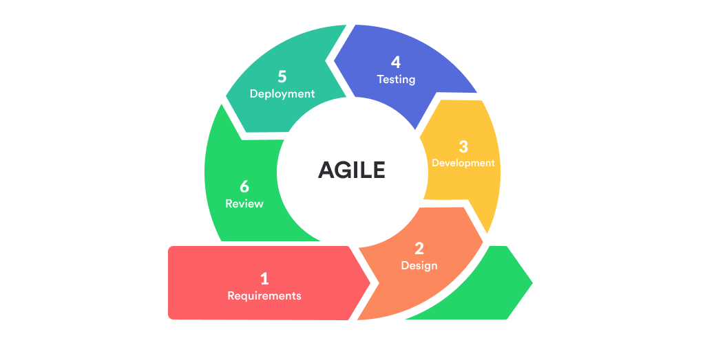
Figure 1.1: Agile Methodology [1]

1.5. Report Organization
This project report is organized into five chapters:
Here’s a summary of each chapter:
Chapter 1 (Introduction): Introduces the project background, problem statement, key objectives, and development methodology.
Chapter 2 (Background Study & Literature Review): Reviews security standards and compares existing scanners with this project.
Chapter 3 (System Analysis & Design): Details requirements, feasibility, database schemas, and UML models.
Chapter 4 (Implementation & Testing): Describes development tools, module logic, and includes unit testing test cases.
Chapter 5 (Conclusion & Recommendations): Summarizes findings and suggests improvements for future iterations.

CHAPTER 2

BACKGROUND STUDY AND LITERATURE REVIEW

2.1. Background Study
As digital services migrate to cloud environments, web applications have become central to commerce, education, finance, and public administration. This transition, however, has widened the attack surface. Cybercriminals actively seek software weaknesses to bypass security controls and access backend databases.
Historically, organizations relied on manual security testing (penetration testing) performed by external experts. Although highly effective at uncovering complex logical flaws, manual audits are expensive, slow, and hard to scale. Consequently, automated vulnerability scanners have become essential.
Standard security scanners like Burp Suite or OWASP ZAP offer powerful capabilities but often present steep learning curves for novice developers. Building lightweight, custom scanner dashboards using modern frameworks like React and Flask allows development teams to incorporate security checks directly into their daily workflows.

2.2 Literature Review
Erturk (2017) [2]: Discussed the deployment of automated vulnerability scanners in educational settings. The study examined Acunetix and its internal modules, AcuSensor and AcuMonitor, demonstrating how automated scanners speed up vulnerability detection and provide actionable remediation advice to developers.
Ge (2006) [3]: Investigated the integration of security mechanisms into Agile software lifecycles. The author emphasized that waiting until the deployment phase to run security tests is highly inefficient. Incorporating automated testing during active sprints reduces the cost of patching security vulnerabilities.
Sajjad Rafique (2002) [4]: Evaluated the role of intrusion detection systems (IDS) and secure design practices in reducing application-level security threats. The research highlighted that input validation rules implemented during the early coding stages act as a critical shield against database exploits.
Domínguez-García et al. (2023) [5]: Conducted a systematic literature review (SLR) from 2017 to 2022. The study classified 18 software testing techniques, 88 tools, and 4 secure development models, mapping them against the STRIDE threat classification.
Nawrocki (2024) [6]: Explored trends in web exploits and evaluated layered defense strategies guided by the OWASP framework. The author simulated attacks against test applications, demonstrating that combining automated testing with secure development practices significantly decreases vulnerability rates.
Rafique et al. (2015) [7]: Compiled an empirical map of vulnerability detection approaches from 1994 to 2014. The authors classified detection methods against the software development stages and the OWASP Top 10 vulnerabilities, providing a baseline for modern scanner designs.

CHAPTER 3

SYSTEM ANALYSIS AND DESIGN

3.1. System Analysis

3.1.1 Requirement Analysis
3.1.1.1 Functional Requirements
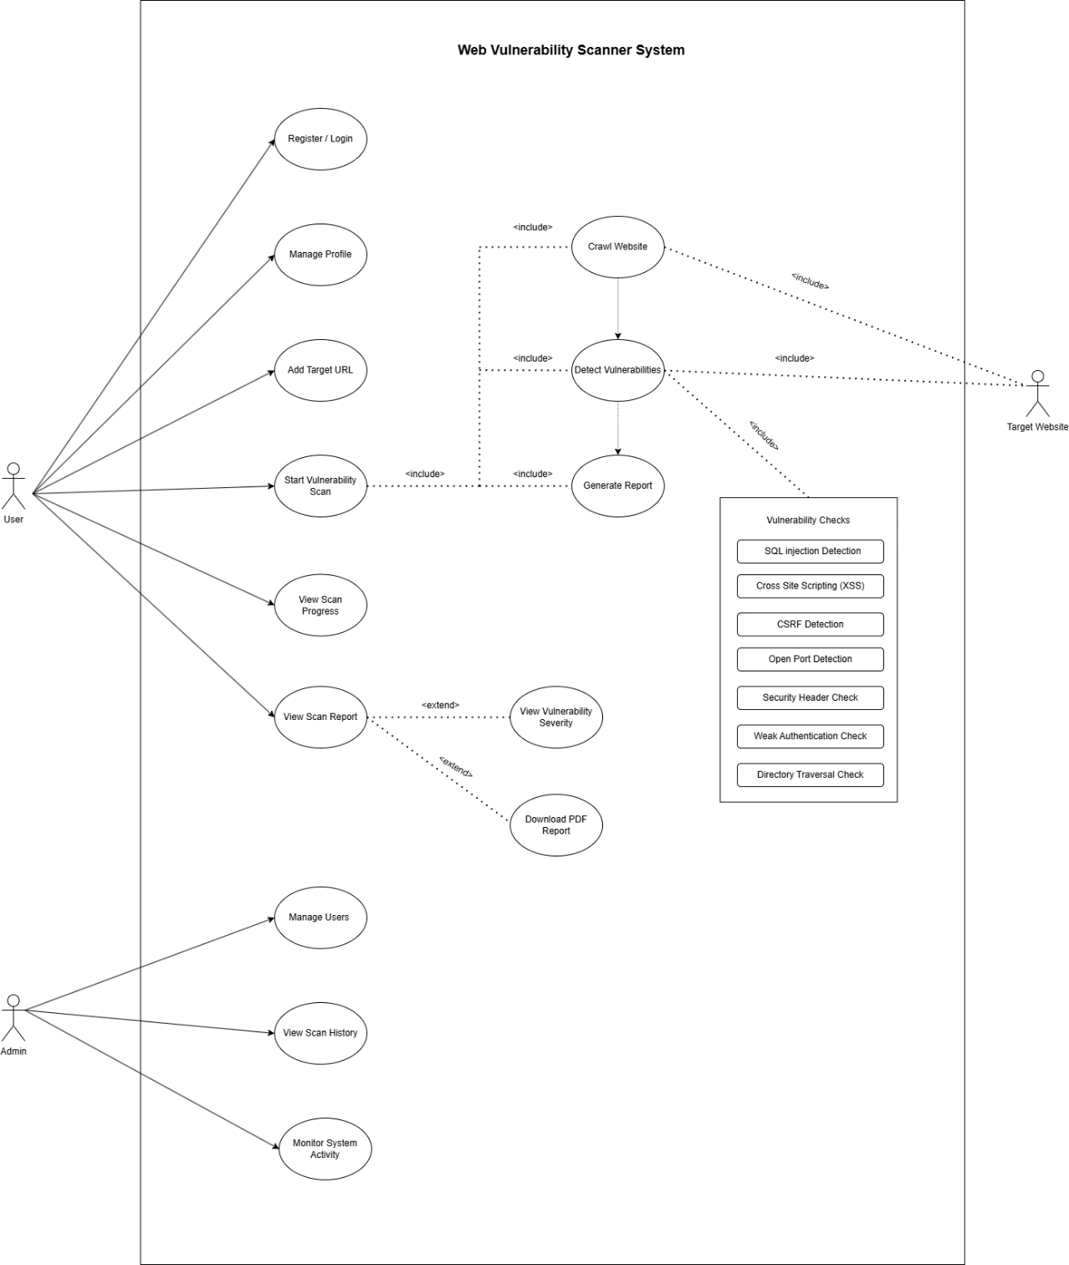
Figure 3.1: Use Case Diagram for Web Application Vulnerability Scanner
1. Login/Registration:
User Registration & Login: Users must be able to sign up and authenticate using secure credentials.
2. Manage Profile:
Profile Management: Registered users can update their email, username, and password.
3. Add Target URL:
Target URL Registration: Users specify the URL of the target web application they wish to scan.
4. Start Vulnerability Scan:
Vulnerability Scanning: The backend engine crawls the target site, identifies forms, runs tests, and detects security flaws.
5. Crawl Website:
Real-Time Progress Tracking: The frontend must stream active scan updates to the user using Server-Sent Events (SSE).
6. Detect Vulnerabilities:
Report Generation: The system compiles completed scans into structured reports detailing severity levels and recommended patches.
7. Generate Scan Report:
Scan History Logs: Users can access a dashboard containing previous reports.

8. View Scan Progress:

9. View Scan Reports:

10. View Vulnerability Details:

11. Manage Users:
User Management (Admin): Administrators can manage registered accounts, edit permissions, or suspend users.
12. View All Scan Histories:
System Activity Monitor (Admin): Admins can review server logs and scan execution histories globally.
13. Monitor System Activities:

3.1.1.2. Non-Functional Requirements
1. User Friendly:
Usability: The interface must remain clean and intuitive, requiring no advanced cybersecurity training to operate.

2. Simple and Easy to Use:

3. Security:
Security: Password storage must use strong hashing (bcrypt), and APIs must be protected via JSON Web Tokens (JWT).
4. Fast Scanning Performance:
Performance: Scans must run asynchronously in background threads to avoid blocking user interactions.
5. Accuracy:
Accuracy: Detection rules must be tuned to minimize false positives and false negatives.
6. Reliability:

7. Responsive Design:

8. Scalability:
Scalability: The architecture must support concurrent scan sessions without performance degradation.
9. Availability:
Availability: The scanning engine should remain accessible for local or remote audits.
10. Maintainability:

3.1.2. Feasibility Analysis

3.1.2.1. Technical Feasibility
The system's technical feasibility is demonstrated by combining standard web libraries with modular scanning logic. It uses Flask for the API, MongoDB for persistence, and React for the frontend. By isolating different vulnerability scanners (SQLi, XSS, open ports, etc.) into independent Python classes, the application remains lightweight, modular, and easy to extend with new vulnerability rules.

3.1.2.2. Operational Feasibility
The application is operationally viable because it hides complex security parameters behind a simplified user interface. Initiating a scan only requires entering a target URL, and reports are rendered with clear visual severity indicators. The modular structure of the code simplifies debugging and maintenance for developers.

3.1.2.3. Economic Feasibility
Economically, the project relies entirely on open-source technologies (React, Flask, MongoDB), eliminating software license fees. Automating scans reduces the need for manual security consultants, providing a cost-effective safety checking mechanism for small and medium development teams.

3.1.2.4. Schedule Feasibility
- The development schedule was distributed over 52 days. The timeline allowed for initial brainstorming and requirements gathering, followed by system design, module coding, and continuous testing, concluding with documentation and final deployment.

Table 3.1: Schedule Feasibility
Task | Start Date | End Date | Days to Complete
Brainstorm | 3/1/26 | 3/10/26 | 8
Design | 3/11/26 | 3/31/26 | 15
Development | 4/1/26 | 4/30/26 | 22
Testing | 5/1/26 | 5/4/26 | 2
Deployment | 5/5/26 | 5/11/26 | 5
Documentation | 3/1/26 | 5/11/26 | 52

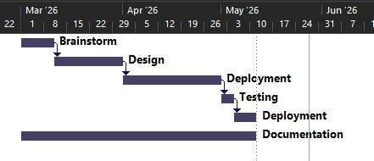
Figure 3.2: Gantt Chart for Web Application Vulnerability Scanner

3.1.3. Object Modeling using Class Diagram
The system's database structure uses two primary entities, User and Scan, representing a one-to-many relationship. The User class holds credentials and roles, while the Scan class stores the target URL, raw vulnerability lists, and calculated risk scores.
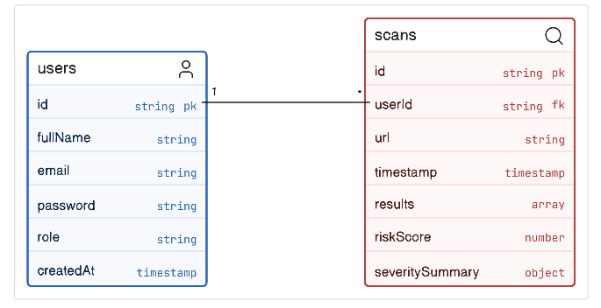
Figure 3.3: Class Diagram for Web Application Vulnerability Scanner

3.1.4. Dynamic Modelling using State and Sequence Diagrams
The state machine transitions from input validation through scanning to reporting. The sequence diagram outlines the asynchronous communication between the client, backend Flask application, database, and the target website.

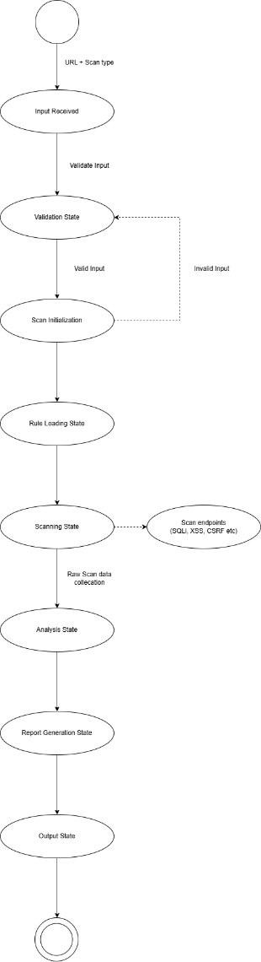
Figure 3.4: State Diagram for Web Application Vulnerability Scanner

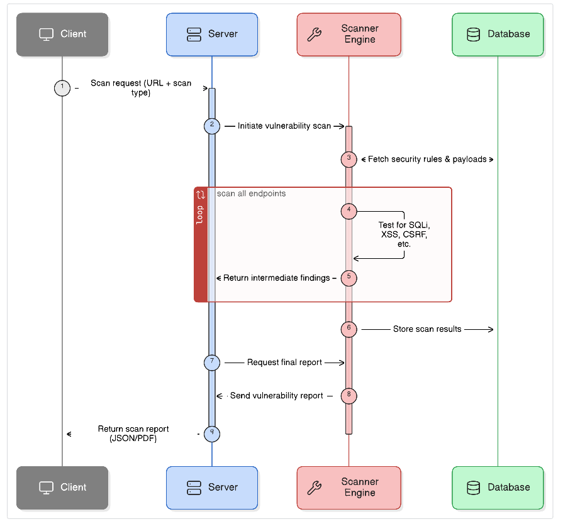
Figure 3.5: Sequence Diagram for Web Application Vulnerability Scanner

3.1.5. Process Modelling Using Activity Diagrams
The activity flow starts when a user inputs a validated URL. The scanning coordinator initiates checking modules in parallel, summarizes severities, and logs reports in MongoDB.
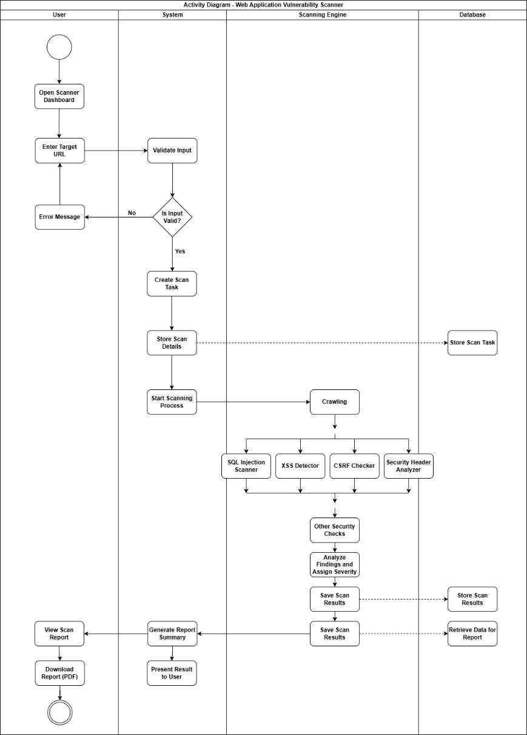
Figure 3.6: Activity Diagram for Web Application Vulnerability Scanner

3.2. System Design

3.2.1. Component Diagram
The system consists of three main components: the frontend presentation layer (React components), the backend application layer (Flask endpoints and the scanning coordinator), and the persistence layer (MongoDB database).

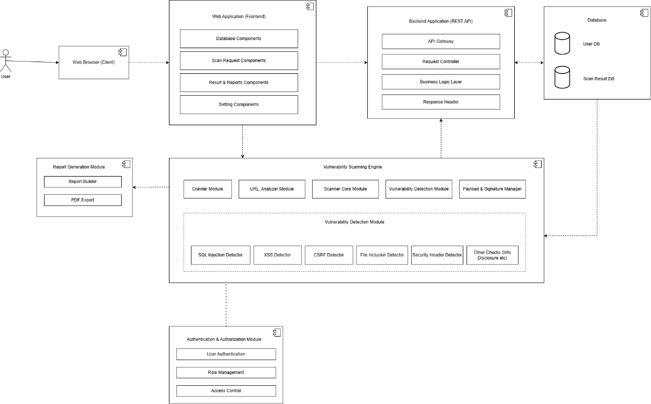
Figure 3.7: Component Diagram for Web Application Vulnerability Scanner

3.2.2. Deployment Diagram
The local deployment model runs the React client on port 5173 and the Flask API server on port 5000, communicating over HTTP. MongoDB runs as a background service on port 27017.
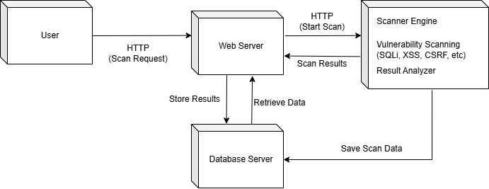
Figure 3.8: Deployment Diagram for Web Application Vulnerability Scanner

3.3. Algorithm Details

3.3.1. Web Application Vulnerability Scanning Algorithm (Core System)
The core algorithm coordinates scanning modules sequentially or in parallel. It normalizes target URLs, runs checks, aggregates results, and calculates risk ratings.

3.3.2. Rule-Based Detection Algorithm
The rule-based module checks static HTTP header settings and cookie attributes, comparing server configurations with recommended security benchmarks.
- Absence of security headers
- Unsecure attributes of cookies
- Misconfiguration of CORS policy
- Exposure of server details
- Access of sensitive files

3.3.3. Payload Injection Algorithm
The payload injection engine checks parameters for SQL Injection and Cross-Site Scripting (XSS). It inserts active payloads (e.g. ' OR '1'='1) into input parameters and checks response patterns and database errors.
- SQL Injection using bad SQL code like' OR '1'='1
- Cross-Site Scripting, also known as XSS using JavaScript code like <script>alert('xss)</script>
After we put in the bad code the system looks at what the server says to figure out:
- If there are any SQL error messages
- If any bad scripts are run
- If the server is acting weird
The Payload Injection Algorithm helps us find problems that happen when a program does not check what users put in well. This is important because the Payload Injection Algorithm can help us make sure the Payload Injection Algorithm is working by using the Payload Injection Algorithm to test it.

3.3.4. Signature-Based Detection Algorithm
This module scans server outputs for known error patterns and database syntax messages to confirm successful exploit execution.
- SQL error codes (MySQL, Oracle, PostgreSQL error codes)
- Signatures of JavaScript execution
- Signatures of sensitive files
- Signatures of debugging/system errors

3.3.5. Response Analysis Algorithm
Evaluates anomalies in status codes, page sizes, and execution times between control requests and manipulated payloads.
- Reflected input values
- Unexpected output changes
- Error variations
- Data leakage patterns

3.3.6. Port Scanning Algorithm (Socket-Based)
Checks target hosts for open ports (such as FTP, SSH, HTTP, HTTPS, and MySQL) using TCP socket connection requests.
- HTTP (port 80), HTTPS (port 443)
- SSH (port 22), FTP (port 21)
- Database ports (ports 3306, 5432)
- Remote ports (port 3389)

3.3.7. Severity Scoring Algorithm
Computes the overall application risk rating using a weighted sum of vulnerabilities: $ ext{Risk Score} = (40 imes ext{Critical}) + (20 imes ext{High}) + (10 imes ext{Medium}) + (5 imes ext{Low})$.
- Critical
- High
- Medium
- Low
- Informational

Risk Rating = Critical x 40 + High x 20 + Medium x 10 + Low x 5
Where:
- Critical: Number of critical vulnerabilities
- High: Number of high vulnerabilities
- Medium: Number of medium vulnerabilities
- Low: Number of low vulnerabilities

3.3.8. Technology Fingerprinting Algorithm
Identifies running web servers, CMS systems, and application frameworks by analyzing HTTP headers and HTML footprints.
- Web server (Apache, Nginx)
- Framework (React, Angular, Laravel, Django)
- CMS (WordPress, Drupal, Joomla)
It uses signature-based detection for:
- Headers in server responses
- X-Powered-By headers
- HTML source code

3.3.9. Directory Brute Force / Enumeration Algorithm
Iterates through a wordlist of paths (like /admin, /.env, /.git) to identify exposed files and directories.
- /admin
- /.env
- /.git
- /backup
- /phpmyadmin

- 200 → The accessible resource
- 403 → Access forbidden
- 301/302 → The resource got redirected

3.3.10. Cookie Security Validation Algorithm
Validates cookie security configurations, checking for missing flags like Secure, HttpOnly, and SameSite to prevent session leaks.
- The Secure property (cookie should be HTTPS-only)
- The HttpOnly property (cookie can’t be accessed via JavaScript)
- SameSite property

CHAPTER 4

IMPLEMENTATION AND TESTING

4.1. Implementation

4.1.1. Tools Used
Flask: Lightweight Python framework used to build REST APIs and manage request routing.
Flask-CORS: Manages cross-origin resource sharing configuration between the backend and React dashboard.
PyMongo: Python driver used to connect with and query MongoDB databases.
PyJWT: Used to issue and validate secure JSON Web Tokens for user authentication.
React (Vite + TypeScript): Used to construct the components for the UI dashboard.
TanStack React Query: Used for server-state management, handling caching, background data fetching, and API synchronization.
Zustand: Light state-management library used to track active scan updates and login states globally.
Vite: A fast build tool that provides hot module reloading and fast server startup.

4.1.2. Implementation Details of Modules
The following are the modules used for implementation of Web Application Vulnerability Scanner.

4.1.2.1. Registration Model:
The registration module validates unique email addresses, hashes passwords using bcrypt, and logs new user accounts into MongoDB.

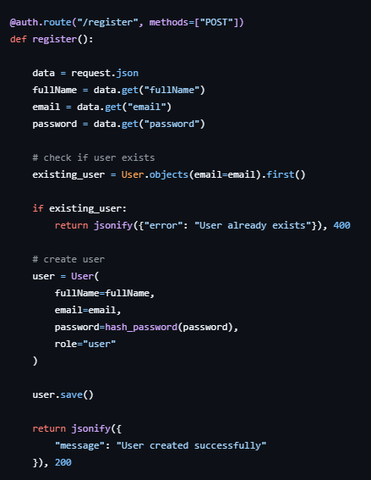
Figure 4.1: Code Snippet of Registration Model

4.1.2.2. Real-Time Vulnerability Scanning and Streaming Model
Validates target URLs, runs scanning modules in background threads, and streams updates back to the UI in real time via Server-Sent Events.
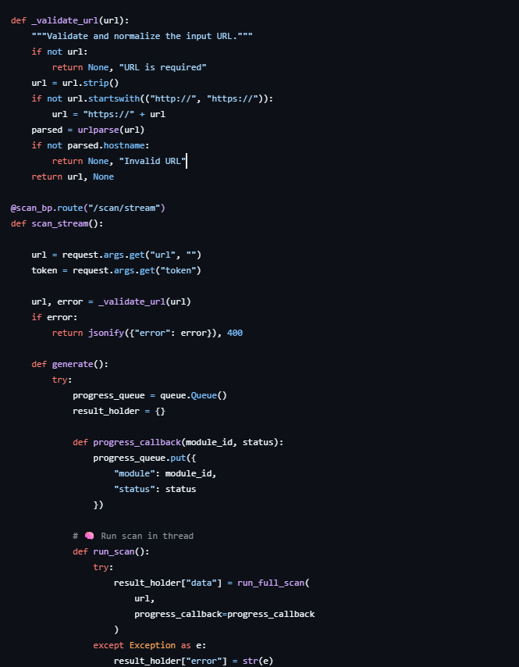
Figure 4.2: Code Snippet of Real-Time Vulnerability Scanning and Streaming Model

4.1.2.3. HTTP Security Header Analysis Model
Analyzes target servers for missing security headers, including Content-Security-Policy and X-Frame-Options, logging missing items.
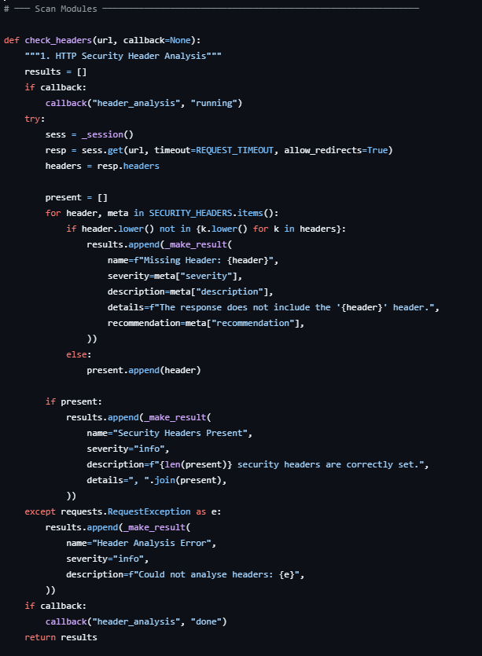
Figure 4.3: Code Snippet of HTTP Security Header Analysis Model

4.1.2.4. SSL/TLS Certificate Validation Model
Validates TLS certificate parameters, checking validity periods, issuer data, and warning against deprecated TLS protocols.
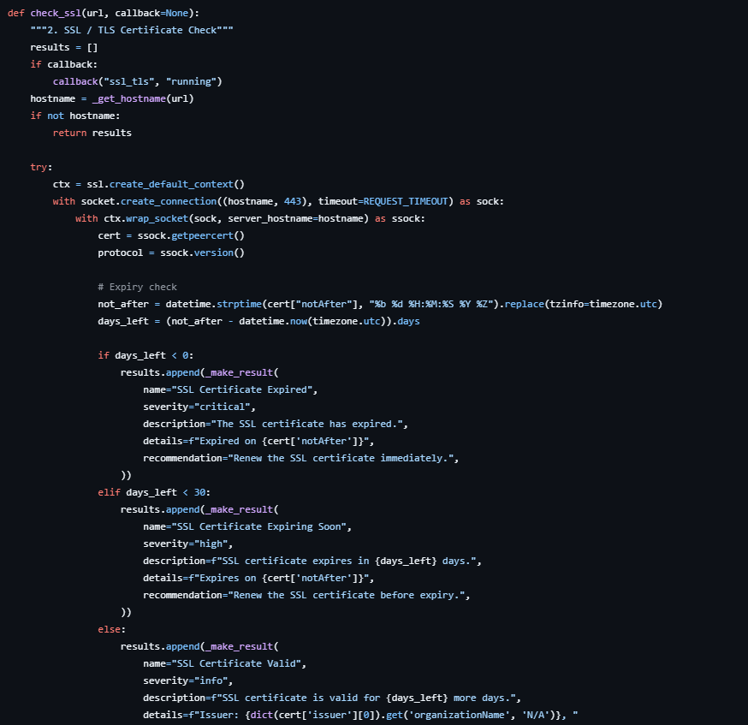
Figure 4.4: Code Snippet of SSL/TLS Certificate Validation Model

3.1.2.5. Port Scanning Model
Queries target hosts for open ports concurrently using threading, highlighting open administrative or database services.
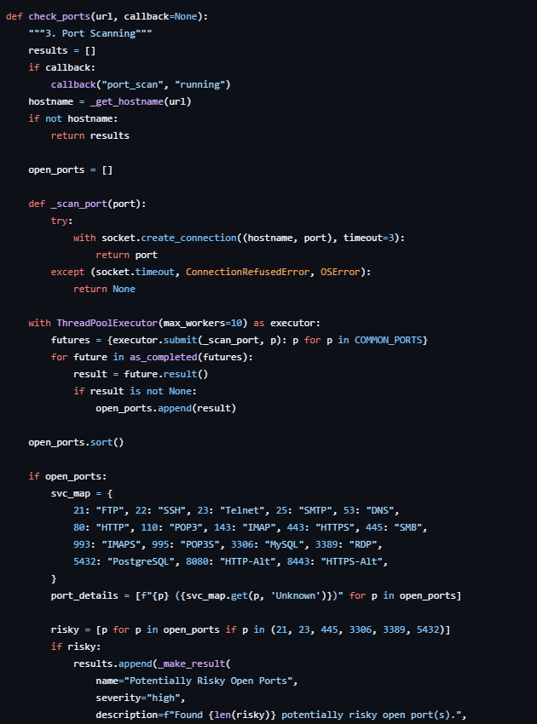
Figure 4.5: Code Snippet of Port Scanning Model

4.1.2.6. Technology Detection Model
Fingerprints target systems to identify web servers, operating systems, and frameworks from headers and HTML tags.
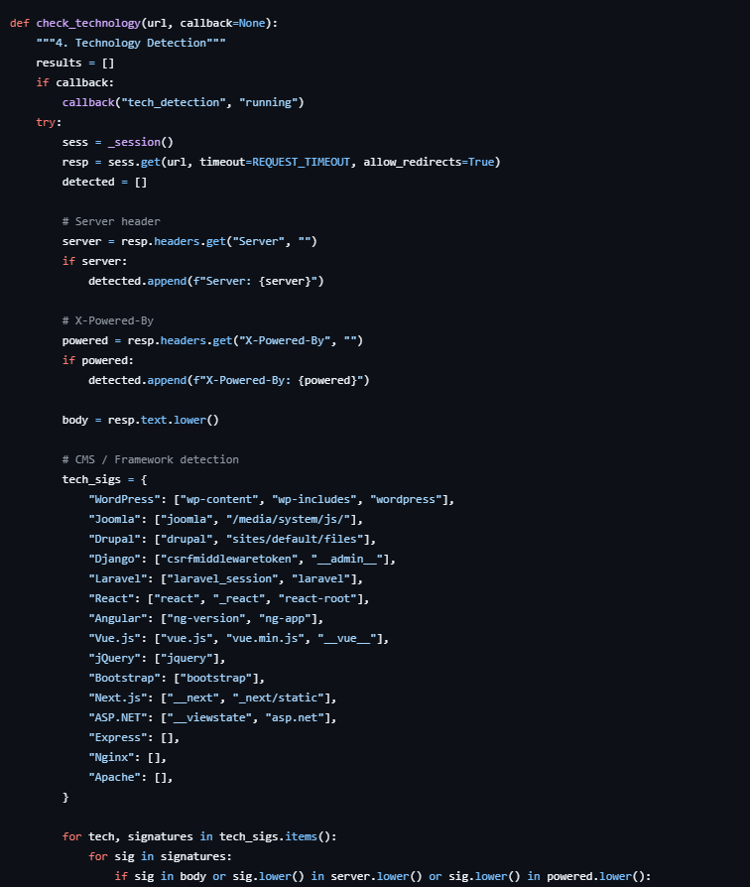
Figure 4.6: Code Snippet of Technology Detection Model

4.1.2.7. Directory and Sensitive File Enumeration Model
Scans target URLs for standard directory paths and files, flagging exposed system settings or credentials.
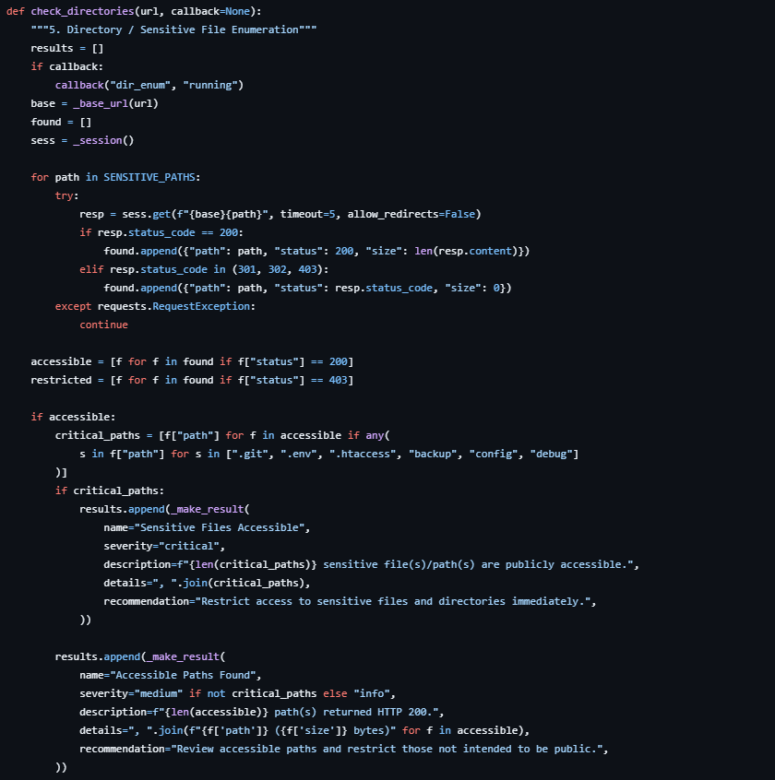
Figure 4.7: Code Snippet of Directory and Sensitive File Enumeration Model

4.1.2.8. SQL Injection Detection Model
Tests URL parameters by injecting SQL payloads and checking responses for database syntax error signatures.
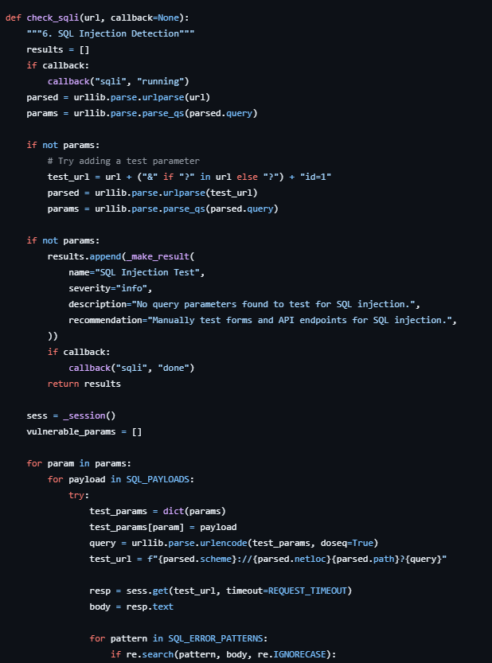
Figure 4.8: Code Snippet of SQL Injection Detection Model

4.1.2.9. Cross-Site Scripting (XSS) Detection Model
Checks reflected parameters for XSS vulnerabilities by verifying if script payloads are returned unencoded in HTML.
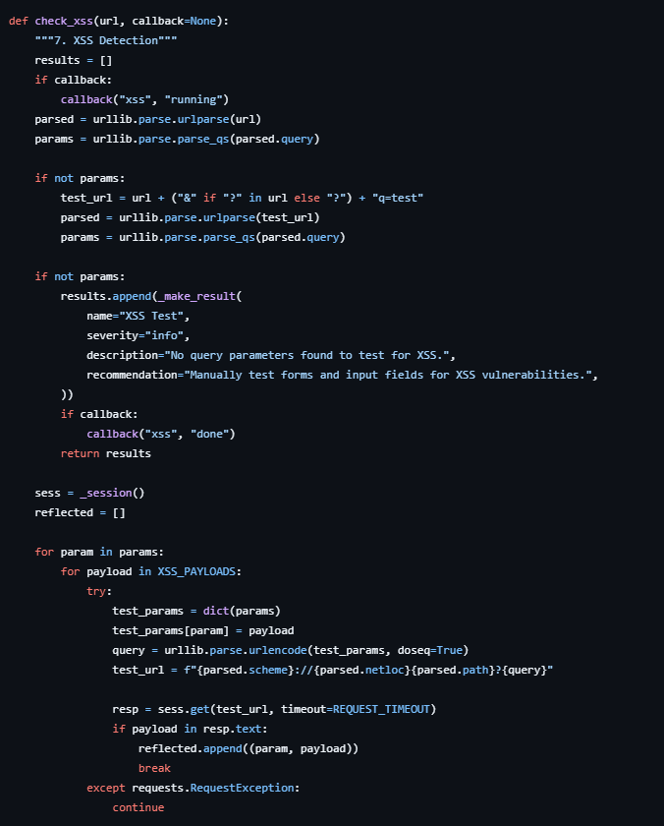
Figure 4.9: Code Snippet of Cross-Site Scripting (XSS) Detection Model

4.1.2.10. CORS Misconfiguration Detection Model
Checks cross-origin resource sharing policies, flagging wildcard configurations that allow credentials access.
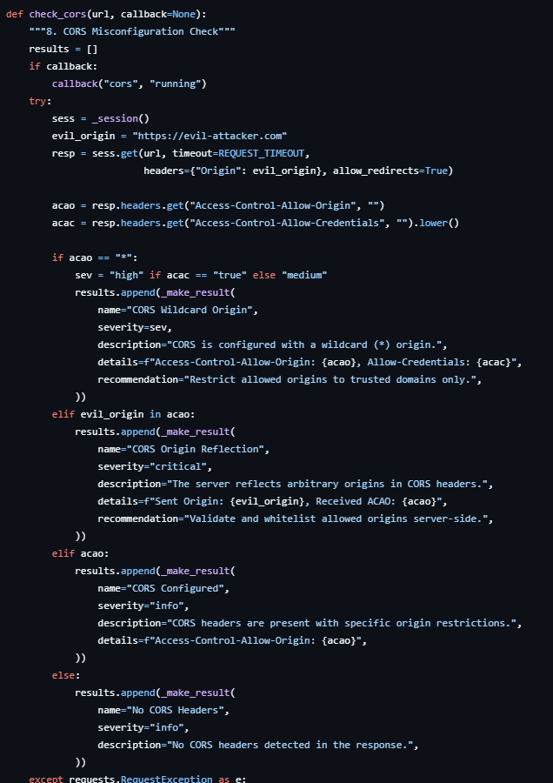
Figure 4.10: Code Snippet of CORS Misconfiguration Detection Model

4.1.2.11. Cookie Security Analysis Model
Checks cookie attributes in response headers, flagging sessions lacking HttpOnly, Secure, or SameSite protections.
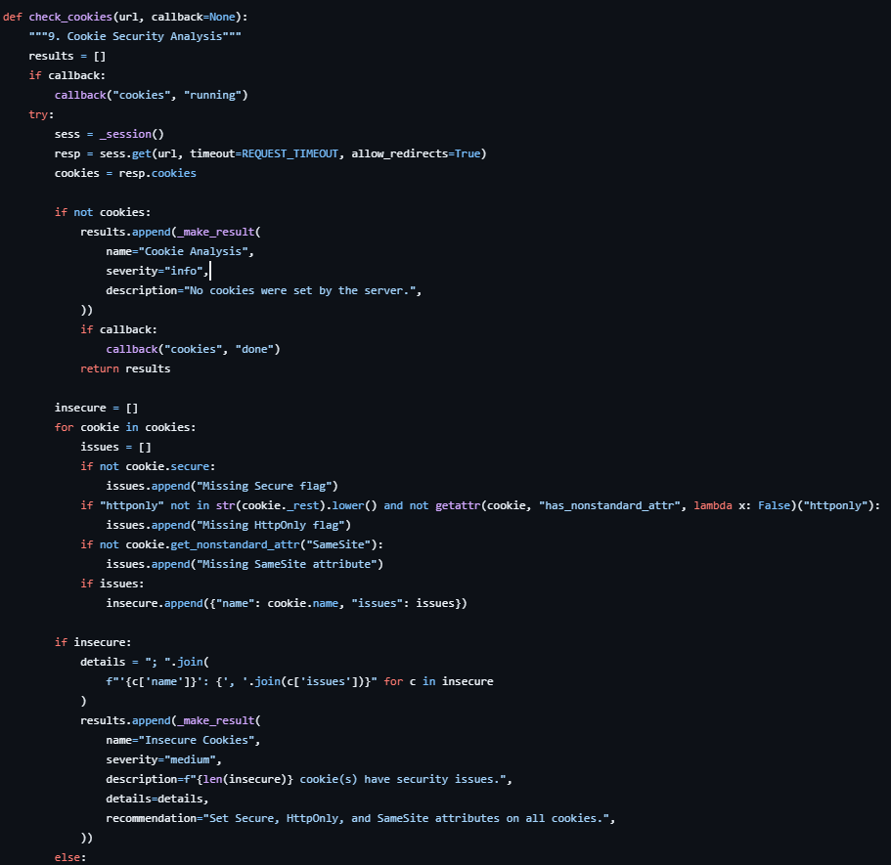
Figure 4.11: Code Snippet of Cookie Security Analysis Model

4.1.2.12. Information Disclosure Detection Model
Scans response bodies and headers for email leaks, internal IP addresses, system comments, or software versions.
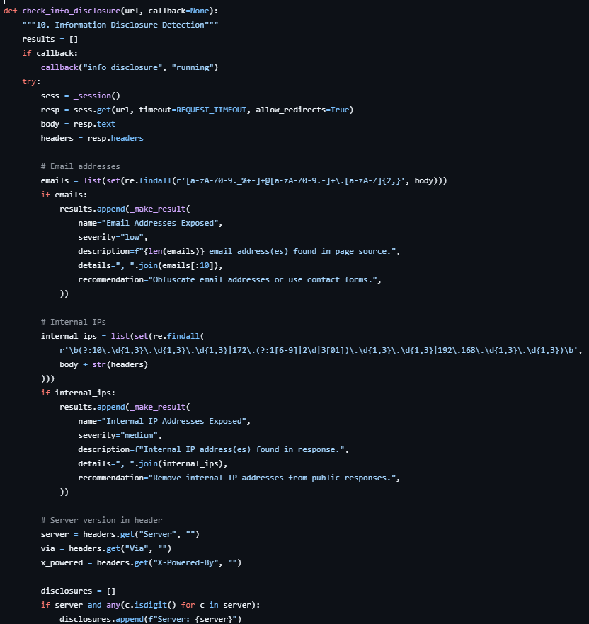
Figure 4.12: Code Snippet of Information Disclosure Detection Model

4.1.2.13. Vulnerability Scanning Orchestration Model
Coordinates the sequence of checking modules, handles connection timeouts, and compiles results into an overall report.
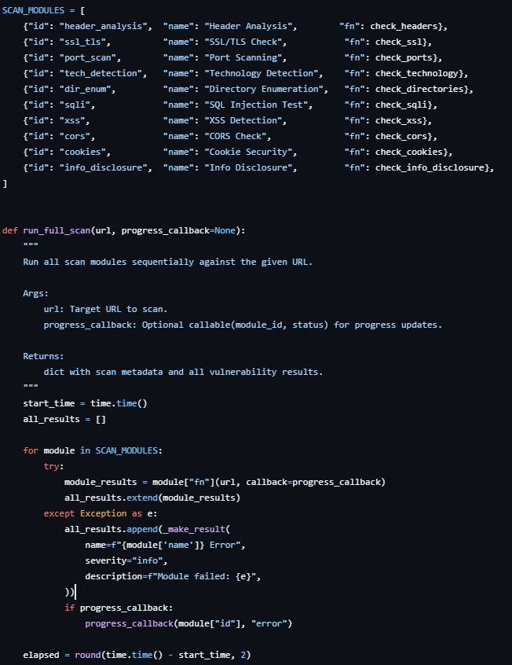
Figure 4.13: Code Snippet of Vulnerability Scanning Orchestration Model

4.2. Testing

4.2.1. Test Case for Unit Testing
Table 4.1: Test Case for Unit Testing of Web Vulnerability Scanner APIs
S.N | Action | Input | Expected Outcomes | Actual Outcomes | Test Results
1 | Launch Application | http://127.0.0.1:5000/ | Application starts successfully | Application starts successfully | Pass
2 | Register User with Empty Fields | Empty fullName, email, password | Validation error message | User created with missing fields | Fail
3 | Register User | Valid fullName, email, password | User account created successfully | User account created successfully | Pass
4 | Register Existing User | Existing email address | Error message “User already exists” | Error message displayed | Pass
5 | Login Without Password | Email only | Proper validation error | Internal server error generated | Fail
6 | Login User | Valid email and password | JWT token generated with user data | JWT token generated successfully | Pass
7 | Login with Invalid Password | Wrong password | Invalid credentials error | Invalid credentials error | Fail
8 | Start Scan Stream | Valid URL and token | Real-time scan starts and streams progress | Scan progress streamed successfully | Pass
9 | Start Scan with Invalid URL | Invalid URL format | URL validation error | URL validation error display | Fail
10 | Access Scan Report | Valid scan ID and authenticated user | Scan report returned successfully | Scan report returned successfully | Pass
11 | Access Scan Without Token | Unauthorized request | 401 Unauthorized response | 401 Unauthorized response | Fail
12 | List User Scans | Authenticated user request | List of previous scans returned | Scan history displayed | Pass
13 | Save Scan Result | Completed vulnerability scan | Results stored in database | Results stored successfully | Pass
14 | Scan Stream Server Failure | Simulated backend exception | Proper error response returned | Stream interrupted unexpectedly | Fail

Table 4.2: Test Cases for Unit Testing of Vulnerability Detection Modules
S.N | Action | Input | Expected Outcomes | Actual Outcomes | Test Results
1 | Check Security Headers | Valid website URL | Missing security headers detected | Headers analyzed successfully | Pass
2 | Validate SSL Certificate | HTTPS enabled website | SSL certificate details retrieved | SSL validated successfully | Pass
3 | Scan Open Ports | Target website URL | Open ports identified | Open ports detected correctly | Pass
4 | Detect Technologies | Website source code and headers | Frameworks and technologies identified | Technologies identified | Pass
5 | Enumerate Directories | Website URL | Sensitive directories detected | Sensitive paths detected | Pass
6 | Perform SQL Injection Test | URL with query parameters | SQL injection patterns checked | SQL tests completed | Pass
7 | Perform XSS Detection | URL with input parameters | Reflected XSS payload detection | XSS vulnerabilities detected | Pass
8 | Check CORS Misconfiguration | Website URL | CORS headers analyzed | CORS analysis completed | Pass
9 | Analyze Cookies | Website cookies | Missing security flags detected | Cookie security issues detected | Pass
10 | Detect Information Disclosure | Website response headers and source | Sensitive information identified | Information disclosure detected | Pass
11 | Run Full Scan | Valid target URL | All modules executed sequentially | Complete scan completed | Pass
12 | Scan Invalid/Offline Website | Non-responsive website URL | Graceful error handling | Connection timeout caused module failure | Fail

CHAPTER 5

CONCLUSION AND FUTURE MANAGEMENTS

5.1. Conclusion
The Web Application Vulnerability Scanner provides a lightweight, automated method for detecting security flaws early in development. By integrating multiple modules (crawling, injection, header analysis, and port scanning), the tool provides developers with a local, visual method to audit their code and maintain security standards.
The system's modular backend runs Flask with MongoDB, and its React/Vite frontend displays real-time progress streamed using Server-Sent Events (SSE).
Functional testing validated that the scanner successfully identifies vulnerabilities, scores risks, and handles database persistence correctly.
Overall, the scanner supports secure software development practices, helping organizations identify weaknesses before they can be exploited.

5.2. Future Recommendation
Future updates should introduce advanced checking modules (such as API scanning and CSRF detection), incorporate AI-based threat severity analysis, support distributed background worker queues, and package the architecture using Docker containerization.
- Integrate Advanced Vulnerability Detection: Add advanced security testing features such as CSRF detection, command injection testing, authentication bypass analysis, and API security scanning.
- AI-Based Risk Analysis: Implement machine learning techniques to predict vulnerability severity and prioritize risks based on attack patterns and historical scan data.
- Real-Time Threat Monitoring: Extend the system to support continuous monitoring and real-time alert notifications for newly discovered vulnerabilities.
- PDF and Dashboard Reporting: Add professional PDF report generation and interactive analytics dashboards for easier vulnerability analysis and reporting.
- Multi-Threaded and Distributed Scanning: Improve performance by implementing distributed scanning architecture for handling large-scale web applications efficiently.
- User Role and Team Management: Introduce role-based access control and collaborative team features for enterprise-level vulnerability management.
- Cloud Deployment and Containerization: Deploy the system using Docker and cloud platforms to improve scalability, portability, and production readiness.
- Integration with Security Tools: Integrate the scanner with tools such as Nmap, OWASP ZAP, or Burp Suite for deeper and more advanced security assessments.

REFERENCES

[1] | s. gray, "Medium," 29 July 2020. [Online]. Available: https://serenagray2451.medium.com/what-is-the-agile-methodology-in-software-development-c93023a7eb85.
[2] | E. R. A. Erturk, "harvard," June 2017. [Online]. Available: https://ui.adsabs.harvard.edu/abs/2017arXiv170608017E/abstract.
[3] | X. P. R. P. F. C. H. a. B. P. Ge, "Agile Development of Secure Web Applications," 11 July 2006. [Online]. Available: https://www.scirp.org/reference/referencespapers?referenceid=1565154.
[4] | M. H. Z. G. A. A. H. J. Sajjad Rafique, "Secure Software," RTO/NATO Real-Time Intrusion Detection Symp, 15 September 2002. [Online]. Available: https://www.scirp.org/reference/referencespapers?referenceid=1565156.
[5] | X. L. J. O. O.-H. J. C. P.-A. Antonio De Jesús Domínguez-García, "IEEE Xplore," Security Testing for Web Applications, 6 10 2023. [Online]. Available: https://ieeexplore.ieee.org/document/10568290/authors#authors.
[6] | M. Nawrocki., "ACIG," Vulnerabilities of Web Applications, 2 3 2024. [Online]. Available: https://www.acigjournal.com/Vulnerabilities-of-Web-Applications-Good-Practices-and-New-Trends,199521,0,2.html#S1.
[7] | S. Rafique, M. Humayun, B. Hamid, A. Abbas and K. I. Muhammad Akhtar, "IEEE Xplore," Web application security vulnerabilities detection approaches, 01 June 2015. [Online]. Available: https://ieeexplore.ieee.org/document/7176244. [Accessed 06 August 2015].

APPENDICES
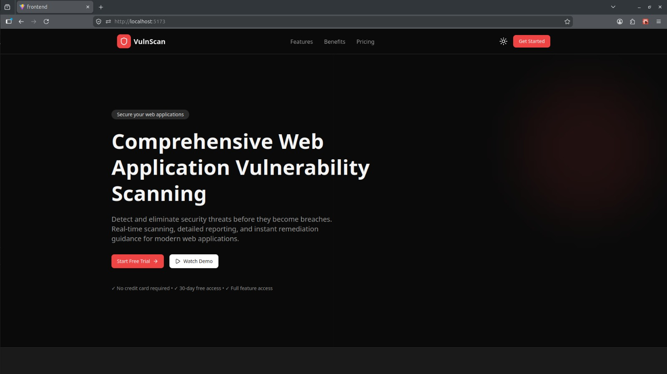
Figure: Landing Page
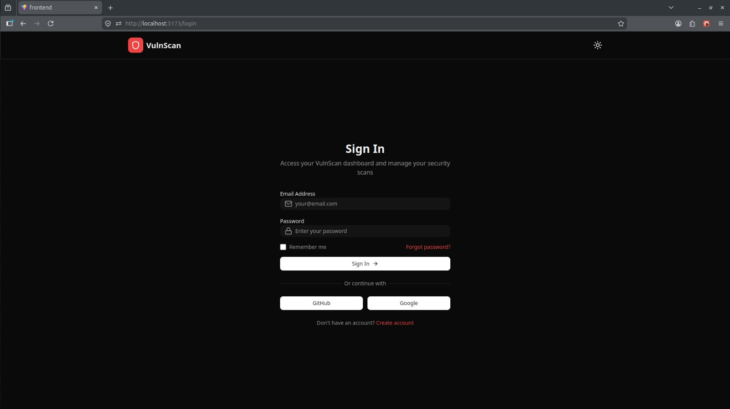
Figure: Login Page
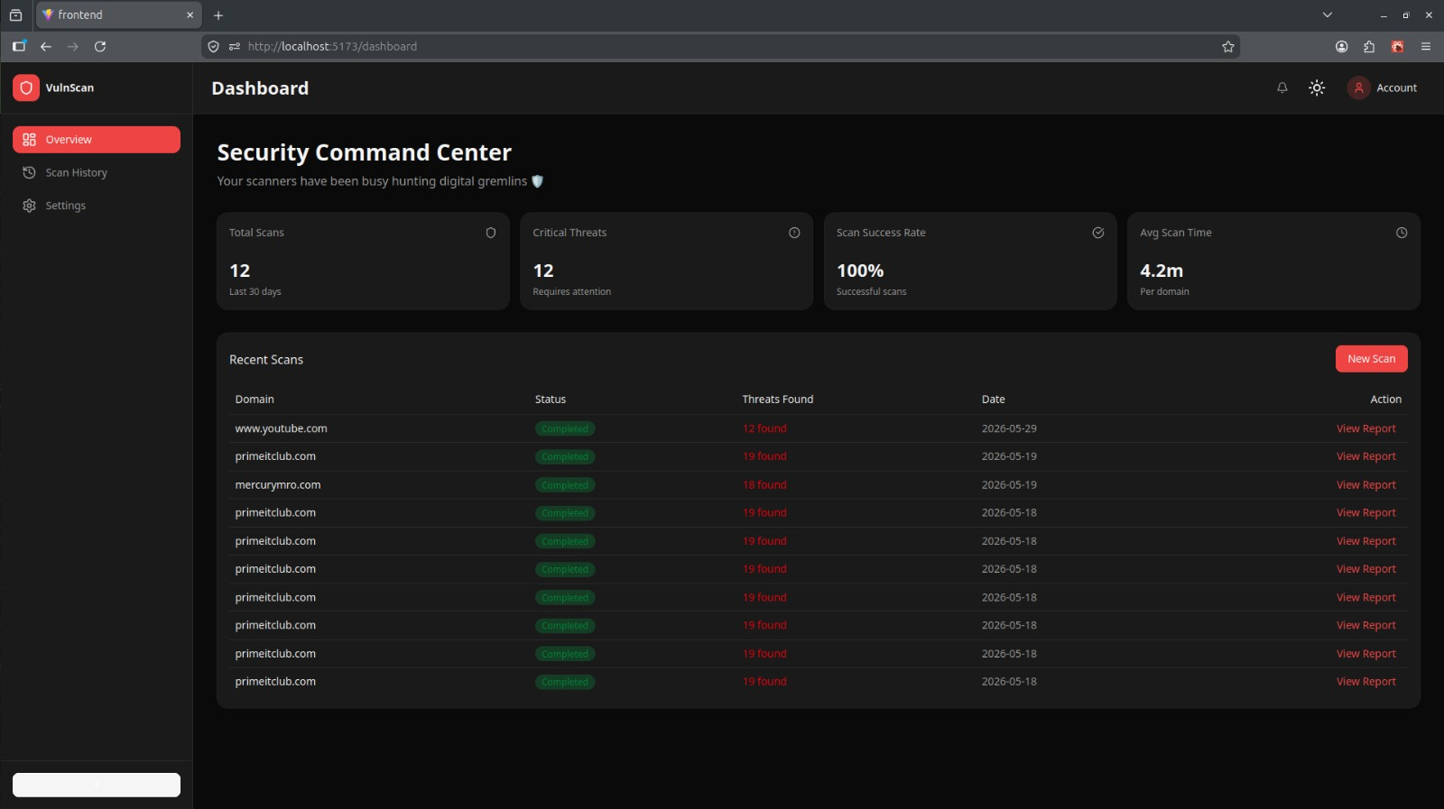
Figure: Dashboard Page
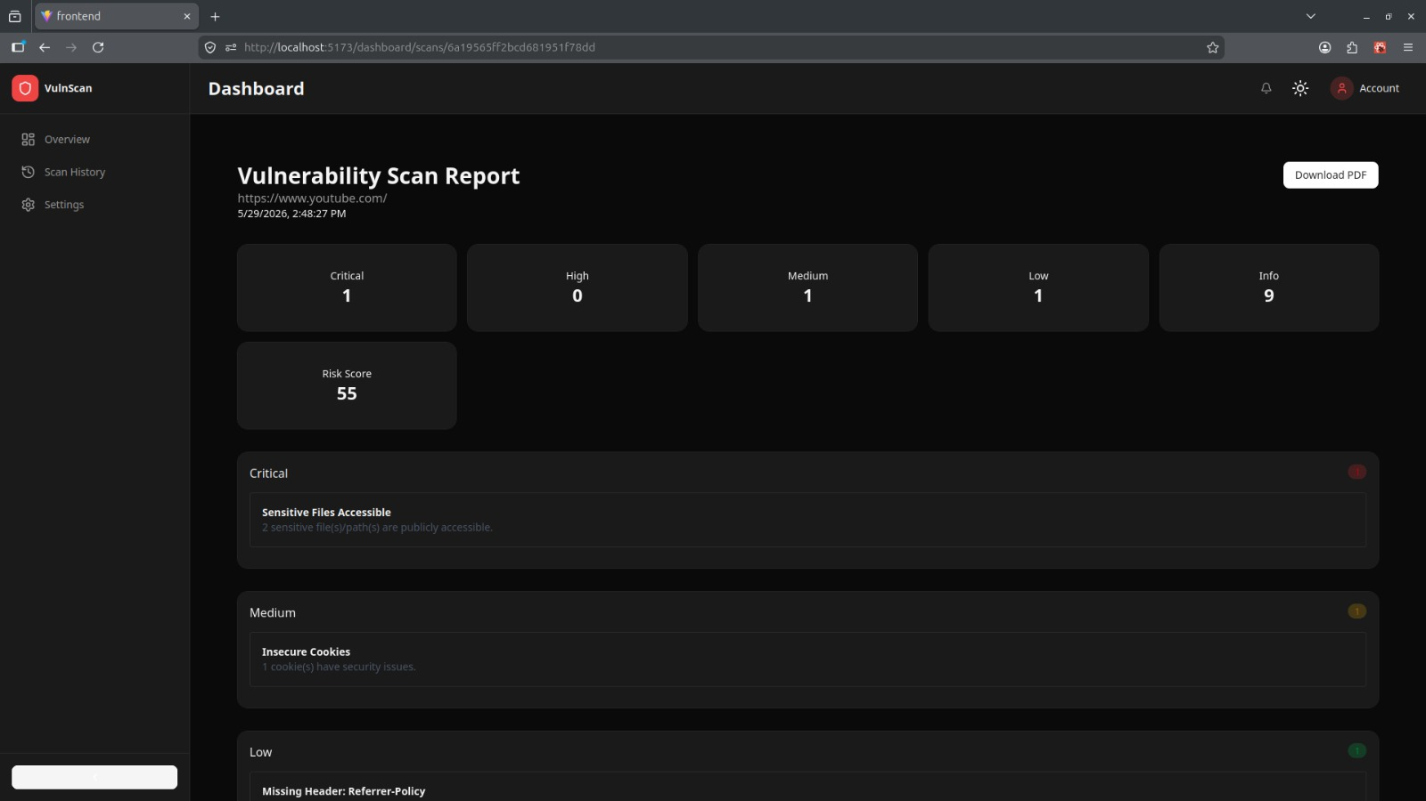
Figure: Scan Report Page
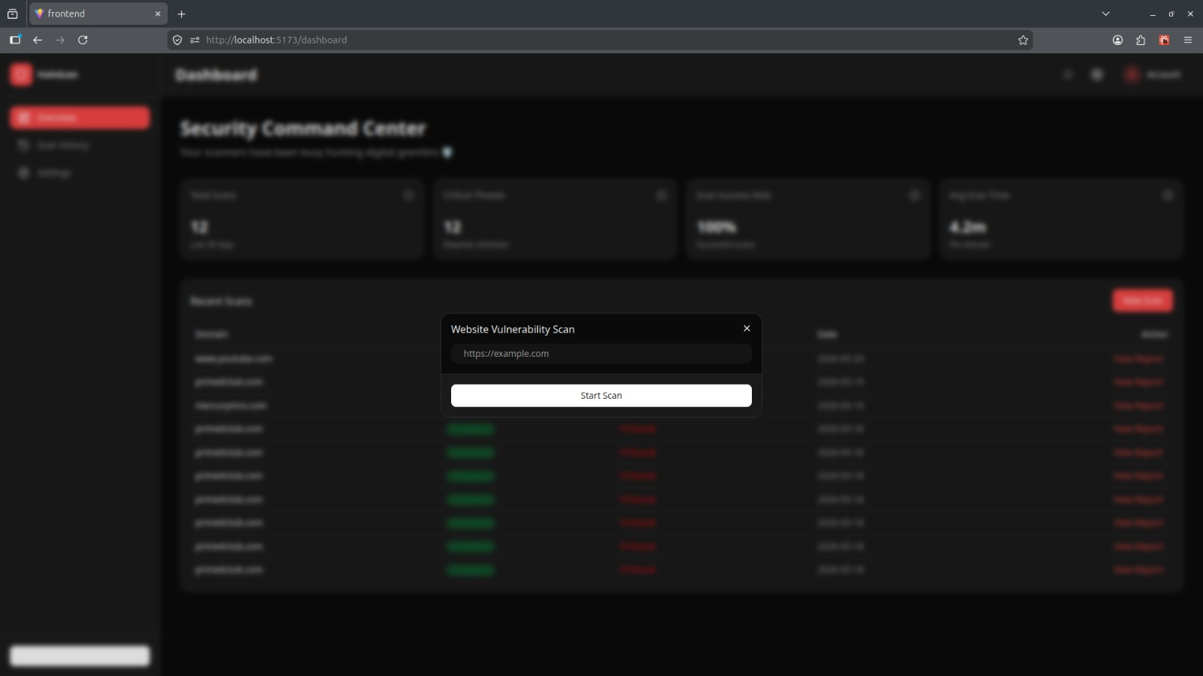
Figure: Scan Dialog
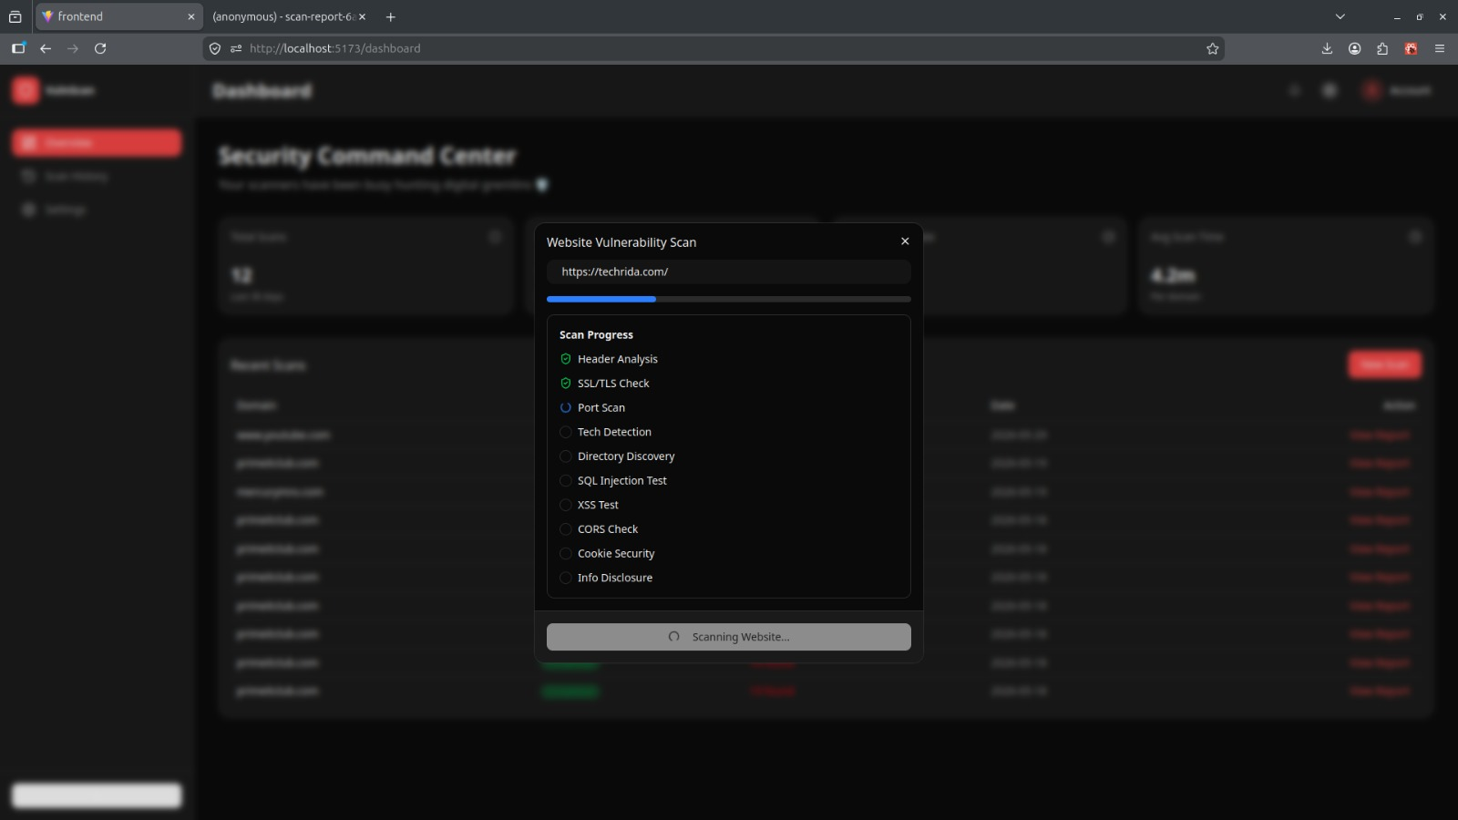
Figure: Live Scan Dialog

