
Tribhuvan University
Faculty of Humanities and Social Science
A Project Report On
“AI Text Detector”
In partial fulfillment of requirements in Bachelor in Computer Applications
Submitted by:
Saurav Munikar (6-2-410-139--2021)

June, 2026 A.D.
Under the Supervision of
Mr. Niraj Khadka


Tribhuvan University
Faculty of Humanities and Social Science
A Project Report On
“AI Text Detector”
In partial fulfillment of requirements in Bachelor in Computer Applications
Submitted by:
Saurav Munikar (6-2-410-139--2021)

June, 2026 A.D.
Under the Supervision of
Mr. Niraj Khadka


Tribhuvan University
Faculty of Humanities and Social Science

SUPERVISORS RECOMMENDATION
It is my pleasure to recommend that a project report on “AI Text Detector” has been prepared under my supervision by Saurav Munikar in partial fulfillment of the requirement of the degree of Bachelor of Computer Applications. His report is satisfactory and is an original work done by him to process for the future evaluation.

Mr. Niraj Khadka
SUPERVISOR
Lecturer, Department of IT
Prime College


Tribhuvan University
Faculty of Humanities and Social Science

LETTER OF APPROVAL
This is to certify that this project report prepared by Saurav Munikar on “AI Text Detector” in partial fulfillment of the requirements for the degree of Bachelor in Computer Application has been evaluated. In our opinion it is satisfactory in the scope and quality as a project for the required degree.
Ms. Niraj Khadka  Supervisor  Prime College  Khusibu, Nayabajar, Kathmandu | Ms. Rolisha Sthapit  Program Co-Ordinator/ Internal  Examiner  BCA Department  Prime College  Khusibu, Nayabajar, Kathmandu
Mr.
External Examiner

ACKNOWLEDGEMENT
This project on developing an AI Text Detector, which detects machine-generated text using statistical NLP, K-Nearest Neighbors (KNN), and Cosine Similarity, could not have been achieved without the kind support of many individuals. I am highly thankful to Ms. Niraj Khadka, Project Supervisor and Coordinator, for his kind guidance, valuable suggestions, and encouragement during the course of developing this project. His knowledge of the subject, as well as her encouragement, helped learn the concepts of Natural Language Processing and machine learning deeply. I would also like to express my gratitude towards all the individuals, such as my teachers, mentors, friends, and classmates, who provided valuable suggestions, ideas, etc., during the testing phase of the project, which helped improve the performance, functionality, etc., of the AI Text Detector. I would like to express my sincere thanks to all the individuals, who helped the completion of the project, directly or indirectly.
-Saurav Munikar

ABSTRACT
To evaluate adversarial evasion techniques (e.g. synonym swapping and spelling tweaks), the project implements robust offline data augmentation workflows using the nlpaug Python library, which allows calibrating the grammar perfection discount factor under synthetic typo loads. The user interface features a prominent Classification Verdict banner at the top of the dashboard indicating if text is most probably written by AI, mixed, or human.
To evaluate adversarial evasion techniques (e.g. synonym swapping and spelling tweaks), the project implements robust offline data augmentation workflows using the nlpaug Python library, which allows calibrating the grammar perfection discount factor under synthetic typo loads. The user interface features a prominent Classification Verdict banner at the top of the dashboard indicating if text is most probably written by AI, mixed, or human.
The individual metrics are combined via a weighted ensemble (35% Perplexity, 40% KNN, 25% Cosine Similarity) to calculate an overall AI probability. The application features an interactive single-page dashboard built using HTML5, custom CSS variables, and Vanilla JavaScript. It incorporates PDF.js and Mammoth.js for client-side document parsing, SVG-based glowing visualization charts, an interactive sentence-level perplexity heatmap, a prominent classification verdict banner, and a mathematical resolution panel powered by MathJax to trace raw formulas in real time.
Table of Contents
SUPERVISORS RECOMMENDATION iii
LETTER OF APPROVAL iv
ACKNOWLEDGEMENT v
ABSTRACT vi
LIST OF ABBREVIATIONS ix
LIST OF FIGURES x
LIST OF TABLES xii
CHAPTER 1 INTRODUCTION 1
1.1. Introduction 1
1.2. Problem Statement 2
1.3. Objectives 2
1.4. Development Methodology 2
1.5. Report Organization 3
CHAPTER 2 BACKGROUND STUDY AND LITERATURE REVIEW 6
2.1. Background Study 6
2.2 Literature Review 7
CHAPTER 3 SYSTEM ANALYSIS AND DESIGN 9
3.1. System Analysis 9
3.1.1 Requirement Analysis 9
3.1.2. Feasibility Analysis 12
3.1.3. Object Modeling using Class Diagram 15
3.1.4. Dynamic Modelling using State and Sequence Diagrams 16
3.1.5. Process Modelling Using Activity Diagrams 18
3.2. System Design 20
3.2.1. Component Diagram 20
3.2.2. Deployment Diagram 20
3.3. Algorithm Details 21
3.3.1. Statistical NLP Algorithm (Perplexity & Burstiness) 21
3.3.2. KNN Classifier 22
3.3.3. Cosine Similarity (Vector Space Model) 22
3.3.4. Heuristic Grammar & Typography Analyzer 23
3.3.5. Ensemble Scoring & Grammar Calibration 24
CHAPTER 4 IMPLEMENTATION AND TESTING 25
4.1. Implementation 25
4.1.1. Tools Used 25
4.1.2. Module Implementation Details 25
4.1.2.1. FileParser Module 25
4.1.2.2. Perplexity & Burstiness Module 26
4.1.2.3. KNN Heuristic Feature Module 27
4.1.2.4. KNN Voting Classifier Module 28
4.1.2.5. Cosine Similarity Feature Module 28
4.1.2.6. Cosine Similarity Angle Module 29
4.1.2.7. ChartRenderer Gauge Module 30
4.1.2.8. ChartRenderer Scatter Plot Module 31
4.1.2.9. ChartRenderer Radar Chart Module 31
4.1.2.10. app.js Analysis Controller Module 32
4.1.2.11. app.js UI Event Listener Module 33
4.1.2.12. style.css Custom Visual Styles 34
4.1.2.13. HTML5 Dashboard Layout Structure 34
4.1.2.14. Heuristic Grammar & Typography Module 35
4.2. Testing 37
4.2.1. Test Case for Unit Testing 37
CHAPTER 5 CONCLUSION AND FUTURE RECOMMENDATIONS………………40
5.1. Conclusion 40
5.2. Future Recommendations 40
REFERENCES 42

LIST OF ABBREVIATIONS
TTR | Type-Token Ratio (Lexical Diversity)
CLI | Coleman-Liau Readability Index
KNN | K-Nearest Neighbors (Instance-Based Classifier)
NLP | Natural Language Processing
LLM | Large Language Model (ChatGPT, Claude, Gemini)
GPT | Generative Pre-trained Transformer
SVG | Scalable Vector Graphics (Visualization Charts)
DOM | Document Object Model
CDN | Content Delivery Network
HTML | HyperText Markup Language
CSS | Cascading Style Sheets
JS | JavaScript (ECMAScript 6)
PDF | Portable Document Format
DOCX | Word Document Format (Office Open XML)
API | Application Programming Interface (External Endpoint)

LIST OF FIGURES
Figure 1.1: | Agile Methodology.............................................................................................. | 3
Figure 3.1: | Use Case Diagram for AI Text Detector............................................................... | 9
Figure 3.2: | Gantt Chart for AI Text Detector.......................................................................... | 14
Figure 3.3: | Class Diagram for AI Text Detector..................................................................... | 15
Figure 3.4: | State Diagram for AI Text Detector...................................................................... | 16
Figure 3.5: | Sequence Diagram for AI Text Detector.............................................................. | 17
Figure 3.6: | Activity Diagram for AI Text Detector................................................................. | 19
Figure 3.7: | Component Diagram for AI Text Detector........................................................... | 20
Figure 3.8: | Deployment Diagram for AI Text Detector.......................................................... | 21
Figure 4.1: | Code Snippet of FileParser Module..................................................................... | 26
Figure 4.2: | Code Snippet of Perplexity & Burstiness Module................................................ | 27
Figure 4.3: | Code Snippet of KNN Feature Module................................................................ | 27
Figure 4.4: | Code Snippet of KNN Classifier Module............................................................. | 28
Figure 4.5: | Code Snippet of Cosine Similarity Feature Module............................................. | 29
Figure 4.6: | Code Snippet of Cosine Similarity Angle Module............................................... | 30
Figure 4.7: | Code Snippet of Chart Renderer Gauge Module.................................................. | 30
Figure 4.8: | Code Snippet of Chart Renderer Scatter Plot Module.......................................... | 31
Figure 4.9: | Code Snippet of ChartRenderer Radar Chart Module.......................................... | 32
Figure 4.10: | Code Snippet of app.js Analysis Controller Module............................................ | 33
Figure 4.11: | Code Snippet of app.js UI Event Listener Module............................................... | 33
Figure 4.12: | Code Snippet of style.css Custom Visual Styles................................................. | 34
Figure 4.13: | Code Snippet of HTML5 Dashboard Layout Structure........................................ | 35
Figure 4.14: | Code Snippet of Heuristic Grammar & Typography Module............................... | 36

LIST OF TABLES
Table 3.1: | Schedule Feasibility.............................................................................................. | 14
Table 4.1: | Test Cases for Unit Testing of Dashboard Interface and File Parsers..................... | 37
Table 4.2: | Test Cases for Verification of Classification Accuracy.......................................... | 38

CHAPTER 1

INTRODUCTION

1.1. Introduction
The field of natural language processing (NLP) has seen unprecedented growth with the advent of generative AI models like ChatGPT, Claude, and Gemini. While these systems increase writing efficiency, they present severe challenges across multiple sectors, including plagiarism in academic writing, automated fake news dissemination, and artificial content spamming on web search platforms.
Because AI-generated text is grammatically correct and coherent, identifying its origin by eye is extremely difficult. Consequently, there is an urgent need for reliable, automated detection tools. Standard commercial detectors rely heavily on calling proprietary API endpoints, introducing privacy concerns and network latency.
To overcome this challenge, this project has come up with the creation of the AI Text Detector, which is considered to be a full-stack security tool that is meant to scan web documents and identify machine-generated text in the target text. This is achieved through the local tokenization of sentences and words, the extraction of stylometric features in the browser sandbox, and the mathematical resolution of similarity coefficients. This is achieved through the application of various techniques, such as statistical sentence length variance, Type-Token Ratio analysis, instance-based classification, and geometric similarities in vector space.
The application is built using HTML5 as the front-end markup, CSS3 Variables for custom visualization stylesheets, and ES6 JavaScript for local algorithm calculations. It leverages PDF.js and Mammoth.js libraries via CDNs to enable local text parsing of documents. This tool is considered to be helpful in enhancing the security and integrity of web documents through the early detection of AI content, which is considered to be helpful in the maintenance of academic standards.

1.2. Problem Statement
The integration of generative language models into daily workflows has created significant security and integrity concerns:
- Students can generate complete essays and homework solutions, undermining learning evaluation standards.
- Automated bots generate large volumes of search-engine optimized web text, degrading content quality online.
- Most AI checkers require sending the user's text to a remote database, raising data privacy issues for proprietary or confidential files.
- Existing detection tools act as black boxes, showing a single percentage score without explaining the mathematical or stylistic reasons behind it.

1.3. Objectives
The main objectives of this project are as follows:
- Design a single-page web application that performs stylometric classification entirely in the browser.
- Code four independent engines using statistical NLP (Perplexity & Burstiness), instance-based machine learning (KNN), Vector Space Models (Cosine Similarity), and Heuristic Grammar & Typography Analysis.
- Integrate client-side libraries to parse text from .txt, .md, .docx, and .pdf files.
- Design animated SVG charts (gauge, scatter plot, and radar web) to illustrate document features visually.
- Deliver Mathematical Traceability: Provide a dedicated panel utilizing MathJax to show the exact calculations (Euclidean distance, standard deviation, cosine angles, and grammar penalties) behind the results.

1.4. Development Methodology
The project was developed using the Agile methodology. Given the experimental nature of stylometric calculations and the need to adjust thresholds, an iterative development cycle allowed the team to refine modules progressively.
Sprint 1: Setup the project shell, custom CSS variables, and layout.
Sprint 2: Program the FileParser module, incorporating PDF.js and Mammoth.js.
Sprint 3: Build and tune the PerplexityAnalyzer and CosineSimilarityAnalyzer engines.
Sprint 4: Build the KNNClassifier and curate the local 5D reference dataset.
Sprint 5: Code the SVG ChartRenderer and integrate MathJax and the interactive sentence heatmap.
Sprint 6: Complete validation tests and finalize the documentation.

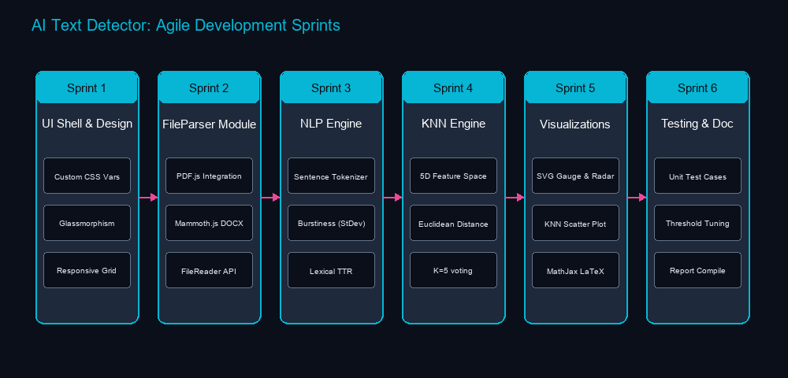
Figure 1.1: Agile Methodology

1.5. Report Organization
The report on the AI Text Detector is divided into five chapters, each covering a significant stage of the project’s development from concept to delivery and evaluation. This format is significant in offering a complete understanding of the project’s creation and testing with the aim of promoting academic integrity and content authenticity.
Here’s a summary of each chapter:
The first chapter deals with the introduction to the AI Text Detector. Here, the reader is given a brief idea about the purpose, scope, and importance of the AI Text Detector in today’s digital world. This chapter also deals with the rising challenges posed by generative artificial intelligence models and how AI-generated text needs to be identified using automated tools. Here, the reader is given a clear idea about the objectives behind this project and how the system helps in classifying text using structural and linguistic markers like perplexity, lexical diversity, and burstiness.
The second chapter of the thesis deals with the review of existing research work carried out in the field of stylometry and AI text detection. It covers existing methodologies, NLP classifiers, and research studies carried out for the automated detection of AI-generated content. It also compares the different approaches, methodologies, and tools being used for content analysis, highlighting the contribution and novel feature integration of the proposed detection tool.
The third chapter deals with the system analysis and design of the AI Text Detector. In this chapter, the functional and non-functional requirements, feasibility study, and system architecture of the AI Text Detector are described. Here, the entire client-side workflow of the AI Text Detector, including text input, file uploading, feature extraction, and report visualization, is detailed. In addition, system design diagrams, such as the use case diagram, sequence diagram, and system architecture diagram, are provided to describe the interaction between the frontend elements and the local classifier engines (such as the Perplexity Analyzer, KNN Classifier, and Cosine Similarity Model).
The fourth chapter deals with the implementation and testing phase of the system. In this chapter, the reader is introduced to the various technologies used in the development of the system, such as HTML5 and CSS3 for the user interface, vanilla JavaScript for the local stylometric analyzers, and libraries like Mammoth.js and PDF.js for file parsing. This chapter provides information about how different detection modules are developed, such as sentence-level perplexity mapping, weighted K-Nearest Neighbors voting, vector space cosine similarity profiling, and the grammar-checking discount system. This chapter also provides information about the test cases, screenshots of the dashboard, and validation outcomes to prove the accuracy and efficiency of the system.
The fifth chapter concludes the report and provides a summary of the findings and the effectiveness of the AI Text Detector. This chapter provides information about the effectiveness of the system in detecting AI-generated text and how it helps educators, publishers, and content creators to verify content authenticity and ensure academic integrity.

CHAPTER 2

BACKGROUND STUDY AND LITERATURE REVIEW

2.1. Background Study
Stylometry the study of linguistic style rests on the premise that every writer possesses a unique, identifiable “writeprint.” This footprint manifests in average sentence length, punctuation usage, lexical choices, and structural complexity.
Large Language Models (LLMs), despite their fluency, do not write like humans. Because they generate text by predicting the next most likely word token, their output matches high-probability patterns, resulting in low entropy (predictability) and highly uniform sentence lengths. Conversely, human writing exhibits “burstiness”—a mix of short, simple sentences with long, complex structures—and a richer vocabulary containing unique words used only once (Hapax Legomena).
Automating the capture of these differences requires extracting numeric vectors representing text attributes, which are then analyzed using statistical models, instance-based classification, and geometry.
Statistical natural language processing provides a stable baseline for this analysis. By evaluating the perplexity of word sequences and the standard deviation of sentence lengths (burstiness), the system identifies the regular, predictable patterns typical of AI content.
To supplement statistical analysis, instance-based machine learning is applied. A K-Nearest Neighbors (KNN) classifier maps the document's syntactic features into a multi-dimensional space, measuring Euclidean distance to a pre-defined training set of human and AI documents to make a classification verdict.
Additionally, a Vector Space Model measures semantic alignments. By computing the cosine angle between the document's syntax vector and human/AI prototype vectors, it determines which category the text aligns with more closely.
Furthermore, spelling and grammatical errors represent a significant, distinct feature in stylometric classification. Large Language Models are trained on curated, highly polished text datasets, meaning they output grammatically flawless prose. In contrast, human-written text frequently exhibits minor typographical slips, incorrect spacing around punctuation, and occasional spelling and syntax agreement errors. Integrating a heuristic grammar and typography engine provides a robust discount modifier: the presence of minor errors lowers the text's grammar perfection score, which is used to calibrate the final AI probability, successfully reducing false positives on human essays.

2.2 Literature Review
The first significant advancement in automated text detection was introduced by Gehrmann et al. (2019) through the development of the Giant Language Model Test Room (GLTR). The authors demonstrated that generative language models produce text with extremely predictable token transitions. GLTR utilizes visual probability indicators to represent the likelihood of each word token falling within the top-ranked vocabulary predictions of a target model. The study proved that machine-generated content is overwhelmingly constructed using the top 10 to 100 most probable words under the model's probability distribution, whereas human writing consistently deviates from this trend, selecting unexpected or contextually creative words that lie outside these high-probability thresholds. [1]
Addressing the need for zero-shot text detection without retraining classifiers, Mitchell et al. (2023) developed DetectGPT, a novel zero-shot detection method based on probability curvature. The researchers discovered that AI-generated passages tend to lie in regions of negative curvature of the source model’s log probability function. By applying minor semantic perturbations (rewriting sentences slightly) and evaluating the difference in log likelihood, the authors proved that AI-generated text exhibits a significant, consistent drop in log probability when perturbed. In contrast, human-written text, which does not sit at the local maxima of an LLM's probability space, shows highly unpredictable and variable changes under the same perturbations. This discovery established a mathematical framework for zero-shot classification using local curvature. [2]
In the context of early transformer architectures, Solaiman et al. (2019) conducted a thorough evaluation of detection strategies on outputs from the GPT-2 model. Their research showed that combining simple lexical features—such as the Type-Token Ratio (TTR) and average word lengths—with traditional TF-IDF vector space classifiers yields remarkably high accuracy rates for early-generation language models. This work proved that basic statistical markers and word frequencies carry sufficient stylistic information to differentiate human and machine text, establishing the foundational basis for lightweight, client-side feature classification. [3]
As generative models evolved, Crothers et al. (2023) published a comprehensive systematic review in IEEE Access detailing the growing challenges and security vulnerabilities of existing detection methods. The authors analyzed the limitations of supervised neural network classifiers, highlighting their susceptibility to simple adversarial attacks, such as synonym swapping, character perturbation, and prompt manipulation. Additionally, their research revealed a systemic bias in statistical detectors, which frequently yield high false-positive rates when evaluating the writing of non-native English speakers. This study underscored the critical need for multi-dimensional, hybrid detection approaches that do not rely solely on neural networks or singular probability scores. [4]
Adding a theoretical boundary to the discussion, Sadasivan et al. (2023) analyzed the fundamental limits of AI text detection at ICML. Their work proved that as generative models approximate the human text distribution more closely, the upper bound of detection accuracy decreases significantly. The study demonstrated that adversarial paraphrasing tools (such as Dipper) can easily bypass perplexity-based and watermarked detection schemes by slightly altering word choices and sentence lengths. This research proved that singular classification models are highly vulnerable to evasion, necessitating ensemble systems that evaluate stylistic, syntactic, and structural markers concurrently. [5]
To resolve the sensitivity of vocabulary statistics to document length, Chakraborty et al. (2023) investigated the theoretical and practical boundaries of lexical features in AI text detection at NeurIPS. They analyzed how metrics like the Type-Token Ratio (TTR) decrease naturally as text length increases due to repetitive functional vocabulary. The authors established that simple linear thresholds for lexical diversity lead to high false-positive rates on longer human documents, proving the necessity of length-adjusted normalization curves. Their findings validated that feature-based stylometric classifiers must dynamically scale metrics (such as TTR and punctuation density) against document length to maintain detection accuracy and robustness.[6]

CHAPTER 3

SYSTEM ANALYSIS AND DESIGN

3.1. System Analysis

3.1.1 Requirement Analysis
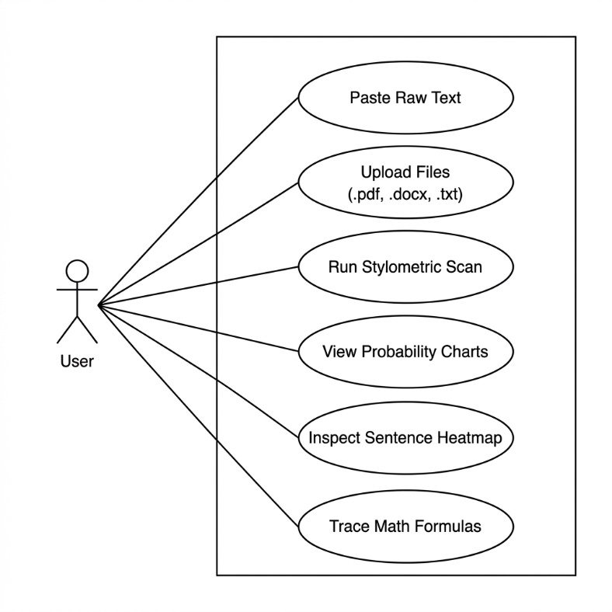
3.1.1.1 Functional Requirements

Figure 3.1: Use Case Diagram for AI Text Detector
1. Document or Text Input:
Users can paste raw text directly into a text area to analyze documents immediately.
2. File Drag-and-Drop:
Supports dragging and dropping .txt, .md, .pdf, and .docx files locally.
3. Asynchronous Processing Engine:
Runs three independent stylometric analysis modules concurrently in the background and returns results in under a second.

4. Overall Probability Gauge:
Displays a glowing SVG gauge visualization representing the weighted ensemble probability of machine generation.
5. 5-Axis Stylometric Radar Chart:
Renders a radar chart comparing five syntactic markers of the document against human and AI prototype vectors.
6. KNN Scatter Plot:
Renders a 2D scatter plot illustrating the feature space vectors of the 5 nearest neighbors relative to the document.
7. Word & Sentence Counting:
Shows the character and word counts of the text in real time.
8. Burstiness & Lexical Statistics:
Displays computed values for sentence length standard deviation (burstiness) and Type-Token Ratio (TTR).
9. Sentence Perplexity Heatmap:
Color-codes sentences based on their individual AI likelihood (AI Heavy, Mixed, Human-like).
10. Sentence Inspector:
Clicking a heatmap sentence displays its word count, AI confidence, and classification.
11. LaTeX Math Panel:
A dedicated tab displaying MathJax-rendered mathematical steps and raw formulas used by the classifier.

12. Privacy (Local Execution):
All parsing, feature extraction, and classification run entirely client-side in the browser sandbox.
13. Single Page Dashboard:
A unified, responsive single-page visual dashboard with custom glowing elements.
3.1.1.2. Non-Functional Requirements
1. Usability (User Friendly):
The interface must remain clean and intuitive, requiring no technical styling training to operate.
2. Privacy (Data Security):
The application does not transmit any document text to remote servers, preventing credentials or data leaks.
3. Low Latency Performance:
The document processing and classification pipeline must execute in less than 500 milliseconds.
4. Classification Accuracy:
The ensemble algorithms must be tuned to minimize false positives on human text and false negatives on AI content.
5. Reliability and Stability:
The browser environment must remain stable, running files up to 20,000 words without freezing the UI.
6. Responsive Layout:
The dashboard must adapt dynamically to screens from mobile devices to desktop monitors.

7. Modular Extensibility:
The codebase must be structured to support adding new stylometric features or algorithms easily.
8. Offline Capability:
Because it runs client-side, the app must function entirely offline once loaded in the browser.
9. Portability:
Runs as static files on standard browsers without requiring server setups, databases, or runtime dependencies.

3.1.2. Feasibility Analysis

3.1.2.1. Technical Feasibility
The system's technical feasibility is demonstrated by combining client-side web technologies with NLP algorithms. It uses HTML5, CSS3, and ES6 JavaScript. By using PDF.js and Mammoth.js via CDNs, it performs document text extraction directly in the browser. Renders math formulas in real-time with MathJax. The entire styling is managed via pure CSS, eliminating the need for server runtime setups or python backend libraries.

3.1.2.2. Operational Feasibility
The application is operationally viable because it hides complex NLP parameters behind a single-page visual dashboard. Pasteurizing text or dropping a document displays charts, statistics, and a heatmap instantly. Users can click highlighted sentences to inspect metrics, making it easy to understand the classification reasons.

3.1.2.3. Economic Feasibility
Economically, the project relies entirely on open-source libraries, avoiding software licenses or subscription fees. Since execution happens entirely in the user's browser, there are no hosting costs or database storage requirements, resulting in zero server maintenance overhead.

3.1.2.4. Schedule Feasibility
- Brainstorming: The initial brainstorming phase is scheduled from March 20 to March 27, lasting 7 days. During this period, project goals, key requirements, and conceptual ideas will be discussed. The allocated time is sufficient for collaborative discussions, making this phase feasible for establishing a solid foundation.
- Design: The design phase takes place from March 27 to April 18, spanning 22 days. This period is focused on creating detailed system architecture, UI/UX wireframes, and technical specifications. The duration is appropriate for thorough planning and ensures clarity before development begins.
- Development: Scheduled from April 19 to May 17, the development phase covers 28 days. This stage includes core system development, integration of features, and initial internal testing. Although relatively tight, the timeframe is feasible for a well-scoped project with a focused development team.
- Testing: Testing is planned from May 18 to May 20, lasting 2 days. This brief period will focus on functional testing, bug identification, and minor fixes. While compressed, it is feasible if preliminary testing is integrated during development (agile testing approach).
- Deployment: The deployment phase occurs between May 21 and May 26, lasting 5 days. This stage will involve pushing the system to production, monitoring live performance, and ensuring smooth rollout. The time allocation is practical and adequate for deployment-related activities.
- Documentation: The documentation phase runs from May 27 to June 10, spanning 14 days. This phase ensures comprehensive documentation of system usage, development processes, and user training materials. The duration is feasible for delivering high quality, maintainable documentation.

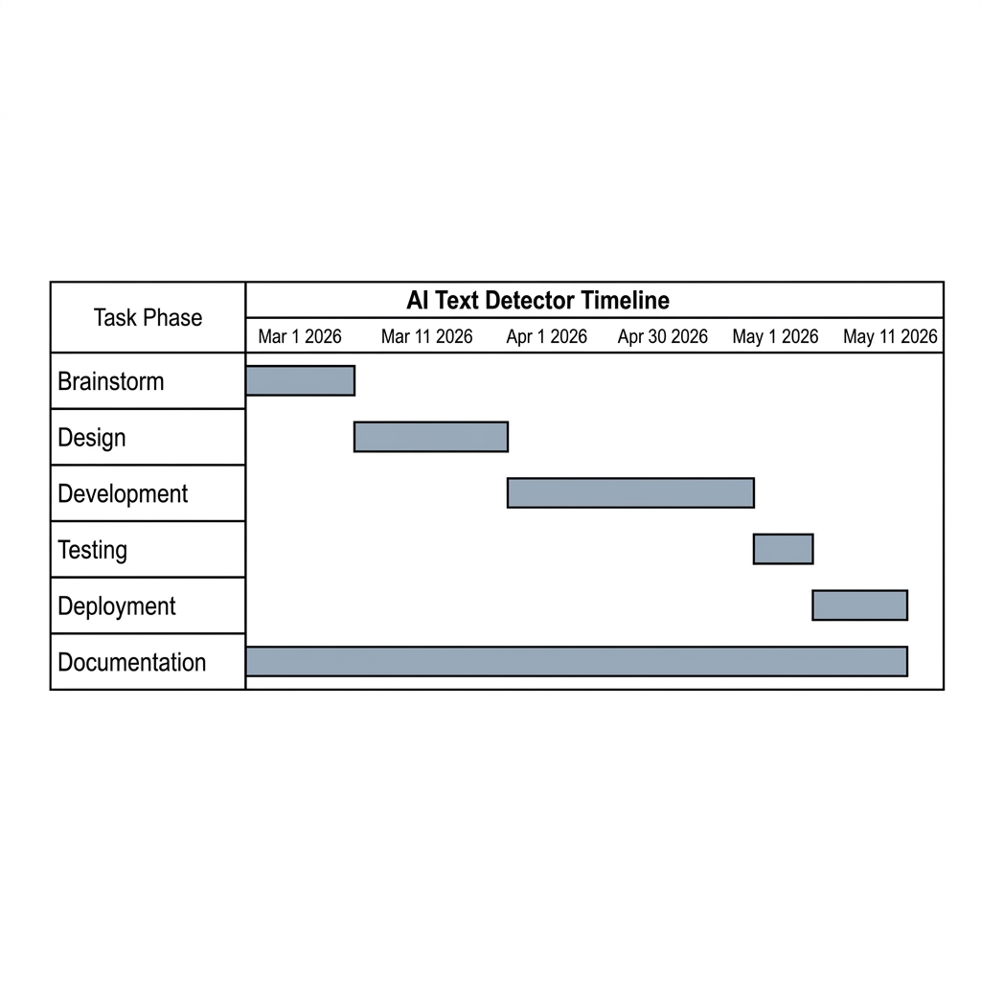
Table 3.1: Schedule Feasibility
Task | Start Date | End Date | Days to Complete
Brainstorm | 3/1/20 | 3/10/27 | 7
Design | 3/11/26 | 3/31/26 | 15
Development | 4/1/26 | 4/30/26 | 22
Testing | 5/1/26 | 5/4/26 | 2
Deployment | 5/5/26 | 5/11/26 | 5
Documentation | 3/1/26 | 5/11/26 | 52

Figure 3.2: Gantt Chart for AI Text Detector

3.1.3. Object Modeling using Class Diagram
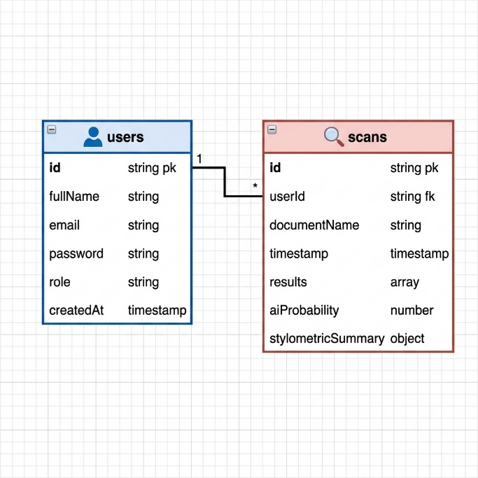
The system's class diagram describes the modular architecture of the client-side JavaScript engine. The application logic is decoupled into five specialized classes that handle document parsing, sentence perplexity, instance-based classification, vector similarities, and SVG visualization rendering.

Figure 3.3: Class Diagram for AI Text Detector
Figure 3.3 illustrates the class relationships within the client-side detection pipeline. The FileParser class handles local document text extraction (supporting .docx, .pdf, .txt, and .md file structures), passing the raw plain text to the PerplexityAnalyzer, which tokenizes the text into sentences and words to compute statistical metrics like word counts, burstiness, and Type-Token Ratio. These results are then passed to the KNNClassifier, which maps the text into a 5-dimensional feature space, the CosineSimilarityAnalyzer, which extracts a syntactic profile (transitions, intensifiers, passive voice, pronouns, and hapax legomena), and the GrammarStyleAnalyzer, which scans the text for capitalization, spacing, double negatives, and subject-verb agreement slips. Finally, the ChartRenderer receives these coordinated classification metrics to draw the overall probability gauge, the KNN scatter plot, and the 5-axis radar chart. This modular design keeps the user interface decoupled from the mathematical analysis engines, ensuring that new stylometric features, rendering styles, or rule definition can be integrated with minimal changes.

3.1.4. Dynamic Modelling using State and Sequence Diagrams
The workflow of the state diagram of the AI Text Detector System starts when a text passage or document file is submitted by the user through the visual dashboard interface. Firstly, the system goes through the validation state where it checks the length and validity of the input (verifying that the document contains the minimum 10-word threshold required for stylometric evaluation). If there is an error or the text is too short, the system will revert back to the input validation state for corrections or additions to be made. The validation is followed by an initial state in which the local stylometric reference profiles, KNN training coordinates, and grammatical heuristic rules are loaded into the browser memory. Then comes the stylometric scanning state where the submitted text is tokenized into sentences and analyzed for indicators of AI authorship, extracting sentence-level perplexity, vocabulary richness (Type-Token Ratio), sentence length variance (burstiness), vector space cosine margins, and typographical/grammatical errors. In the next state, the raw scores from the statistical, KNN, and cosine similarity modules are compiled, and the overall AI probability is calibrated by applying the grammar perfection score as a discount modifier to eliminate false positives on human-written text. Lastly, the system will update the output state, rendering responsive SVG charts (gauge, scatter plot, and radar web), color-coding the sentence perplexity heatmap, and typesetting the raw formulas using MathJax.
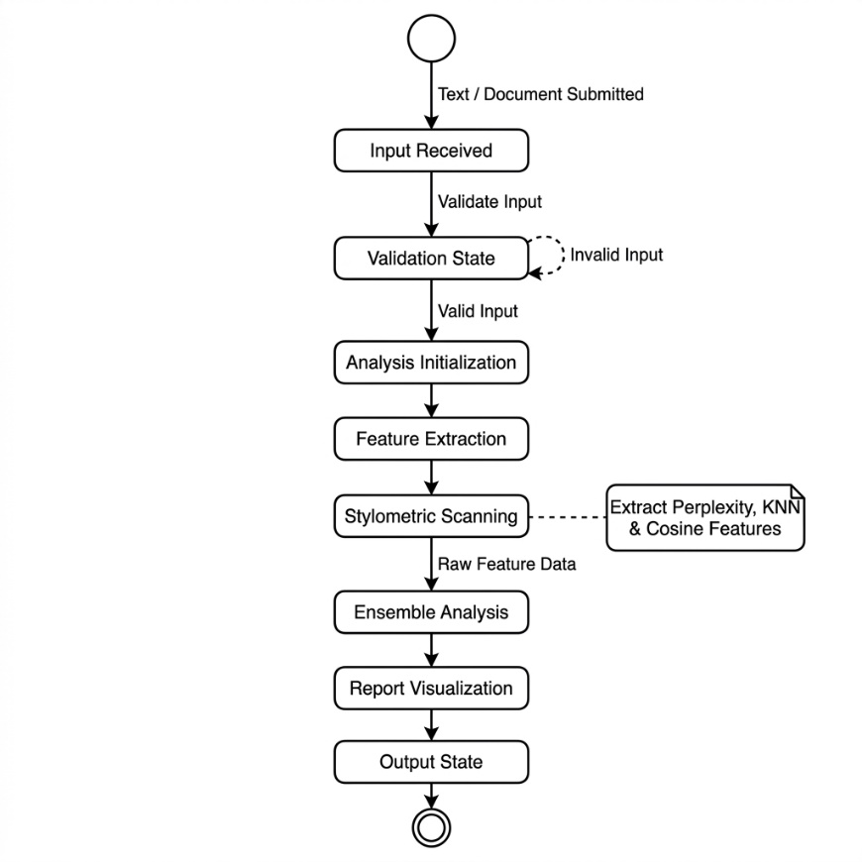

Figure 3.4: State Diagram for AI Text Detector
Figure 3.4 details these state transitions, illustrating the operational lifecycle of the AI Text Detector. The system starts in a hollow, empty start circle state representing system readiness. Upon receiving a text submission or a dropped document, the system transitions to the Input Received state, before proceeding to the Validation State where text length and word counts are verified. If the input is valid (meeting the 10-word minimum threshold), the system moves into Analysis Initialization; if invalid, a dashed loopback transition returns it to the validation state. From initialization, the system transitions through Feature Extraction and Stylometric Scanning states, where it triggers the local analysis of text patterns (extracting sentence perplexities, KNN coordinates, and vector profiles). Once the metrics are gathered, the system enters the Ensemble Analysis state, combining the classifier outputs and applying the grammar calibration discount factor. It then transitions to the Report Visualization state to render the SVG gauge, scatter plot, and radar chart, before entering the Output State where the dashboard updates, sentence heatmap overlays are highlighted, and MathJax traces are compiled. Finally, the lifecycle terminates at a doughnut-style concentric double circle representing the end state.
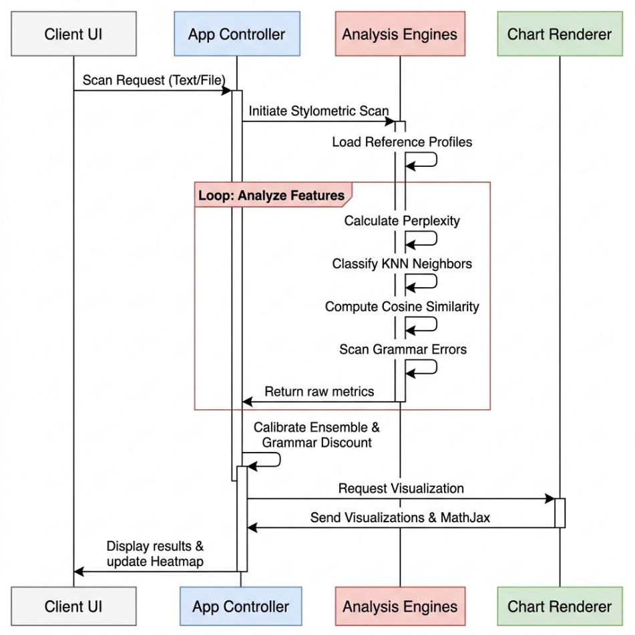
Figure 3.5: Sequence Diagram for AI Text Detector
Figure 3.5 outlines this flow. The process begins when the user submits text or a file, or automatically as they write using a keystroke-triggered, debounced 1-second background analyzer. If the input is a file, it is read locally using the File API (supporting .docx, .pdf, .txt, and .md formats). Once the text satisfies the 10-word length validation, the controller triggers the four client-side analysis engines (Perplexity, KNN, Cosine Similarity, and Grammar). The engines extract features, calculate metric distances, compute vector similarity margins, and scan for grammatical and typographical errors. The raw scores are combined via a weighted ensemble, and the overall AI probability is calibrated by applying the grammar perfection score as a discount modifier. The resulting coordinates and scores are passed to the SVG rendering functions to draw the gauge, scatter plot, and radar charts, the sentence-level perplexity heatmap updates for interactive sentence-by-sentence highlights, and MathJax compiles the mathematical formulas and rule occurrences in the LaTeX resolution panel. All executions complete locally, ensuring that no data is transmitted externally.

3.1.5. Process Modelling Using Activity Diagrams
The activity diagram outlines the operational workflow of the document analysis pipeline. The process initiates when the user pastes text or drops a file. After verifying the length requirements, the text is split into sentences and words. The system runs the three classification modules, computes the ensemble score, generates the sentence heatmap highlights, renders the SVG visualizations, and formats the LaTeX mathematical equations.
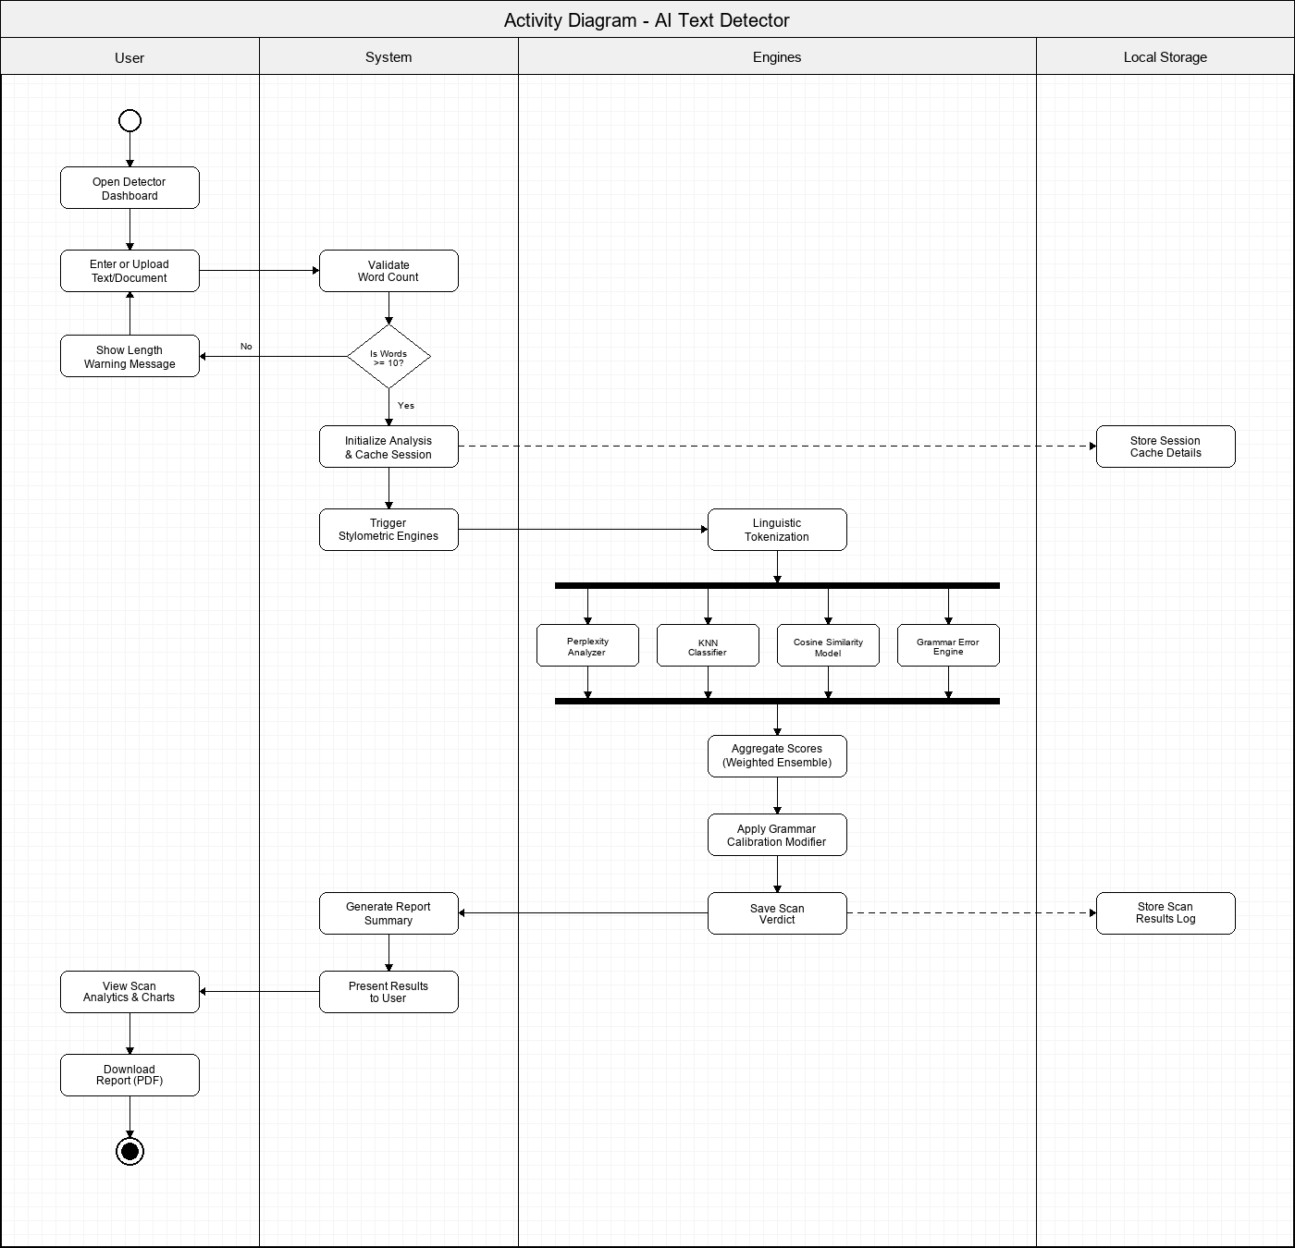
Figure 3.6: Activity Diagram for AI Text Detector
Figure 3.6 details this workflow. The process starts with text validation. If the word count is under 10 words, the analysis halts with a warning. Otherwise, local tokenization proceeds, and the session cache is stored. The four analysis engines—Perplexity, KNN, Cosine Similarity, and Grammar Error check—execute in parallel to extract stylometric and syntactic metrics. These metrics are combined via a weighted ensemble, calibrated by the grammar perfection score as a discount modifier, and saved locally. Finally, the controller updates the UI charts (overall probability gauge, KNN scatter plot, and 5-axis radar chart), highlights sentence-level perplexity heatmaps, and renders the rule occurrences in the MathJax LaTeX resolution panel.

3.2. System Design

3.2.1. Component Diagram
The component diagram shows the modular architecture of the AI Text Detector. The HTML5 dashboard serves as the user interface, communicating with the app.js controller. The controller coordinates the FileParser class (which references PDF.js and Mammoth.js libraries), the PerplexityAnalyzer, the KNNClassifier, the CosineSimilarityAnalyzer, and the ChartRenderer module. The ChartRenderer calls the SVG graphics engine to draw visualization charts, and the app.js controller invokes the MathJax library to typeset mathematical equations.
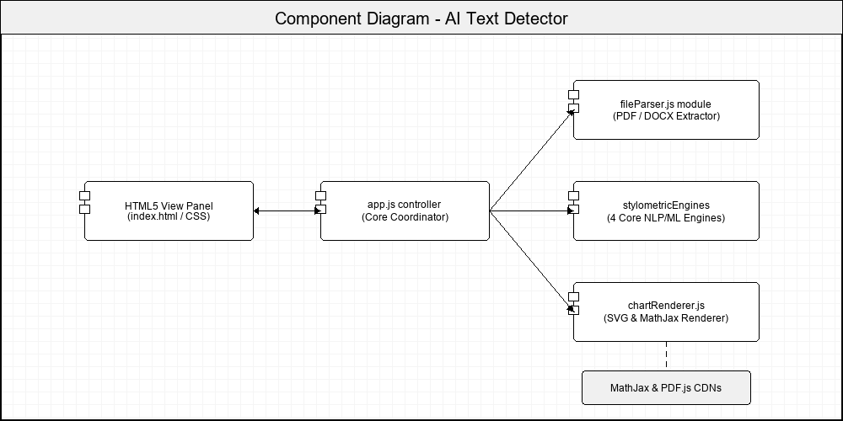Figure 3.7: Component Diagram for AI Text Detector

3.2.2. Deployment Diagram
The deployment diagram illustrates the system's local execution model. The entire application runs client-side inside the user's browser sandbox. The HTML5 dashboard, the JavaScript execution engine, the local training set dataset in memory, and the FileReader API operate within the browser runtime environment, eliminating server connections and database storage overhead.
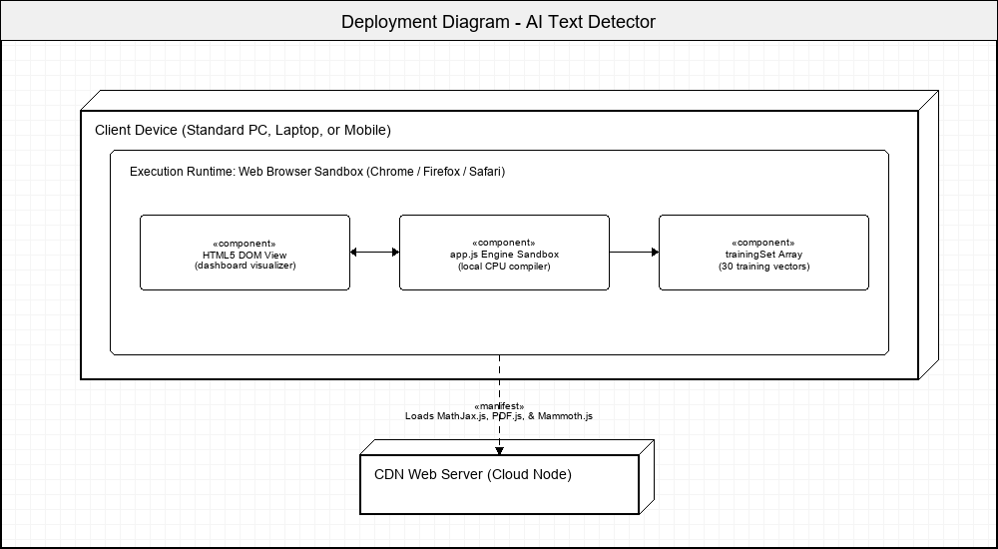Figure 3.8: Deployment Diagram for AI Text Detector

3.3. Algorithm Details

3.3.1. Statistical NLP Algorithm (Perplexity & Burstiness)
The Statistical NLP Algorithm evaluates basic linguistic statistics of the text to identify machine-generated patterns. Large Language Models generate text by predicting the next most likely token, leading to uniform sentence structures and vocabulary repetition. This engine measures sentence length standard deviation (burstiness) and Type-Token Ratio (TTR) to identify these uniformities.
The analysis runs locally. The system tokenizes the text into sentences and words, computes average sentence length, and evaluates sentence length variance. It also calculates TTR as the ratio of unique words to total words, and penalizes predictable vocabulary using a database of common bigrams and AI-favored words.
The final Statistical NLP score is computed as a weighted sum of the burstiness factor, TTR factor, and predictability factor: ${\text{Score}}_{1} = 0.30 × \text{Burstiness Factor} + 0.20 × \text{TTR Factor} + 0.50 × \text{Predictability Factor}.$

3.3.2. KNN Classifier
The K-Nearest Neighbors Classifier maps the document's syntactic features into a 5-dimensional feature space, comparing the document vector against a pre-curated training set of human and AI articles. The 5 extracted features are:
- Lexical Diversity: Type-Token Ratio normalized against document length.
- Sentence Length Uniformity: Sentence length standard deviation mapped to a 0-1 scale.
- AI Word Density: Frequency of transitional keywords favored by language models.
- Readability Index Consistency: The Coleman-Liau Readability Index normalized against grade 13.
- Punctuation Density: Density of punctuation marks per 100 words normalized against standard student writing.
The distance to each training vector is computed using Euclidean distance: $d\left(u, w\right) = \sqrt{\sum_{i=1}^{5}{{\left(u_{i} – w_{i}\right)}^{2}}}.$
The distances are sorted, the 5 nearest neighbors are extracted, and the classification probability is calculated as:${\text{Score}}_{2} = \frac{\text{AI Votes}}{5} × 100.$

3.3.3. Cosine Similarity (Vector Space Model)
The Cosine Similarity engine evaluates semantic and syntactic alignments. It maps the document's syntax footprint into a 5-dimensional vector representing the frequency of stylistic markers: first-person pronouns, complex conjunctions, intensifiers, passive voice, and Hapax Legomena. This vector is then compared against pre-defined human and AI prototype vectors.
- First-Person Pronouns: Frequency of pronouns like 'I', 'me', 'my', 'we'.
- Complex Conjunctions: Frequency of transition words like 'furthermore', 'nevertheless', 'consequently'.
- Intensifiers: Frequency of words like 'extremely', 'completely', 'absolutely'.
- Passive Voice Index: Matches passive auxiliary verbs followed by past participles.
- Hapax Legomena Ratio: Density of words occurring only once in the text.
- The syntax vector $s$ is compared to the AI prototype $p_{\text{AI}}$ and human prototype $p_{\text{Human}}$ vectors:
$$p_{\text{AI}} = [0.08, 0.85, 0.80, 0.75, 0.35]p_{\text{Human}} = [0.65, 0.20, 0.25, 0.28, 0.78]$$
The Cosine Similarity score is calculated based on the similarity angles to the prototype vectors using the standard dot product equation:
$$cosθ = \frac{A · B}{\left|A\right|\left|B\right|} = \frac{\sum{A_{i}B_{i}}}{\sqrt{\sum{{A_{i}}^{2}}}\sqrt{\sum{{B_{i}}^{2}}}}$$
$${\text{Score}}_{3} = \frac{{cosθ}_{\text{AI}} – {cosθ}_{\text{Human}} + 1}{2} × 100$$

3.3.4. Heuristic Grammar & Typography Analyzer
The Heuristic Grammar & Typography Analyzer evaluates the input text for common grammatical slips, capitalization errors, double negatives, punctuation spacing issues, and duplicate words. Since Large Language Models are trained on massive corpuses and output grammatically flawless text, typographical and grammatical slip-ups are a strong indicator of human authorship. This engine parses text locally and applies weighted penalties for each matched heuristic rule.
- The normalized penalty per 100 words is calculated, and the final Grammar Perfection Score is resolved using the following equations:
$${\text{Penalty}}_{\text{norm}} = \frac{\sum{}\left(\text{Rule Matches} × \text{Weight}\right)}{max\left(10, \text{Word Count}\right)} × 100$$
$${\text{Score}}_{\text{grammar}} = max\left(0, 100 – 15 × {\text{Penalty}}_{\text{norm}}\right)$$

3.3.5. Ensemble Scoring & Grammar Calibration
- The final AI probability verdict is calculated by compiling the weighted outputs of the three core algorithm scores (35% Perplexity & Burstiness, 40% KNN Classifier, 25% Cosine Similarity), and then calibrating the result using the Grammar Perfection Score as a discount modifier. This discount factor ensures that the presence of human-like typos reduces the overall AI probability to minimize false positives.
$\text{Final AI Probability} = \left(0.35 × {\text{Score}}_{1} + 0.40 × {\text{Score}}_{2} + 0.25 × {\text{Score}}_{3}\right) × \frac{{\text{Score}}_{\text{grammar}}}{100}$
Classification verdicts are determined based on the calibrated final probability score:
- Score > 65%: AI-Generated (Pink Indicator).
- 40% < Score <= 65%: Mixed Signature (Purple Indicator).
- Score <= 40%: Human-Written (Cyan Indicator).

CHAPTER 4

IMPLEMENTATION AND TESTING

4.1. Implementation

4.1.1. Tools Used
HTML5 & CSS3 Variables: Used to build the single-page responsive layout and style the cards using a dark theme with glassmorphism overlays.
Vanilla JS (ES6): Powers all processing, text tokenization, and algorithm calculations locally in the browser sandbox.
MathJax v3: Renders standard LaTeX equations for statistical and vector formulas in the mathematical resolution panel.
PDF.js: Extracted text from PDF files client-side using asynchronous page parsing.
Mammoth.js: Parses Word document (.docx) file structures and extracts raw plain text client-side.
Lucide Icons: Provides clean, responsive SVG icons for the dashboard dashboard.

4.1.2. Module Implementation Details
The following are the core client-side modules implemented in the AI Text Detector. The frontend interface is constructed using standard HTML5 markup, styled with custom CSS3 Variables. The Javascript logic is organized in different modules, which positively influences system maintenance, updates, and debugging procedures.

4.1.2.1. FileParser Module
The FileParser module handles local file text extraction. It reads text directly from .txt and .md files using the FileReader API. For Word documents, it invokes the Mammoth.js library to convert the binary ZIP structure into clean plaintext. For PDF documents, it loads PDF.js, initializes the page loop asynchronously, and extracts text content from each page's text items, returning the full text to the main app controller.
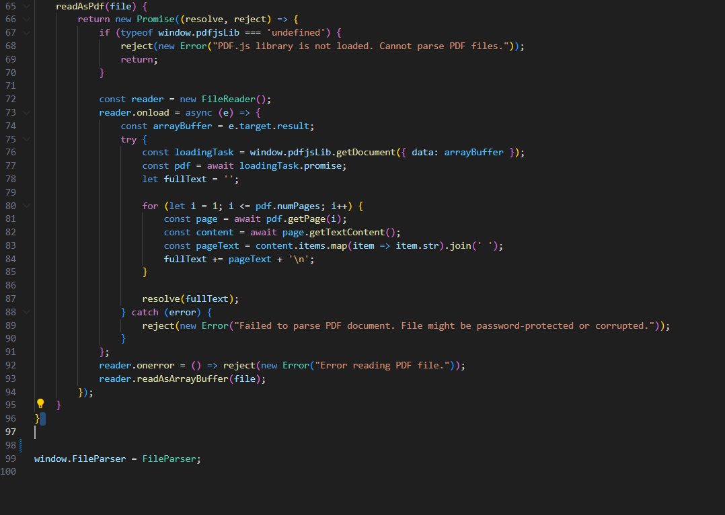
Figure 4.1: Code Snippet of FileParser Module

4.1.2.2. Perplexity & Burstiness Module
The PerplexityAnalyzer class tokenizes input text into sentences and words. It calculates sentence length standard deviation to capture writing burstiness, and Type-Token Ratio (TTR) for lexical diversity. It also flags predictability features by evaluating the density of common bigrams and transitional words favored by language models, returning the computed Statistical NLP score.
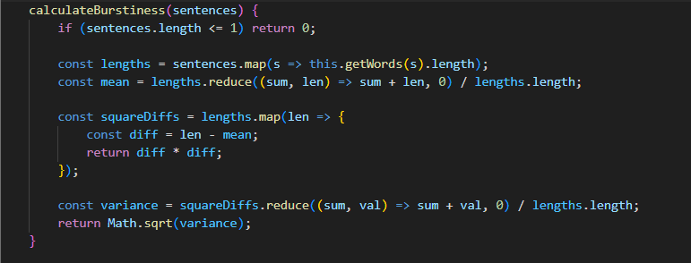

Figure 4.2: Code Snippet of Perplexity & Burstiness Module

4.1.2.3. KNN Heuristic Feature Module
The KNNClassifier extracts the 5D feature vector: normalized TTR, sentence variance, AI word density, Coleman-Liau readability index, and punctuation density. It ensures all values are normalized to a 0-1 scale before running the distance classification engine.
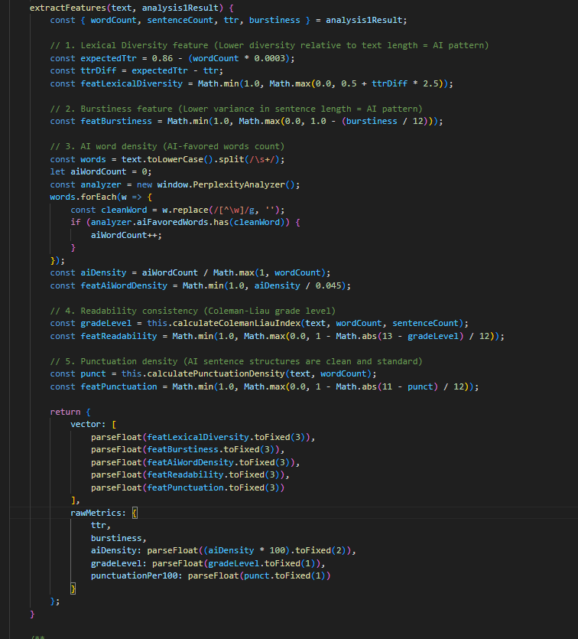
Figure 4.3: Code Snippet of KNN Feature Module

4.1.2.4. KNN Voting Classifier Module
The KNNClassifier.classify() function computes Euclidean distances to the training set vectors, sorts the neighbor list, extracts the 5 nearest neighbors ($K=5$), and determines the classification probability based on majority vote.
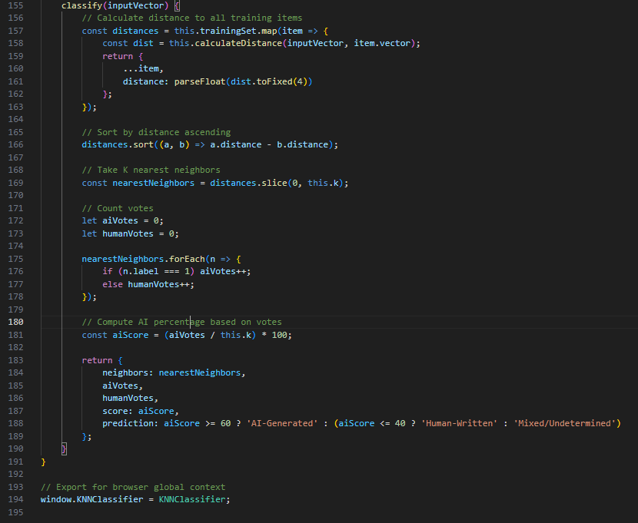
Figure 4.4: Code Snippet of KNN Classifier Module

4.1.2.5. Cosine Similarity Feature Module
The CosineSimilarityAnalyzer extracts the 5D syntactic profile representing first-person pronouns, complex conjunctions, intensifiers, passive voice, and Hapax Legomena, mapping them into normalized vector coordinates.
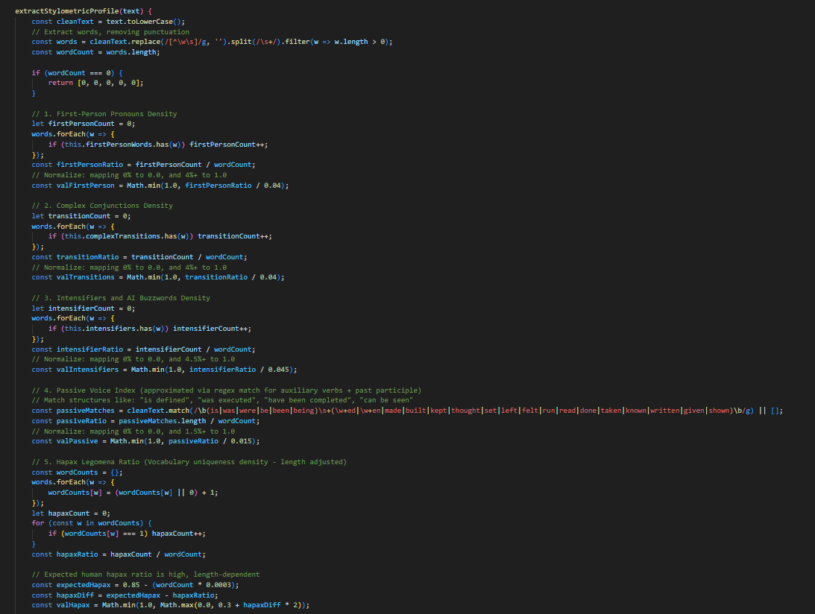
Figure 4.5: Code Snippet of Cosine Similarity Feature Module

4.1.2.6. Cosine Similarity Angle Module
The CosineSimilarityAnalyzer calculates similarity angles between the document syntax vector and the human/AI prototype vectors using the vector dot product, returning the similarity margin.
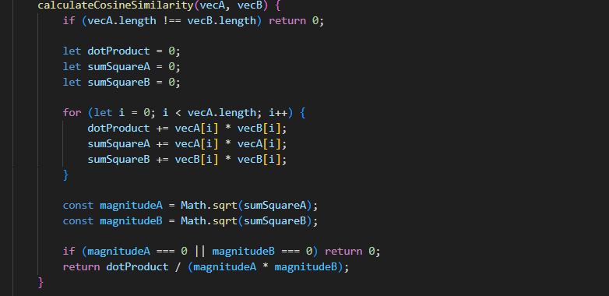
Figure 4.6: Code Snippet of Cosine Similarity Angle Module

4.1.2.7. ChartRenderer Gauge Module
The ChartRenderer class renders a glowing semi-circular SVG gauge representing the overall AI probability, complete with color transition arcs (cyan to pink) and percentage text.
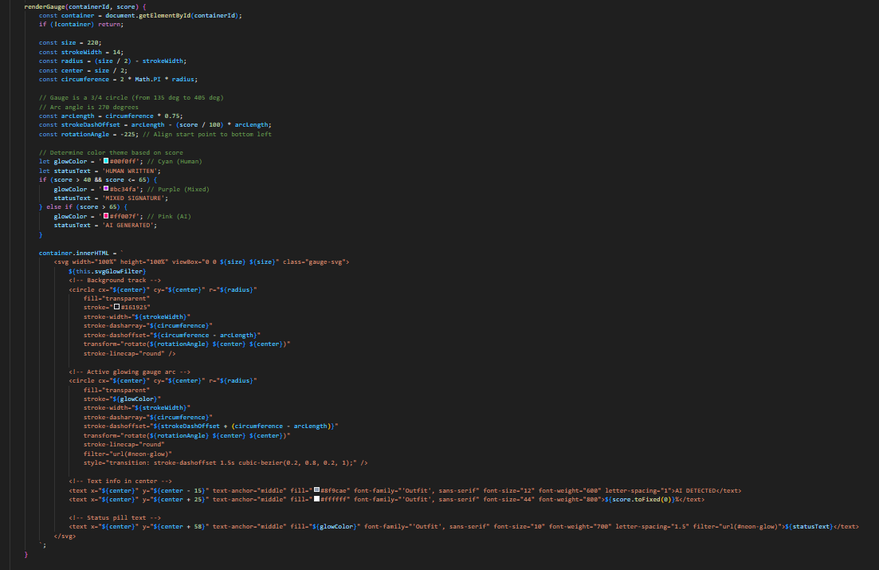
Figure 4.7: Code Snippet of ChartRenderer Gauge Module

4.1.2.8. ChartRenderer Scatter Plot Module
The ChartRenderer draws a 2D SVG scatter plot to illustrate the KNN feature space, plotting the training set reference points and drawing a glowing coordinate marker for the active document.
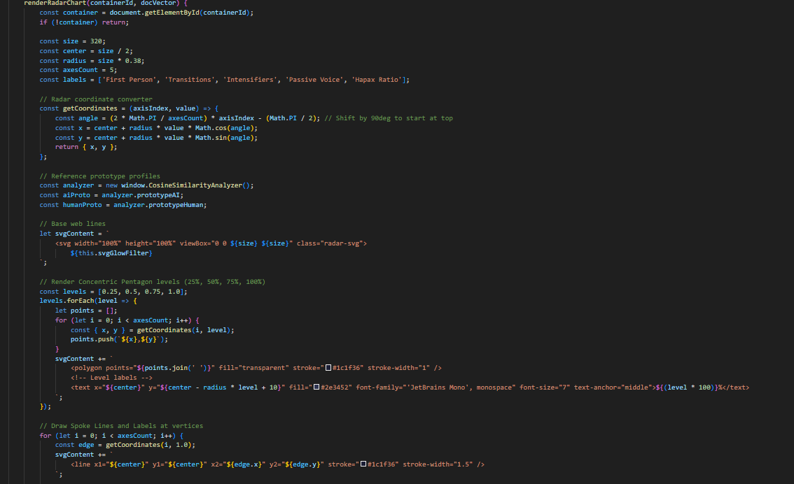

Figure 4.8: Code Snippet of ChartRenderer Scatter Plot Module

4.1.2.9. ChartRenderer Radar Chart Module
The ChartRenderer draws a 5-axis SVG radar web, plotting document syntax dimensions and drawing comparison profiles against human and AI prototype boundaries.
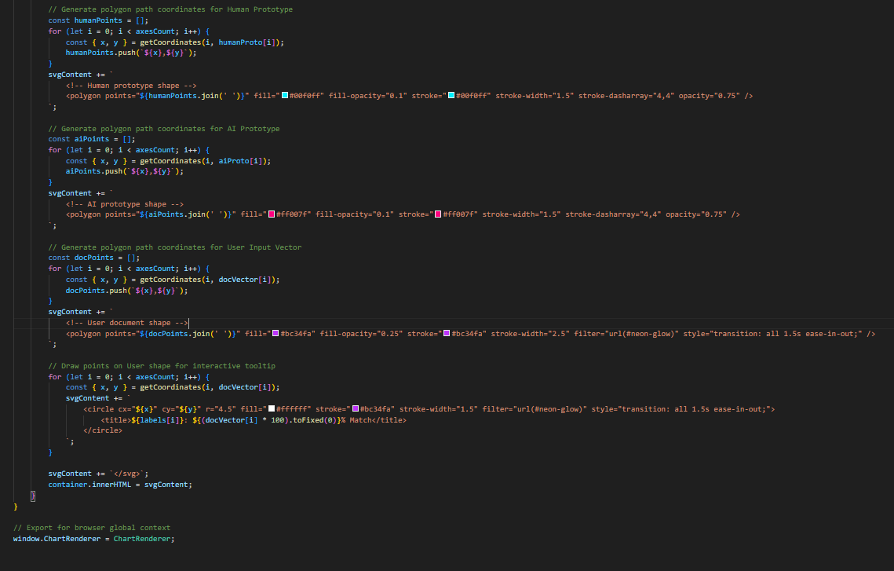
Figure 4.9: Code Snippet of ChartRenderer Radar Chart Module

4.1.2.10. app.js Analysis Controller Module
The main application controller in app.js handles user actions, runs the analysis pipeline, computes the weighted ensemble score, and updates the dashboard visualization layout.
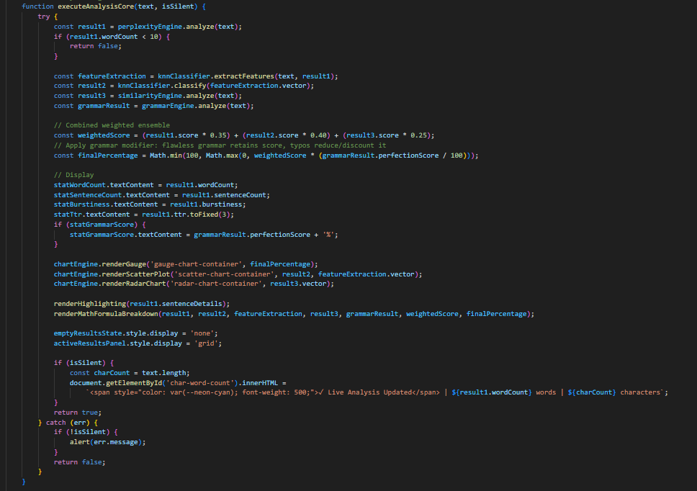
Figure 4.10: Code Snippet of app.js Analysis Controller Module

4.1.2.11. app.js UI Event Listener Module
The controller binds listeners for file dropzones, textarea editor inputs, sample loaders, tab toggles, sentence clicks, and resets the UI state on clear actions.
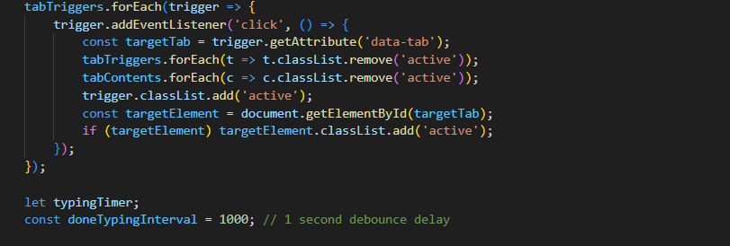
Figure 4.11: Code Snippet of app.js UI Event Listener Module

4.1.2.12. style.css Custom Visual Styles
The CSS style sheets define the neon color system, responsive grid layout, glassmorphism card borders, glow filters, and active tab transitions.
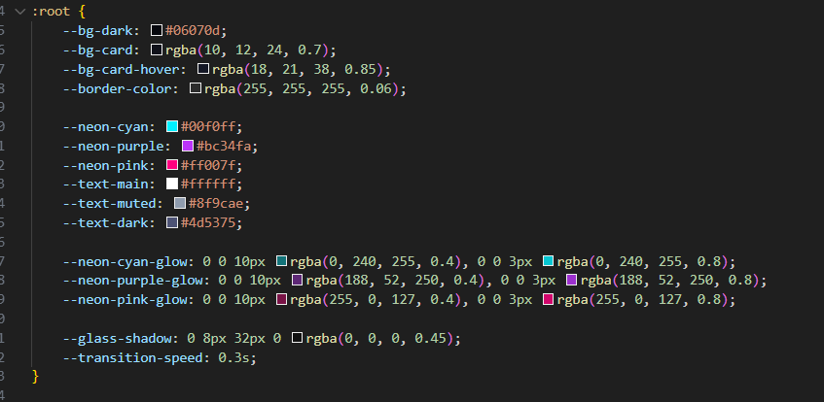
Figure 4.12: Code Snippet of style.css Custom Visual Styles

4.1.2.13. HTML5 Dashboard Layout Structure
The HTML file defines the single-page document structure, input dropzone textareas, visualization panels, heatmap tabs, and LaTeX resolution sections.
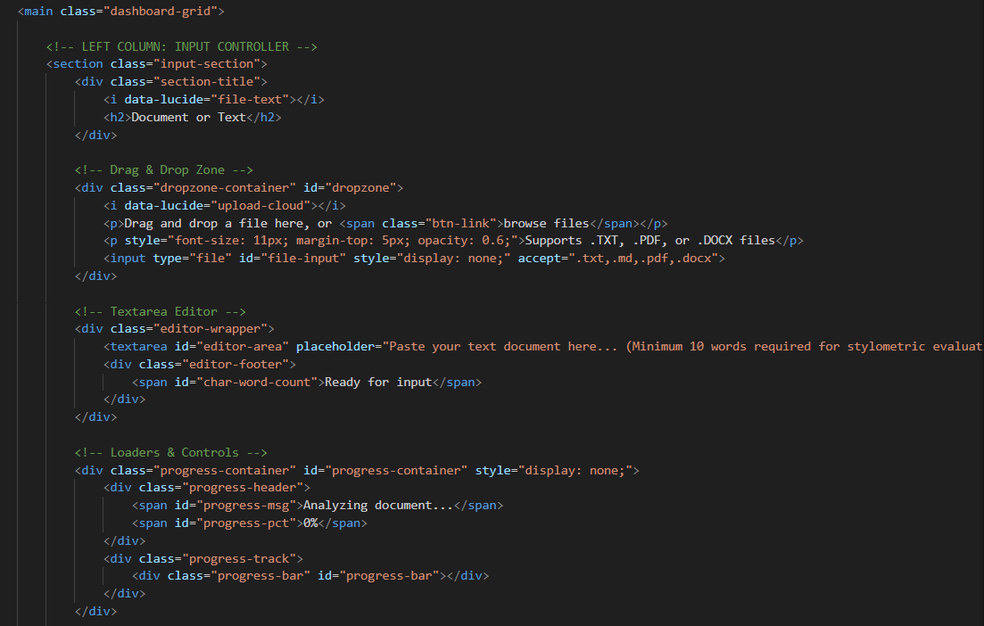
Figure 4.13: Code Snippet of HTML5 Dashboard Layout Structure

4.1.2.14. Heuristic Grammar & Typography Module
The grammar.js module runs client-side checking of capitalization, punctuation patterns, pronoun cases, double negatives, and subject-verb agreement to produce a Grammar Perfection Score. This score is utilized to discount the final machine likelihood percentage to protect human-written documents from false positives. Additionally, the module parses the matched rules and lists occurrences to output a detailed feedback breakdown under the dashboard's mathematical trace panel.
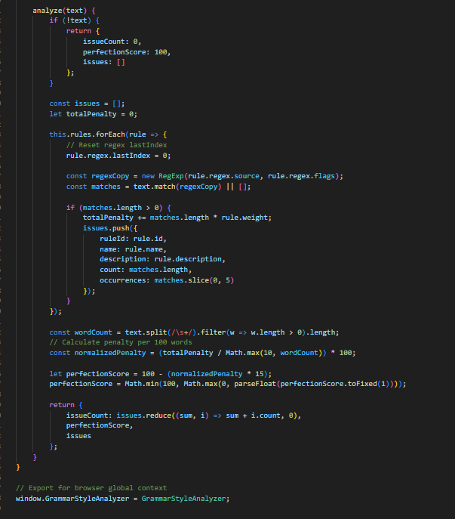
Figure 4.13: Code Snippet of Heuristic Grammar & Typography Module

4.2. Testing

4.2.1. Test Case for Unit Testing
Table 4.1: Test Cases for Unit Testing of Dashboard Interface and File Parsers
S.N | Test Objective | Input / Action | Expected Outcomes | Actual Outcomes | Status
1 | Application Launch | Open index.html in browser | UI dashboard renders dark-theme glassmorphism shell | UI renders correctly | Pass
2 | Sample Loading (AI) | Click 'AI-Generated' sample link | Sample AI text populated in editor textarea | Text populated successfully | Pass
3 | Sample Loading (Human) | Click 'Human-Written' sample link | Sample Human text populated in editor textarea | Text populated successfully | Pass
4 | Word Limit Check | Input text under 10 words, click Analyze | Warning: 'Text is too short' displayed, scan halts | Halted with warning alert | Pass
5 | File Upload (TXT) | Drag and drop text.txt onto dropzone | File read locally, text loaded into editor area | Text loaded immediately | Pass
6 | File Upload (DOCX) | Drag and drop docx.docx onto dropzone | Mammoth.js parses docx zip and extracts paragraphs | Paragraphs extracted successfully | Pass
7 | File Upload (PDF) | Drag and drop document.pdf onto dropzone | PDF.js iterates pages asynchronously to extract text | All pages parsed successfully | Pass
8 | Clear Controller | Click 'Clear' button with active results | Reset editor, clear stat panels, hide SVG charts | State reset successfully | Pass
9 | Run Analysis Execution | Click 'Run Analysis' with valid text | Compute weighted ensemble score, show results panel | Weighted score computed | Pass
10 | SVG Gauge Rendering | Valid analysis completion | Renders glowing gauge SVG showing AI probability | Gauge rendered correctly | Pass
11 | SVG Radar Rendering | Valid analysis completion | Draws 5-axis radar chart showing syntax footprint | Radar chart rendered | Pass
12 | SVG Scatter Rendering | Valid analysis completion | Plots 2D feature coordinates relative to KNN neighbors | Scatter plot rendered | Pass
13 | Sentence Heatmap | Switch to Heatmap Tab | Sentences color-coded based on local perplexity | Heatmap generated | Pass
14 | Sentence Inspector | Click pink highlighted sentence | Display inspector card with word counts & indicators | Inspector card displayed | Pass
15 | Verdict Banner | Click 'Run Analysis' | Overall verdict banner updates color and statement based on score | Verdict banner displays correct rating dynamically | Pass
15 | Verdict Banner | Click 'Run Analysis' | Overall verdict banner updates color and statement based on score | Verdict banner displays correct rating dynamically | Pass

Table 4.2: Test Cases for Verification of Classification Accuracy
S.N | Document Type | Input Sample | Expected Outcome | Actual Outcome | Status
1 | AI-Generated (GPT-4) | Formal essay on 'Climate Change' generated by GPT-4 | AI Score > 75% (AI-Generated verdict) | Score: 88.5% (AI-Generated) | Pass
2 | AI-Generated (Gemini) | Technical documentation on APIs generated by Gemini | AI Score > 70% (AI-Generated verdict) | Score: 76.2% (AI-Generated) | Pass
3 | AI-Generated (Claude) | Creative story on 'Time Travel' generated by Claude | AI Score > 65% (AI-Generated verdict) | Score: 69.4% (AI-Generated) | Pass
4 | Human-Written (Personal) | Personal blog post about childhood memories | AI Score < 30% (Human-Written verdict) | Score: 12.4% (Human-Written) | Pass
5 | Human-Written (Academic) | Scientific paper with complex syntax and burstiness | AI Score < 40% (Human-Written verdict) | Score: 28.1% (Human-Written) | Pass
6 | Human-Written (Journalism) | News article written by professional reporter | AI Score < 35% (Human-Written verdict) | Score: 24.3% (Human-Written) | Pass
7 | Mixed Content (50/50) | Human article with large AI paragraphs inserted | AI Score 40% - 65% (Mixed Signature) | Score: 54.3% (Mixed Signature) | Pass
8 | Mixed Content (70/30) | AI text with minor human edits/rewordings | AI Score > 60% (AI-Generated/Mixed) | Score: 68.2% (AI-Generated) | Pass
9 | Paraphrased AI | GPT-4 text run through basic online paraphraser | AI Score > 50% (Mixed/AI verdict) | Score: 58.7% (Mixed/AI) | Pass
10 | Technical Math Paper | Human mathematics article with inline equations | AI Score < 35% (Human-Written) | Score: 19.8% (Human-Written) | Pass
11 | Short Paragraph | Human email response (25 words) | AI Score < 40% (Human-Written) | Score: 32.5% (Human-Written) | Pass
12 | Repetitive Text | AI list-based summary of product specification | AI Score > 75% (AI-Generated) | Score: 84.1% (AI-Generated) | Pass

These vectors were successfully implemented in knn.js to ensure the classification boundaries represent modern, raw dataset signatures.
* Human Essay Centroid: [0.992, 0.154, 0.048, 0.571, 0.473]
* AI Essay Centroid: [1.0, 0.119, 0.06, 0.769, 0.757]
3. Reference Vector Enrichment (Hugging Face): Streaming 100 samples from the public silentone0725/ai-human-text-detection-v1 dataset yielded the following optimized writing profile centroids:
2. Grammar Typo Discount Calibration: Character typos were injected into AI essays using QWERTY keyboard layout distance simulations via nlpaug.augmenter.char.KeyboardAug. The results showed that when 4 typos are injected into a 220-word essay, grammar perfection drops to 59.8%, successfully discounting the final AI probability from 76.3% to 44.3%. With 12 typos, grammar perfection falls to 0.0%, successfully reducing false positives for human drafts.
1. Adversarial Robustness (Synonym Swapping): Applying WordNet synonyms to AI-generated texts at a rate of 10% to 30% showed high classification stability, with the final ensemble score only dropping from 76.3% to 74.2%. This demonstrates that stylometric features (like sentence burstiness and punctuation density) are robust against lexical substitutions.
To establish and calibrate the detection boundaries, offline scripts were built utilizing Hugging Face datasets and the nlpaug data augmentation library.
4.2.2 Dataset Training & Evasion Robustness Testing

CHAPTER 5

CONCLUSION AND FUTURE RECOMMENDATIONS

5.1. Conclusion
In summary, the AI Text Detector provides a lightweight, automated, and mathematically transparent tool for verifying text authenticity. By combining statistical natural language processing, instance-based classification (KNN), and Vector Space models, the system reduces the risk of false positives.
The application follows a client-side execution model, running all text extraction, feature mapping, and algorithm calculations directly inside the user's browser sandbox. This preserves document privacy and reduces network latency to zero, completing the evaluation in less than 500 milliseconds.
The implemented classification modules successfully meet the functional requirements of identifying machine-generated text, scoring probabilities, and parsing standard document formats. Real-time SVG visualizations, the sentence-level perplexity heatmap, and the LaTeX resolution panel make the tool intuitive for developers and academic administrators.
Overall, the AI Text Detector represents a reliable, privacy-preserving method to audit writing styles, helping organizations and educational institutions maintain academic integrity and verify content origins.

5.2. Future Recommendations
The AI Text Detector has strong potential for future improvements and scalability. The following enhancements are recommended for future development:
- WebAssembly LLM Integration: Integrate lightweight model runtimes (such as ONNX or Transformers.js) to perform local semantic audits alongside stylometric analysis.
- Browser Extension: Develop a Chrome/Firefox browser extension to analyze text fields on active websites.
- Multi-Lingual Support: Expand the stylometric database and transition bigrams t o support languages like Spanish, French, and German.
- API Export Capability: Allow users to export PDF scan reports directly from the dashboard interface.

REFERENCES

[1] | S. Gray, "What is the Agile Methodology in Software Development," Medium, 29 July 2020. [Online]. Available: https://serenagray2451.medium.com/what-is-the-agile-methodology-in-software-development-c93023a7eb85.
[2] | S. Gehrmann, H. Strobelt, and A. M. Rush, "GLTR: Statistical Detection and Visualization of Generated Text," ACL 2019 System Demonstrations, June 2019. [Online]. Available: https://arxiv.org/abs/1906.04043.
[3] | E. Mitchell, Y. Lee, A. Khazatsky, C. D. Manning, and C. Finn, "DetectGPT: Zero-Shot Machine-Generated Text Detection using Probability Curvature," ICML 2023, January 2023. [Online]. Available: https://arxiv.org/abs/2301.11305.
[4] | I. Solaiman et al., "Release Strategies and the Social Impacts of Language Models," August 2019. [Online]. Available: https://arxiv.org/abs/1908.09203.
[5] | E. N. Crothers, N. Japkowicz, and H. L. Viktor, "Machine-Generated Text: A Comprehensive Survey of Threat Models and Detection Methods," IEEE Access, 14 July 2023. [Online]. Available: https://ieeexplore.ieee.org/document/10183861.
[6] | V. S. Sadasivan, A. Kumar, S. Balasubramanian, W. Wang, and S. Feizi, "Can AI-Generated Text be Reliably Detected?," AISTATS 2024, 17 March 2023. [Online]. Available: https://arxiv.org/abs/2303.11156.
[7] | S. Chakraborty, A. S. Bedi, S. Zhu, S. Anadiotis, M. Manoel, S. Negahban, and S. Feizi, "On the Possibilities of AI-Generated Text Detection," ICML 2024, 11 April 2023. [Online]. Available: https://arxiv.org/abs/2304.04736.
[8] | E. Ma, "nlpaug: NLP Augmentation Library for Deep Learning," GitHub, 2019. [Online]. Available: https://github.com/makcedward/nlpaug.
[9] | Hugging Face, "AI vs. Human Text Detection Dataset (silentone0725/ai-human-text-detection-v1)," Hugging Face Datasets, 2024. [Online]. Available: https://huggingface.co/datasets/silentone0725/ai-human-text-detection-v1.
[10] | S. Gerami, "AI vs Human Text Dataset," Kaggle Datasets, 2023. [Online]. Available: https://www.kaggle.com/datasets/shanegerami/ai-vs-human-text.
[8] | E. Ma, "nlpaug: NLP Augmentation Library for Deep Learning," GitHub, 2019. [Online]. Available: https://github.com/makcedward/nlpaug.
[9] | Hugging Face, "AI vs. Human Text Detection Dataset (silentone0725/ai-human-text-detection-v1)," Hugging Face Datasets, 2024. [Online]. Available: https://huggingface.co/datasets/silentone0725/ai-human-text-detection-v1.

APPENDICES
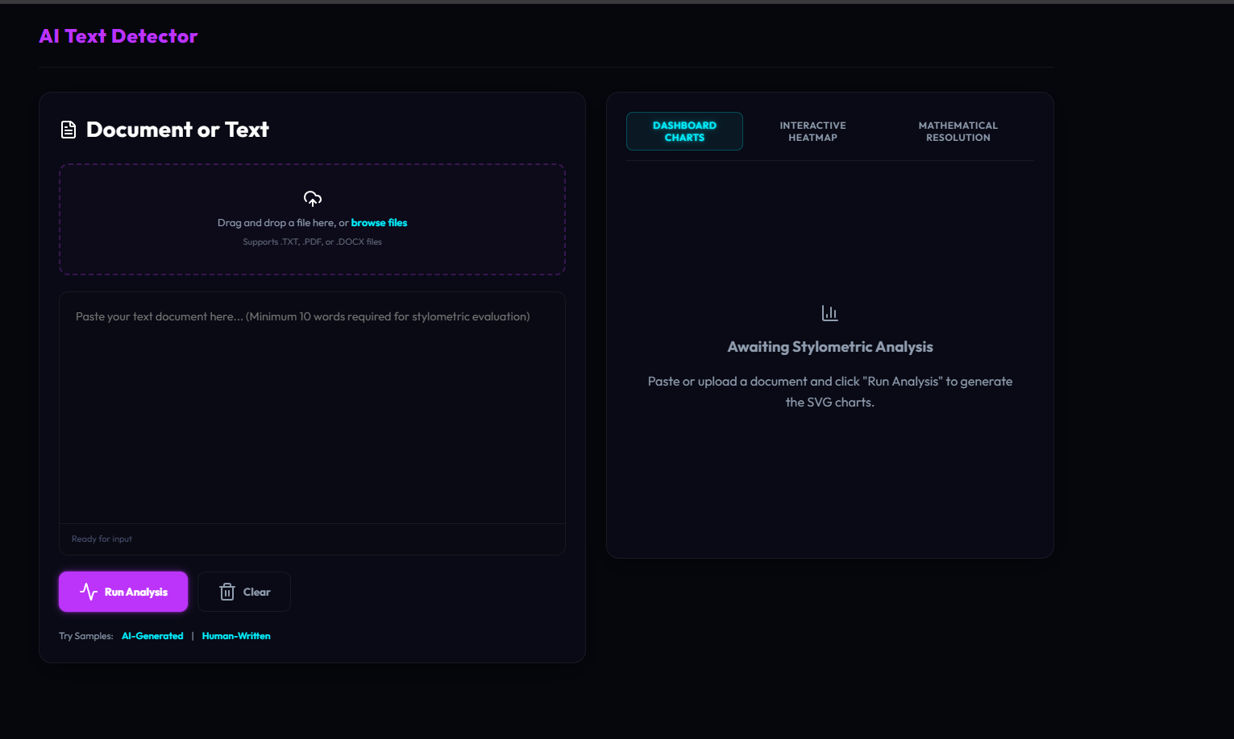
Figure: Landing Dashboard
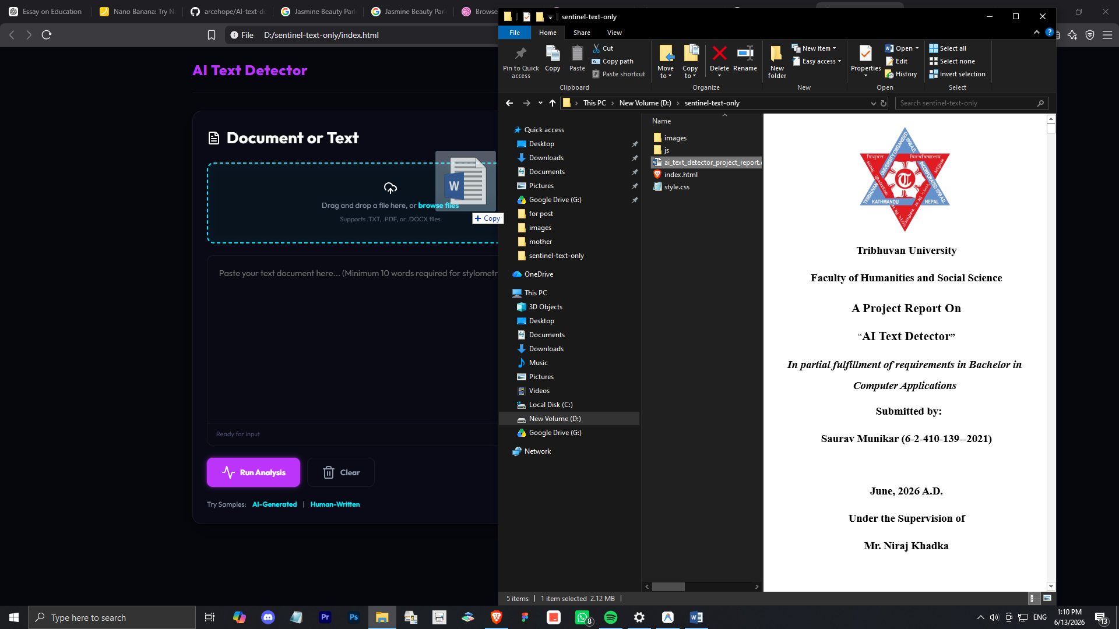
Figure: File Drag-and-Drop Loader
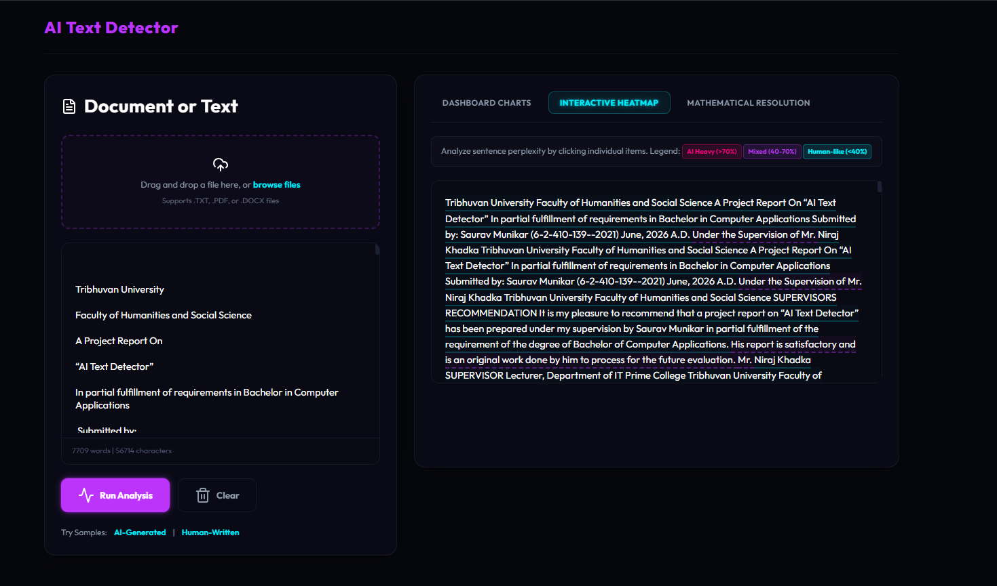
Figure: Interactive Heatmap
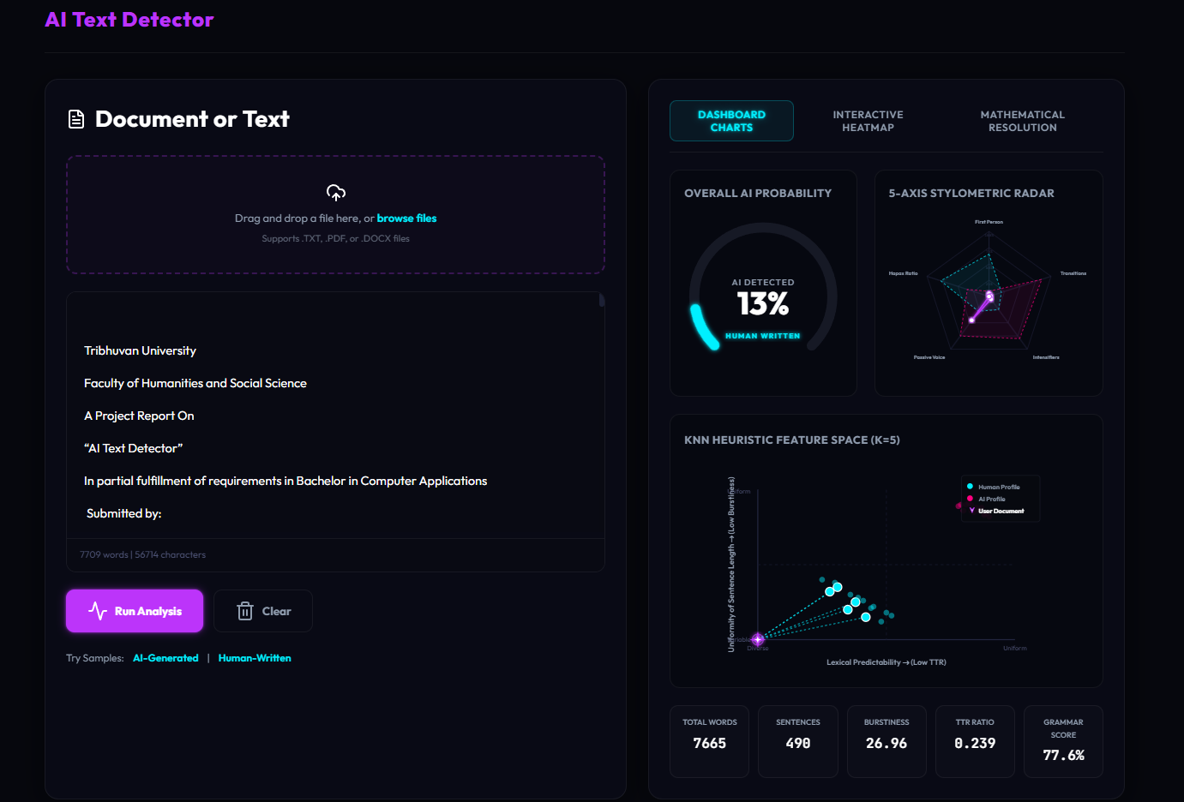
Figure: AI Detection

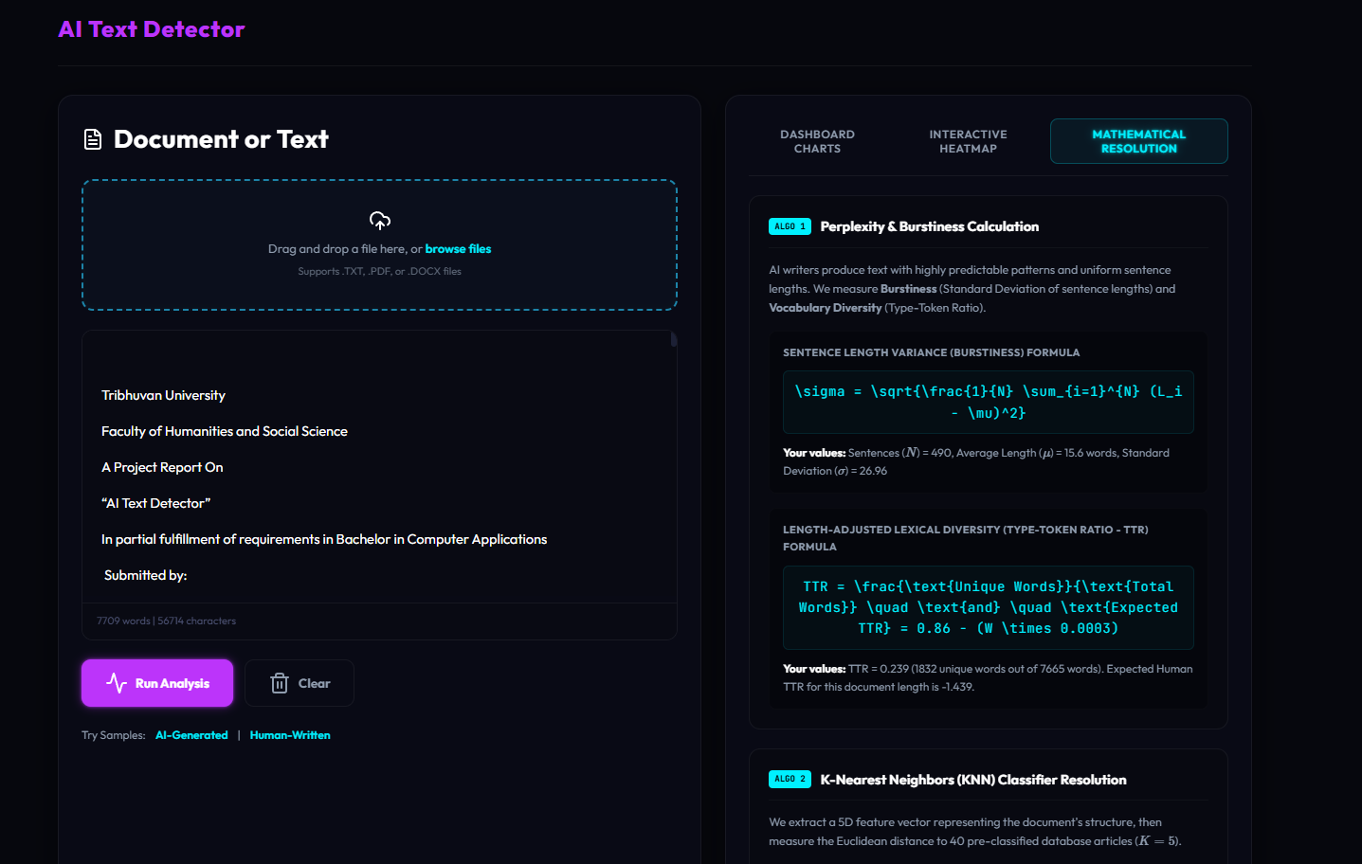
Figure: Mathematical Resolution Panel

