WST LABORATORY 8

Names: Jerica Mae Espelimbergo
Rowecker Brent Arce
Course & Sec: BSIT-2C
Date: May 22, 2026

Postman API Testing (POST Request)
A Postman showing a successful POST request to add a product. The request sends the data for a "Gaming Mouse" to the backend server, which processes it and returns a 200 OK status along with the created product details, confirming it was accepted.
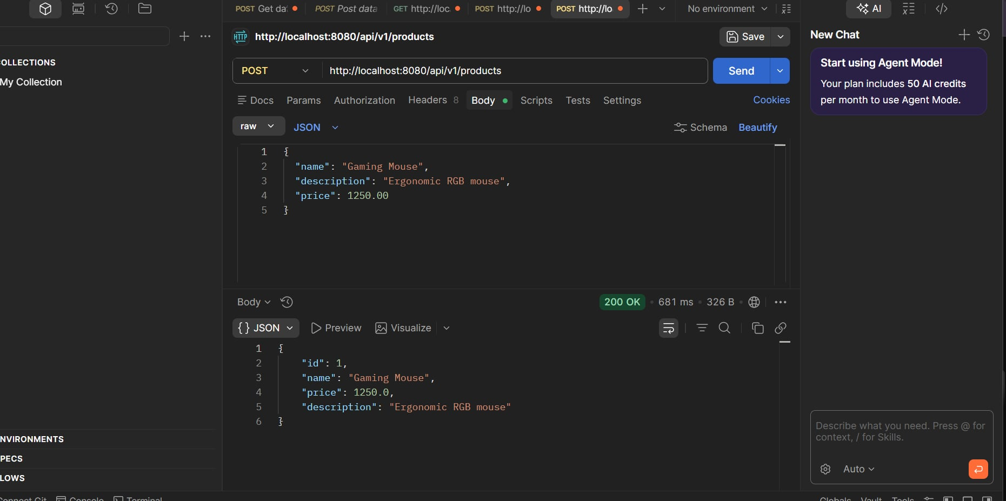

Web Browser
A web browser displaying the saved data. By opening the product API link directly in Chrome, it displays the "Gaming Mouse" data string on the screen, proving that the product was successfully saved by the backend application and can be retrieved.
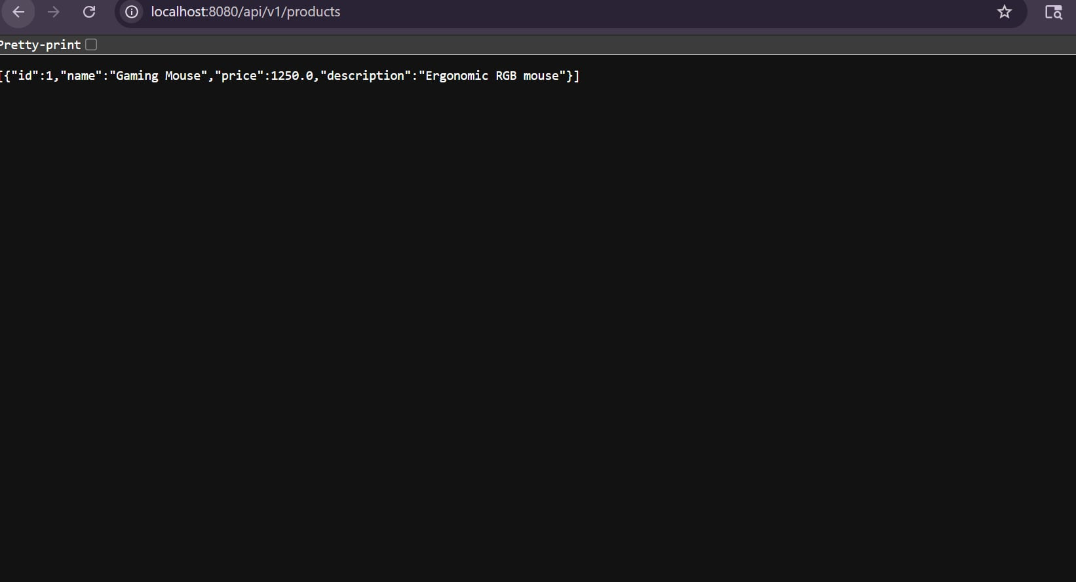

MYSQL WORKBENCH
This screenshot shows the successful execution of an SQL query in MySQL Workbench. The query SELECT * FROM products; was used to display all records from the products table inside the ecommerce_db database. The result grid below the query editor shows two records containing product information such as category, description, and name. The output section also indicates that the query was successfully executed and returned two rows. The screenshot demonstrates proper database connection and data retrieval using MySQL Workbench.

