WST LABORATORY 9

Names: Jerica Mae Espelimbergo
Rowecker Brent Arce
Course & Sec: BSIT-2C
Date: May 22, 2026

POSTMAN

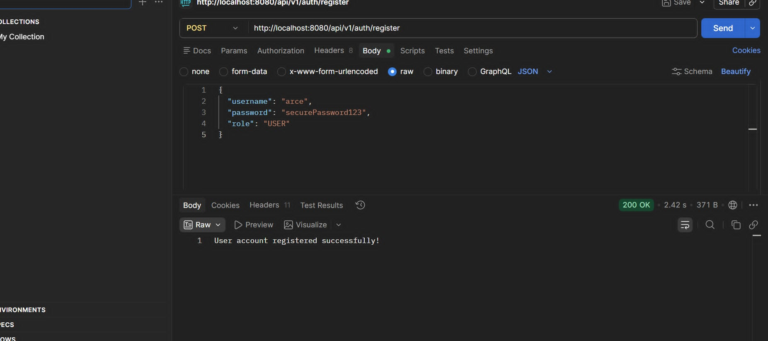
POSTMAN (Post User Registration)

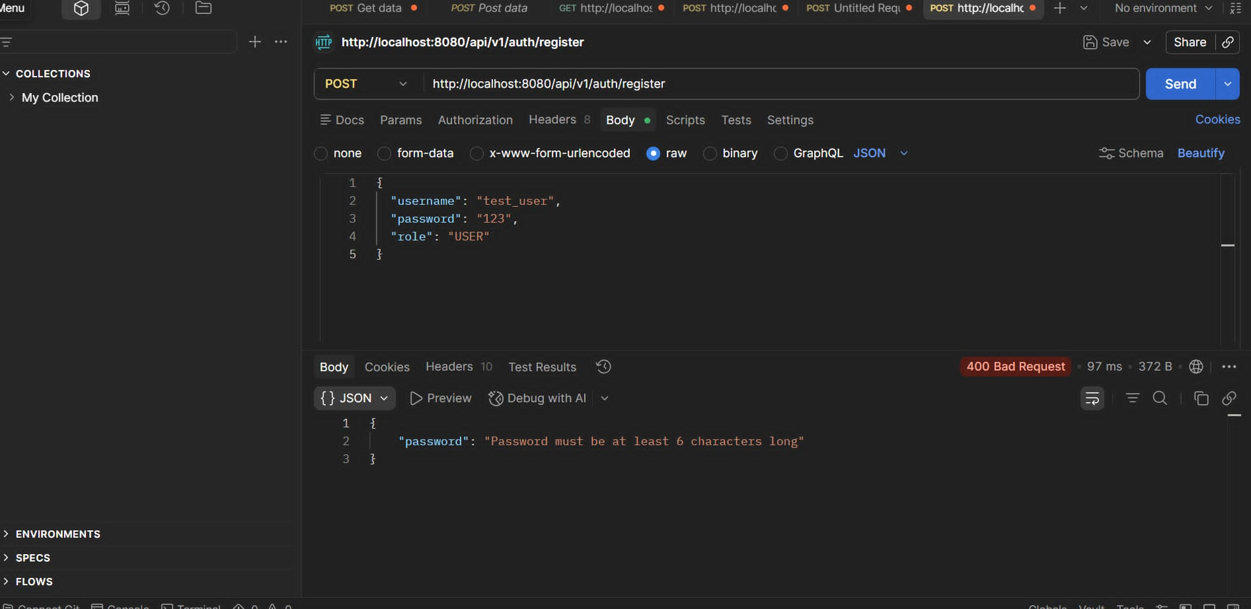
POSTMAN (Validation Failure - 400 Bad Request)

Web Browser
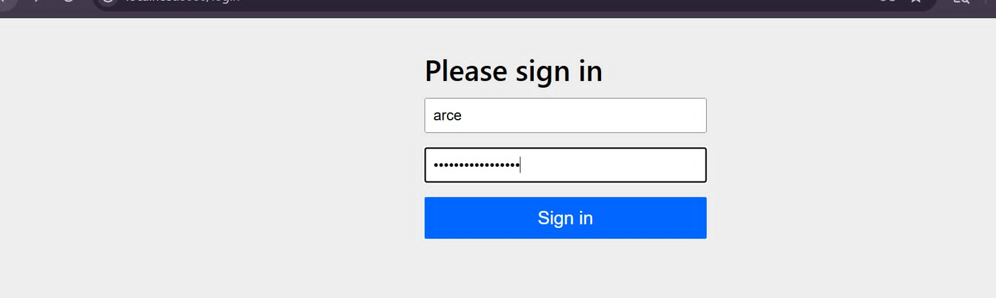
BROWSER (Spring Security Login Form)

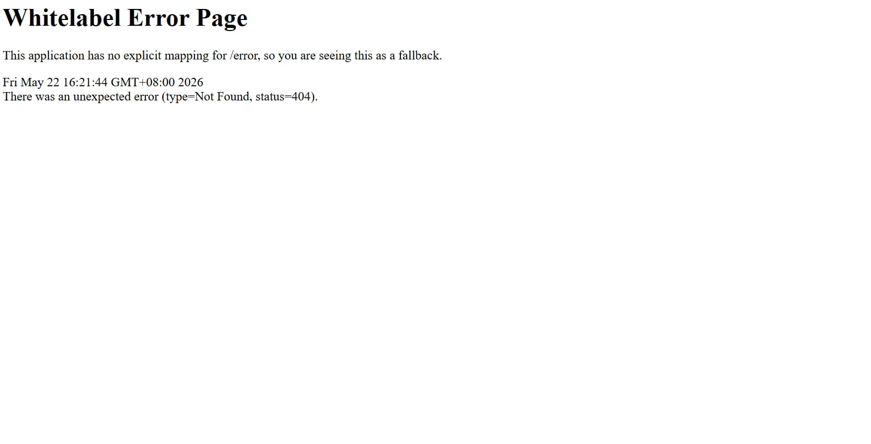
BROWSER (Whitelabel Error Page)

