***J S P – S E R V L E T – J D B C 1 0 1***

***JSP – SERVLET***

Imma use the Viewing of Items as basis for this hehehehe:

(idk how to do ship in php so I can’t compare stuff that much [but they said both are similar] sooo I’ll just put screenshots)

BASICS:

Think of it as the MVC Design Pattern

M -> JDBC

V -> JSP

C -> Servlet

STEPS (IN ANY ORDER AS LONG AS YOU DO ALL):

1: HOW TO REFER TO A SERVLET

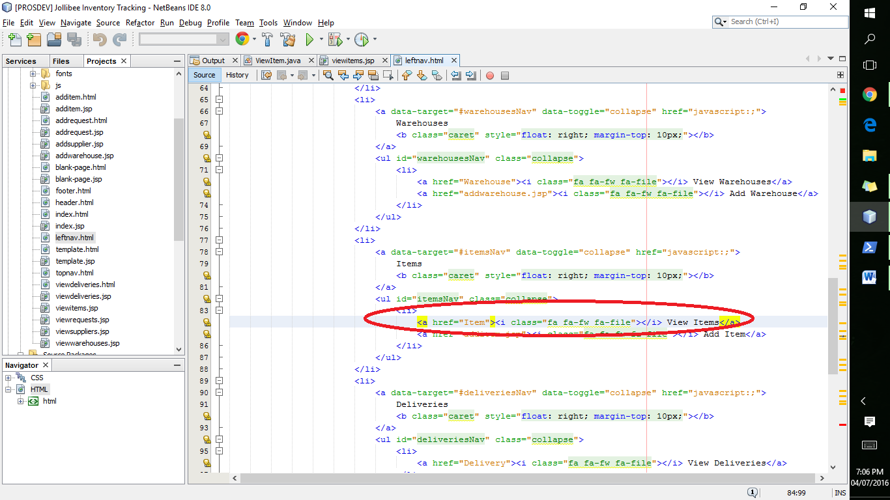

<a href = “Item”> means u refer to the Servlet with the name, Item. In this case, it will refer to ViewItems.java (SERVLET)

2: ADDING SERVLET

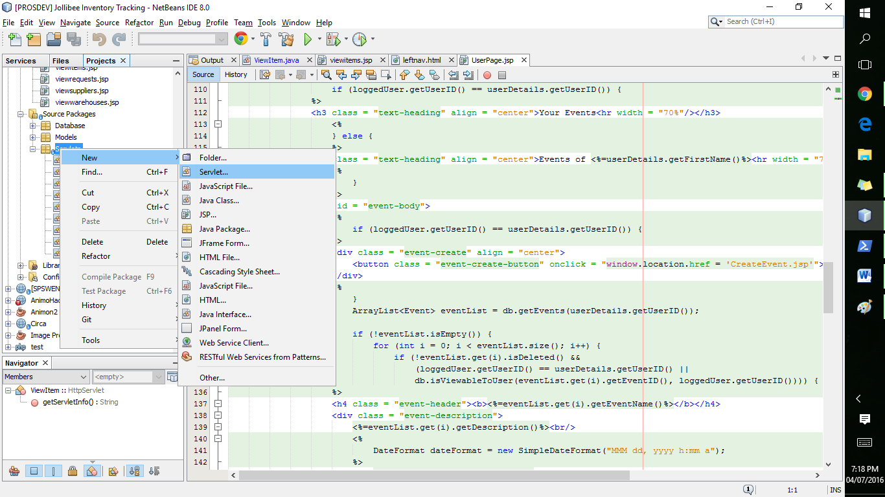

NEW -> SERVLET

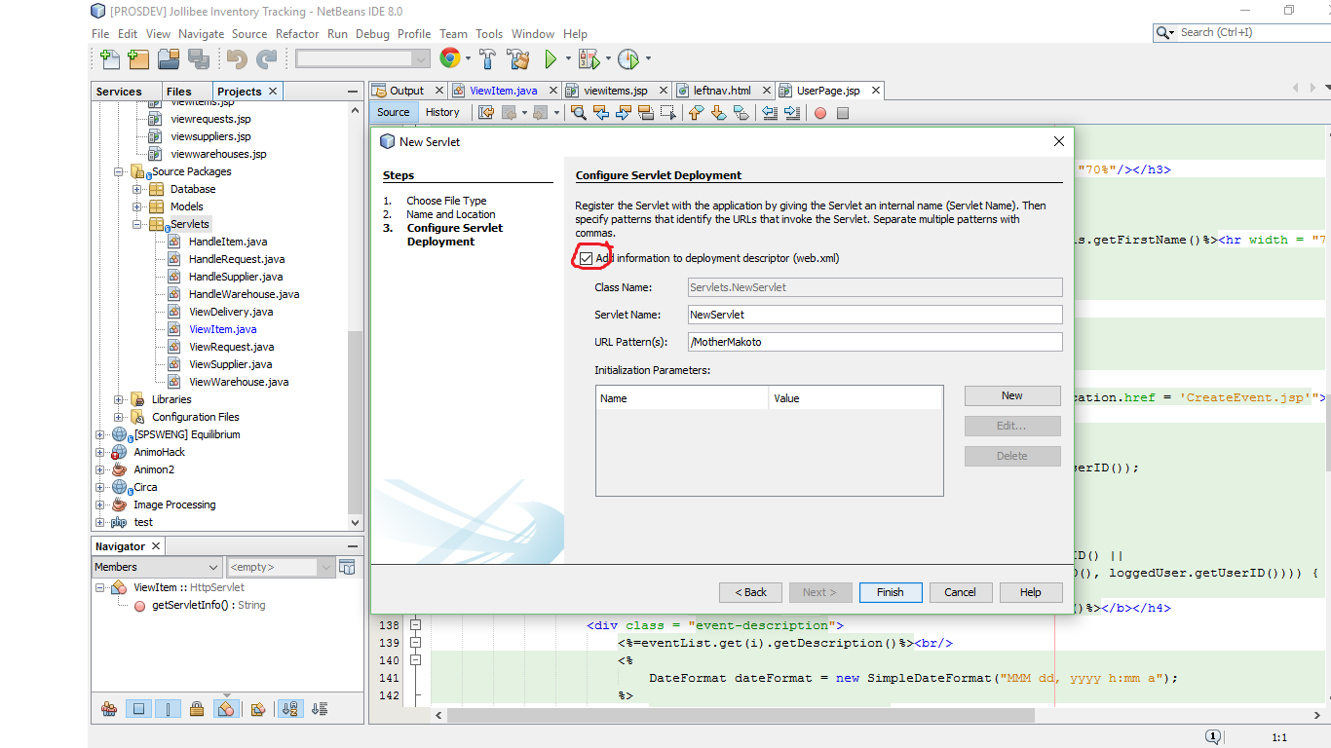

Always remember to check this

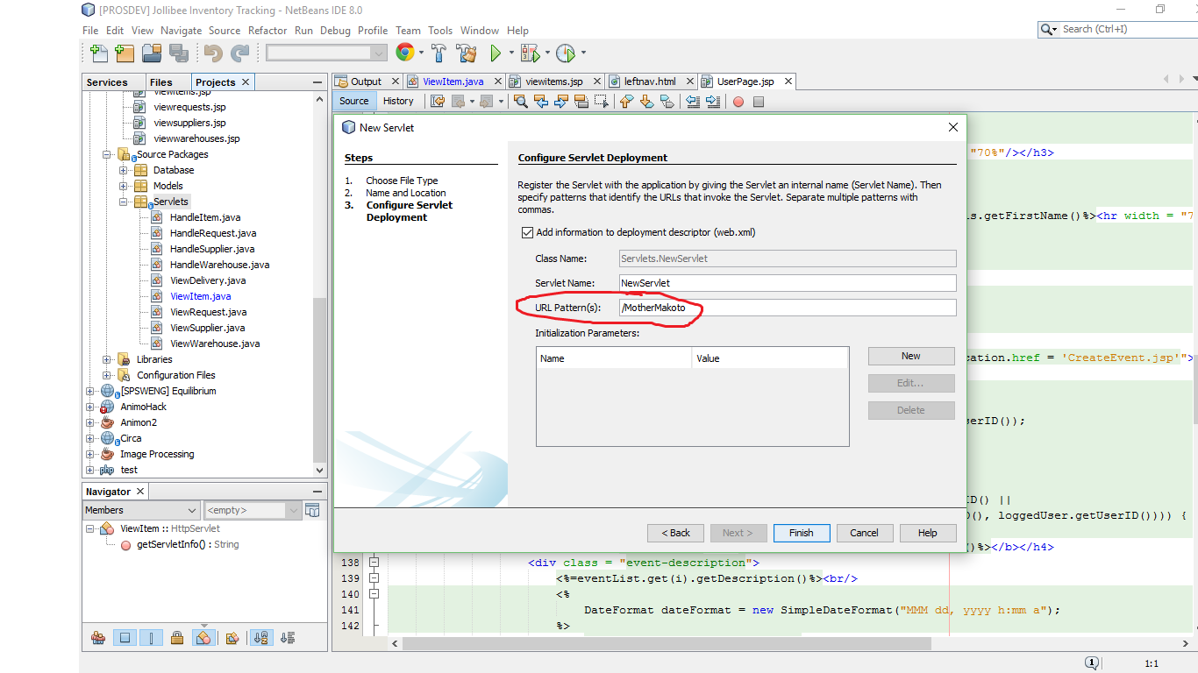

This will be the one that you will use when trying to call a Servlet (in this case, MotherMakoto). So if you want to go to the new Servlet, call MotherMakoto hurrah

** you can use a servlet for many purposes so no need to add a servlet for a every module

3: SERVLET FUNCTIONALITY

Netbeans has a pre-made template for their servlets. Regardless if it’s POST or GET, it makes it call the function processRequest (unless u change the code). (for me I always put my code there HEHEHEHEHEHE)

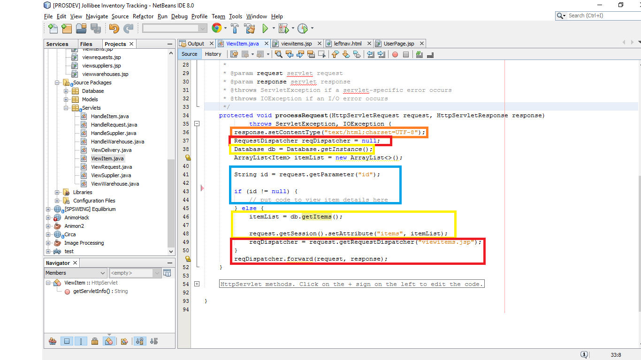

**Follow the colors!**

**Idk I don’t remove this hehehehehe**

**This will be responsible for redirecting to another page (example will go to viewitems.jsp)**

**First is how to call Database (it’s a singleton class [REMEMBER DESPA]) while the next box will get items in database and put it in session**

**How to get parameter in Session. In Step 1, we just did <*a href = Item>* so the Servlet didn’t receive any id parameter so it’s null. It’s probably the same in php if you want to pass parameters (use *<a href = Item?id=123>, submit forms, etc.).***

** As said in step 3, no need to create a new servlet for every module. The one above can be used to view the LIST of items and the items themselves (just use conditions [e.g. If there’s no id received {id = null}, then the user must be viewing the list but if there’s an id received, then the user must be viewing the item details] HEHE) + idk other functions maybe

4: DISPLAY IN JSP

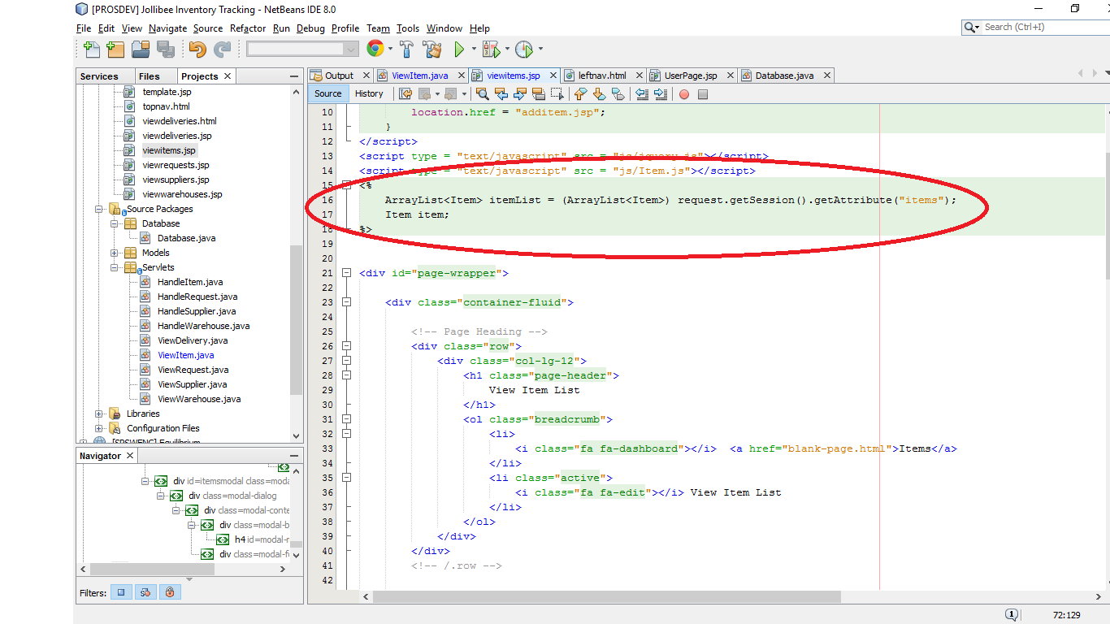

This is similar to the <? > thing of php [idk the syntax but you’ll get it]. So uhhhhh use <% %> for your java codes that will not return anything to the html page. If you want to display the item details (name, etc.), you need to use <%=item.getName()%> like this

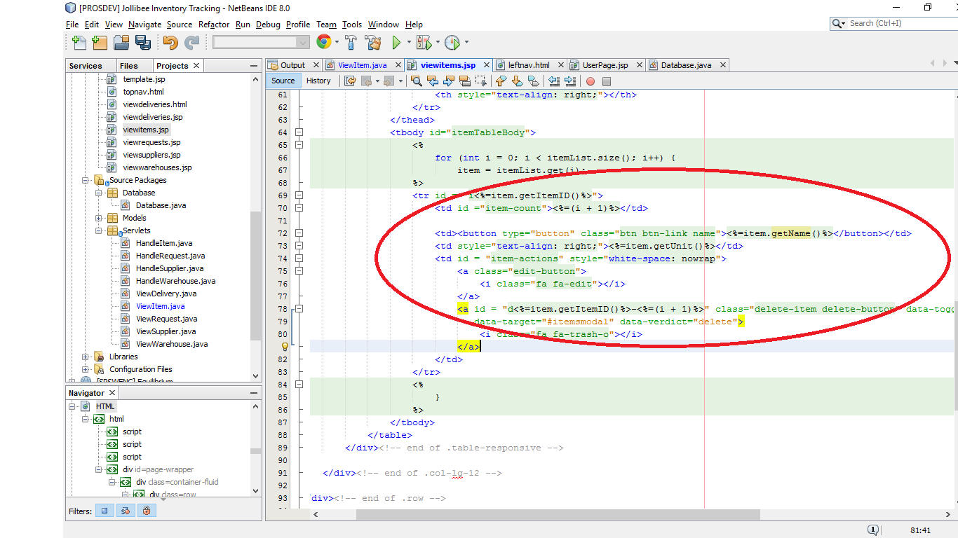

5: JAVA DATABASE CONNECTION

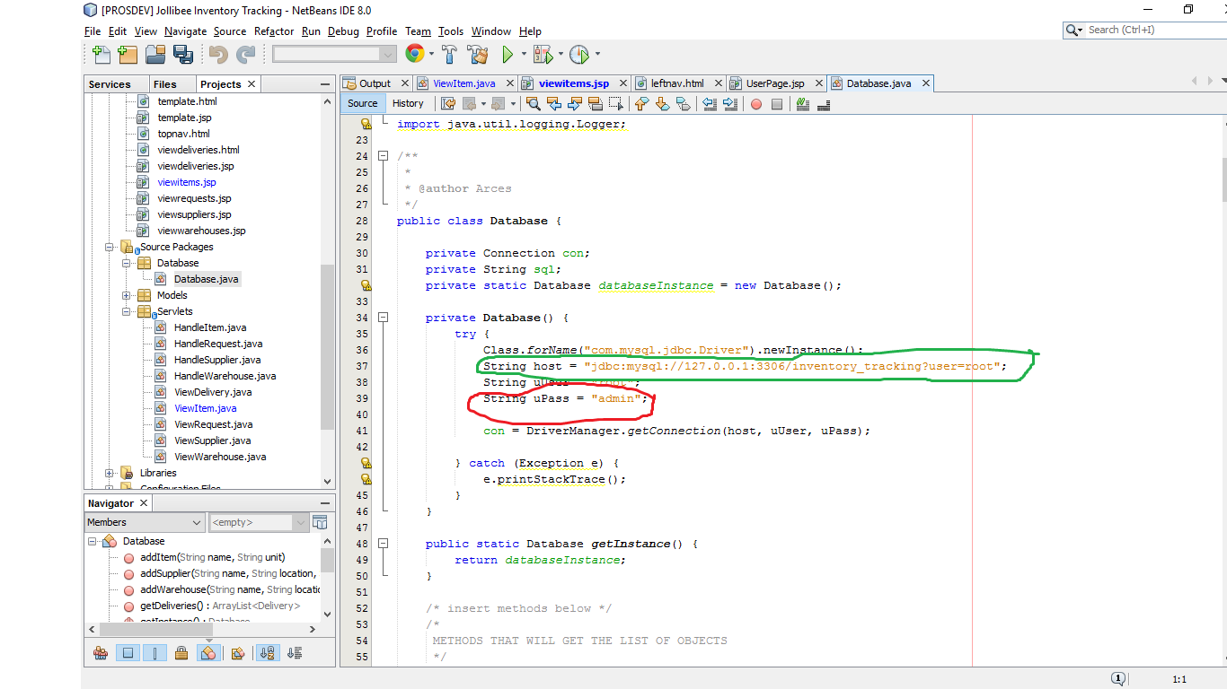

**Follow the colorzszszszs again! (U NEED MYSQL HEHEZ)**

**This will be where you need to define the name of your db**

**Just change the password ifever you need to use the db (mine’s set to “admin” \o/)**

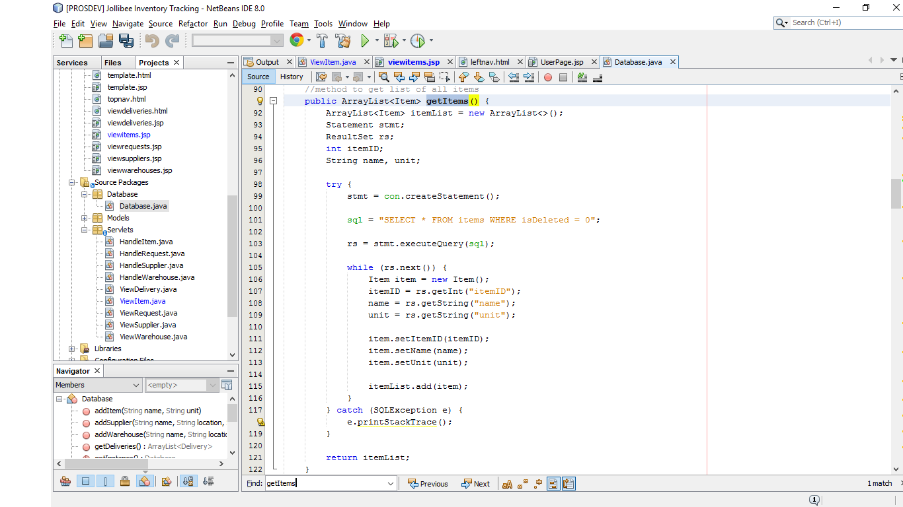

This is the method that will get the items :steamsalty:

* Put the sql statement in the *sql* variable
* Statement will be the one to execute the query
* ResultSet will be the one to receive the returned rows

rs.getInt(“itemID”); this is the column name in mysql

This is how retrieving in JDBC works. There are codes that add items so you can use that for basis if you want to update or something.

**T H E E N D \ o /**