Where To Set Any Business Up?

I have developed some code that can identify a good business location in Scarborough, Toronto. Note that this code is for any type of business, be it a restaurant, be it a Theatre.

Problem: Many contractors have faced a major loss, not because of the business itself but because of the location, so I have been making a solution for this;

Where To Set A Business Up?
Setting Up a business can already be hard but finding a location for it can be just as challenging so as a result I have developed some code to find the ideal neighbourhood for a business to grow in Toronto. This factor is very important as staff and customers depend on this factor and when there is a good customer and staff base from a good location, a business really grows and generates a large amount of profit. We will be using clustering to achieve this.

The Data To Be Used
I will be using foursquare and list the best neighbourhoods by finding the ones with most venues, the most common venues in a neighbourhood to do this and also I will get the neighbourhoods with the most incomes from this dataset - Demographics of Toronto neighbourhoods - Wikipedia. Then with these conditions I will cluster the locations on a map and display it.

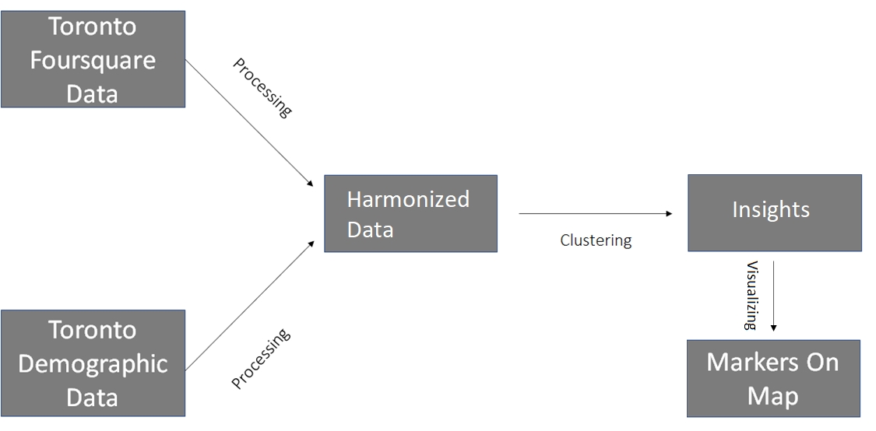
Solution Architecture (Updated)

The Methodology
First, I used the previous assignment’s code to get the postal code data of Toronto and merge it with the geospatial coordinates. After the merging has been done, I scrape the Scarborough neighbourhood(‘s) demographic data which consists of columns such as the population and the average income of the place. From this dataset we shall extract the neighbourhoods that have an income greater than 40,000 and a population greater than 10,000.

Next, I get the foursquare location data of the place which consists of the venue data. From this venue data that we have got, We can extract the neighbourhoods with many venues because where there are more venues (such as airports and restaurants), people come from various other areas, this helps in the growth of a business.

Now we have two datasets, one consisting of income and population and the other consisting of the neighbourhoods with the greatest number of venues in an area. So, to get the best neighbourhoods to set a business up in, we look at the common neighbourhoods between the two datasets. These common neighbourhoods are the best places. So, from the data I got 7 neighbourhoods;
- Davisville (+ Davisville North)
- High Park
- The Beaches
- Harbourfront
- Swansea
- The Annex
- Riverdale

We have our best neighbourhoods now, but instead of just marking them on a map, we will be clustering them to find out the similarity between all the places.

The advantage of clustering is that if a person wants to go to one of the neighbourhoods above but they cannot (because of some reason), we can always recommend them a neighbourhood similar to the one the wanted to go to.

Results
We have got our neighbourhoods ready and clustered on the map that is shown below:-
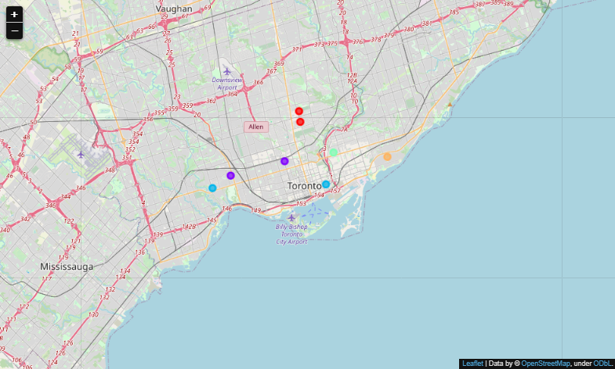

Conclusion
We can conclude that Davisville, High Park, The Beaches, Harbourfront, Swansea, The Annex and Riverdale are some good neighbourhoods to set a business up. Also here is the similarity between the Neighbourhoods;

Swansea and Harbourfront are similar,
The High Park and The Annex are similar,
Riverdale and The Beaches are not similar to any neighbourhood,
and obviously Davisville and Davisville North are similar.

- Archit Narain.G

