Output

- Create Resource Group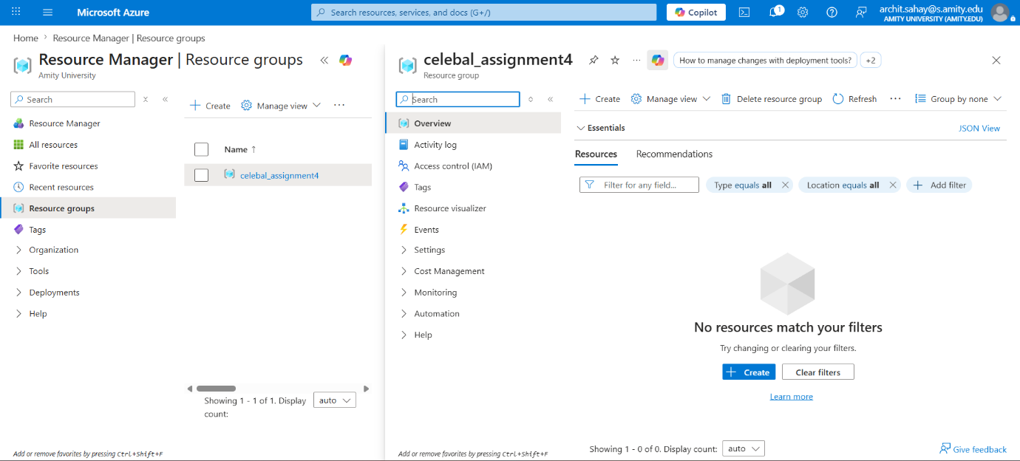

- Create Storage Account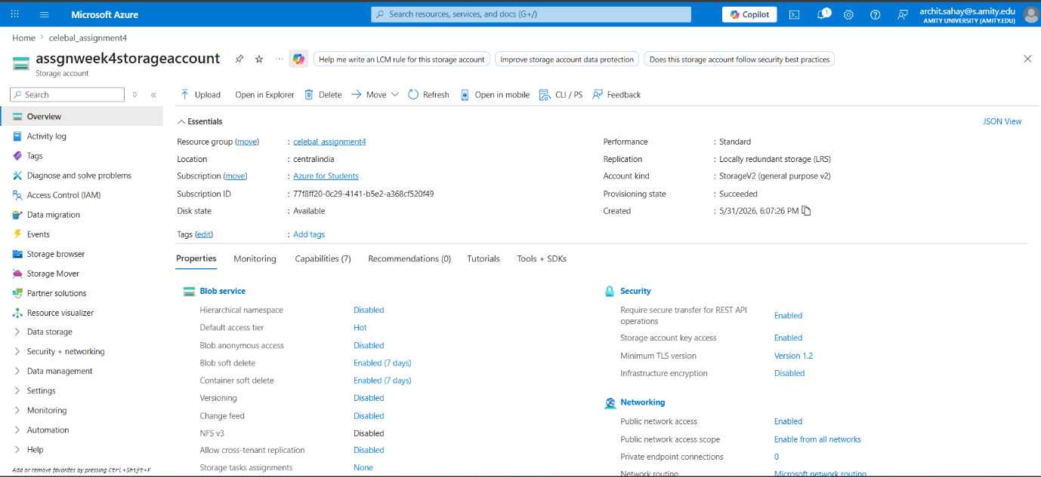

- Create Blob Containers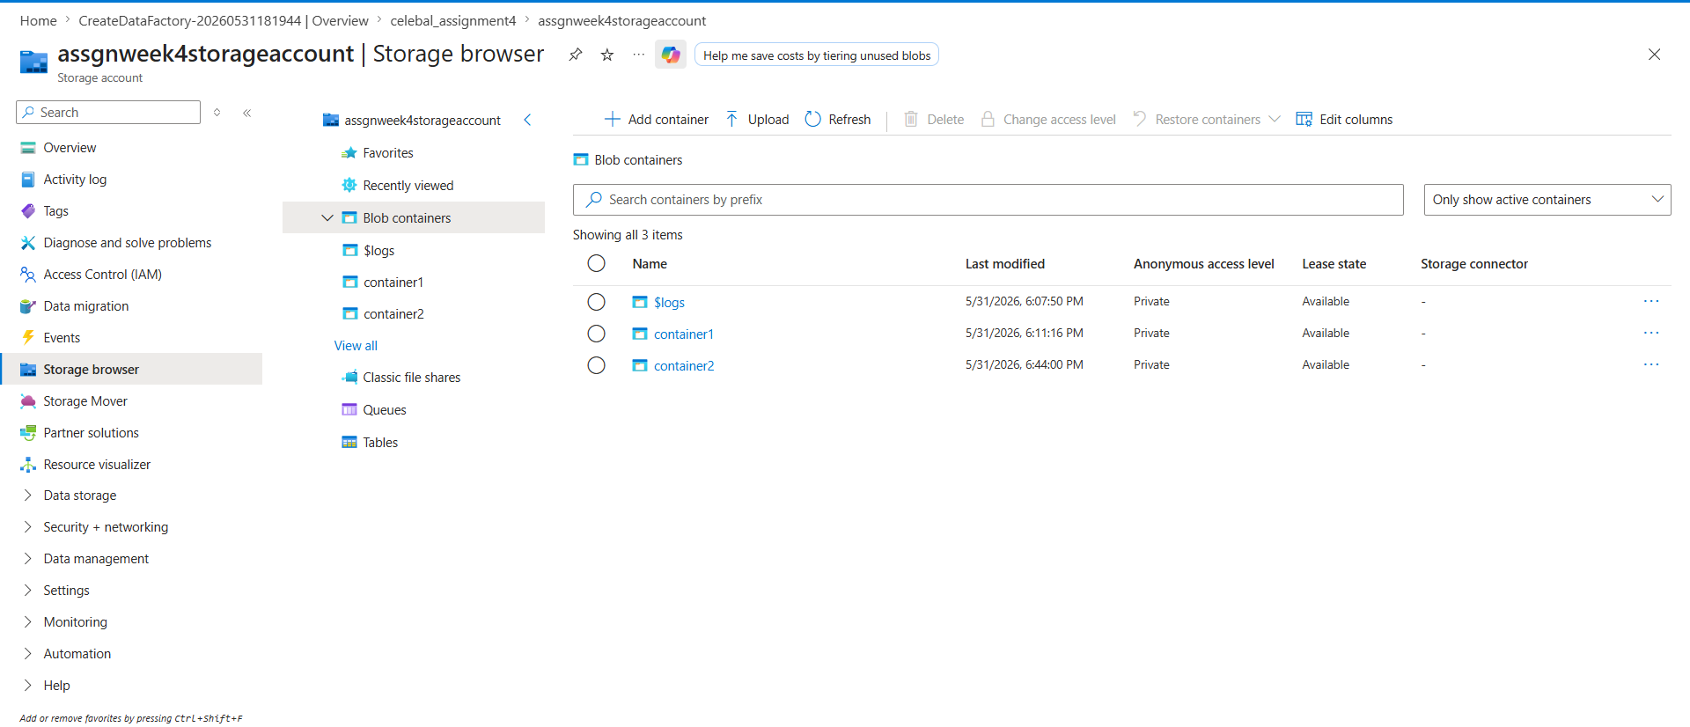

- Create ADF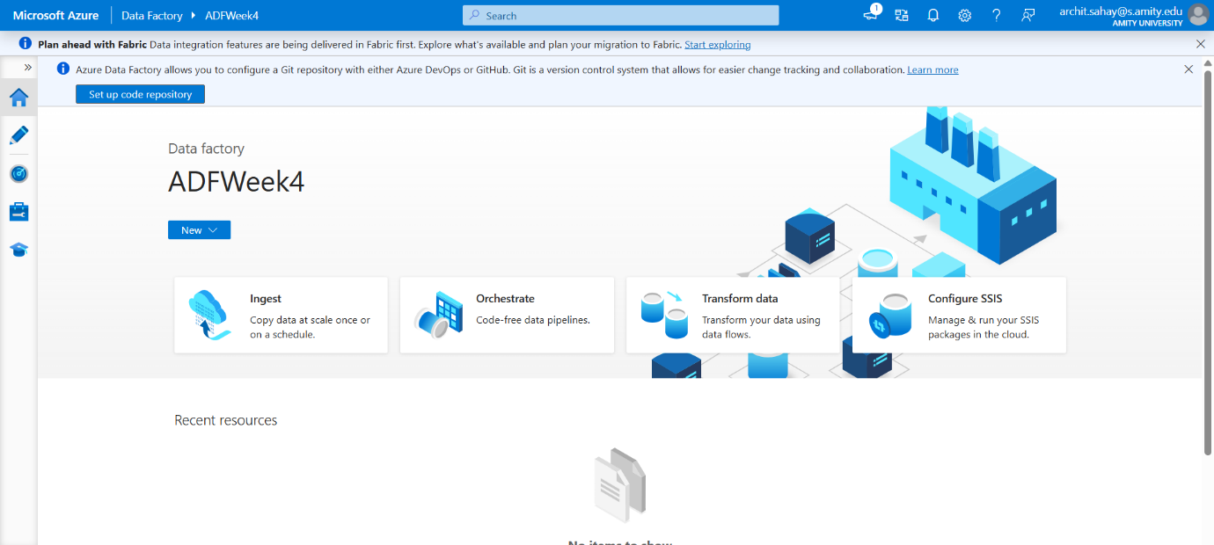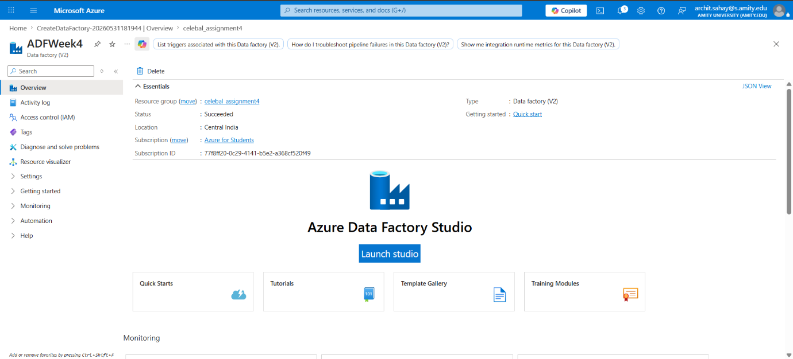

- Create Linked Services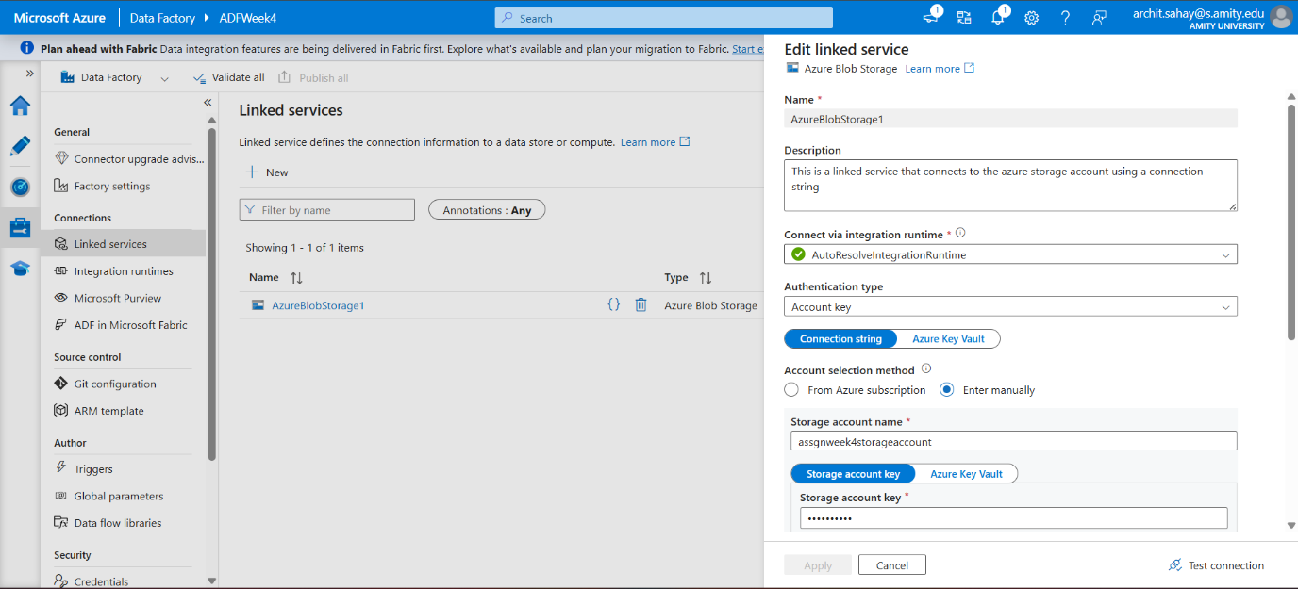

- Create Source and Destination Datasets and Pipeline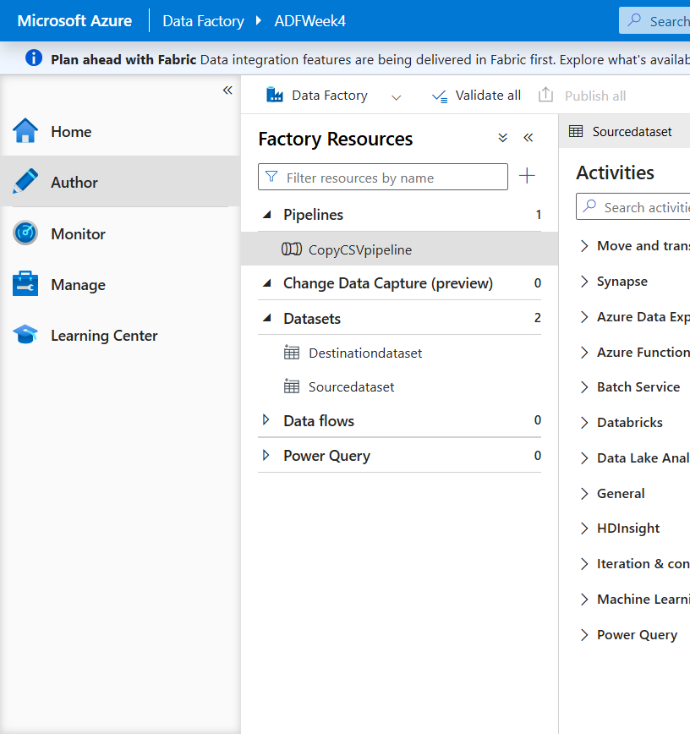

- Executed Pipeline Results

Pipeline Execution results
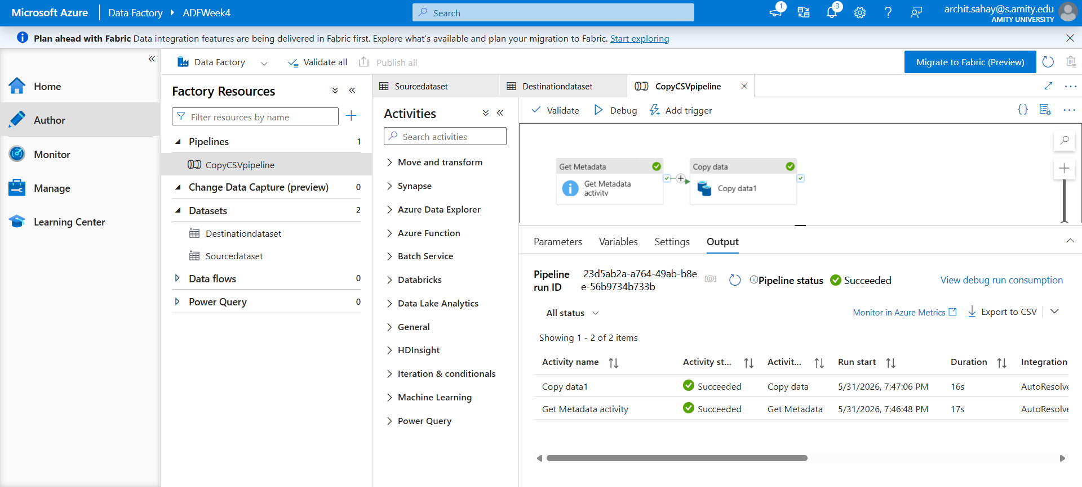

Before Pipeline Execution
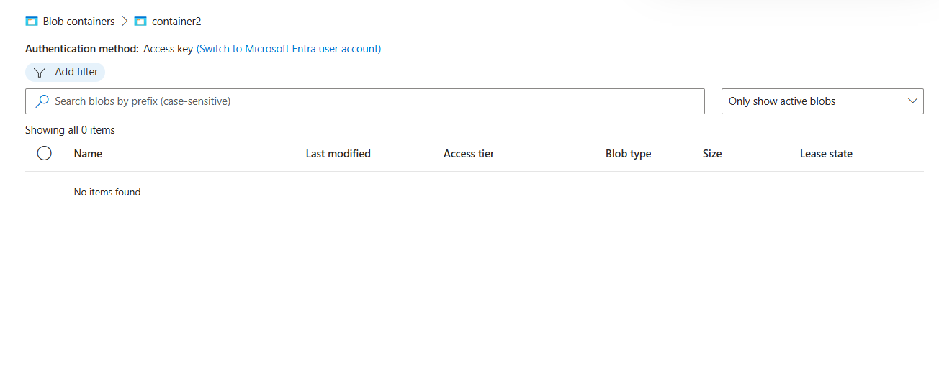

After Pipeline Execution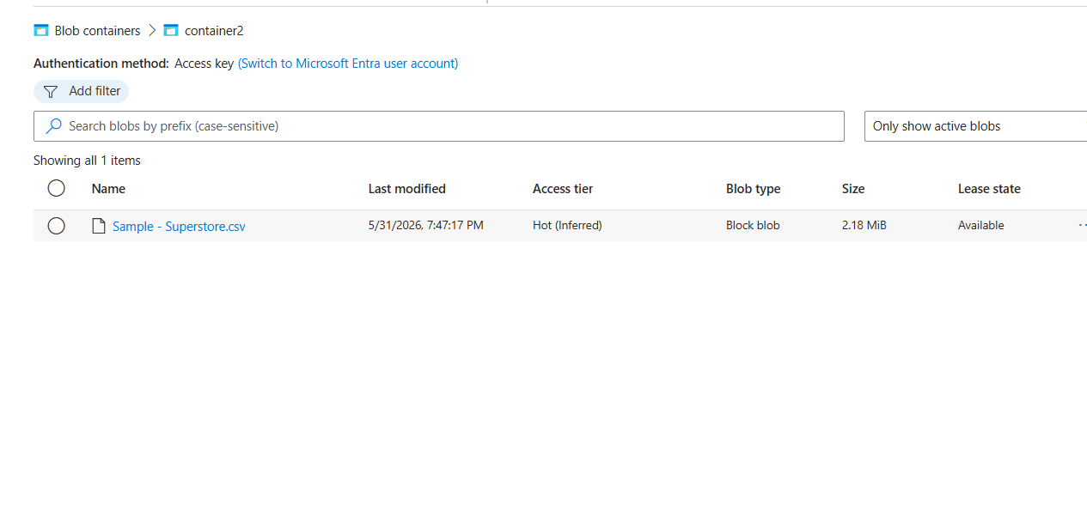

Brief Summary:-
A Resource Group was set up in an allowed region, followed by a Storage Account configured for Blob Storage. Inside it, two containers were created: one as the source(container1) and the other as the destination(contaienr2). A CSV file was uploaded into the source container.
An Azure Data Factory instance was then created in the same region. A Linked Service was configured to connect ADF with the Storage Account. Two datasets were then defined pointing to the source file and destination container.
A pipeline was built with a Get Metadata activity to validate file existence and a Copy Data activity to transfer the CSV from source to destination. The pipeline was executed successfully, and the copied file appeared in the destination container.

