**Output**

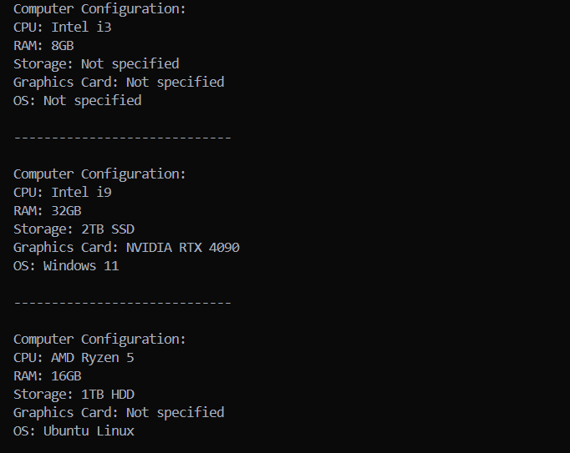

The code is Hard-Coded to make the understanding easier.