**Output**

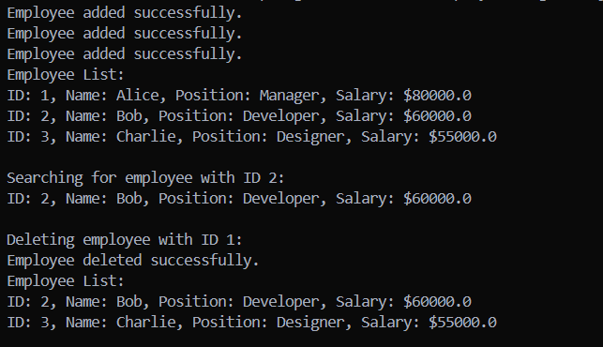

The Code has been hard-Coded to make the understanding Simpler