**Output**

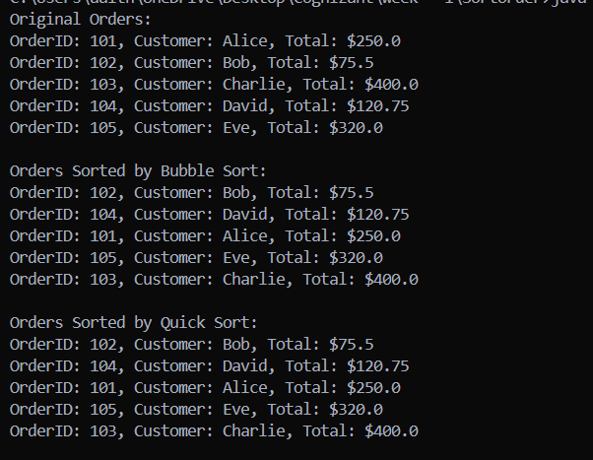

The code has been hard-Coded to make the understandings easier