**Output**

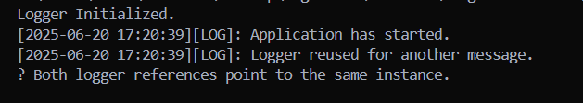

The Code has been Hard - Coded inorder to make the understanding Simple.