**Output**

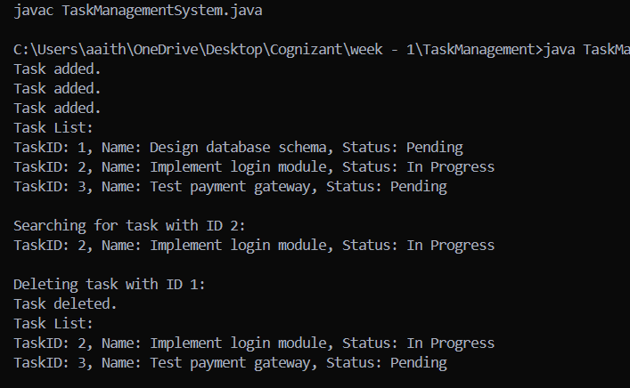

The code has been Hard-Coded For Simpler understanding