***Lepidocaris rhyniensis***

* Up to 3mm long
* Strong asymmetric mandibles with mandibular groove
  + Medial teeth on one for gripping, grinding food particles
* Comb setae on the posterior mouthparts
  + Scraping? Similar to mystacocarids living in interstitial spaces b/w sand grains
* PE’s of thoracopods bear long setae reaching far into median food groove, overlapping
  + Could transport food particles anteriorly
  + Longer, more finely toothed distal spine swept up loose material dislodged by anterior spines as in extant scraping anomopodans (Fryer 1985)
* Fryer (1985) suggests scraping as in chydorids and macrothrieids
* **Primary diet**: benthic, epiphytic, and film-forming algae/cyanobacteria, fungi parasitic on aquatic macrophytes, aquatic detritus
* **Secondary diet**: planktonic algae/cyanobacteria and aquatic single-celled fungi (or fungi that parasitize single celled algae)

***Castracollis wilsonae***

* Up to 10+ mm long
* Thoracopods have elongate basipods bearing endites with brush-like setae
  + More like branchiopod ground pattern than *Lepidocaris*, endites fully equipped w setae (Haug 2018)
* Anterior thoracopods have non-filtratory morphology, as in Notostraca (Fayers & Trewin 2002)
  + “We believe *Castracollis* to have been predominantly a detritivore and probably also a facultative predator”
* Comparable ecology to notostracans?
  + Anterior Limbs used for digging, swimming, food collection and manipulation, sensing; posterior limbs used for food handling and generating respiratory stream (Fryer 1988)
  + Detrital particles to large prey organisms, filtering NOT involved (Fryer 1988)
  + *note: castracollis mandibles don’t appear to have as robust cusps for cutting/tearing as Triops or Lepidurus
* Triops eats plant matter, filamentous algae, fungi, bryozoans, smaller crustaceans, sometimes small vertebrates, detritus (Boix et al. 2006)
* **Primary diet**: filamentous algae, aquatic fungi, aquatic detritus, smaller aquatic arthropods, nematodes(?)
* **Secondary diet**: cannibalism, medium aquatic arthropods, land plants (growing in shallow water)

**nauplii (larvae of unknown larger crustacean)**

* Up to 300µm (Haug et al. 2012), probably was a suspension feeder using sweep net motion (Haug 2018)
* Haug 2012: possibly copepod or thecostracan (Ascothoracida?)
  + Extant ascothoracids parasitize cnidarians and echinoderms
* **Primary diet of nauplius:** unicellular algae and cyanobacteria, unicellular aquatic fungi
* **Secondary diet of nauplius:** aquatic bacteria (non producer), aquatic detritus?
* **Adult diet (no reported specimens)??** Filter feeder also? Parasite??

***Ebullitiocaris oviformes***

* About 1-1.5 mm
* Lyall et al. 2003 suggest it is an anomopodan diplostracan
* Benthic habit suggested by “The relatively stable, broad-based configuration seen in E. oviformis, where the height of the carapace is generally equal to the transverse cross-sectional width”
* Found in clusters around Paleonitella stems
* **Primary diet**: benthic, epiphytic, and film-forming algae/cyanobacteria, fungi parasitic on aquatic macrophytes, aquatic detritus, aquatic bacteria
* **Secondary diet**: planktonic algae/cyanobacteria and aquatic single-celled fungi (or fungi that parasitize single celled algae)

***Heterocrania rhyniensis***

* Up to 15 mm long
* Haug 2015: “According to Anderson & Trewin [11], H. rhyniensis may have been carnivorous, catching prey items with spines on its legs in a similar mode to the extant anostracan Branchinecta gigas. Yet, these assumptions cannot be further corroborated (or rejected) in the absence of better preserved material.”
  + “The extensive labrum of euthycarcinoids implies that feeding was active and not based on sediment ingestion, as is also suggested by the presence of leg spines in some species” (aria et al 2021)
* Lack of paddles indicates benthic habit
  + May have been detritivore?“amorphous organic debris in gut” Andreson & Trewin 2003
* **Primary diet:** detritus, other aquatic arthropods
* **Secondary diet:** benthic, and film-forming algae/cyanobacteria and fungi
* **^^alternative:** other aquatic arthropods are secondary/not prey items

***Rhynimonstrum* *dunlopi***

* Anderson & Trewin 2003: ID unclear, but probably either Devonobiomorphan chilopod, or arachnid (whip spider or whip scorpion or attercopus-like)
  + All of these are predatory
* If centipede antennae, their
* width (~1.75mm) implies a head width of about 7-10 mm! And total length ~10cm!! very large for Devonian arthropod
* Arachnid
  + uropygid, abdomen width of 1.5-2 cm, body length (w/out flagellum) ~6 cm
  + uraneid (e.g. attercopus), abdomen width 1.4-1.75 cm, body length (w/out flagellum) ~4.3 cm
  + amblypygid?? Would be huge
* Regardless of ID, appears to be very large terrestrial predator. Found among ventaura axes and coprolites: probably lived in litter near aquatic environments
* **Primary diet:** all terrestrial arthropods above 3mm, esp. those in litter
* **Secondary diet:** Heterocrania and Castracollis, “arboreal” arthropods, arthropods smaller than 3 mm (see Van de Walle & Logghe 2023)

***Eoarthropleura***

* ~3.5-7 mm wide, ~1.5-3 cm long body based on K plate from Fayers & Trewin 2004 and full body reconstruction from Shear & Selden 1995 – but this may have been a small individual, plus this is a very rough estimate
* Detritivores, sporivores
* **Primary diet:** terrestrialdetritus
* **Secondary diet:**land plant spores, terrestrial bacteria

***Crussolum***

* Leg ~2+ mm long, head ~5 mm wide; ~3.5 cm long body (Anderson & Trewin 2003)
* Primarily leaf litter predator
* **Primary diet:** most medium-large terrestrial arthropods, esp. those in litter besides Rhynimonstrum due to size
* **Secondary diet:** Rhynimonstrum, “arboreal” arthropods, acari + collembola smaller than 3 mm (see Van de Walle & Logghe 2023)

**unnamed centipede**

* Fayers & Trewin 2004: head is about 0.75 mm wide, so body ~5-10 mm long?
  + Small predator
* **Primary diet:** collembolans, acariforms other terrestrial arthropods smaller than 1 cm, nematodes (Bonato et al 2021)?

***Rhyniella preacursor***

* 1-2 mm body length
* Id as Isotomidae (collembola) by Greenslade & Whalley 1986
* “Gut content analyses of field-collected Collembola include decomposed plant material, fungal spores and hyphae, algae, diatoms, arthropod feces and exuvia, and amorphous materials (BOdvarsson 1970; Gilmore and Raffensperger 1970; Anderson and Healey 1972)”
* Chen et al 1996 for Isotoma diet in Michigan (includes bacteria)
* **Primary diet:** terrestrial fungi, detritus, terrestrial bacteria
* **Secondary diet:** algal mats, nematodes, protozoa, plant spores, lichen

***Leverhulmia mariae***

* > 11 mm long
* Fayers & Trewin 2005: appendages suggest hexapod ID (similar to Archaeognatha and Zygentoma)
* “The gut contents include arthropod cuticle (C), but primarily macerated plant debris, spores and amorphous organic material. A”
  + “The heterogeneity of the gut contents strongly suggests a detritivorous habit, and is comparable with the contents of coprolites found in the chert and contemporaneous deposits elsewhere that have been identified as the products of detritivorous arthropods (Habgood 2000; Habgood et al. 2004). Extant forms of the Archaeognatha and Zygentoma are also known to be detritivorous, which tantalisingly is in keeping with the preserved gut contents seen in the Leverhulmia holotype.”
* Archaeognaths eat algae, lichen, fungi, decomposing plants, scavenge dead arthropods
* Zygentoma are generalists and eat a wide variety of algae, lichens, or starchy vegetable matter (decomposed plants), also scavengers
* **Primary diet:** detritus, algal mats,terrestrial saprotrophic fungi, lichen
* **Secondary diet:** plant spores, terrestrial bacteria

***Rhyniognatha hirsti***

* Mandibles are ~0.1 mm long, 0.2 mm wide; head capsule approx.. 0.25-0.3 mm wide
* Regarded as pterygotan insect by Engel & Grimaldi 2004, but this has been called into question, most recently by Haug et al. 2017 who propose an ID as a small scutigeromorph centipede (a post larval Crussolum).
* Either way, its scissor-like, bladed mandibles suggest a carnivorous diet
* **\*\*\*exclude from analysis as it may be a myriapod that is already included?**
* **Primary diet:** collembolans, acariforms other terrestrial arthropods smaller than 5 mm, nematodes (Bonato et al 2021)?

***Devonopilio hutchinsoni***

* **\*\*\*exclude from analysis as it may be a specimen of Heterocrania, and is likely not an opilionid. See Perez-Gonzalez and Shultz 2021**

***Eophalangium sheari***

* Member of Opiliones; total body length ~2-6mm
* Dunlop et al 2003: gut trace
  + Possibly implies an “omnivorous diet including a significant proportion of robust cuticle from plant remains. The predatory trigonotarbid arachnids with preoral digestion filtering out hard parts of cuticle never preserve a gut trace at Rhynie. Individual spores or identifiable cuticles cannot be resolved within the harvestman gut”
  + “The authors suspect that it was a predator on other, smaller arthropods, probably supplementing its diet by scavenging and/or facultative omnivory”
* “Opiliones consume a broader diet than any other arachnids other than mites. The basic pattern is predation, but some, for example, specialize on snails, which are otherwise rarely consumed by non-acarine arachnids. Opiliones also are known to eat dead insects, fruit, and decaying vegetable matter.” (Selden 2017)
* Powell et al 2021 on New Zealand Neopilionidae: opportunistic, generalist foragers with a diet composed of a wide variety of prey and scavenged soft-bodied invertebrates, including worms, amphipods, species from nine orders of insects, and two orders of arachnids (including conspecifics)
* Nyffeler et al 2023: harvestmen often eat fungi (small forest mushrooms), fruit pulp, plant detritus, seeds
* **Primary diet:** invertebrates less than 10 mm in length, terrestrial detritus
* **Secondary diet:** saprophytic fungi, plant spores

***Palaeocharinus rhyniensis***

* Holotype is 1.5 mm long (Dunlop 1994)
* Dunlop 1994: “…extant arachnids generally feed on other arthropods rather than terrestrial or cryptozoic worms, molluscs, large protozoans or similar soft bodied animals. However, in Devonian terrestrial ecosystems, trigonotarbids seem to have been one of the most abundant animals in terms of the number of body fossils in the Rhynie Chert and since their cuticle is one of the commonest types recovered in macerates from Gilboa.”
* Haug 2018: “the overall morphology can be interpreted as having a similar function to what is found in mesothelan spiders, i.e. penetrating a prey animal with the distal part of the chelicerae. Strong tooth-like protrusions of the proximal part of the chelicerae would have provided a firm grip prohibiting the prey from slipping off. Therefore, the chelicerae could have been used in immobilizing the prey”
  + “We can assume that trigonotarbids had an extra-intestinal type of digestion.”
* **Primary diet:** invertebrates less than 3 mm long, nematodes

***Palaeocharinus hornei***

* Holotype is 2mm long (Dunlop 1994)
* **Primary diet:** arthropods less than 5 mm long, nematodes

***Palaeocharinus tuberculatus***

* Holotype 6mm long (Fayers et al. 2005)
* **Primary diet:** arthropods between 0.5 and 10 mm long
* **Secondary diet:** arthropods less than 0.5 mm long, nematodes

**large trigonotarbid**

* 14 mm+ long (undescribed but discussed by Fayers et al. 2005)
* **Primary diet:** arthropods between 2 and 25 mm long
* **Secondary diet:** arthropods less than 2 mm long

***Paraprotacarus hirsti***

* Acari, Endeostigmata, Tydeidae
* Body length 0.31-0.4 mm
* Dunlop & Garwood 2018: “Prostigmatid mites express a bewildering variety of lifestyles from free-living predators, to parasites, to plant feeders. At Rhynie the fossils’ affinities dictate that we focus on Tydeidae, modern species of which include predators, scavengers and groups feeding on fungi or directly on plants [40]. In their catalogue of modern tydeids, Da Silva et al. [41] also listed them as phytophages, mycophages, pollenophages, insect parasites or scavengers, but further noted that the majority of today’s species are scavengers or mycophages (i.e. fungi-feeders). Both of these feeding ecologies are compatible with the Rhynie palaeoenvironment”
* 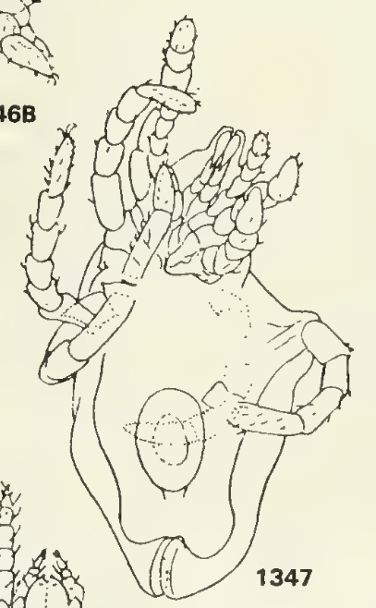
* **Primary diet:** terrestrial fungi, terrestrial detritus, some algae
* **Secondary diet:** plant spores, nematodes, *Protacarus, Protospeleorchestes*, amoebazoans, bacteria

***Palaeotydeus devonicus***

* Acari, Endeostigmata, Tydeidae
* Body length 0.31 mm
* See above (Paraprotacarus)
* 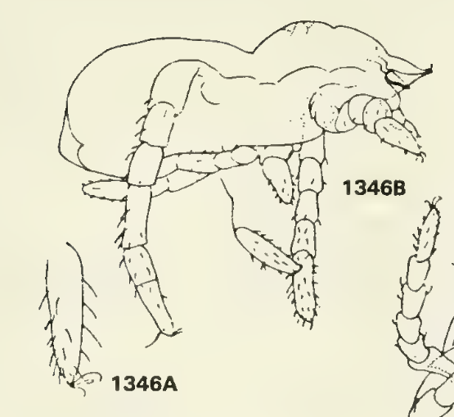
* **Primary diet:** terrestrial fungi, terrestrial detritus, some algae
* **Secondary diet:** plant spores, nematodes, *Protacarus, Protospeleorchestes*, amoebazoans, bacteria

***Protacarus crani***

* Acari, Endeostigmata, Alycidae
* Body length ~0.25 mm
* 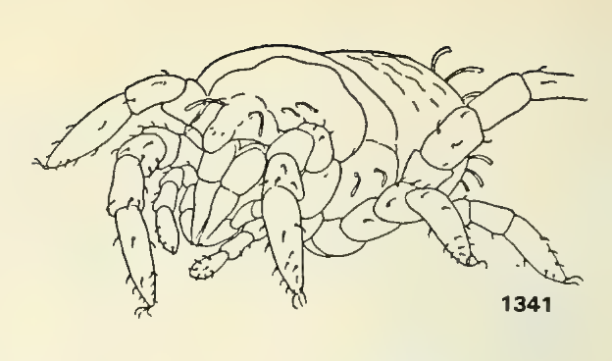
* Modern alycids feed on nematodes or plants (but latter mouthparts don’t match Rhynie species)
* **Primary diet:** nematodes
* **Secondary diet:** plant spores, fungi, bacteria, protozoa, amoebazoans, detritus

***Protospeleorchestes pseudoprotacarus***

* Acari, Endeostigmata, Nanorchestidae
* Body length ~0.2 mm
* Feed on fungi and algae, probably bacteria too
  + Fluid feeders
* 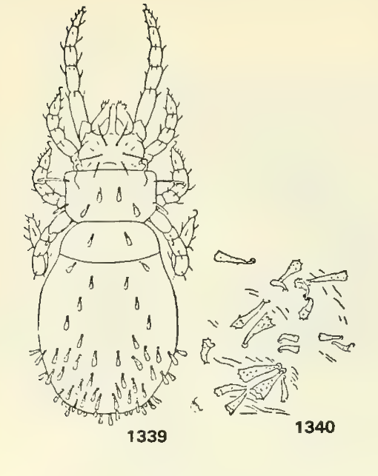
* **Primary diet:** terrestrial fungi, lichen, some algae
* **Secondary diet:** bacteria, detritus

***Pseudoprotacarus scoticus***

* Acari, Endeostigmata, Alicorhagiidae
* Body length 0.29 mm
* Alicorhagiidae are omnivores, feed on fungi and soft inverts (eg nematodes)
* 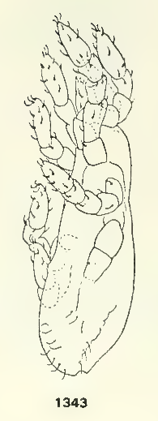
* **Primary diet:** terrestrial fungi, terrestrial detritus, nematodes
* **Secondary diet:** plant spores, algae, nematodes, mat forming bacteria

***Saccogulus seldeni***

* 3.7 mm fossil (probably ~7mm total body length)
* Arachnid?
* Probably a terrestrial predator, but not much known
* **\*\*include or is too little known? I think should be included because it is fairly clearly a new taxon and if arachnid is almost certainly a predator**
* **Primary diet:** arthropods between 0.5 mm and 10 mm
* **Secondary diet:** cannibalism, arthropods below 0.5 mm

***Palaeonema phyticum***

* 0.89 mm long
* Poinar et al. 2008: “Based on the structure of its buccal cavity, Palaeonema gen. n. would be classified as an **epistrate feeder**, which employs a tear and swallow feeding strategy (Moens et al., 2006). By everting its buccal teeth, Palaeonema gen. n. could have been capable of mechanically disrupting cortical cells and swallowing the contents. Some extant diplogastrids (Tylopharynx spp.) have a narrow stoma that is apparently protrusible and could be used to break through plant cell walls (Maggenti, 1981).”
* **Primary diet:** terrestrial and benthic aquatic algae, mat-forming bacteria, terrestrial and aquatic fungi
* **Secondary diet:** lichen, plant roots, amoebozoans

**scolecodont?**

* Size unknown
* Diet??
* **Primary diet:** aquatic detritus
* **Secondary diet:** aquatic arthropods below XXX size, algae, Palaeonitella, fungi

***Prototaxites taiti* (=*Nematophyton*)**

* Honegger et al. 2017 refer it to Ascomycota
* Possibly lichenized and photoautotrophic, possibly saprotrophic, possibly both
* **Primary diet:** terrestrial detritus
* **Secondary diet:** sunlight

***Nematoplexus* *rhyniensis***

* Aquatic(?, found with castracollis)
* Algae? Nematophytes are weird
* **Primary diet:** sunlight
* **Secondary diet:** aquatic detritus?

***Palaeomyces* agglomeratus**

* Mucuromycota
* Associated with aerial axes of Rhynia and surrounding chert
* **Primary diet:** terrestrial detritus (saprotroph)
* **Secondary diet:** endomycorrhizae of Rhynia, other plants?

**Palaeomyces asteroxyli**

* Mucuromycota
* Associated with intact and degraded aerial stem of Asteroxylon
* **Primary diet:** endomycorrhizae of Asteroxylon, or parasitic??? (Strullu-derien et al. 2015)
* **Secondary diet:** endomycorrhizae of other plants? Saprotroph (terrestrial detritus)

**Palaeomyces gordonii**

* Mucuromycota
* Associated with intact and degraded aerial stem of Asteroxylon
* **Primary diet:** endomycorrhizae of Asteroxylon, or parasitic??? (Strullu-derien et al. 2015)
* **Secondary diet:** endomycorrhizae of other plants? Saprotroph (terrestrial detritus)

**Palaeomyces horneae**

* Mucuromycota
* Associated with stems of Horneophyton
* **Primary diet:** endomycorrhizae of Horneophyton
* **Secondary diet:** endomycorrhizae of other plants? Saprotroph (terrestrial detritus)

**Palaeomyces simpsonii**

* Mucuromycotina
* Associated with decayed stems of Rhynia
* **Primary diet:** terrestrial detritus (saprotroph)
* **Secondary diet:** endomycorrhizae of Rhynia, other plants?

***Windipila spinifera***

* Krings 2022: reproductive unit of a fungus in the Glomeromycota or zygomycetes
* Found on degraded plant axes
* **Primary diet:** terrestrial detritus (saprotroph)

***Windipila wimmervoecksii***

* Krings & Harper 2019: reproductive unit of terr. fungus (Glomeromycota?)
* Found on degraded plant axes
* **Primary diet**: terrestrial detritus (saprotroph)

***Windpila pumila***

* Krings & Harper 2018: reproductive unit of terr. fungus
* Found on degraded plant axes
* **Primary diet:** terrestrial detritus OR terrestrial plants (endomycorrhizae)

***Zwergimyces vestitus***

* Found in litter layers with intact and degraded plants
* Reproductive structure, mantle and spores preserved
* **Primary diet:** terrestrial detritus (saprotroph)

***Palaeoendogone gwynne-vaughaniae***

* Mucuromycotina
* Associated with basal stem of Horneophyton
* **Primary diet:** endomycorrhizae of Horneophyton
* **Secondary diet:** endomycorrhizae of other plants?

***Palaeopyrenomycites devonicus***

* Found in axes and lateral branches of Asteroxylon (Kerp et al. 2005)
* **Primary diet:** terrestrial detritus (saprotroph)
* **Secondary diet:** parasite of Asteroxylon?

***Potteromyces asteroxylicola***

* Ascomycota
* Pathogenic of Asteroxylon (strullu-derien 2023)
* **Primary diet:** Asteroxylon (parasite)
* **Secondary diet:** other land plants?

***Krispiromyces discoides***

* Parasitic (and saprotrophic?) on *Palaeonitella* (Taylor et al 1992 Mycologia)
* **Primary diet:** *Palaeonitella*
* **Secondary diet:** aquatic detritus

***Lyonomyces pyriformes***

* saprotrophic on *Palaeonitella* (Taylor et al 1992 Mycologia)
* **Primary diet:** aquatic detritus
* **Secondary diet:** Palaeonitella?

**Milleromyces.rhyniensis**

* Parasitic (and saprotrophic?) on *Palaeonitella* (Taylor et al 1992 Mycologia)
* **Primary diet:** *Palaeonitella*
* **Secondary diet:** aquatic detritus

***Globicultrix nugax***

* Chytrid; endobiotic in large fungal spores (glomerocycotinan)
  + Could be parasitic or saprotrophic
  + Krings, Dotzler, et al. 2009
* Repro structure + hyphae + spores preserved
* **Primary diet:** glomeromycotan fungi
* **Secondary diet:** terrestrial detritus

***Rhizophydites matryoshkae***

* Chytrid
* Found growing on partly degraded horneophyton spores
* **Primary diet:** Horneophyton (parasitizes spores), terrestrial detritus
* **Secondary diet:** other land plant spores? (saprotroph)

***Brijax amictus***

* chytrid
* Found very rarely in glomeromycotan acaulospores
* Krings & Harper 2020: perhaps it favored another host such as algae or another type of fungus?
* **Primary diet:** terrestrial detritus (saprotroph) + glomeromycota
* **Secondary diet:** algae? Other fungi?

***Perexiflasca tayloriana***

* Chydridomycota?
* Found in intact and degraded plant tissues—unknown if parasitic or saprotrophic (Krings et al. 2017)
* **Primary diet:** terrestrial detritus (saprotroph)
* **Secondary diet:** land plants (parasite)

***Cultoraquaticus trewinii***

* Chytridiomycota, epibiotic on possible Lepidocaris eggs
  + Parasitic on arthropod eggs?
  + Possibly just saprotrophic
  + Strullu-Derien et al. 2016
* Repro structure + hyphae + spores preserved
* **Primary diet:** aquatic detritus (saprotroph), Lepidocaris (parasite)
* **Secondary diet:** other aquatic arthropods?

***Illmanomyces corniger***

* Chytrid; endobiotic in fungal spores (glomerocycotinan)
  + Could be parasitic or saprotrophic
  + Taylor & Krings 2014
* Repro structure + hyphae + spores preserved
* Maybe aquatic? Found near palaeonitella
* **Primary diet:** glomeromycotan fungi, aquatic + terrestrial detritus

***Rhyniovexator penetrans***

* parasitic on single-cell algae (found in Anechosoma)
* **Primary diet:** single celled aquatic algae (eukaryotic)
* **Secondary diet:** filamentous aquatic algae?

***Scutellosporites devonicus***

* Found in axes of degraded Asteroxylon
* Very similar morphology to Scutellospora, an endomycorrhizal fungus
* **Primary diet:** terrestrial detritus (saprotroph)
* **Secondary diet:** endomycorrhizae of Asteroxylon

***Glomites rhyniensis***

* Sporocarps, hyphae, spores in axes of Aglaophyton
* **Primary diet:** endomycorrhizae of Aglaophyton
* **Secondary diet:** endomycorrhizae of other plants?

***Glomites sporocarpoides***

* Sporocarps, hyphae, spores in axes of Aglaophyton and Rhynia
* **Primary diet:** endomycorrhizae of Aglaophyton and Rhynia
* **Secondary diet:** endomycorrhizae of other plants?

***Palaeoglomus boullardi***

* Mucuromycotina
* Associated with aerial stem of Horneophyton
* **Primary diet:** endomycorrhizae of Horneophyton
* **Secondary diet:** endomycorrhizae of other plants?

***Archaeosporites rhyniensis***

* Glomeromycota
* Found in mostly intact Aglaophyton axes, Dotzler et al 2021 suggests they are endomycorrhizal
* **Primary diet:** endomycorrhizae of Aglaophyton
* **Secondary diet:** endomycorrhizae of other plants? Terrestrial detritus (saprophyte?)

***Mycokidstonia sphaerialoides***

* Glomeromycotina, Ambisporaceae
* Spores + saccule + acaulospore wall
* Found on Rhynia axes
* **Primary diet:** endomycorrhizae of Rhynia
* **Secondary diet:** endomycorrhizae of other plants?

***Hassiella monospora***

* Peronosporomycetes (not true fungus)
* Found with degraded plant bits
* **Primary diet:** terrestrial detritus (saprotroph)
* **Secondary diet:** terrestrial plants (parasite)

***Frankbaronia polyspora***

* Peronosporomycetes (not true fungus)
* Found in Croftalania mat
* Similar to Saprolegniales, mostly saprotrophs
* **Primary diet:** aquatic detritus (saprotroph), terrestrial detritus
* **Secondary diet:** aquatic mat-forming algae and bacteria

***Frankbaronia velata***

* Peronosporomycetes (not true fungus)
* Found in Croftalania mat and leaf litter
* Similar to Saprolegniales, mostly saprotrophs
* **Primary diet:** aquatic detritus (saprotroph), terrestrial detritus
* **Secondary diet:** aquatic mat-forming algae and bacteria

***Paleoblastocladia milleri***

* Blastocladiomycota
* Found on degraded Asteroxylon stems
* **Primary diet:** terrestrial detritus (saprotroph)

***Retesporangius lyonii***

* Blastocladiomycota
* Saprotophic adaptations
* Hyphal thallus + repro structures preserved
* **Primary diet:** terrestrial detritus (saprotroph)

***Palaeozoosporites renaultii***

* Perhaps Blastocladiomycota (Krings et al. 2017)
* Endobiotic in rhizomes of Asteroxylon
* Strullu-Derien et al. 2015 argued it is parasitic not mutualistic
* **Primary diet:** parasitic of Asteroxylon
* **Secondary/alternate diet:** endomycorrhizae of Asteroxylon and other plants?

***Trewinomyces annulifer***

* Found on degraded land plant axes, saprotrophic (Krings et al 2016)
* Hyphae, repro structure preserved
* **Primary diet:** terrestrial detritus (saprotroph)

***Rhyniomycelium endoconidiarum***

* Krings & Harper 2023; A fungal mycelium containing abundant endoconidia from the Lower Devonian Rhynie cherts of Scotland
  + Resembles Geotrichum candidum (Saccharomycetales)
  + Mycelium and repro structures preserved
  + Found on degraded plant axis
  + Spores common but previously not associated with hyphal structure
* **Primary diet:** terrestrial detritus (saprotroph)

***Kryphiomyces catenulatus***

* Endobiotic on probable glomeromycotan spores
* Possible chytrid
* Hyphae + repro structures
* **Primary diet:** gloceromycota, terrestrial detritus?

***Triskelia scotlandica***

* Krings 2021: Triskelia scotlandica, an enigmatic Rhynie chert microfossil revisited
  + Unclear affinity, possibly oomycote
  + Parasitic on Aglaophyton or possibly saprotroph
* **Primary diet:** Aglaophyton (parasite)
* **Secondary diet:** other land plants (parasite), terrestrial detritus (saprotroph)

***Mycocarpon rhyniense***

* Mucoromycota sporocarp
* Terrestrial?
* **Primary diet:** terrestrial detritus (saprotroph)

***Helmutella devonica***

* Mucoromycota sporocarp
* **Primary diet:** terrestrial detritus (saprotroph)

***Scepasmatocarpion fenestrulatum***

* Mucromycota or Ascomycota
* Found free-floating in microbial mats
* **Primary diet:** aquatic detritus
* **Secondary diet:** aquatic mat-forming algae and bacteria

***Winfrenatia reticulata***

* lichen; mucoromycota + cianobacteria
* hard terrestrial substrate
* **Primary diet:** SUNLIGHT

***Anechosoma oblongum***

* single celled alga; 20 microns long
* **Primary diet:** SUNLIGHT

***Palaeonitella cranii***

* Charophyte green algae like Nitella; macrophyte
* **Primary diet:** SUNLIGHT

***Mackiella rotunda***

* filamentous green alga
* individual cells ~40microns
* filaments each have 3-25 cells (120microns to 1mm)
* **Primary diet:** SUNLIGHT

***Rhynchertia punctata***

* filamentous green alga
* ~30 micron long cells
* each filament is unbranched, many cells (>20) ~1mm
* **Primary diet:** SUNLIGHT

***Cymatiosphaera***

* unicellular green alga (24-48 microns)
* planktonic
* **Primary diet:** SUNLIGHT

***Glaphyrobalantium hueberi***

* 2-8 cell colonies surrounded by sheath
  + 30 micron diameter
* Planktonic
* Possibly cyanobacteria, or green algae
* **Primary diet:** SUNLIGHT

***Rhyniotaenium velatum***

* Zygnematales, Mesotaeniaceae
* unicellular saccoderm desmid, 14.5 micron long
* benthic, lived on microbial mat
* **Primary diet:** SUNLIGHT

**unnamed alga**

* epiphytic/benthic unicellular or clustering green alga (Wellman et al 2019)
  + ~50 microns
* **Primary diet:** SUNLIGHT

***Aglaophyton major***

* Some features of rhyniophytes, but no true tracheids in xylem so not a true vasc. Plant
* preferred growing on **litter-covered, organic-rich surfaces** and was never a primary coloniser of sinter substrates
  + mainly **dry substrates**
* **Primary diet:** SUNLIGHT

***Rhynia gwynne-vaughanii***

* Rhyniophyte—early divergent vascular plant
* commonly grew as monotypic stands, **an early colonizer of well-drained sinter and sandy substrates**.
  + also found associated with all other Rhynie plants, though only very rarely with Horneophyton
  + most common Rhynie plant
* **Primary diet:** SUNLIGHT

***Horneophyton lignieri***

* sterile central columella in the sporangia of Horneophyton is a feature in extant plants seen only in some **bryophytes BUT also has well-developed vascular strand w tracheids, so is a vascular plant(?)**
* preferred **sandy and organic-rich substrates**. The plant is commonly present as **monotypic stands**, perhaps indicating it was also an early coloniser of sinter surfaces being able to tolerate environmental conditions unfavourable to many other Rhynie plants (Powell, et al. 2000b)
* **damp to wet conditions**
* **Primary diet:** SUNLIGHT

***Nothia aphylla***

* Shares traits w bryophytes (unthickened water-conducting cells), rhyniophytes (naked axes, dichotomous branching), and zosterophylls
* preferring **sandy soils**
* with the exception of rhizomal axes, not commonly preserved in growth position
  + suggests a much longer lifespan for the rhizomal (subterranean) axes than the aerial axes the growth of which was perhaps determined by seasonal changes
* **Primary diet:** SUNLIGHT

***Ventarura lyon***

* Zosterophyll (stem lycophyte)
* the plant probably grew at the edges of or at least within the vicinity of these pools and may have preferred sandy and organic-rich substrates
* **Primary diet:** SUNLIGHT

***Asteroxylon mackiei***

* True lycophyte, deeper roots and more complex than other Rhynie plates
* Asteroxylon primarily lived as part of a diverse plant community rather than as monotypic stands (Powell et al. 2000b)
* likely that Asteroxylon could tolerate quite **dry habitats** compared with most of the other Rhynie flora
* **Primary diet:** SUNLIGHT

***Trichophereophyton teuchansii***

* Zosterophyll (stem lycophyte)
* Relatively rare
* **always as part of a diverse flora** including Nothia, Horneophyton and locally Rhynia
* **late coloniser of humus-rich substrates**
* **Primary diet:** SUNLIGHT

***Palaeoleptochlamys hassii***

* Amoebozoa, Arcellina (Strullu-Derien et al 2019)
* 50 microns across
* Found with bacterial sheaths (aquatic)
* Arcellinids feed on bacteria, fungi, algae, or other protozoa
* **Primary diet:** aquatic bacteria, algae below 30 microns
* **Secondary diet:**aquatic fungi, cannibalism

**possible terrestrial protist**

* Amoebozoa, Arcellina? (Strullu-Derien et al 2019) Originally described by Krings et al 2013 as zygomycotan spores
* 50 microns across
* Terrestrial
* **Primary diet:** terrestrial bacteria, terrestrial fungi
* **Secondary diet:**cannibalism

***Archaeothrix contexa***

* filamentous cyanobacteria (planktonic? Epiphytic?)
* tubular filaments 2 microns diameter
* **Primary diet:** SUNLIGHT

***Archaeothrix oscillatoriformis***

* filamentous cyanobacteria
* tubular filaments 4 microns diameter, 100-750 microns long
* can be found in Aglaophyton lesions, lived near shore? Epiphytic?
* **Primary diet:** SUNLIGHT

***Kidstoniella fritschii***

* filamentous cyanobacteria
* length up to 300microns, diameter 20-40 microns
* **Primary diet:** SUNLIGHT

***Langiella scourfieldii***

* filamentous cyanobacteria
* up to 160 microns long, 24 micons wide
* **Primary diet:** SUNLIGHT

***Rhyniosarcina devónica***

* planktonic colony-forming cyanobacteria (small spheroids)
  + 2-5.5 micron diameter
* **Primary diet:** SUNLIGHT

***Rhyniella vermiformis***

* filamentous cyanobacteria
* 140 microns long (individual cells ~14 microns)
* **Primary diet:** SUNLIGHT

***Rhyniotaxillus devonicus***

* planktonic coccoid colonial cyanobacteria
  + up to 64 cells, total diameter 20-100 microns; each cell ~3 microns
* **Primary diet:** SUNLIGHT

***Rhyniotaxillus minutulus***

* planktonic coccoid colonial cyanobacteria
  + up to 64 cells, total diameter 10-30 microns; each cell ~1 microns
* **Primary diet:** SUNLIGHT

***Palaeolyngbya kerpii***

* filamentous cyanobacteria
* 30 microns wide (large), filaments > 1 mm
* **Primary diet:** SUNLIGHT

***Rhystigonema obscurum***

* filamentous cyanobacteria
* benthic/epilithic/littoral
* 50 micron wide, >150 microns long (large), branched, sheathed filaments
* **Primary diet:** SUNLIGHT

***Rhyniococcus.uniformis***

* planktonic sheet colony cianobacteria
* **Primary diet:** SUNLIGHT

***Croftalania venusta***

* filamentous cyanobacteria,
* sessile benthic/epiphytic mat-forming
  + major component of aquatic microbial mats in Rhynie
* **Primary diet:** SUNLIGHT

**sulfate-reducing prokaryote**

* Parnell et al. 2022; Trace Element Geochemistry in the Earliest Terrestrial Ecosystem, the Rhynie Chert
* **Primary diet:** sulphate

**aquatic bacteria (unnamed Schizophyta)**

* **Primary diet:** cannibalism, aquatic detritus, cyanobacteria

**terrestrial bacteria (not preserved)**

* **Primary diet:** cannibalism, terrestrial detritus