Course Title: **IFT 511 – Analyzing Big Data**

**Team Number:** 29

**Team Members:**

Archana Kanchimireddy-1232309145

Yasaswi Pandaraboyina - 1231868705

Venkata Naga Sai Chakradhar Kollipara – 1232332129

Raghu Menni Lokanadhanaidu-1232328671

**Project Task:** Build a recommender system that recommends books to read for every user based on their personal tastes and previous book ratings.

**Project Step 1:** Task Selection and Data Cleaning

**Due Date:** November 10, 2024

**Task 1**:

**Code**:

import pandas as pd

from collections import defaultdict

# Loading the dataset

ratings_df = pd.read_csv('Ratings.csv', sep=';', names=['User-ID', 'ISBN', 'Rating'], skiprows=1)

# Mapping each unique User-ID and ISBN starting from 1

user_to_index = {user: i + 1 for i, user in enumerate(ratings_df['User-ID'].unique())}

isbn_to_index = {isbn: i + 1 for i, isbn in enumerate(ratings_df['ISBN'].unique())}

# Dictionary to store each user's ratings, {isbn_index: rating}

user_ratings = defaultdict(dict)

# Populate the user_ratings dictionary with sequential user and ISBN indices

for _, row in ratings_df.iterrows():

user_idx = user_to_index[row['User-ID']]

isbn_idx = isbn_to_index[row['ISBN']]

user_ratings[user_idx][isbn_idx] = row['Rating']

# Write the LIBSVM formatted output to a file, without user ID

with open('user_booklibsvmnew.libsvm', 'w') as f:

for user_idx in sorted(user_ratings):

ratings = [f'{isbn_idx}:{rating}' for isbn_idx, rating in sorted(user_ratings[user_idx].items())]

line = ' '.join(ratings) + '\n'

f.write(line)

print("LIBSVM file has been created.")

**Screenshot of code**:

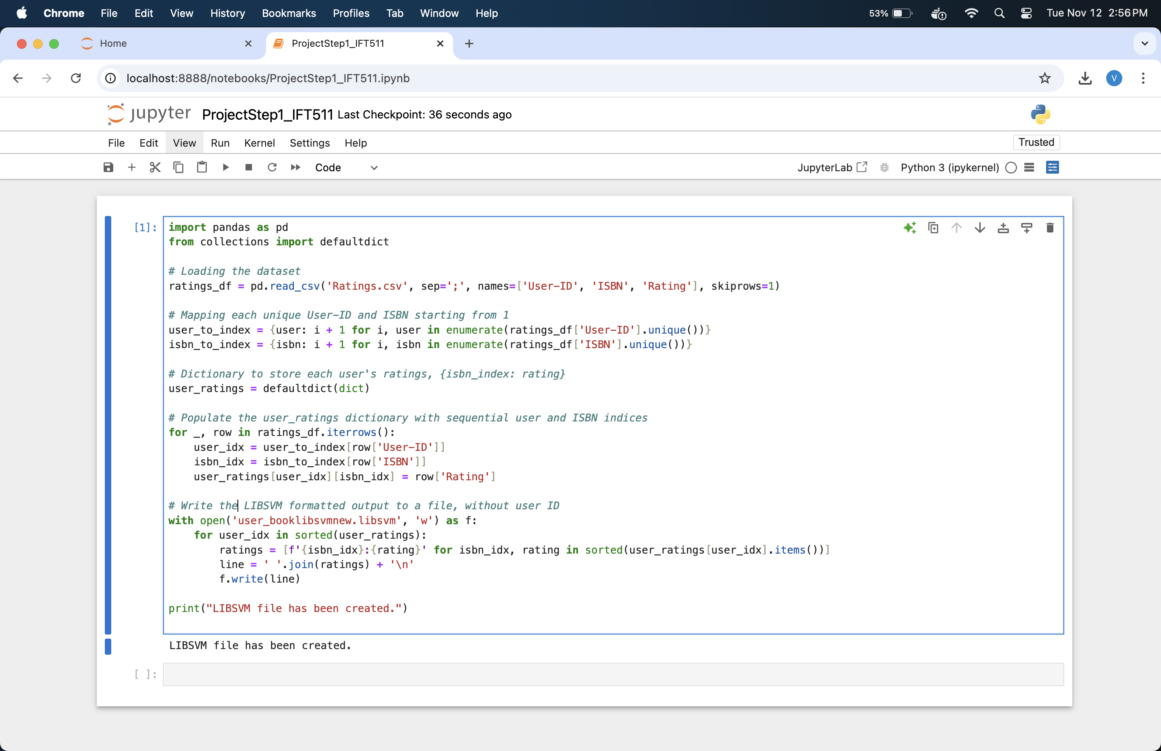

**LibSVM file Screenshot**:

