Task 6: Additional SQL Analysis and Insights
Objective
Demonstrate how the implemented database can support analytical and business questions through SQL queries and provide insights for decision-making.

1. Average Movie Ratings by Subscription Type
SQL Query
SELECT
m.Title,
u.SubscriptionStatus,
ROUND(AVG(r.Rating), 2) AS Average_Rating,
COUNT(r.RatingID) AS Number_of_Ratings
FROM Ratings r
JOIN Movies m ON r.MovieID = m.MovieID
JOIN Users u ON r.UserID = u.UserID
GROUP BY m.Title, u.SubscriptionStatus
ORDER BY m.Title, u.SubscriptionStatus;
Result
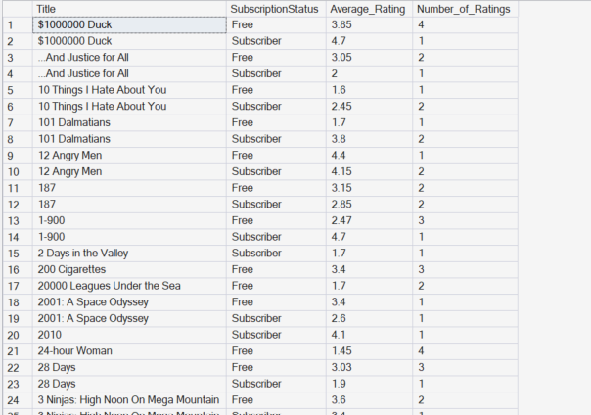

2. Top 10 Highest Rated Movies
Business Question
Which movies have the highest average ratings?
SQL Query
SELECT TOP 10
m.Title,
ROUND(AVG(r.Rating), 2) AS Average_Rating,
COUNT(r.RatingID) AS Number_of_Ratings
FROM Ratings r
JOIN Movies m ON r.MovieID = m.MovieID
GROUP BY m.Title
HAVING COUNT(r.RatingID) >= 5
ORDER BY Average_Rating DESC;
Result
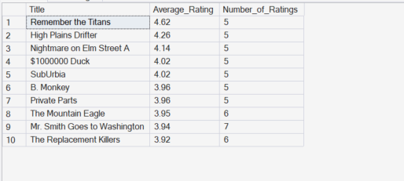

3. Most Rated Movies
SQL Query
SELECT TOP 10
m.Title,
COUNT(r.RatingID) AS Number_of_Ratings,
ROUND(AVG(r.Rating), 2) AS Average_Rating
FROM Ratings r
JOIN Movies m ON r.MovieID = m.MovieID
GROUP BY m.Title
ORDER BY Number_of_Ratings DESC;
Result
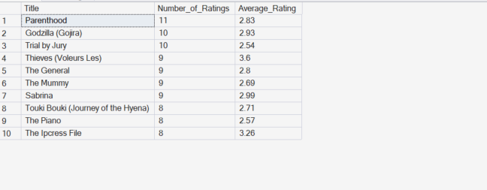

4. Rating Behaviour by Subscription Type
Business Question
Do Free and Premium users rate movies differently?
SQL Query
SELECT
u.SubscriptionStatus,
ROUND(AVG(r.Rating), 2) AS Average_Rating,
COUNT(r.RatingID) AS Total_Ratings
FROM Ratings r
JOIN Users u ON r.UserID = u.UserID
GROUP BY u.SubscriptionStatus
ORDER BY Average_Rating DESC;
Result
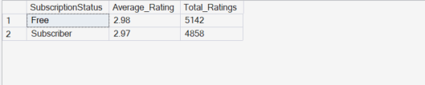

5. User Engagement by Subscription Type
Business Question
How does watch time vary across subscription types?
SQL Query
SELECT
SubscriptionStatus,
COUNT(UserID) AS Number_of_Users,
ROUND(AVG(TotalWatchTime), 2) AS Average_Watch_Time
FROM Users
GROUP BY SubscriptionStatus;
Result
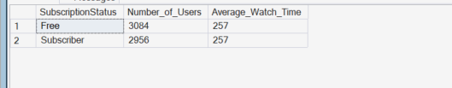
6. Genre Performance Analysis
Business Question
Which genres receive the highest ratings?
SQL Query
SELECT
m.Genres,
ROUND(AVG(r.Rating), 2) AS Average_Rating,
COUNT(r.RatingID) AS Number_of_Ratings
FROM Ratings r
JOIN Movies m ON r.MovieID = m.MovieID
GROUP BY m.Genres
ORDER BY Average_Rating DESC;
Result
