Task 4: Database Schema Design and ERD
Objective
Design the database structure for the Movies Database project by identifying tables, fields, keys, and relationships.
Final Schema Design
Users Table
- user_id (Primary Key)
- age
- gender
- country
- subscription_status
- total_watch_time
- device
Movies Table
- movie_id (Primary Key)
- title
- year
- genres
- language
- country
- total_views
Ratings Table
- rating_id (Primary Key)
- user_id (Foreign Key → Users.user_id)
- movie_id (Foreign Key → Movies.movie_id)
- rating
- timestamp
Entity Relationships
- One user can provide multiple ratings.
- One movie can receive multiple ratings.
- Each rating belongs to exactly one user and one movie.
- The Ratings table acts as a linking table between Users and Movies.
Design Assumptions and Rationale
Assumptions
- Each movie has a unique MovieID.
- Each user has a unique UserID.
- A user can rate multiple movies.
- A movie can receive ratings from multiple users.
- Rating information is stored separately to avoid data duplication.
- Genre values may contain multiple genres in a single field separated by delimiters.
- Total views are maintained at the movie level.
- User subscription status is maintained in the Users table.
Design Rationale
- Separate tables were created to normalize the data and reduce redundancy.
- Primary keys ensure uniqueness of records.
- Foreign keys enforce referential integrity between Ratings, Users, and Movies.
- The Ratings table resolves the many-to-many relationship between Users and Movies.
- The schema supports efficient querying and future scalability.
- The design follows relational database principles and supports data consistency.
ERD Diagram
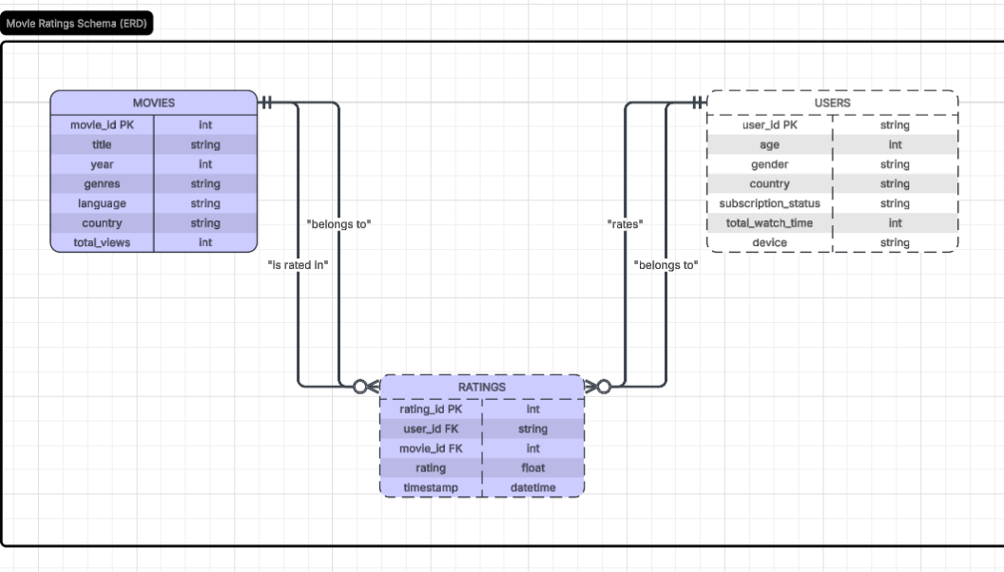Review Summary
The schema and ERD were reviewed and finalized by the team before implementation.
Deliverables
- Schema Design Document
- ERD Diagram
- Reviewed SQL Table Structure
- Final files ready for ClickUp and GitHub upload

