Task 6: SQL Table Implementation and Validation
Objective
Implement the Movies, Users, and Ratings tables in SQL Server using SSMS and validate the relationships between the tables.
Implementation Steps
1. Database Setup
- Connected to SQL Server using SQL Server Management Studio (SSMS).
- Created and used the database Movies_db.
2. Table Creation and Data Import
- Since the Import Data Wizard option was disabled in SSMS, the tables were created during the CSV import process using the Import Flat File feature.
- Imported the Movies, Users, and Ratings datasets into their respective tables.
- Verified that the data was successfully loaded into all three tables.
3. Primary Key Implementation
Primary keys were created to uniquely identify records in each table:
- Movies(MovieID)
- Users(UserID)
- Ratings(RatingID)
4. Foreign Key Implementation
Foreign key constraints were added to establish relationships between the tables:
- Ratings.MovieID references Movies.MovieID.
- Ratings.UserID references Users.UserID.
5. Validation
The following validation steps were performed:
Row Count Validation
Verified that records were successfully imported into all three tables.
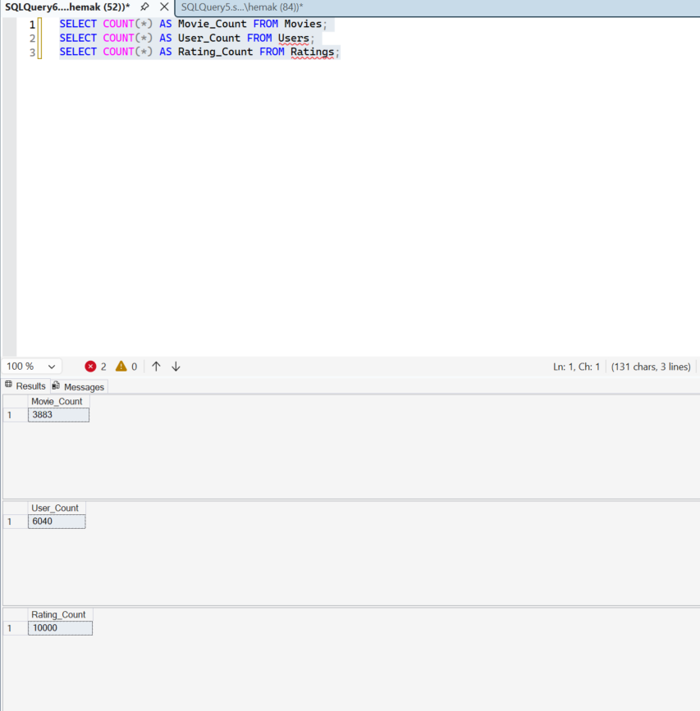
Primary Key Validation
Confirmed that primary key constraints were created successfully.
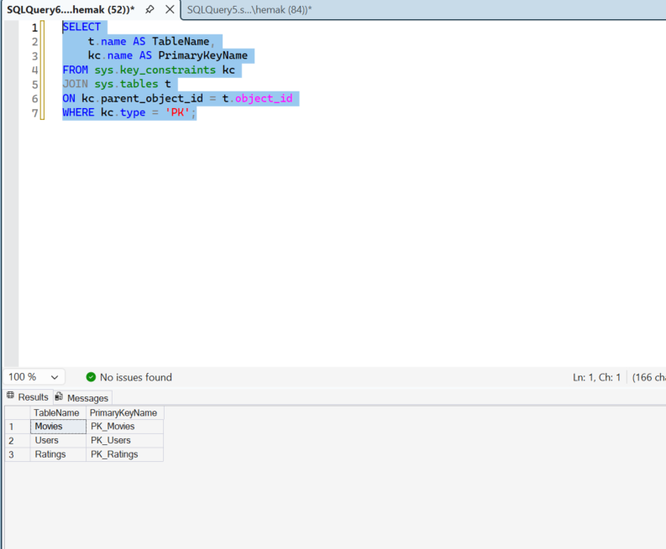
Foreign Key Validation
Confirmed that foreign key constraints were created successfully.
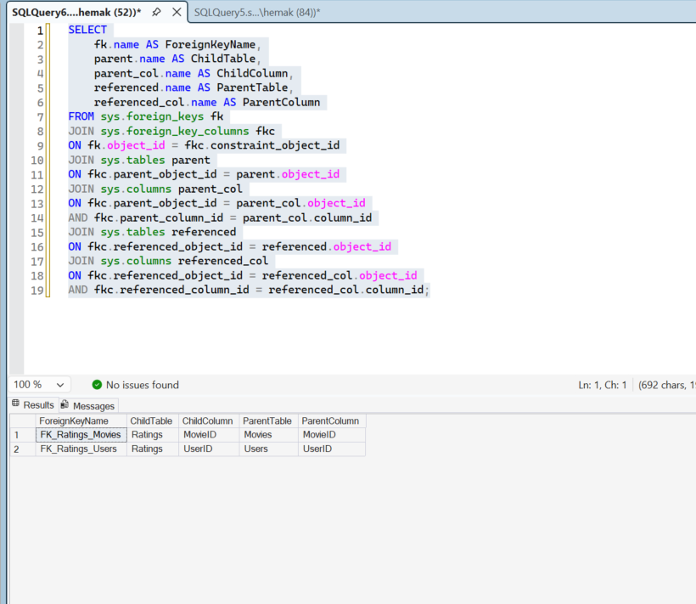
Relationship Validation
Executed JOIN queries between Movies, Users, and Ratings tables to verify that relationships were functioning correctly and that the Ratings table correctly linked users and movies.

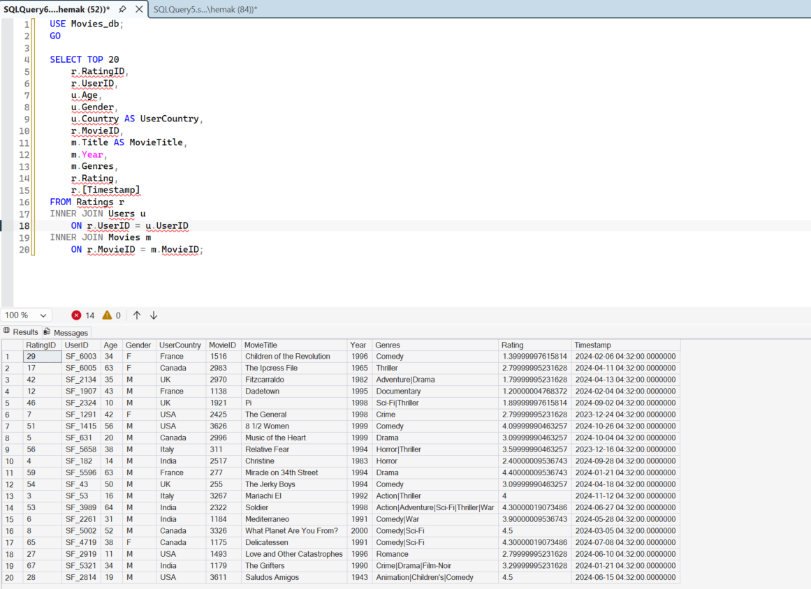
Conclusion
The Movies, Users, and Ratings tables were successfully implemented in SQL Server using SSMS. Data was imported from CSV files, primary and foreign key constraints were established, and validation queries confirmed that the relationships between the tables were functioning correctly.
Screenshots
The following screenshots are attached in this document:
- Movies table import results.
- Users table import results.
- Ratings table import results.
- Primary key validation results.
- Foreign key validation results.
- Relationship validation query and results.

