SOFTWARE REQUIREMENT SPECIFICATION
FOR
ONLINE SHOPPING SYSTEM
Under the Subject of
Software Engineering (Semester – I)
Prepared by:
Khushal Savalakha(22002171410051)
Meetkumar Chavda(22002170310001)
Sanskruti Tripathi(22002171410061)
Archana Menon(22002171410031)
Arnab Ghosh(22002171410019)

Table of Contents

1. Introduction 1
1.1 Purpose
1.2 Intended Audience
1.3 Intended Use
1.4 Project Scope
1.5 Definitions
2. Overall Description 3
2.1 User Needs
2.1.1 Different types of user
2.2 Assumptions and Dependencies
2.2.1 Assumptions
2.2.2 Dependencies
3. System Features and Requirements 5
3.1 Functional Requirements
3.1.1 Registration
3.1.2 Login
3.1.3 Cart
3.1.4 Payment
3.1.5 Report Generation
3.1.6 Logout
3.2 External Interface Requirements
3.2.1 User Interface
3.2.2 Hardware Interface
3.2.3 Software Interface
3.2.4 Communication Interface
3.3 System Features
3.4 Non-Functional Requirements
3.4.1 Performance requirements
3.4.2 Safety requirements
3.4.3 Security requirements
3.4.4 Usability requirements
3.4.5 Scalability requirements
4. Diagram 7
5.1 Use Case Diagram
5.2 Data Flow Diagram
5.2.1 Level 0 DFD
5.2.2 Level 1 DFD
5.2.3 Level 2 DFD
6. Conculsion 11

Introduction

Purpose
Online Shopping System is meant to provide features which facilitate both the customers and vendors to interact with each other without being physically available. The software provides versatile options for customer to buy any product at any time. The software should provide an option to check the availability of product and also to modify or cancel the order for any reason.
The customer should be noted if any further changes are made.

Intended Audience
- People who like the convenience of online shopping
- People who want variety of choices in a product
- People who want an exact product every time
- People who want products which are only available on e-stores
- People who want product from a specific place, country, etc
- People who want to get a better deal on purchase of product
- Authorities and developers of the system
- And various users

Intended Use
- It saves time of both the customer and the vendor
- It provides authenticity of products sold
- It provides various option of payments to customer
- It gives wider range of choice for product
- Provides safety to the customer during pandemic
- No pressure of shopping for customer
- Enables vendors to sell their products from remote or rural areas

Project Scope
The Online Shopping System provides a better platform to the customer and the vendor to communicate effectively for the better deal of product anytime anywhere. It intends to attract variety of customers around the world and also attracts the same customers by offering unique products and services. The main goal of the software is to improve user experience by designing websites which are more interactive, enhancing brand awareness by advertising, reducing shopping cart abandonment, improving customer satisfaction etc.

Definitions
- SRS – Software Requirement Specification
- OSS – Online Shopping System
- Customer – who purchases the product
- Vendor – who sells the product
- Admin – who operates the system
- User – who uses the system to buy product
- LAN – Local Area Network
- WAN – Wide Area Network
- UPS – Uninterruptible Power Supply

Overall Description

User Needs
Customer is the user who will participate from user interface.
- they need ease and convince while shopping
- they want easy ways to compare product prices
- they need efficient search results which provide them the ability to sort results
- they need customer reviews for a product
- they want personalized recommendation on product by analyzing their search
- they want them different types of payment methods
- they want easy checkouts and check-in in the website

Different types of user
- Discount Seekers
- These kind of customer primarily focus on the money they save with each purchase.

- Wandering customers
- These types of customers are there for shopping experience. If they aren’t looking for a particular product, they enjoy browsing and make purchase after browsing fully.

- Impulse buyers
- Impulse shoppers do not have patience and want to buy immediately .They wants to have latest and hottest products in their stock.

- Need based buyers
- Need-based shoppers will research the products before buying. These kinds of buyers aren’t in a hurry and spend their time comparing and contrasting different types of options before making a decision.

- Loyal Customer
- These kinds of customers are willing to engage with and repeatedly purchase from a particular organization versus their competitors

Assumptions and Dependencies

Assumptions
- Customer knows what they want
- Customer will give you feedback
- If customers are satisfied with the service they will advertise us
- Coding should be error free
- An attractive website is effective
- Customer will come back because they like our site
- System should provide search facility and support quick transactions
- System should have more capacity and provide fast access to the database
- Whatever we do will be rapidly outdated by new technological developments
- User may access from any computer that has internet browsing capabilities and an internet connection
- User must have their correct usernames and passwords to enter into theironline accounts and do actions

Dependencies
- On availability of server to run
- On specific hardware and software due to which the system will run
- On willingness of customers to visit online stores and purchase there
- On the basis of listing requirements and specification the project will bedevelop and run
- On growing social media activities and technology
- On proper understanding of the product to users
- On 3rd party shipments

System Features and Requirements

Functional Requirements

Registration
- A customer must register himself/herself first before buy a product; unregistered customer won’t have access to the shopping cart.

Login
- A customer must enter with a valid user id and password to access the shopping cart.

Cart
- After successful login and registration a customer has access to the cart, from which he/she can make an order, change or cancel the order the way they want.

Payment
- A customer can choose a mode of payment as per his/her choice whether is it cash/debit/credit.

Report Generation
- After ordering the product and successful payment a report/bill will be generated which will be sent to customer given id and will be stored in system data.

Logout
- After ordering and surfing for product in website; customers can logout.

External Interface Requirements

User Interface
- An admin can modify everything on the product as he want.
- A user can view the details of product

Hardware Interface
- Hard disk: 40GB
- RAM: 512MB
- Processor: Dual core

Software Interface
- Operating System: Windows, Unix, Linux, Mac etc
- Development tool: Java development tool kit, PHP, JavaScript etc
- Database: MySQL

Communication Interface
- Both the parties should be connected by LAN or WAN for communication purpose
- Both parties( i.e. the user and admin) should have a stable internet connection

System Features
- Should contain detailed product description
- An authority must ensure that the customer is provided with a real product
- Must provide an easy and quick payment system
- An authority should provide customer support
- Security must be provided to the customer information
- A strong database should be there to manage customers information efficiently
- Must work friendly and efficiently in any device

Non-functional Requirements

Performance requirements
- The system should be able to manage high levels of traffic and load with no delays

Safety requirements
- Proper UPS/inverter facility should be there in case of power supply failure
- Database backup should be kept in case of virus or operating system failure at any time

Security requirements
- System should use secured database
- System should prevent unauthorized access or interference with sensitive customer information and transactions
- System must automatically log out customers if they are inactive for a long period of time
- System’s back-end servers shall only be accessible to authenticated management

Usability requirements
- A system should be simple to use and navigate for customers which have a user friendly interface and clear instructions

Scalability requirements
- A system should be able to quickly absorb growth in traffic and product numbers without compromising performance

DIAGRAMS

Use Case Diagram
Login

Add Category

Add item

Manage item

Manage order

Registration
ADMIN
USER

View item

Make order

Make payment

Customer Review

Logout

Data Flow Diagram

Level 0 DFD:

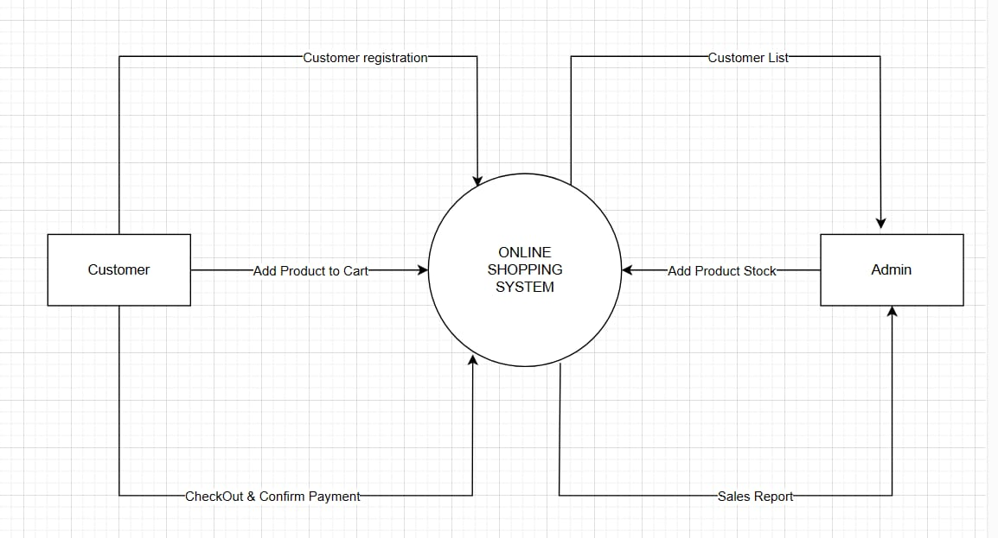

Level 1 DFD

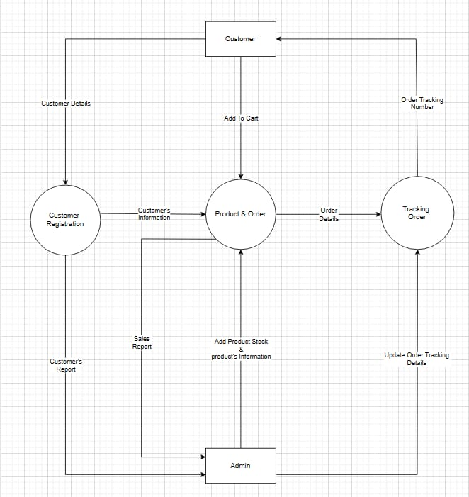

Level 2 DFD
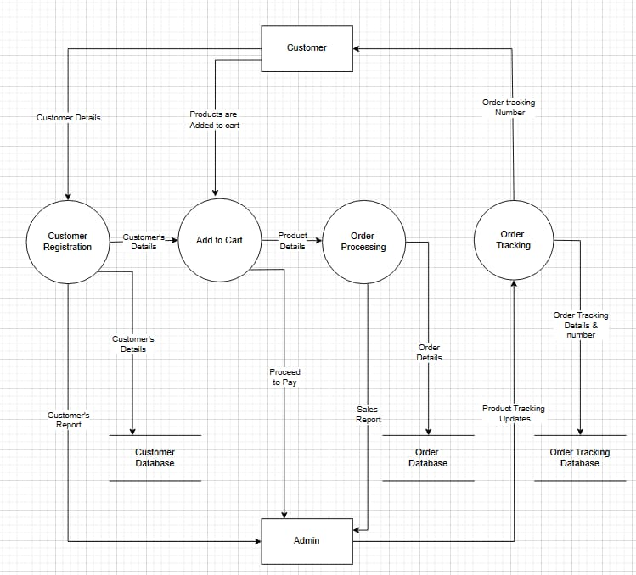

CONCLUSION
We can hereby conclude that:

- More people can use online shopping as faster, more comfortable and not restricted by assortment system of shopping
- Lot of websites and tools to help consumer with online purchasing decision
- Different product price comparison services help customers to compare the prices of identical goods offered by different sellers
- Customers are asked to rate vendors so that the next buyers can rely on this rates which choosing a certain product on the future
- With growing technology we can see the bright future of online shopping

