Data Analytics



SESSION 1: INTRODUCTION

Assignment 1

1

Data Analytics

Table of Contents

1.Introduction 3

2.Objective 3

3.Prerequisites 3

4.Associated Data Files 3

5.Problem Statement 3

6.Expected Output 3

7.Approximate Time to Complete Task 3

2

Data Analytics

1. Introduction

This assignment will help you understand the concepts learnt in the session.

2. Objective

This assignment will test your skills on the basics of Data Analytics.

3. Prerequisites

Not applicable.

4. Associated Data Files

Not applicable.

5. Problem Statement
1. Please mention true or false for the below statements:

- Prescriptive Analytics is used to predict the future outcomes- False
- Base R packages are installed automatically- True

2. What is Recycling of elements in a vector?

Ans- Recycling occurs when vector arithmetic is performed on multiple vectors of different sizes. R takes the shorter vector and repeats them until it becomes long enough to match the longer one.

3. Give an example of recycling of elements.

> 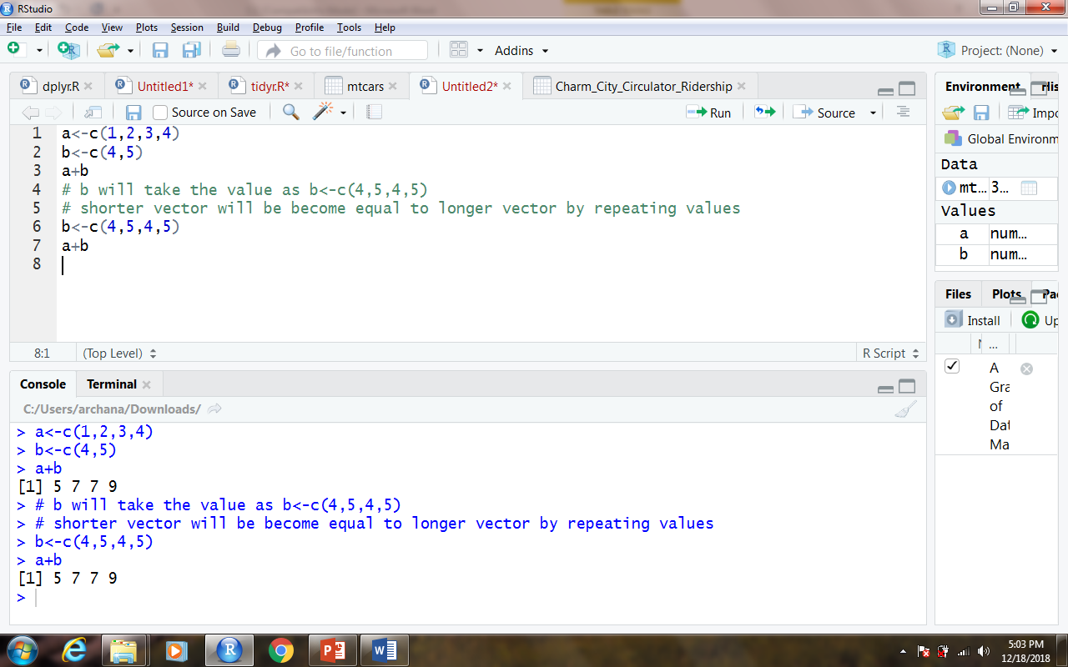

3

Data Analytics

- Expected Format

  - R file should be submitted where applicable.
  - R file should be in PDF or in .r format
  - Proper screenshots of the outputs should be submitted as well

  - The r codes, if submitted in any other format, will be subjected to deduction in marks

Note: Your solution will not be entertained if it is any other format, e.g., .zip, .doc, .rtf etc.

7. Approximate Time to Complete Task

20 mins.

4

