STREAMLINING IT PROCUREMENT
Automating Standard Laptop Procurement Using ServiceNow Flow Designer

Project Title
Streamlining IT Procurement – Automating Standard Laptop Procurement Using ServiceNow Flow Designer

Project Team Members

ARCHANA A
TeamLead

ANITHA A
Member

DEVI PRIYA S
Member

DHARANI T
Member

HEMAVATHY P
Member

Project Overview
Streamlining IT Procurement is a ServiceNow-based project designed to automate the process of requesting and approving standard laptops for employees. The project uses ServiceNow Flow Designer to reduce manual work, improve request processing, and provide a structured procurement workflow.
The project focuses on creating an automated flow where a laptop request is submitted, checked, approved, and processed according to predefined conditions.

Key Objectives
- Automate standard laptop procurement requests.
- Reduce manual processing and paperwork.
- Create an approval workflow using Flow Designer.
- Track laptop procurement requests.
- Improve request processing and visibility.
- Provide a simple and structured IT procurement process.

Target Users
- Employees requesting laptops
- IT Support Team
- IT Procurement Team
- Managers / Approvers
- ServiceNow Administrators
- Students learning ServiceNow and Flow Designer

Project Instruction
Streamlining IT Procurement is a ServiceNow-based automation project developed using Flow Designer.

Quick Start
- Login to ServiceNow
- Open to required application/module
- Create and configure a Flow Designer flow named Standard Laptop Task.
- Configure the flow to create a Catalog Task for the Standard Laptop Requested Item.
- Set the task description and assign it to the Hardware assignment group.
- Associate the flow with the Standard Laptop Catalog Item.
- Place a test order and complete the approval process.
- Verify that the Catalog Task is automatically created and correctly assigned to the Hardware team

Pre-requisites

Hardware Requirements:
- Minimum 4-Core CPU
- Minimum 8 GB RAM
- 256 GB or higher SSD
- Stable Internet connection

Software Requirements:
- ServiceNow Instance
- ServiceNow Service Catalog
- ServiceNow Flow Designer
- Google Chrome / Microsoft Edge
- JavaScript support, if required

Technical Architecture

ServiceNow Architecture
- Request – Handles the laptop procurement request submitted by the employee.

- Flow Designer – Automates the complete procurement process based on predefined conditions.
- Approval – Sends the request to the appropriate manager/approver.
- IT Procurement – Processes the approved laptop request.

- Notification – Provides updates about the request status.

- Task / Record – Stores and tracks the procurement request throughout the workflow.

Process Flowchart and Architecture Diagram

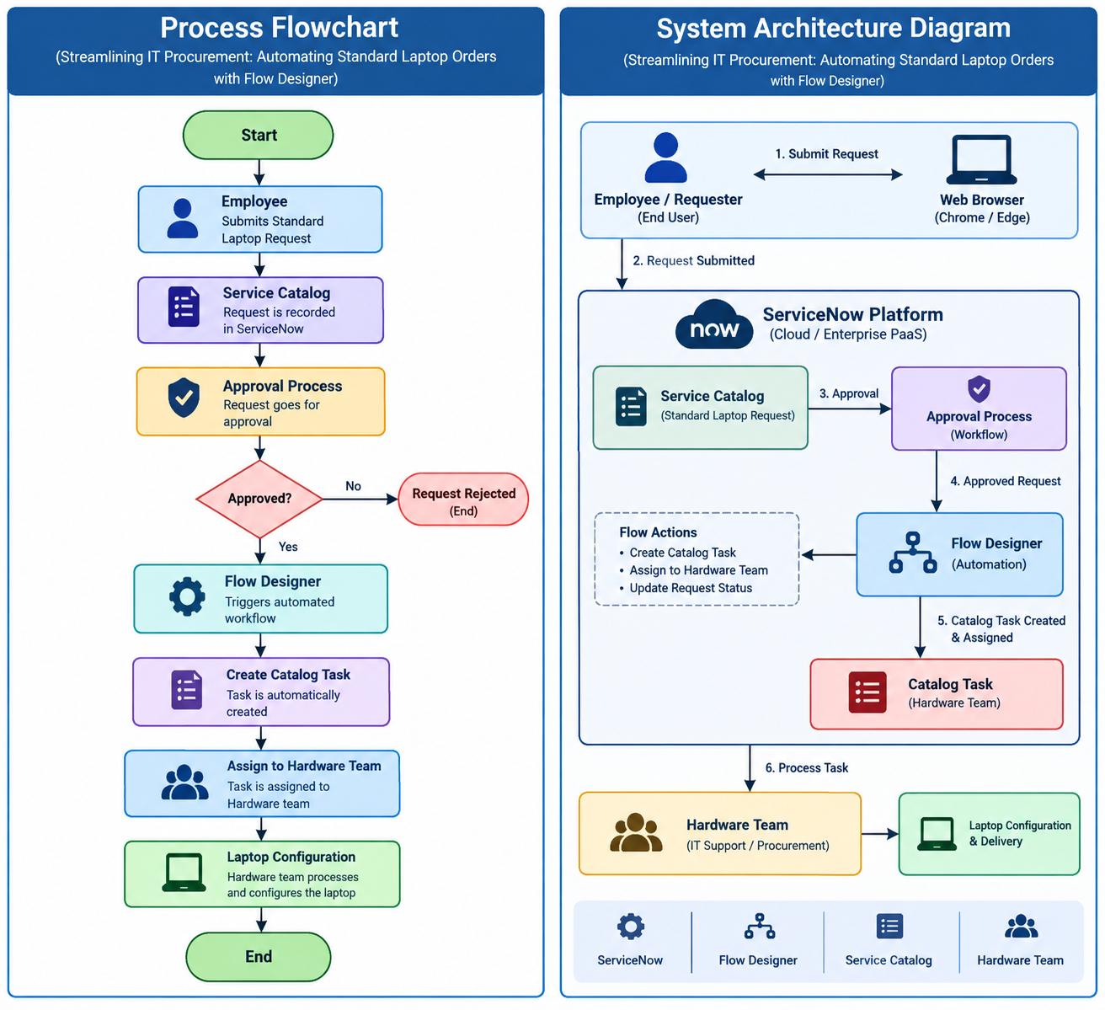

Advantages
- Saves time
- Reduces manual work
- Automatic task creation
- Automatic Hardware team assignment
- Easy request tracking
- Reduces errors
- Simple and organized process

Roles and Responsibilities

Student / Developer
- Create the ServiceNow project.
- Configure procurement request.
- Design Flow Designer workflow.
- Configure approval process.
- Test the workflow.
- Capture screenshots.
- Record project demonstration.
- Prepare project documentation.
- Upload project details to GitHub.

System (Backend / ServiceNow)
- Receive laptop procurement requests.
- Trigger the automated flow.
- Send approval requests.
- Process approved requests.
- Create required tasks.
- Update request status.
- Track the procurement process.
- Provide notifications.

Users Flow
Employee → Login to ServiceNow → Create Laptop Procurement Request → Submit Request → Flow Designer Triggered → Manager Approval → Procurement Task → IT Processing → Request Completed

Project Setup and Configuration

Folder / Project Structure
Streamlining IT Procurement
│
├── ServiceNow Application
├── Request / Catalog Item
├── Flow Designer
│ ├── Trigger
│ ├── Conditions
│ ├── Approval
│ ├── Task Creation
│ └── Notifications
├── Tables / Records
├── Approvals
├── Tasks
└── Documentation
├── Screenshots
├── Project Report
└── Demo Video

Project Setup
- Login to the ServiceNow instance.
- Create the laptop procurement request/catalog item.
- Add fields such as Employee Name, Laptop Model, Department, Request Reason, Laptop Type and Business Justification.
- Open All → Flow Designer.
- Create a new flow for standard laptop procurement.

Backend / Flow Designer Development

Setup Flow Designer
Flow Designer is used to automate the laptop procurement process from request submission through approval, procurement task creation, processing, and completion.
The flow starts when a new laptop procurement request is submitted.

Conditions
The flow checks the request details and determines the next action. For example, it can check whether the request is for a standard laptop.

Approval
The flow sends the request to the appropriate approver. The approver reviews the request and either approves or rejects it.

Approved Request
If approved, the system creates a procurement task, assigns it to the IT/procurement team, and continues the processing workflow.

Rejected Request
If rejected, the request is updated or closed and the employee is notified.

Main Actions
- Get request details
- Check request conditions
- Ask for approval
- Create procurement task
- Assign task to IT team
- Update request status
- Send notification
- Complete the request

Database Development
ServiceNow records are used to store procurement requests, approvals, tasks, assignments, status updates, and comments.

Procurement Request Record
- Request Number
- Requested For
- Laptop Model
- Department
- Request Reason
- Approval Status
- Request Status
- Created Date
- Assigned To

Procurement Task
- Task Number
- Related Request
- Assigned To
- Task Status
- Comments
- Completion Date

Project Execution

Project Execution Steps

- Login to ServiceNow.
- Create laptop procurement requests.
- Enter the required laptop procurement details.
- Submit the request.
- Flow Designer automatically starts the procurement workflow.
- The request is sent for approval.
- Approver reviews and approves or rejects the request.
- For an approved request, a procurement task is created and assigned.
- The IT /procurement team processes the request.
- Request status is updated and the request is completed.

Final Output Screenshot

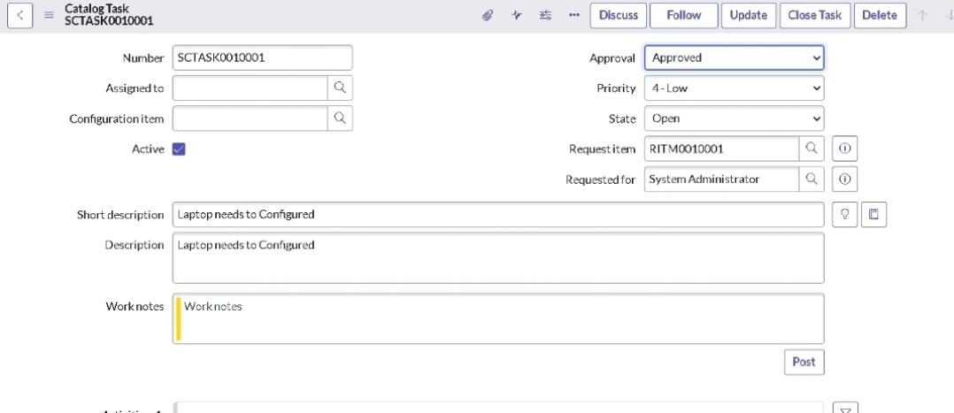

Conclusion

The Streamlining IT Procurement project demonstrates how ServiceNow Flow Designer can automate a standard laptop procurement process. The workflow reduces repetitive manual steps by handling request submission, approval, task creation, status updates, and notifications in a structured manner. The project provides practical experience with ServiceNow, Flow Designer, workflow automation, approvals, tasks, and IT service management.

Reference

Demo Video Link:
https://drive.google.com/file/d/1BW_ccKZ9kTG7YjTpBa1LUqiHeN_6sYme/view?usp=drivesdk

