**WEEK 5 – MICROSERVICES WITH SPRINGBOOT 3 AND SPRING CLOUD**

**ADDITIONAL EXERCISE:**

**CREATE EUREKA DISCOVERY SERVER AND REGISTER MICROSERVICES**

**STEP 1:** Setup and download the project from Spring Initializer by adding Eureka Server dependency.

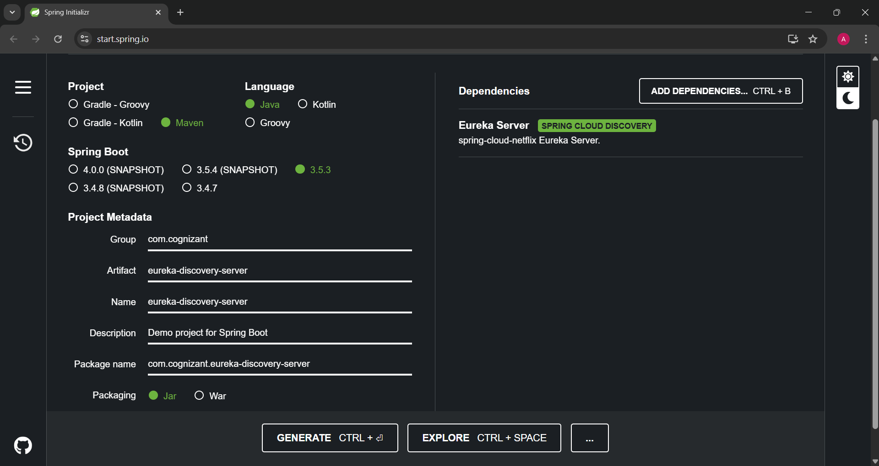

**STEP 2:** After downloading, unzip the file and in command prompt run “mvn clean install”.

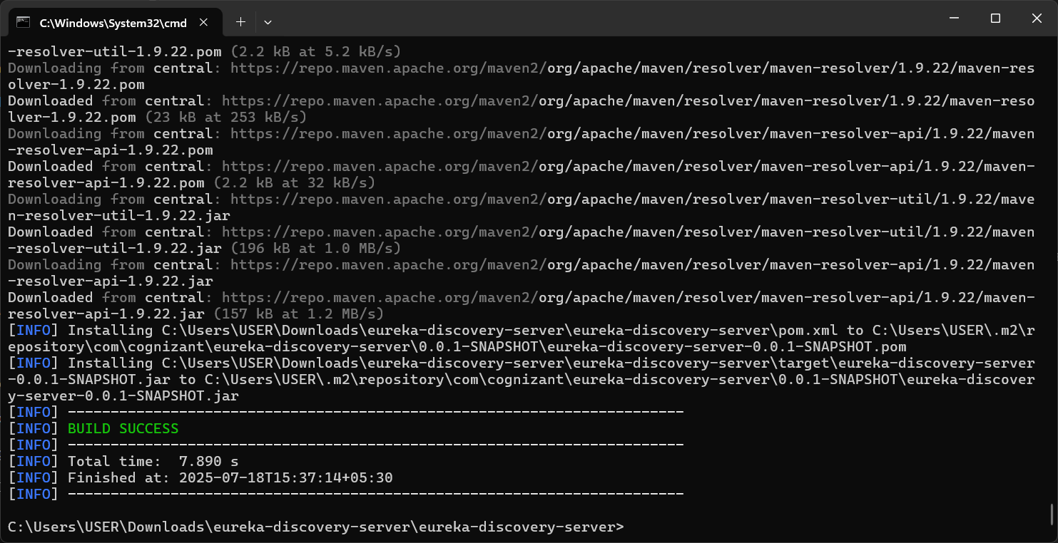

**STEP 3:** Import the file into eclipse.

**EurekaDiscoveryServerApplication.java**

package com.cognizant.eureka_discovery_server;

import org.springframework.boot.SpringApplication;

import org.springframework.boot.autoconfigure.SpringBootApplication;

import org.springframework.cloud.netflix.eureka.server.EnableEurekaServer;

@EnableEurekaServer

@SpringBootApplication

public class EurekaDiscoveryServerApplication {

public static void main(String[] args) {

SpringApplication.run(EurekaDiscoveryServerApplication.class, args);

}

}

**application.properties**

spring.application.name=eureka-discovery-server

server.port=8761

eureka.client.register-with-eureka=false

eureka.client.fetch-registry=false

logging.level.com.netflix.eureka=OFF

logging.level.com.netflix.discovery=OFF

**STEP 4:** Open <http://localhost:8761/> to view the Eureka Server. It should show no instances are registered.

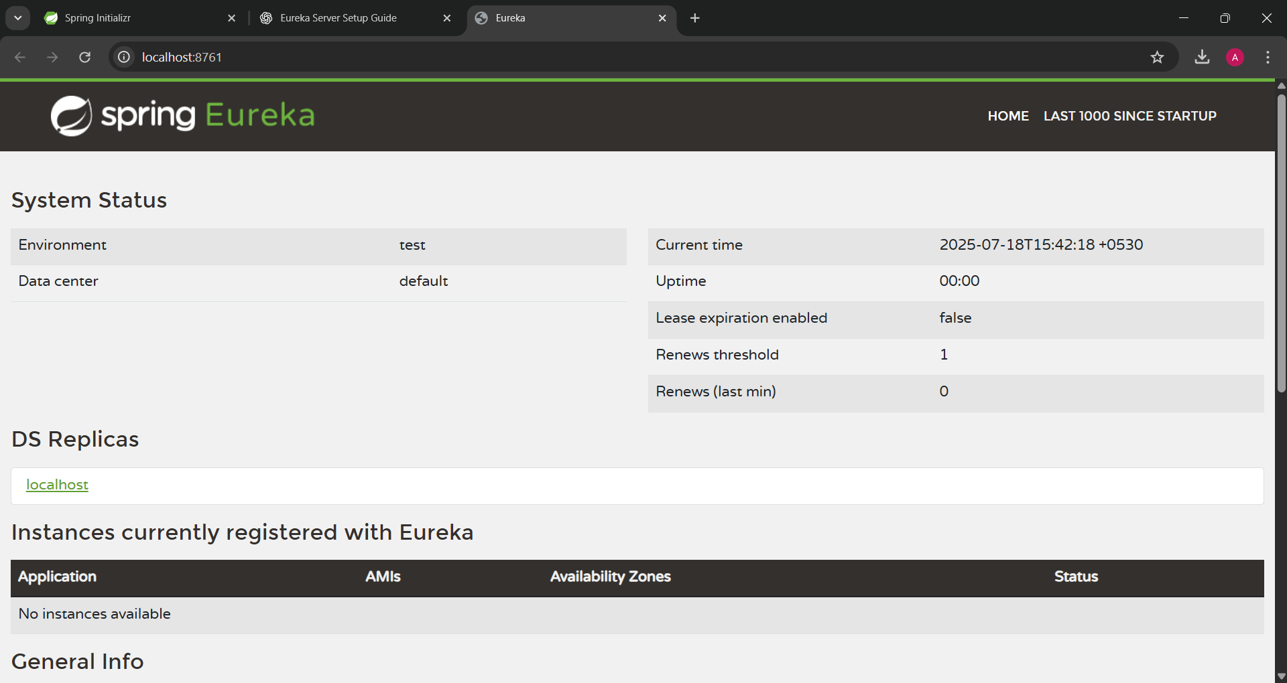

**STEP 5:**

Register Account microservices.

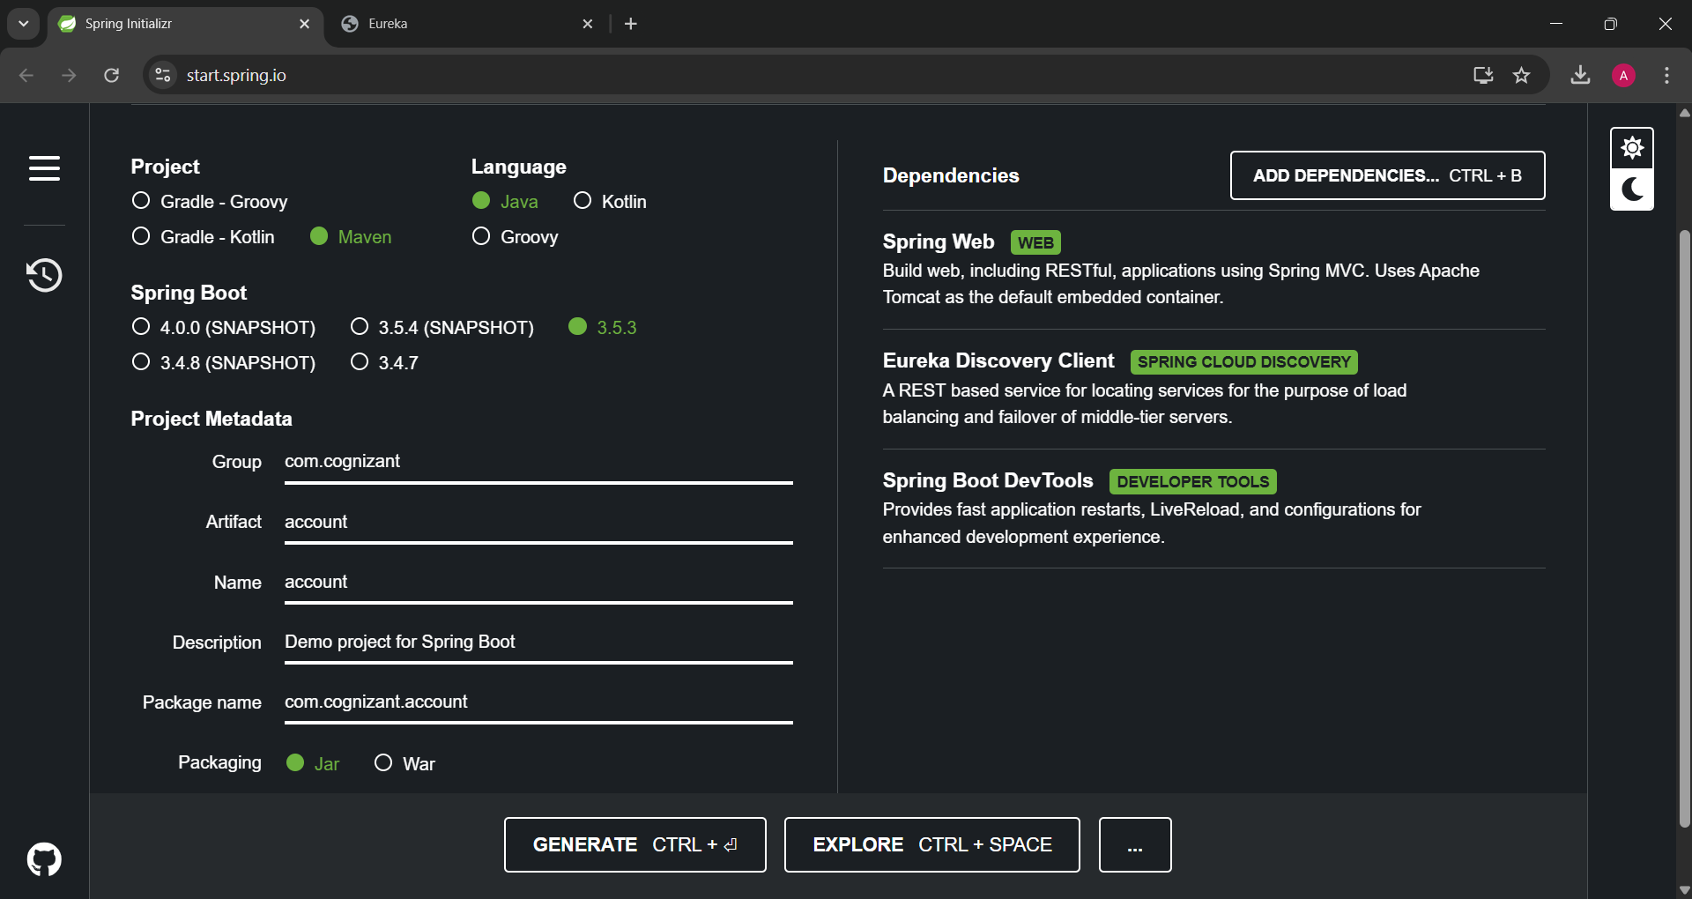

Run “mvn clean install”

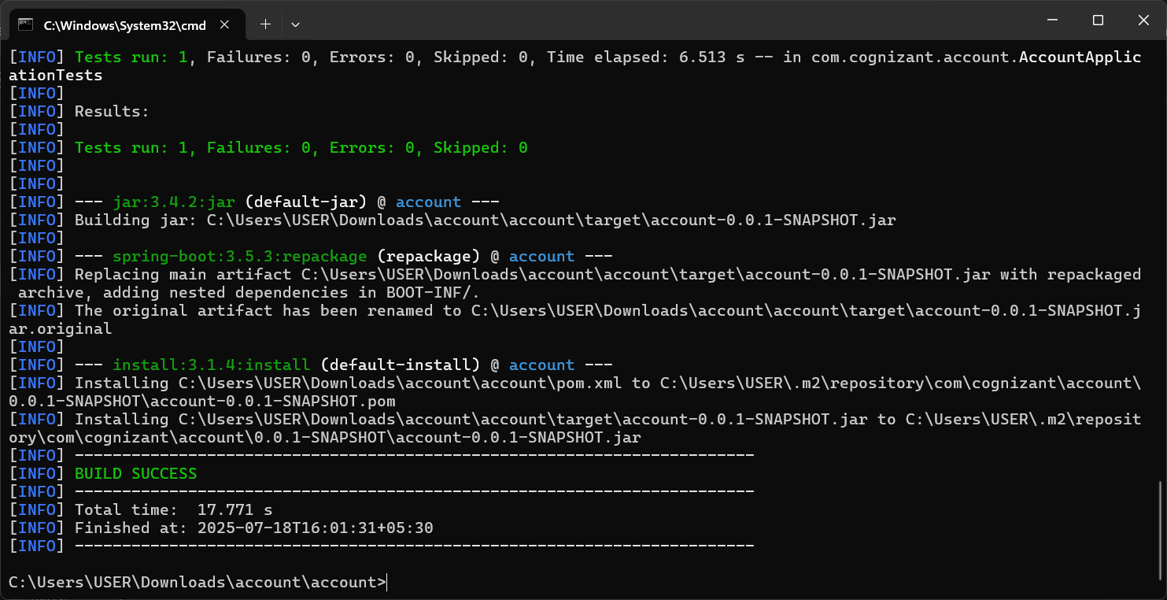

**AccountApplication.java:**

package com.cognizant.account;

import org.springframework.boot.SpringApplication;

import org.springframework.boot.autoconfigure.SpringBootApplication;

import org.springframework.cloud.client.discovery.EnableDiscoveryClient;

@EnableDiscoveryClient

@SpringBootApplication

public class AccountApplication {

public static void main(String[] args) {

SpringApplication.run(AccountApplication.class, args);

}

}

**application.properties:**

spring.application.name=account

spring.application.name=account-service

server.port=8081

eureka.client.service-url.defaultZone=http://localhost:8761/eureka

View <http://localhost:8761/> to find the registered instance with Eureka.

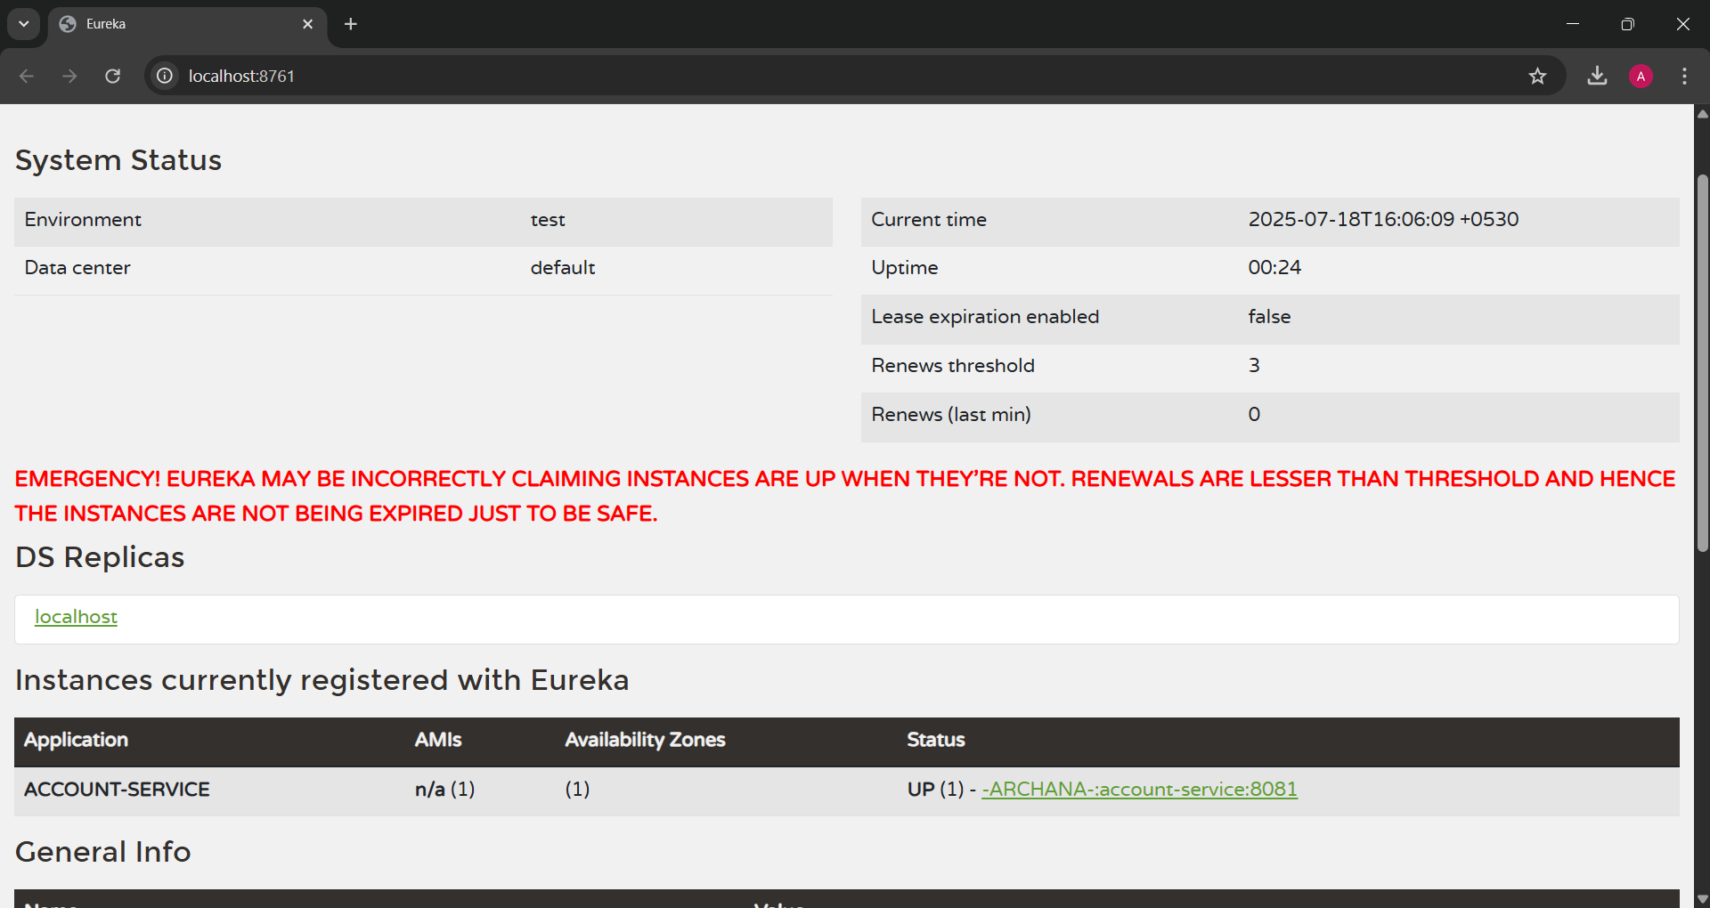

**STEP 6:**

Register Loan microservices.

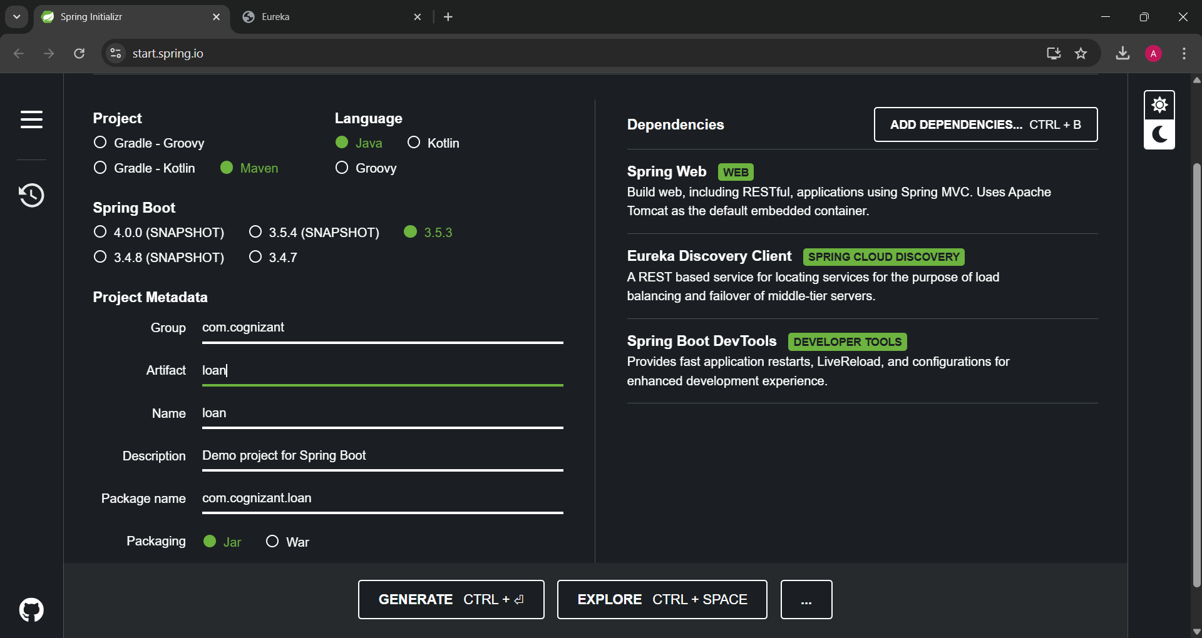

Run “mvn clean install”

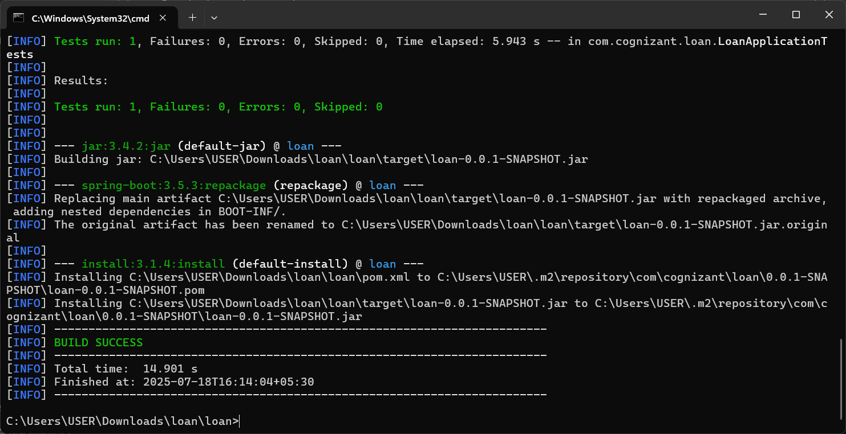

Import into eclipse

LoanApplication.java

package com.cognizant.loan;

import org.springframework.boot.SpringApplication;

import org.springframework.boot.autoconfigure.SpringBootApplication;

import org.springframework.cloud.client.discovery.EnableDiscoveryClient;

@EnableDiscoveryClient

@SpringBootApplication

public class LoanApplication {

public static void main(String[] args) {

SpringApplication.run(LoanApplication.class, args);

}

}

application.properties

spring.application.name=loan

spring.application.name=loan-service

server.port=8082

eureka.client.service-url.defaultZone=http://localhost:8761/eureka

View <http://localhost:8761/> to find the registered instance with Eureka.

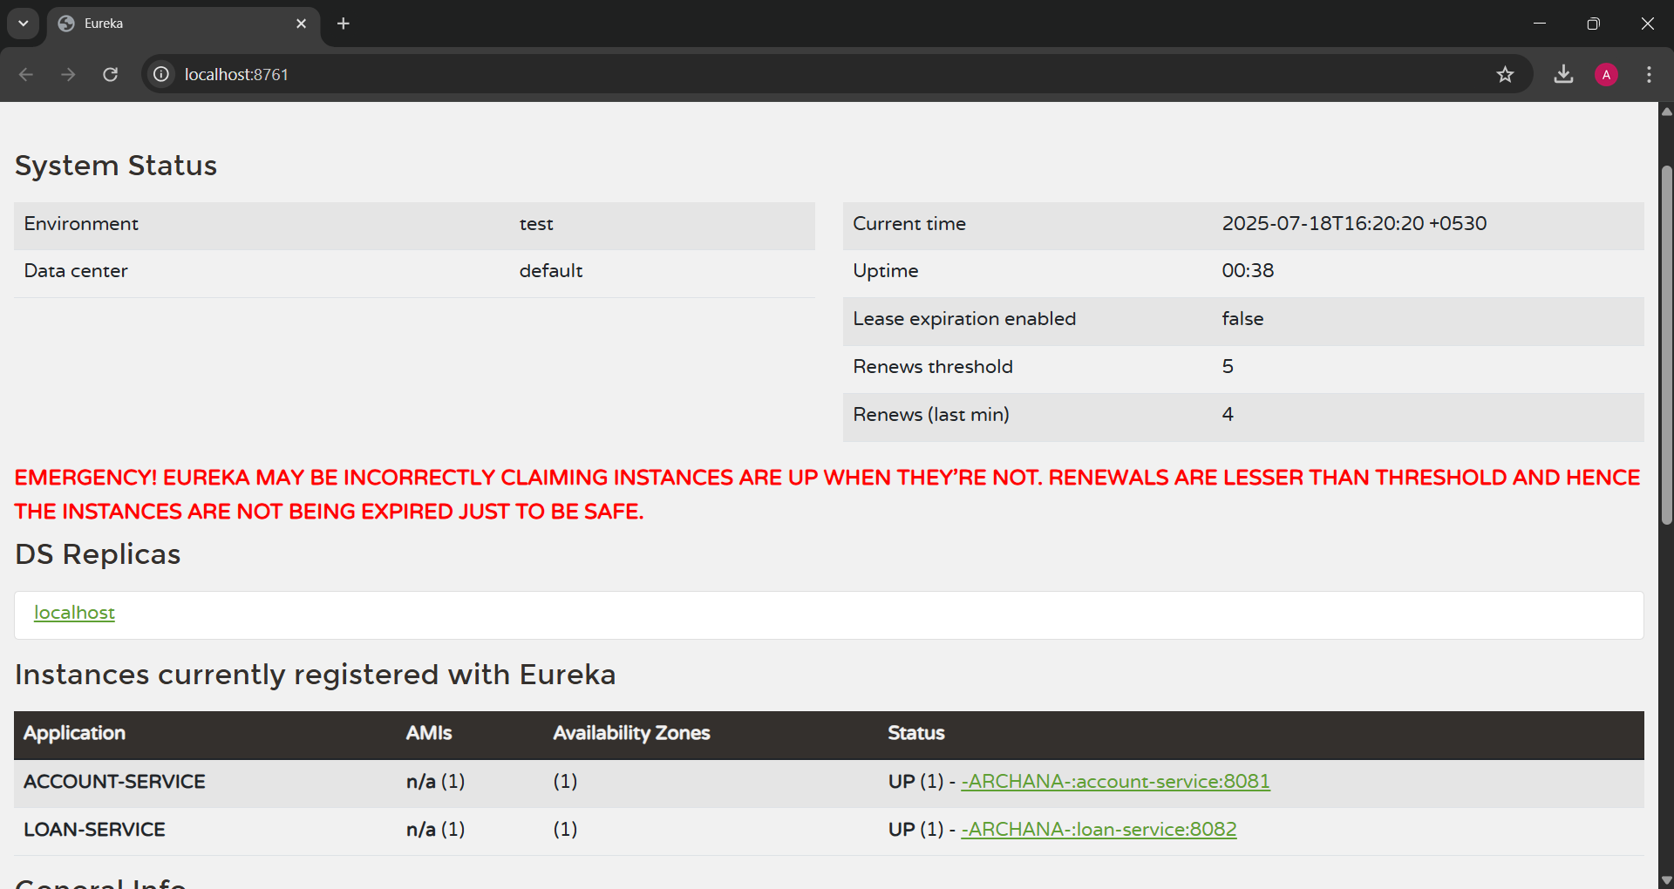

**STEP 6:**

Create and Register greet-service.

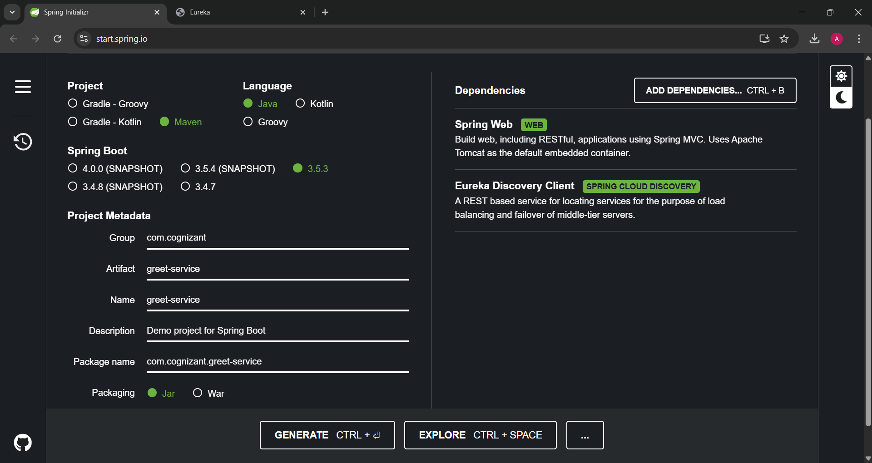

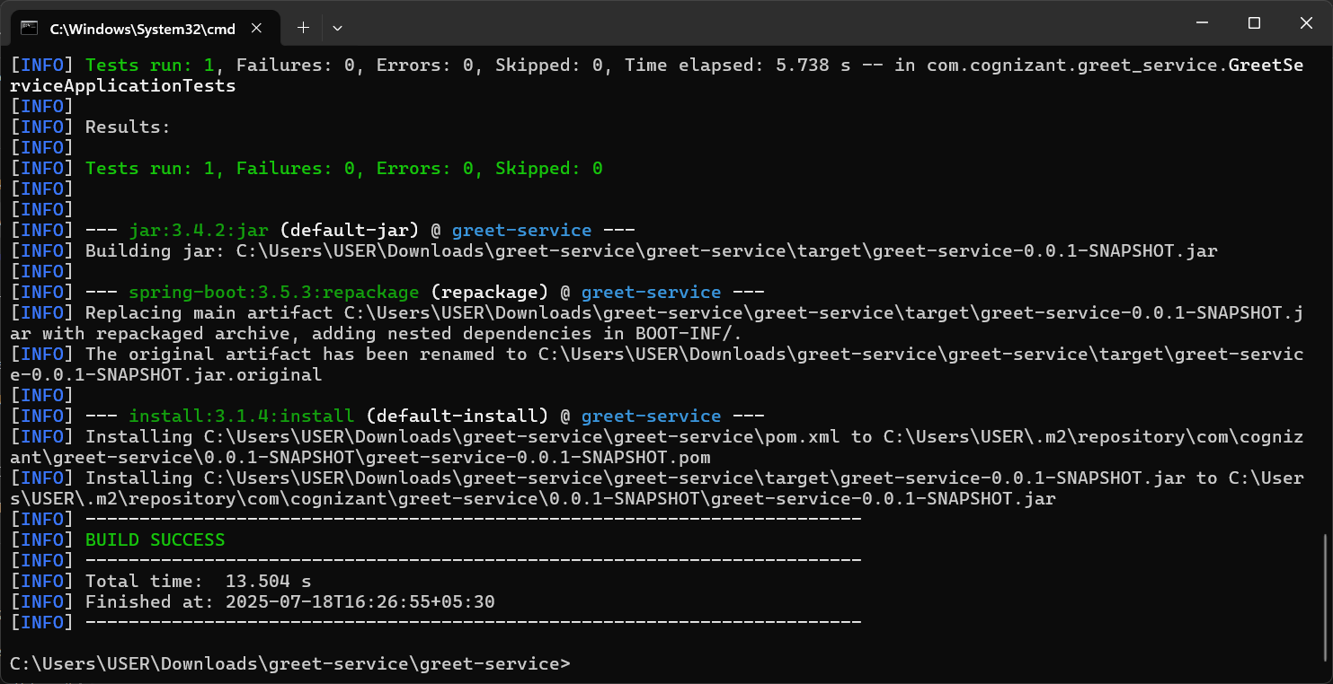

GreetController.java

package com.cognizant.greet_service.controller;

import org.springframework.web.bind.annotation.GetMapping;

import org.springframework.web.bind.annotation.RestController;

*@RestController*

public class GreetController {

*@GetMapping*("/greet")

public String greet() {

return "Hello World";

}

}

application.properties

spring.application.name=greet-service

server.port=8083

eureka.client.service-url.defaultZone=http://localhost:8761/eureka

View <http://localhost:8761/> to find the registered instance with Eureka.

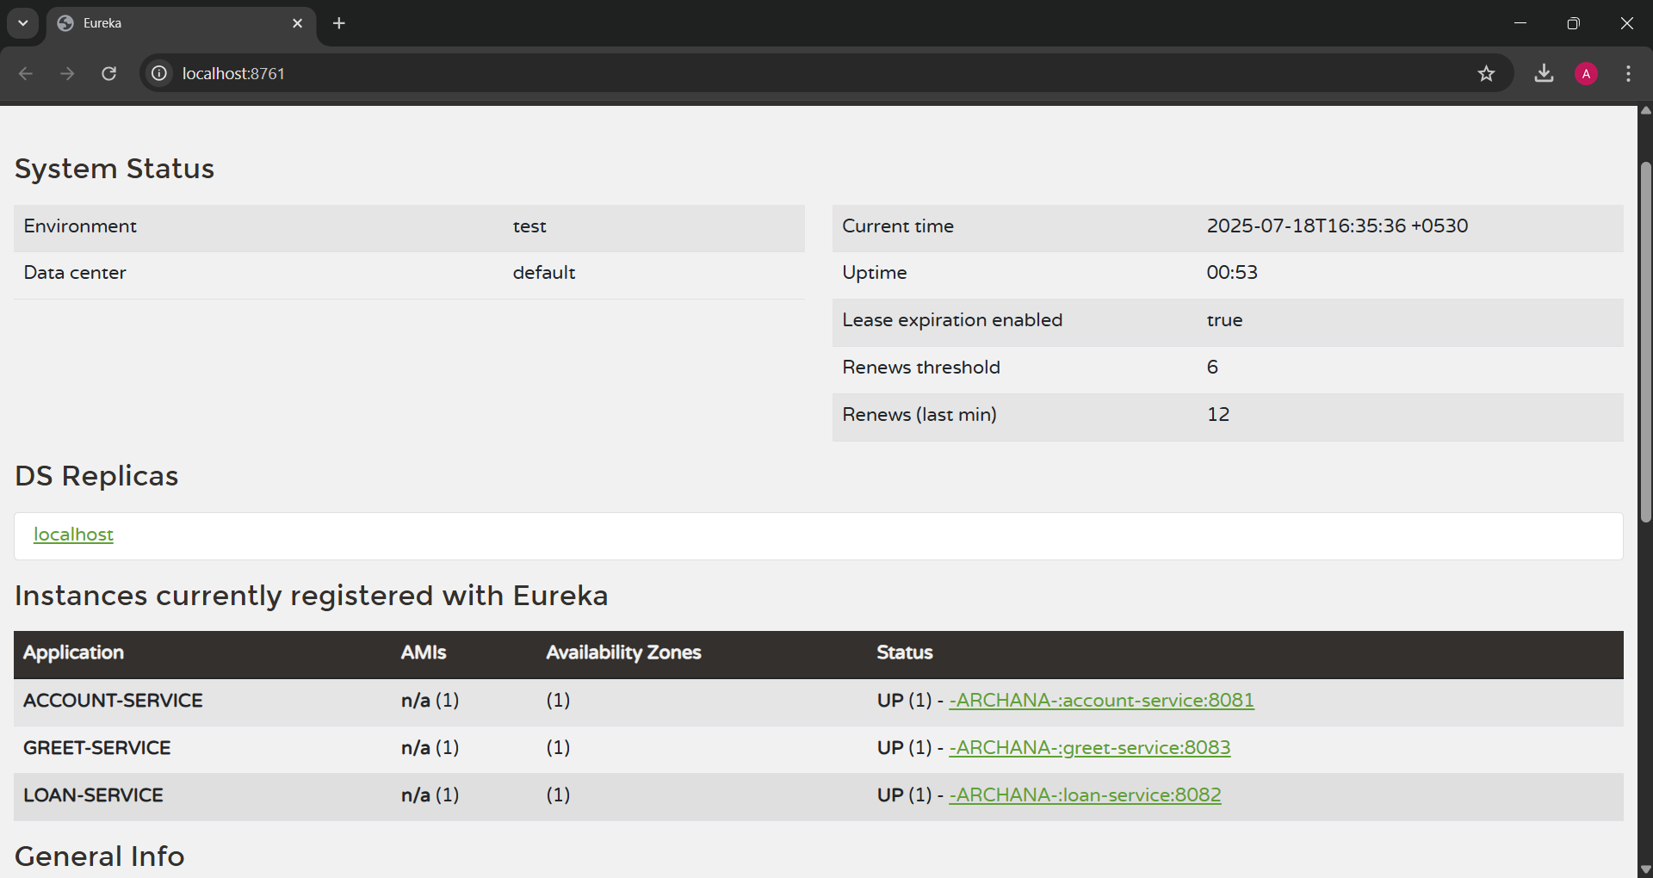

**STEP 7:**

Create api-gateway

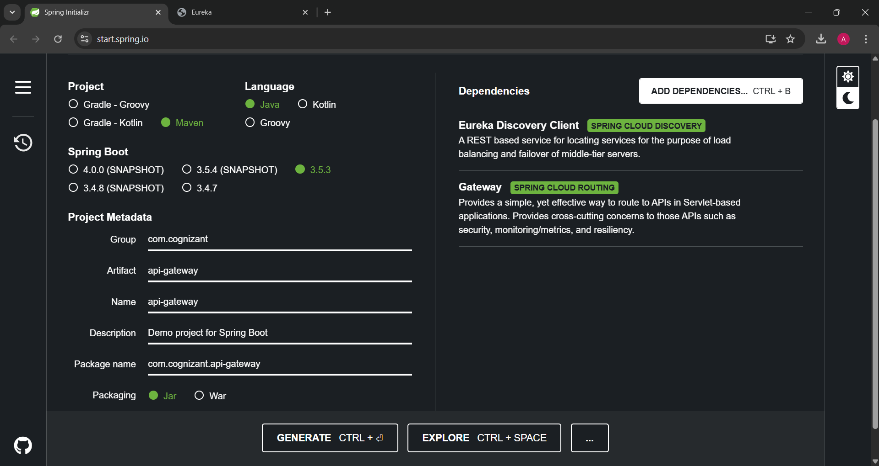

Run “mvn clean install”

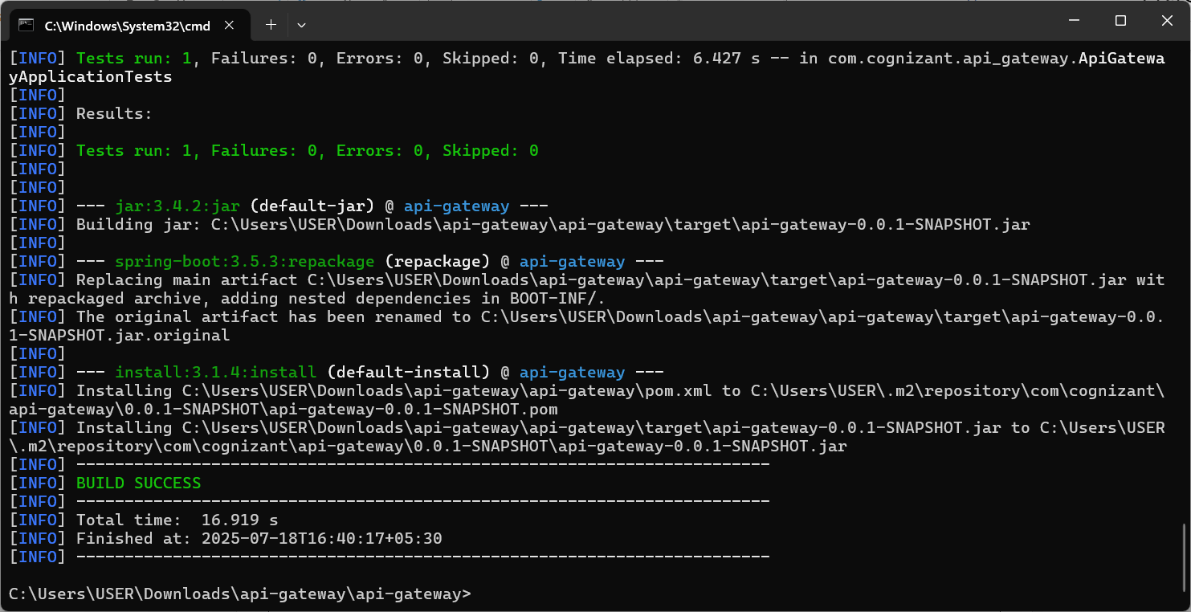

application.properties

spring.application.name=api-gateway

server.port=9090

eureka.client.service-url.defaultZone=http://localhost:8761/eureka

spring.cloud.gateway.discovery.locator.enabled=true

spring.cloud.gateway.discovery.locator.lower-case-service-id=true

View <http://localhost:8761/> to find the registered instance with Eureka.

