**WEEK – 6 : REACT**

**ADDITIONAL EXERCISES:**

**EXERCISE – 6:**

Trainer.js:

class Trainer {

  constructor(trainerId, name, email, phone, technology, skills) {

    this.trainerId = trainerId;

    this.name = name;

    this.email = email;

    this.phone = phone;

    this.technology = technology;

    this.skills = skills;

  }

}

export default Trainer;

TrainersMock.js:

import Trainer from './trainer';

const trainers = [

  new Trainer(1, 'Rahul Sharma', 'rahul@cognizant.com', '9876543210', 'Java', ['Spring', 'Hibernate', 'REST']),

  new Trainer(2, 'Meena Iyer', 'meena@cognizant.com', '9876500000', 'Python', ['Django', 'Flask', 'Pandas']),

  new Trainer(3, 'Anil Kumar', 'anil@cognizant.com', '9988776655', '.NET', ['ASP.NET', 'C#', 'Entity Framework']),

];

export default trainers;

TrainerList.js:

import React from 'react';

import { Link } from 'react-router-dom';

function TrainersList({ trainers }) {

  return (

    <div>

      <h2>Trainer List</h2>

      <ul>

        {trainers.map(trainer => (

          <li key={trainer.trainerId}>

            <Link to={`/trainer/${trainer.trainerId}`}>{trainer.name}</Link>

          </li>

        ))}

      </ul>

    </div>

  );

}

export default TrainersList;

Home.js:

import React from 'react';

function Home() {

  return (

    <div>

      <h2>Welcome to Cognizant Academy Trainers Portal</h2>

      <p>Explore our list of expert trainers in various technologies.</p>

    </div>

  );

}

export default Home;

TrainerDetails.js:

import React from 'react';

import { useParams } from 'react-router-dom';

import trainers from './TrainersMock';

function TrainerDetails() {

  const { id } = useParams();

  const trainer = trainers.find(t => t.trainerId === parseInt(id));

  if (!trainer) {

    return <p>Trainer not found</p>;

  }

  return (

    <div>

      <h2>{trainer.name}</h2>

      <p><strong>Email:</strong> {trainer.email}</p>

      <p><strong>Phone:</strong> {trainer.phone}</p>

      <p><strong>Technology:</strong> {trainer.technology}</p>

      <p><strong>Skills:</strong> {trainer.skills.join(', ')}</p>

    </div>

  );

}

export default TrainerDetails;

App.js:

import React from 'react';

import { BrowserRouter, Routes, Route, Link } from 'react-router-dom';

import Home from './Home';

import TrainersList from './TrainerList';

import TrainerDetails from './TrainerDetails';

import trainers from './TrainersMock';

function App() {

  return (

    <BrowserRouter>

      <div>

        <h1>Trainers Portal</h1>

        <nav>

          <Link to="/">Home</Link> | <Link to="/trainers">Trainer List</Link>

        </nav>

        <hr />

        <Routes>

          <Route path="/" element={<Home />} />

          <Route path="/trainers" element={<TrainersList trainers={trainers} />} />

          <Route path="/trainer/:id" element={<TrainerDetails />} />

        </Routes>

      </div>

    </BrowserRouter>

  );

}

export default App;

Output:

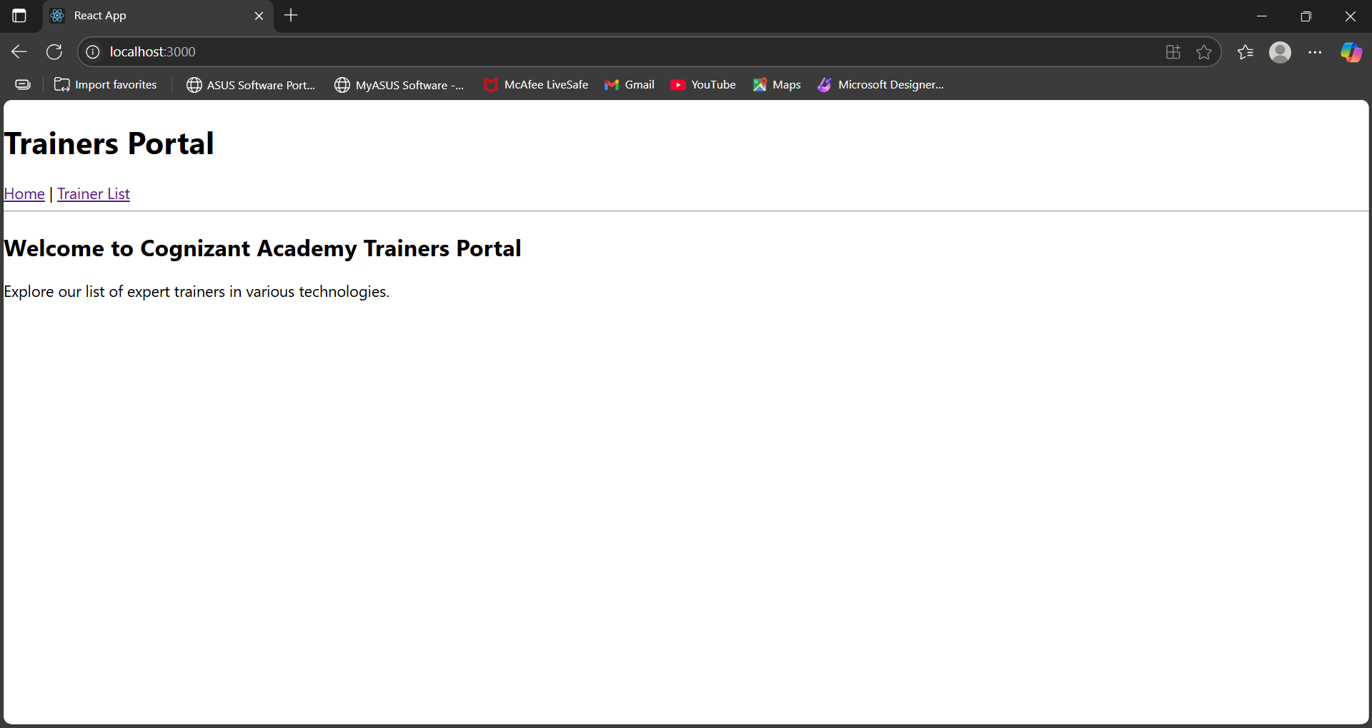

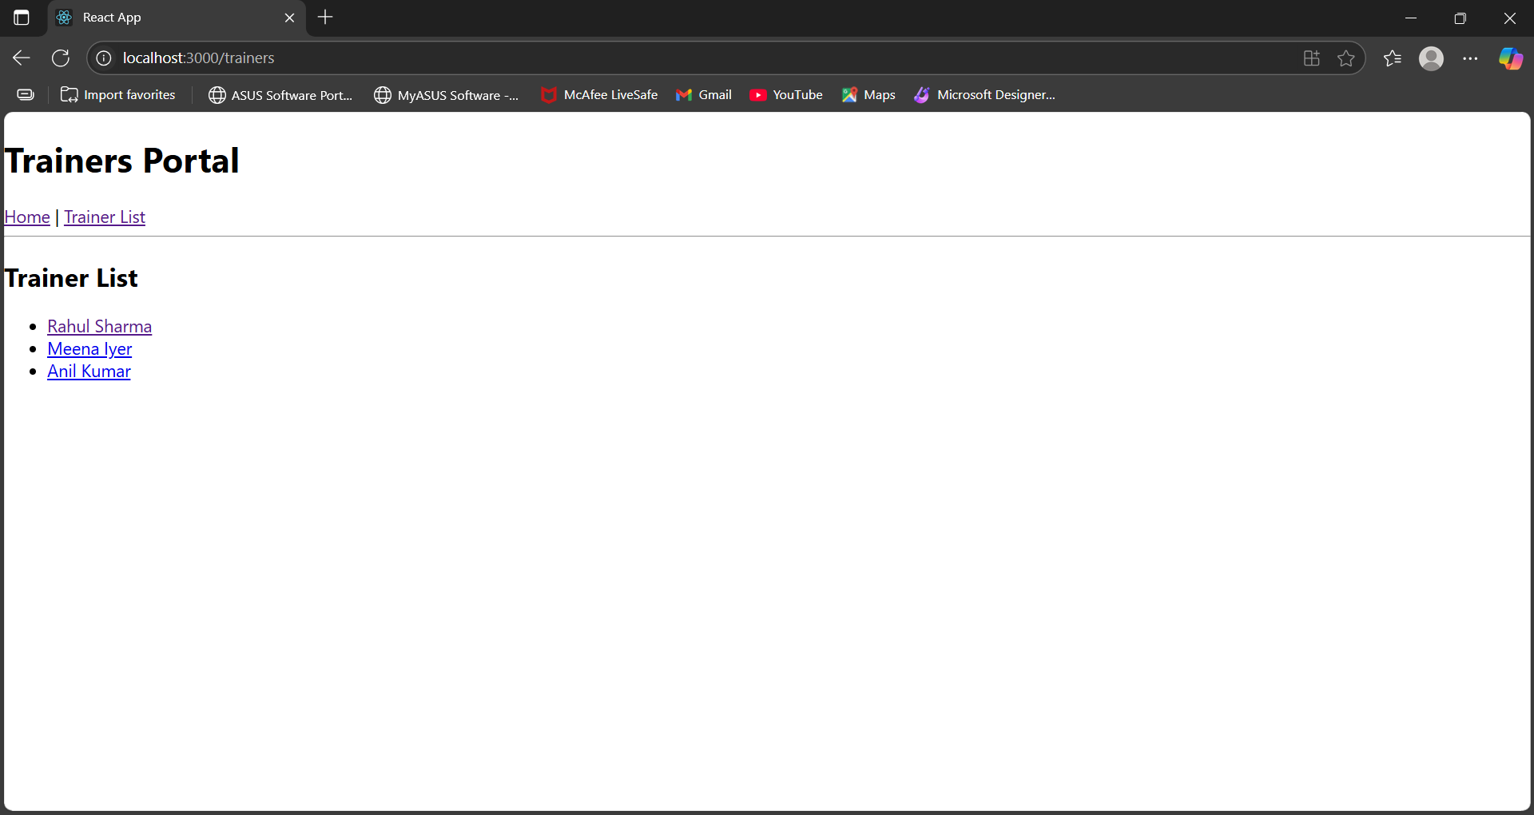

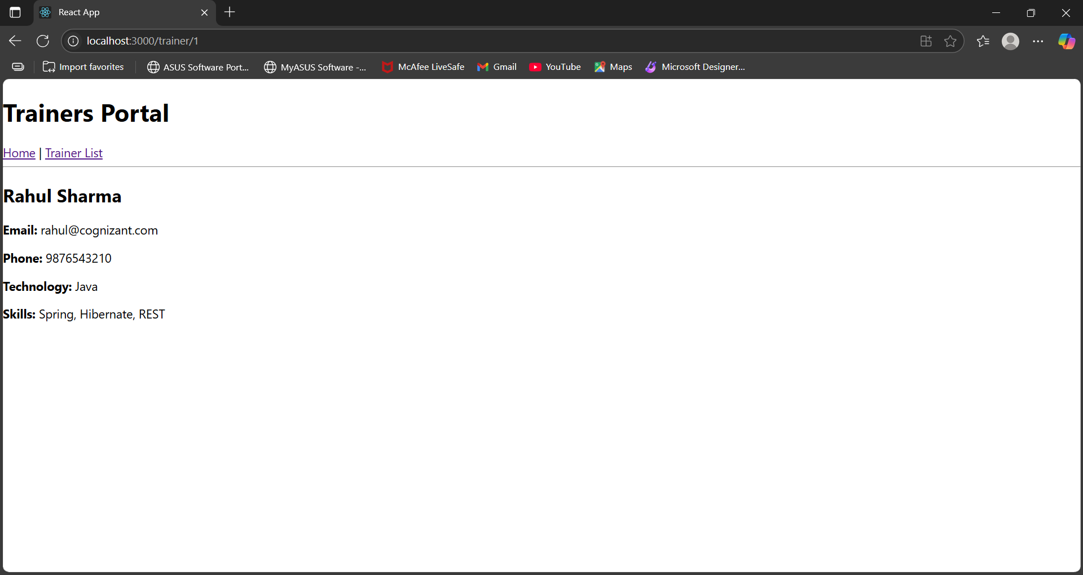

**EXERCISE 7:**

Cart.js:

import React, { Component } from 'react';

class Cart extends Component {

  render() {

    const { itemname, price } = this.props;

    return (

      <tr>

        <td>{itemname}</td>

        <td>₹{price}</td>

      </tr>

    );

  }

}

export default Cart;

OnlineShopping.js:

import React, { Component } from 'react';

import Cart from './Cart';

class OnlineShopping extends Component {

  constructor(props) {

    super(props);

    this.state = {

      items: [

        { itemname: 'T-shirt', price: 499 },

        { itemname: 'Jeans', price: 999 },

        { itemname: 'Shoes', price: 1999 },

        { itemname: 'Watch', price: 1499 },

        { itemname: 'Backpack', price: 899 }

      ]

    };

  }

  render() {

    return (

      <div>

        <h2>Online Shopping Cart</h2>

        <table border="1" cellPadding="10" style={{ margin: 'auto', textAlign: 'left' }}>

          <thead>

            <tr>

              <th>Item Name</th>

              <th>Price (₹)</th>

            </tr>

          </thead>

          <tbody>

            {this.state.items.map((item, index) => (

              <Cart key={index} itemname={item.itemname} price={item.price} />

            ))}

          </tbody>

        </table>

      </div>

    );

  }

}

export default OnlineShopping;

App.js:

import React from 'react';

import './App.css';

import OnlineShopping from './OnlineShopping';

function App() {

  return (

    <div className="App">

      <OnlineShopping />

    </div>

  );

}

export default App;

OUTPUT:

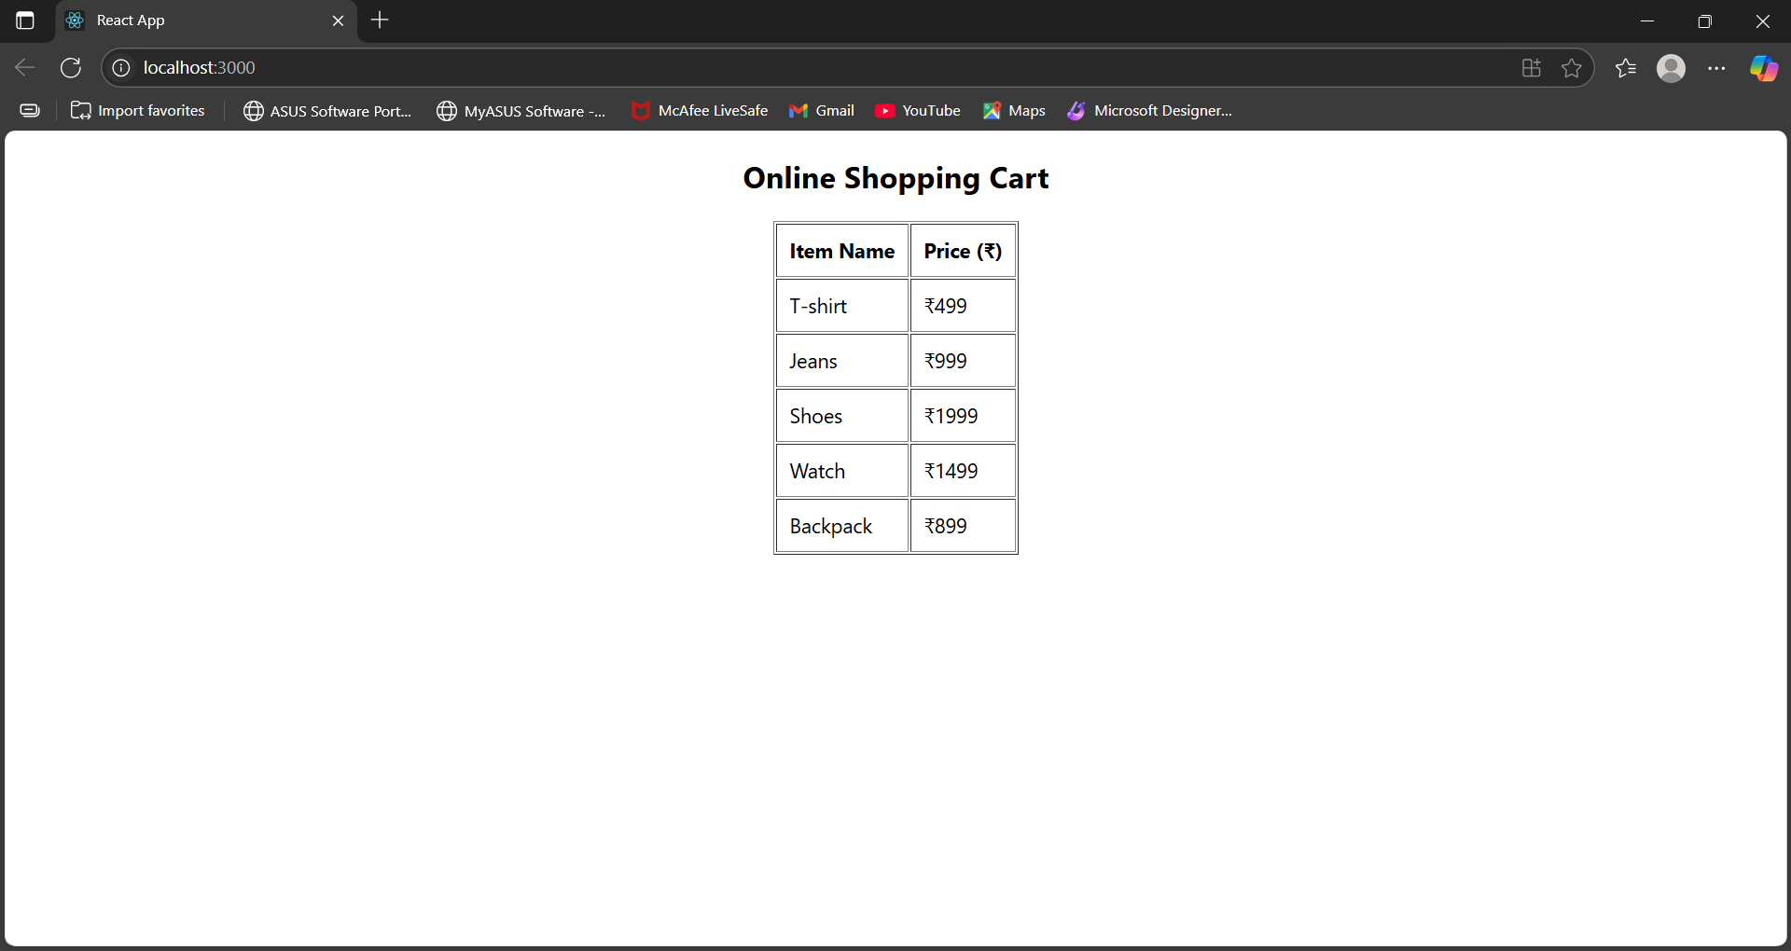

**EXERCISE 8:**

CountPeople.js:

import React, { Component } from 'react';

class CountPeople extends Component {

  constructor(props) {

    super(props);

    this.state = {

      entryCount: 0,

      exitCount: 0

    };

  }

  updateEntry = () => {

    this.setState((prevState) => ({

      entryCount: prevState.entryCount + 1

    }));

  };

  updateExit = () => {

    this.setState((prevState) => ({

      exitCount: prevState.exitCount + 1

    }));

  };

  render() {

    const { entryCount, exitCount } = this.state;

    return (

      <div style={{ textAlign: 'center', marginTop: '50px' }}>

        <button

          onClick={this.updateEntry}

          style={{ backgroundColor: 'lightgreen', padding: '10px 20px', marginRight: '20px' }}

        >

          Login

        </button>

        <span style={{ marginRight: '40px' }}>{entryCount} People Entered!!!</span>

        <button

          onClick={this.updateExit}

          style={{ backgroundColor: 'lightgreen', padding: '10px 20px' }}

        >

          Exit

        </button>

        <span style={{ marginLeft: '10px' }}>{exitCount} People Left!!!</span>

      </div>

    );

  }

}

export default CountPeople;

App.js:

import React from 'react';

import CountPeople from './CountPeople';

function App() {

  return (

    <div>

      <CountPeople />

    </div>

  );

}

export default App;

Output:

