**WEEK – 6 : REACT**

**MANDATORY EXERCISES:**

**EXERCISE – 1:**

**STEP 1:** Create a folder and type the below commands.

npm install -g create-react-app

npx create-react-app myfirstreact

cd myfirstreact

**STEP 2:**

App.js:

import './App.css';

function App() {

  return (

    <h1>Welcome the first session of React</h1>  );

}

export default App;

**STEP 3:** npm start

**OUTPUT:**

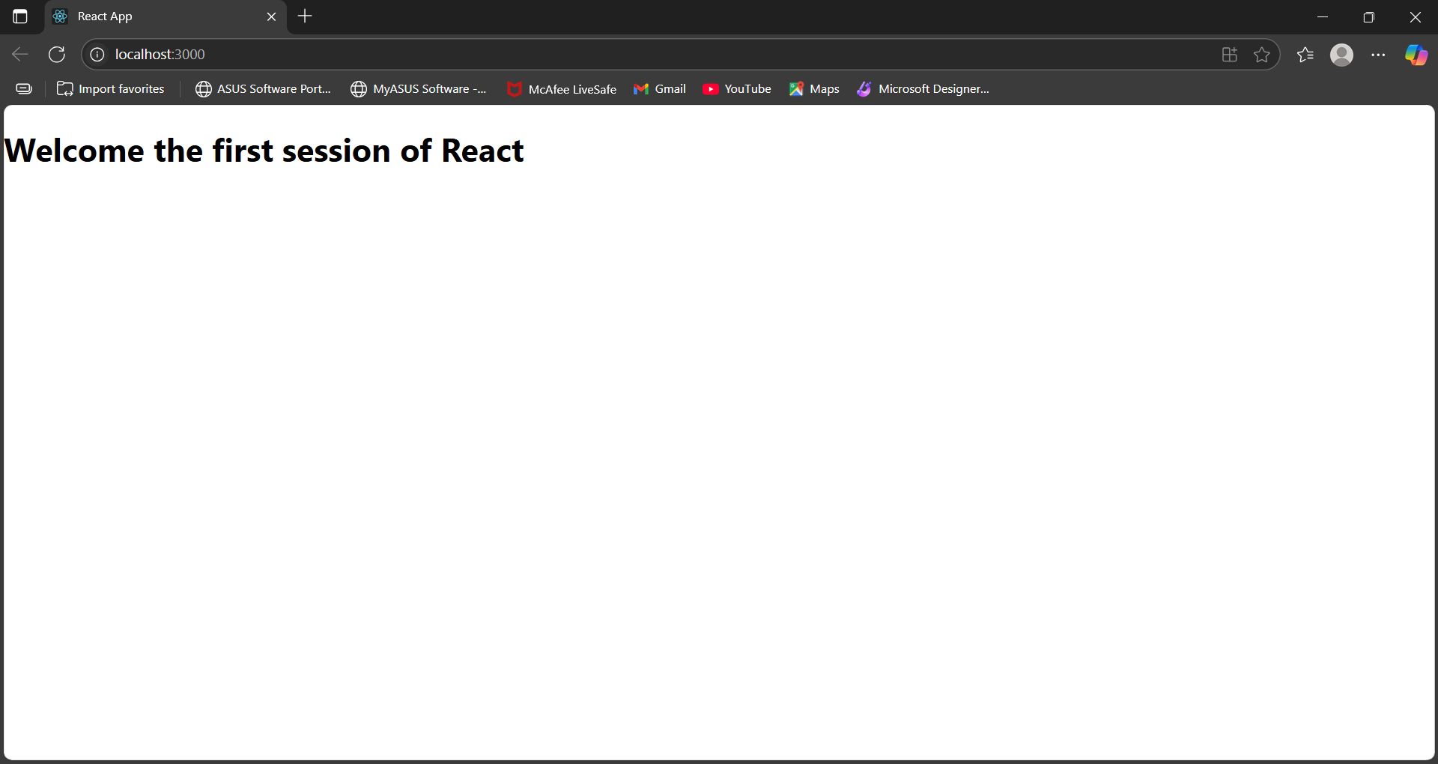

**EXERCISE 2:**

**Studentapp**

**Home.js:**

import React,{ Component } from "react";

class Home extends Component

{

    render(){

        return(

        <div>

            <h3>Welcome to the Home Page of Student Management Portal</h3>

        </div>

    )}

}

export default Home;

**About.js:**

import React,{ Component } from "react";

class About extends Component

{

    render(){

        return(

        <div>

            <h3>Welcome to the About Page of Student Management Portal</h3>

        </div>

    )}

}

export default About;

**Contact.js:**

import React,{ Component } from "react";

class Contact extends Component

{

    render(){

        return(

        <div>

            <h3>Welcome to the Contact Page of Student Management Portal</h3>

        </div>

    )}

}

export default Contact;

**App.js:**

import './App.css';

import Home from './Components/Home';

import About from './Components/About';

import Contact from './Components/Contact';

function App() {

  return (

    <div className='container'>

      <Home/>

      <About/>

      <Contact/>

    </div>

  );

}

export default App;

**Output:**

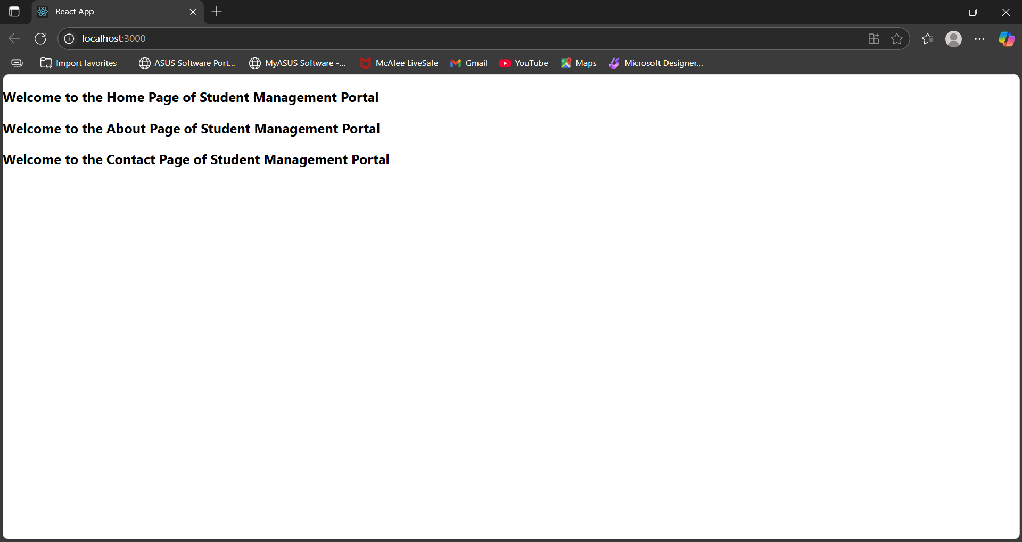

**Exercise: 3**

**CalculateScore.js:**

import React from 'react'

import '../Stylesheets/mystyle.css'

const percentToDecimal = (decimal) =>{

    return (decimal.toFixed(2) + '%')

}

const calcScore = (total, goal) =>{

    return percentToDecimal(total/goal)

}

export const CalculateScore = ({Name, School, total, goal}) =>{

    return(

    <div className="formatstyle">

        <h1><font color="Brown">Student Details:</font></h1>

        <div className="Name">

            <b><span>Name: </span></b>

            <span>{Name}</span>

        </div>

        <div className="School">

            <b><span>School: </span></b>

            <span>{School}</span>

        </div>

        <div className="Total">

            <b><span>Total: </span></b>

            <span>{total}</span>

            <span>Marks</span>

        </div>

        <div className="Score">

            <b>Score: </b>

            <span>

                {calcScore(

                    total,

                    goal

                )}

            </span>

        </div>

    </div>

    )

}

**mystyle.css:**

.Name{

    font-weight: 300;

    color: blue;

}

.School{

    color: crimson;

}

.Total{

    color: darkmagenta;

}

.formatstyle{

    text-align: center;

    font-size: large;

}

.Score{

    color: forestgreen;

}

**App.js:**

import './App.css';

import { CalculateScore } from './Components/CalculateScore';

function App() {

  return (

    <div>

      <CalculateScore Name={"Archana"}

      School = {"ABC Public School"}

      total = {284}

      goal = {3}

      />

    </div>

  );

}

export default App;

**Output:**

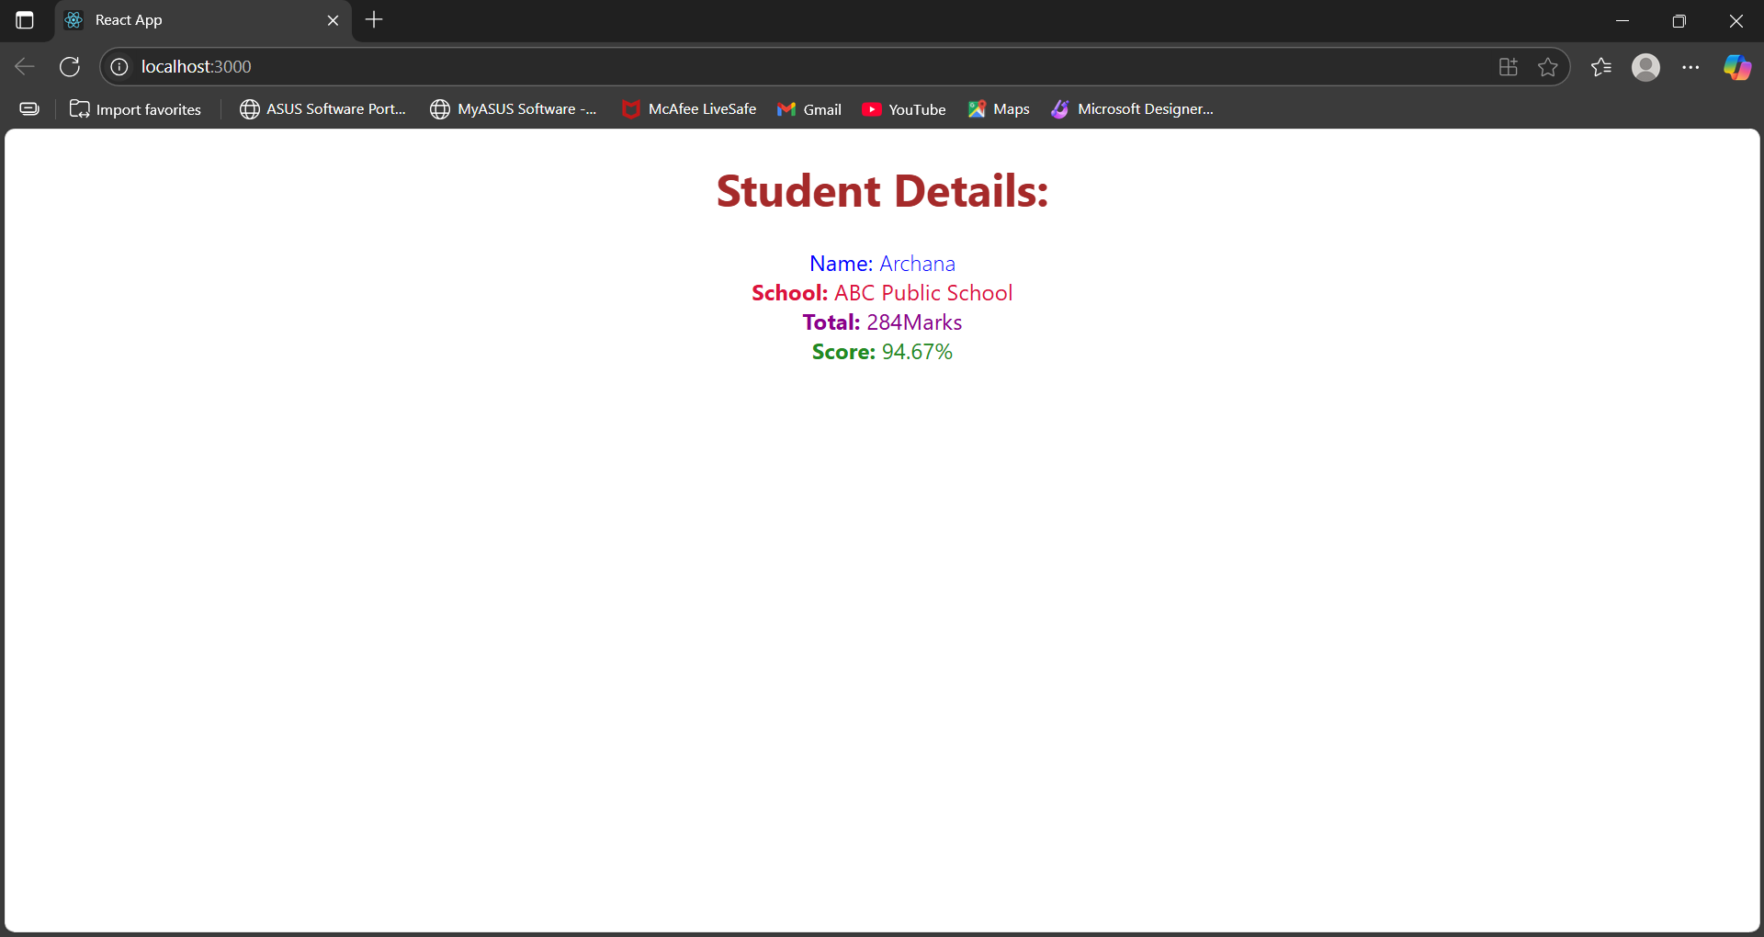

**Exercise 4:**

**Post.js:**

import React from 'react';

class Post extends React.Component {

  render() {

    const { title, body } = this.props;

    return (

      <div style={{ marginBottom: '20px', padding: '10px', border: '1px solid #ccc' }}>

        <h3>{title}</h3>

        <p>{body}</p>

      </div>

    );

  }

}

export default Post;

**Posts.js:**

import React, { Component } from 'react';

import Post from './Post';

class Posts extends Component {

  constructor(props) {

    super(props);

    this.state = {

      posts: [],

      error: null

    };

  }

  loadPosts = () => {

    fetch('https://jsonplaceholder.typicode.com/posts')

      .then(response => {

        if (!response.ok) {

          throw new Error("Failed to fetch posts");

        }

        return response.json();

      })

      .then(data => this.setState({ posts: data }))

      .catch(error => {

        this.setState({ error });

        alert("Error loading posts: " + error.message);

      });

  };

  componentDidMount() {

    this.loadPosts();

  }

  componentDidCatch(error, info) {

    alert("Something went wrong: " + error);

  }

  render() {

    const { posts } = this.state;

    return (

      <div style={{ padding: '20px' }}>

        <h2>Blog Posts</h2>

        {posts.map(post => (

          <Post key={post.id} title={post.title} body={post.body} />

        ))}

      </div>

    );

  }

}

export default Posts;

**App.js:**

import React from 'react';

import './App.css';

import Posts from './Posts';

function App() {

  return (

    <div className="App">

      <Posts />

    </div>

  );

}

export default App;

**Output:**

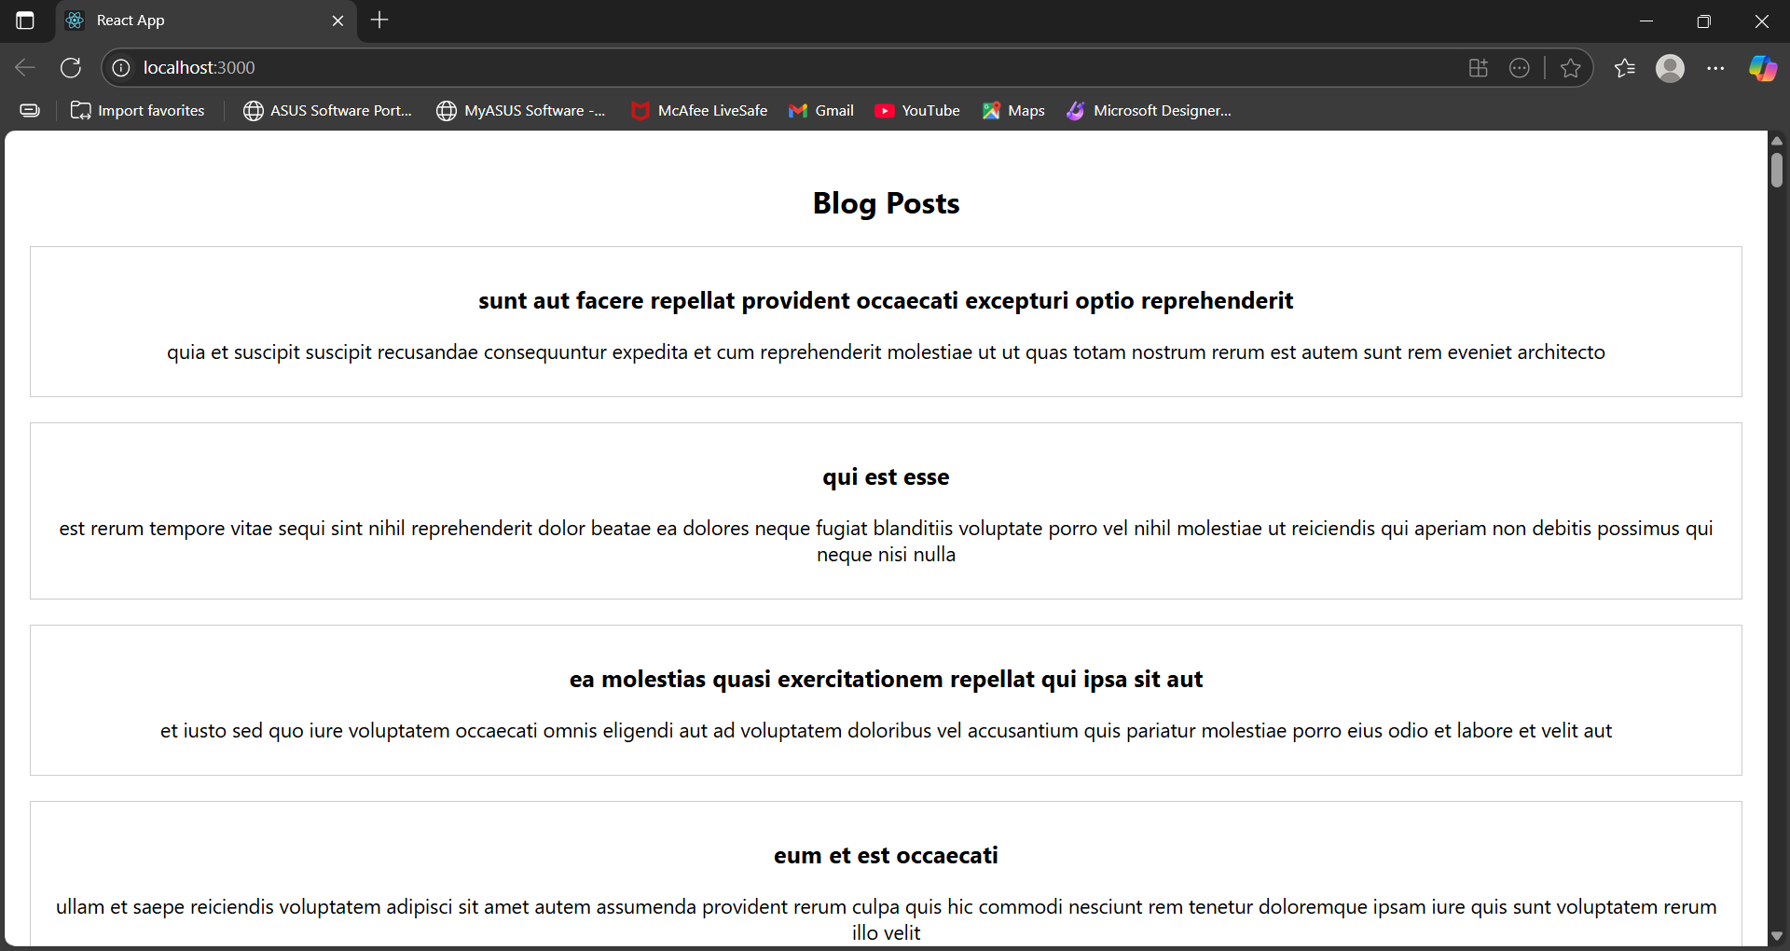

**Exercise 5:**

**CohortDetails.js:**

import React from 'react';

import styles from './CohortDetails.module.css';

function CohortDetails({ cohort }) {

  const titleStyle = {

    color: cohort.status.toLowerCase() === 'ongoing' ? 'green' : 'blue'

  };

  return (

    <div className={styles.box}>

      <h3 style={titleStyle}>{cohort.name}</h3>

      <dl>

        <dt>Started On</dt>

        <dd>{cohort.startDate}</dd>

        <dt>Current Status</dt>

        <dd>{cohort.status}</dd>

        <dt>Coach</dt>

        <dd>{cohort.coach}</dd>

        <dt>Trainer</dt>

        <dd>{cohort.trainer}</dd>

      </dl>

    </div>

  );

}

export default CohortDetails;

**CohortDetails.module.css:**

.box {

  width: 300px;

  display: inline-block;

  margin: 10px;

  padding: 10px 20px;

  border: 1px solid black;

  border-radius: 10px;

  vertical-align: top;

}

dt {

  font-weight: 500;

}

**App.js:**

import React from 'react';

import CohortDetails from './Components/CohortDetails';

const cohorts = [

  {

    name: 'INTIND01 - Java FSD',

    startDate: '15-Jan-2022',

    status: 'Scheduled',

    coach: 'Priya Sharma',

    trainer: 'Rajesh Kumar'

  },

  {

    name: 'INTIND02 - Python FSD',

    startDate: '10-Mar-2022',

    status: 'Ongoing',

    coach: 'Ankit Verma',

    trainer: 'Neha Reddy'

  },

  {

    name: 'INTIND03 - .NET FSD',

    startDate: '25-Feb-2022',

    status: 'Ongoing',

    coach: 'Sneha Joshi',

    trainer: 'Vikram Mehra'

  }

];

function App() {

  return (

    <div>

      <h2>Cohort Details</h2>

      {cohorts.map((cohort, index) => (

        <CohortDetails key={index} cohort={cohort} />

      ))}

    </div>

  );

}

export default App;

**Output:**

