**WEEK 7 – REACTJS**

**ADDITIONAL EXERCISES:**

**EXERCISE 13 : bloggerapp**

**BookDetails.jsx**

import React from 'react';

const BookDetails = ({ display }) => {

  return display ? (

    <div>

      <h2>Book Details</h2>

      <div>Master React<br />670</div>

      <br />

      <div>Deep Dive into Angular 11<br />800</div>

      <br />

      <div>Mongo Essentials<br />450</div>

    </div>

  ) : null;

};

export default BookDetails;

**BlogDetails.jsx:**

import React from 'react';

const BlogDetails = ({ visible }) => (

  visible && (

    <div>

      <h2>Blog Details</h2>

      <h3>React Learning</h3>

      <strong>Stephen Biz</strong>

      <p>Welcome to learning React!</p>

      <h3>Installation</h3>

      <strong>Schwezdienier</strong>

      <p>You can install React from npm.</p>

    </div>

  )

);

export default BlogDetails;

**CourseDetails.jsx:**

import React from 'react';

const CourseDetails = ({ show }) => {

  if (!show) return null;

  const courses = [

    { name: 'Angular', date: '4/5/2021' },

    { name: 'React', date: '6/3/2021' },

  ];

  return (

    <div>

      <h2>Course Details</h2>

      {courses.map((c, i) => (

        <div key={i}>

          <strong>{c.name}</strong>

          <div>{c.date}</div>

        </div>

      ))}

    </div>

  );

};

export default CourseDetails;

**App.js:**

import React, { useState } from 'react';

import CourseDetails from './components/CourseDetails';

import BookDetails from './components/BookDetails';

import BlogDetails from './components/BlogDetails';

import './App.css';

function App() {

  const [view] = useState('all'); // switch-style condition

  const renderComponent = () => {

    switch (view) {

      case 'courses':

        return <CourseDetails show={true} />;

      case 'books':

        return <BookDetails display={true} />;

      case 'blogs':

        return <BlogDetails visible={true} />;

      case 'all':

        return (

          <>

            <CourseDetails show={true} />

            <BookDetails display={true} />

            <BlogDetails visible={true} />

          </>

        );

      default:

        return <p>No content to show.</p>;

    }

  };

  return (

    <div className="app">

      <div className="container">{renderComponent()}</div>

    </div>

  );

}

export default App;

**App.css:**

.app {

  padding: 20px;

  font-family: Arial;

}

.container {

  display: flex;

  justify-content: space-around;

  align-items: flex-start;

}

.container > div {

  padding: 10px;

  border-left: 4px solid green;

  margin: 10px;

}

**OUTPUT:**

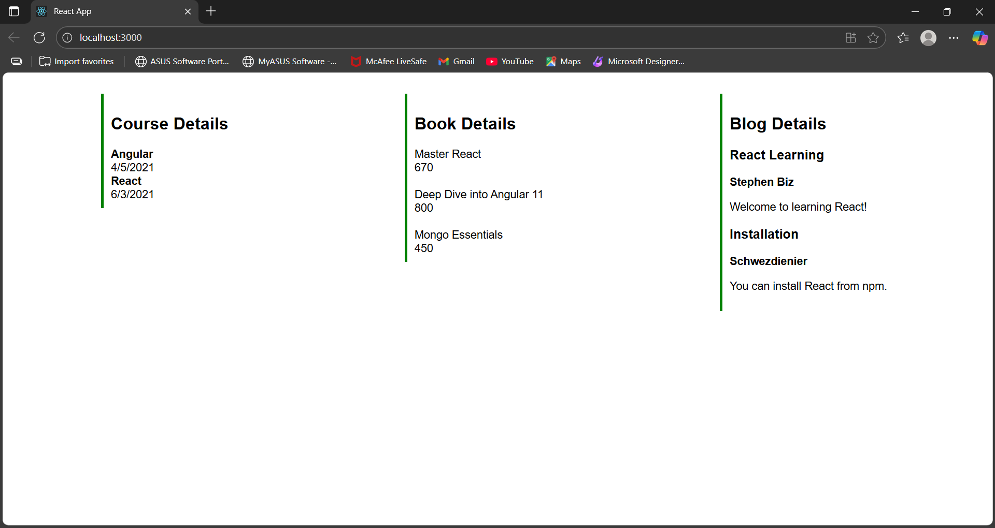

**EXERCISE 14 : Toggletheme**

**ThemeContext.js:**

import React from 'react';

const ThemeContext = React.createContext('light'); // default = light

export default ThemeContext;

**EmployeeList.js:**

import React from 'react';

import EmployeeCard from './EmployeeCard';

function EmployeesList() {

  const employees = [

    { id: 1, name: 'Alice', role: 'Developer' },

    { id: 2, name: 'Bob', role: 'Designer' }

  ];

  return (

    <div>

      {employees.map(emp => (

        <EmployeeCard key={emp.id} employee={emp} />

      ))}

    </div>

  );

}

export default EmployeesList;

**EmployeeCard.js:**

import React, { useContext } from 'react';

import ThemeContext from './ThemeContext';

function EmployeeCard({ employee }) {

  const theme = useContext(ThemeContext);

  const buttonClass = theme === 'light' ? 'btn-light' : 'btn-dark';

  return (

    <div style={{ marginBottom: '15px' }}>

      <h3>{employee.name}</h3>

      <p>{employee.role}</p>

      <button className={buttonClass}>View Profile</button>

    </div>

  );

}

export default EmployeeCard;

**App.js:**

import React, { useState } from 'react';

import ThemeContext from './ThemeContext';

import EmployeeList from './EmployeeList';

import './App.css';

function App() {

  const [theme, setTheme] = useState('light');

  const toggleTheme = () => {

    setTheme(prev => (prev === 'light' ? 'dark' : 'light'));

  };

  return (

    <ThemeContext.Provider value={theme}>

      <div className={`App ${theme}`}>

        <h1>Employee Directory</h1>

        <button onClick={toggleTheme}>Toggle Theme</button>

        <EmployeeList />

      </div>

    </ThemeContext.Provider>

  );

}

export default App;

**App.css:**

.App {

  padding: 20px;

  font-family: sans-serif;

}

.App.light {

  background-color: #fff;

  color: #000;

}

.App.dark {

  background-color: #222;

  color: #fff;

}

button {

  margin: 10px;

  padding: 10px 20px;

  font-size: 16px;

  cursor: pointer;

}

.btn-light {

  background-color: white;

  color: black;

  border: 2px solid black;

}

.btn-dark {

  background-color: black;

  color: white;

  border: 2px solid white;

}

**OUTPUT:**

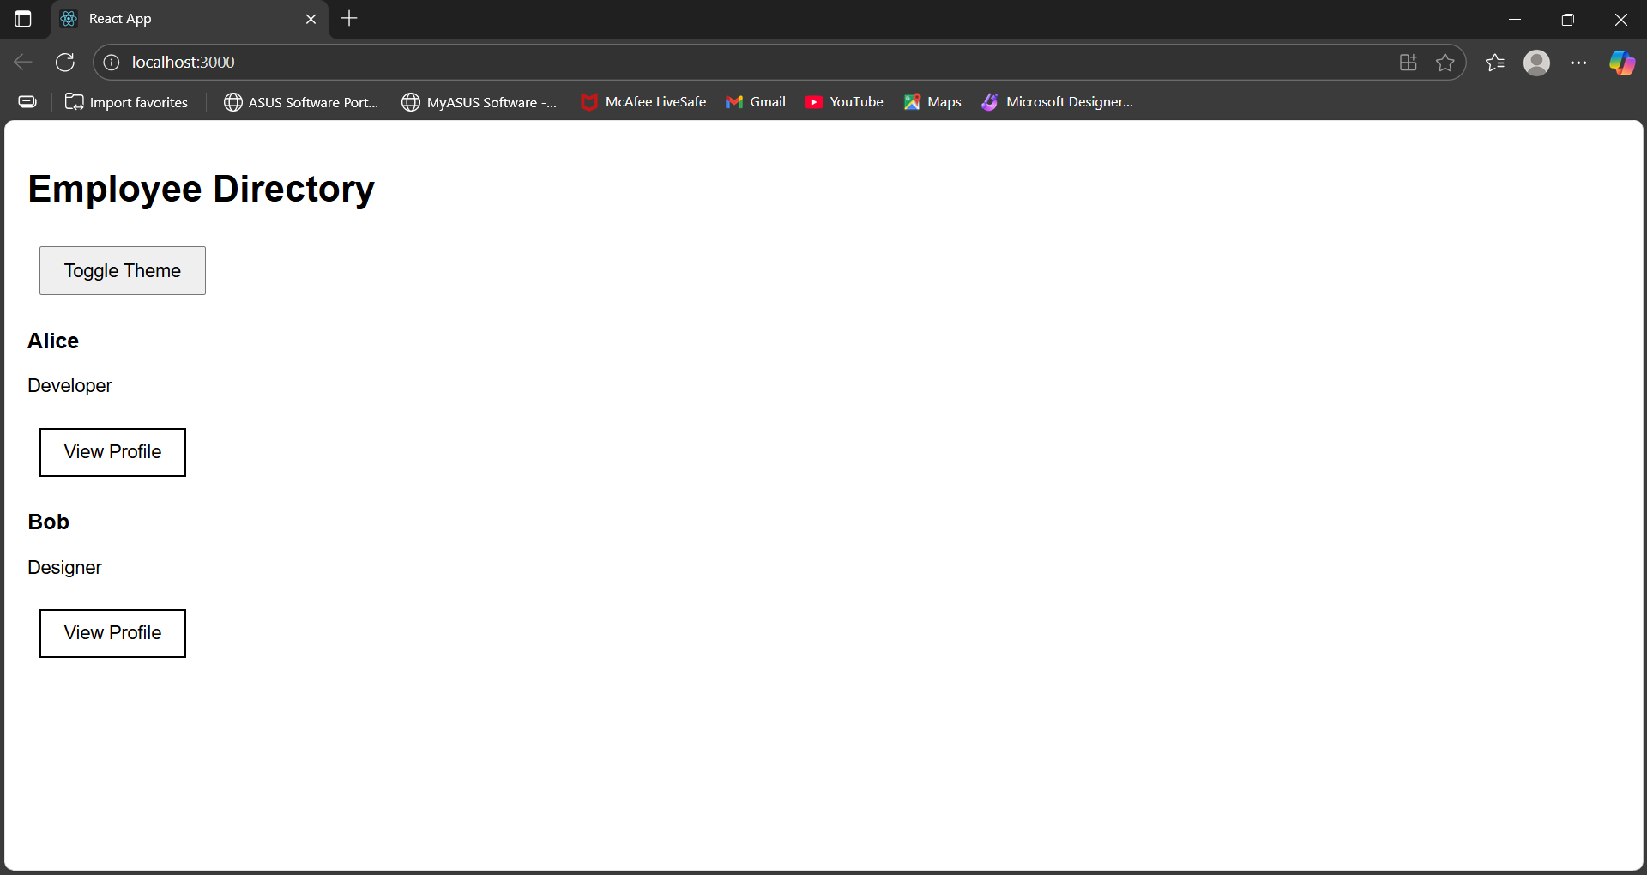

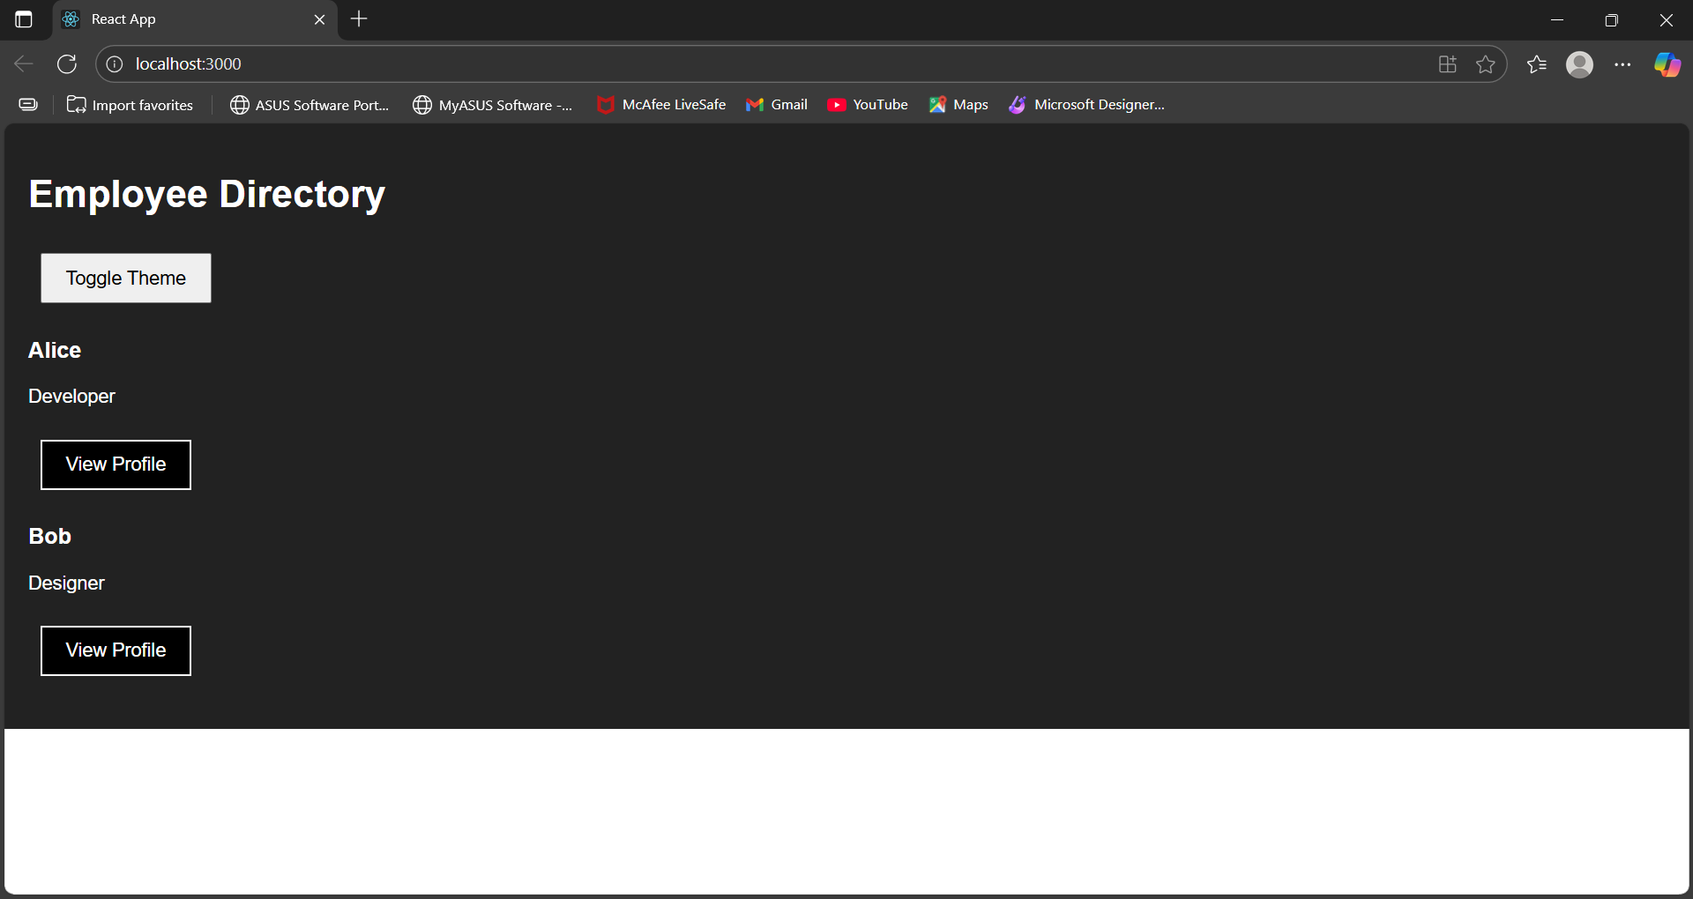

**EXERCISE 15 – ticketraisingapp**

**ComplaintRegister.jsx:**

import React, { useState } from 'react';

function ComplaintRegister() {

  const [name, setName] = useState('');

  const [complaint, setComplaint] = useState('');

  const handleSubmit = (e) => {

    e.preventDefault();

    const referenceNumber = Math.floor(Math.random() * 1000000);

    alert(

      `Complaint Registered Successfully!\n\nName: ${name}\nComplaint: ${complaint}\nReference ID: ${referenceNumber}`

    );

    setName('');

    setComplaint('');

  };

  return (

    <div style={{ padding: '20px', maxWidth: '500px', margin: '0 auto' }}>

      <h2>Complaint Register</h2>

      <form onSubmit={handleSubmit}>

        <div style={{ marginBottom: '10px' }}>

          <label>Employee Name:</label><br />

          <input

            type="text"

            value={name}

            onChange={(e) => setName(e.target.value)}

            required

            style={{ width: '100%', padding: '8px' }}

          />

        </div>

        <div style={{ marginBottom: '10px' }}>

          <label>Complaint:</label><br />

          <textarea

            value={complaint}

            onChange={(e) => setComplaint(e.target.value)}

            required

            rows="4"

            style={{ width: '100%', padding: '8px' }}

          />

        </div>

        <button type="submit" style={{ padding: '10px 20px' }}>Submit Complaint</button>

      </form>

    </div>

  );

}

export default ComplaintRegister;

**App.js:**

import React from 'react';

import ComplaintRegister from './ComplaintRegister';

function App() {

  return (

    <div>

      <ComplaintRegister />

    </div>

  );

}

export default App;

**OUTPUT:**

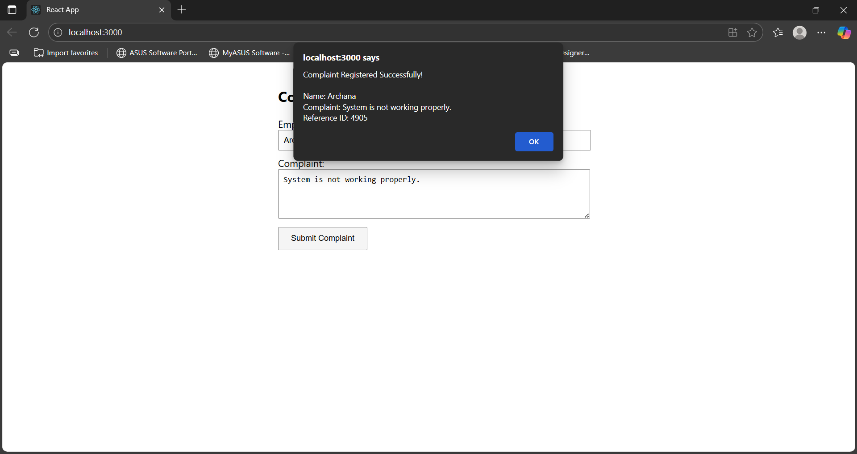

**EXERCISE 16 : mailregisterapp**

**Register.js:**

import React, { useState } from 'react';

function Register() {

  const [formData, setFormData] = useState({

    name: '',

    email: '',

    password: '',

  });

  const [errors, setErrors] = useState({});

  const handleChange = (e) => {

    const { name, value } = e.target;

    setFormData({ ...formData, [name]: value });

    // Live validation

    let newErrors = { ...errors };

    if (name === 'name' && value.length < 5) {

      newErrors.name = 'Name must be at least 5 characters long.';

    } else if (name === 'email' && (!value.includes('@') || !value.includes('.'))) {

      newErrors.email = 'Email must contain @ and .';

    } else if (name === 'password' && value.length < 8) {

      newErrors.password = 'Password must be at least 8 characters.';

    } else {

      delete newErrors[name];

    }

    setErrors(newErrors);

  };

  const handleSubmit = (e) => {

    e.preventDefault();

    const validationErrors = {};

    if (formData.name.length < 5) {

      validationErrors.name = 'Name must be at least 5 characters.';

    }

    if (!formData.email.includes('@') || !formData.email.includes('.')) {

      validationErrors.email = 'Email must contain @ and .';

    }

    if (formData.password.length < 8) {

      validationErrors.password = 'Password must be at least 8 characters.';

    }

    setErrors(validationErrors);

    if (Object.keys(validationErrors).length === 0) {

      alert('Registration Successful!\n\n' + JSON.stringify(formData, null, 2));

      setFormData({ name: '', email: '', password: '' });

    }

  };

  return (

    <div style={{ maxWidth: '400px', margin: '30px auto', padding: '20px', border: '1px solid #ccc' }}>

      <h2>Register</h2>

      <form onSubmit={handleSubmit} noValidate>

        <div>

          <label>Name:</label><br />

          <input

            type="text"

            name="name"

            value={formData.name}

            onChange={handleChange}

          />

          {errors.name && <p style={{ color: 'red' }}>{errors.name}</p>}

        </div>

        <div>

          <label>Email:</label><br />

          <input

            type="text"

            name="email"

            value={formData.email}

            onChange={handleChange}

          />

          {errors.email && <p style={{ color: 'red' }}>{errors.email}</p>}

        </div>

        <div>

          <label>Password:</label><br />

          <input

            type="password"

            name="password"

            value={formData.password}

            onChange={handleChange}

          />

          {errors.password && <p style={{ color: 'red' }}>{errors.password}</p>}

        </div>

        <button type="submit" style={{ marginTop: '10px' }}>Register</button>

      </form>

    </div>

  );

}

export default Register;

**App.js:**

import React from 'react';

import Register from './Register';

function App() {

  return (

    <div className="App">

      <Register />

    </div>

  );

}

export default App;

**OUTPUT:**

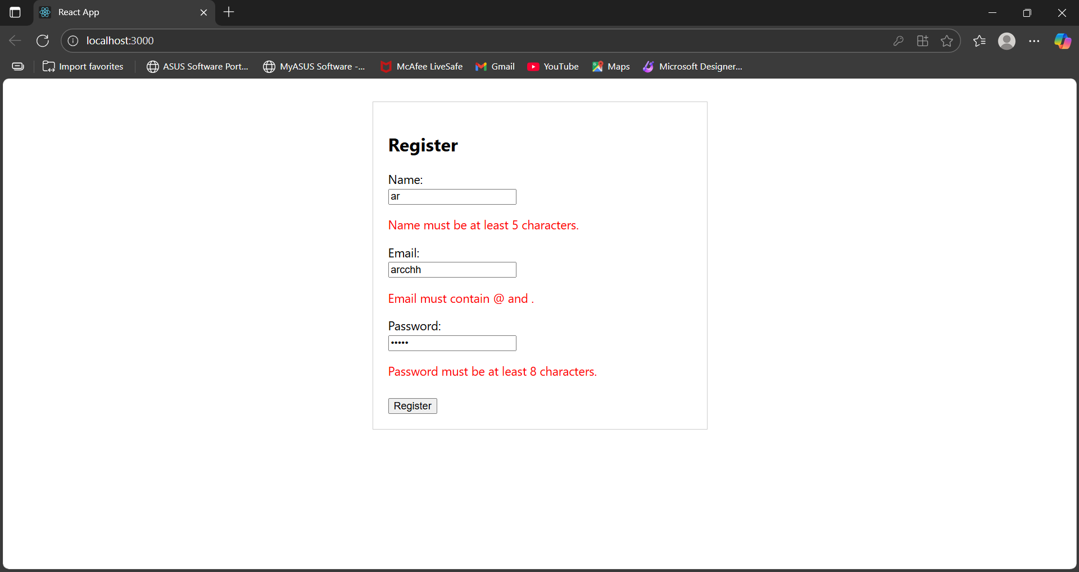

**EXERCISE 17: fetchuserapp**

**Getuser.js:**

import React, { Component } from 'react';

class Getuser extends Component {

  constructor() {

    super();

    this.state = {

      user: null

    };

  }

  componentDidMount() {

    fetch('https://api.randomuser.me/')

      .then(res => res.json())

      .then(data => {

        this.setState({ user: data.results[0] });

      })

      .catch(error => console.log('Error fetching user:', error));

  }

  render() {

    const { user } = this.state;

    if (!user) {

      return <h2>Loading user...</h2>;

    }

    return (

      <div style={{ textAlign: 'center', marginTop: '40px' }}>

        <h2>User Info</h2>

        <p><strong>Title:</strong> {user.name.title}</p>

        <p><strong>First Name:</strong> {user.name.first}</p>

        <img src={user.picture.large} alt="User" style={{ borderRadius: '50%' }} />

      </div>

    );

  }

}

export default Getuser;

**App.js:**

import React from 'react';

import Getuser from './Getuser';

function App() {

  return (

    <div className="App">

      <Getuser />

    </div>

  );

}

export default App;

**OUTPUT:**

