**WEEK 7 – REACTJS**

**MANDATORY EXERCISES:**

**EXERCISE : 9 - Cricketapp**

**ListofPlayers.jsx**

import React from 'react';

const ListofPlayers = () => {

  const players = [

    { name: 'Virat', score: 95 },

    { name: 'Rohit', score: 85 },

    { name: 'Dhoni', score: 67 },

    { name: 'Rahul', score: 72 },

    { name: 'Shreyas', score: 66 },

    { name: 'Hardik', score: 50 },

    { name: 'Jadeja', score: 78 },

    { name: 'Ashwin', score: 35 },

    { name: 'Bumrah', score: 45 },

    { name: 'Shami', score: 70 },

    { name: 'Pant', score: 91 },

  ];

  const lowScorers = players.filter(player => player.score < 70);

  return (

    <div>

      <h2>All Players</h2>

      <ul>

        {players.map((p, index) => (

          <li key={index}>{p.name} - {p.score}</li>

        ))}

      </ul>

      <h2>Players with Score Below 70</h2>

      <ul>

        {lowScorers.map((p, index) => (

          <li key={index}>{p.name} - {p.score}</li>

        ))}

      </ul>

    </div>

  );

};

export default ListofPlayers;

**IndianPlayers.jsx:**

import React from 'react';

const IndianPlayers = () => {

  const allPlayers = [

    'Virat', 'Rohit', 'Dhoni', 'Rahul', 'Shreyas',

    'Hardik', 'Jadeja', 'Ashwin', 'Bumrah', 'Shami', 'Pant',

  ];

  const oddTeam = allPlayers.filter((_, i) => i % 2 === 0);

  const evenTeam = allPlayers.filter((_, i) => i % 2 !== 0);

  const T20players = ['Virat', 'Rohit', 'Hardik'];

  const RanjiTrophyPlayers = ['Pujara', 'Karun Nair', 'Shreyas'];

  const mergedPlayers = [...T20players, ...RanjiTrophyPlayers];

  return (

    <div>

      <h2>Odd Team Players</h2>

      <ul>{oddTeam.map((name, i) => <li key={i}>{name}</li>)}</ul>

      <h2>Even Team Players</h2>

      <ul>{evenTeam.map((name, i) => <li key={i}>{name}</li>)}</ul>

      <h2>Merged Players (T20 + Ranji)</h2>

      <ul>{mergedPlayers.map((name, i) => <li key={i}>{name}</li>)}</ul>

    </div>

  );

};

export default IndianPlayers;

**App.js:**

import React from 'react';

import ListofPlayers from './Components/ListofPlayers';

import IndianPlayers from './Components/IndianPlayers';

const App = () => {

  const flag = true;

  return (

    <div style={{ padding: '20px' }}>

      <h1>🏏 CricketApp</h1>

      {flag ? <ListofPlayers /> : <IndianPlayers />}

    </div>

  );

};

export default App;

**OUTPUT:**

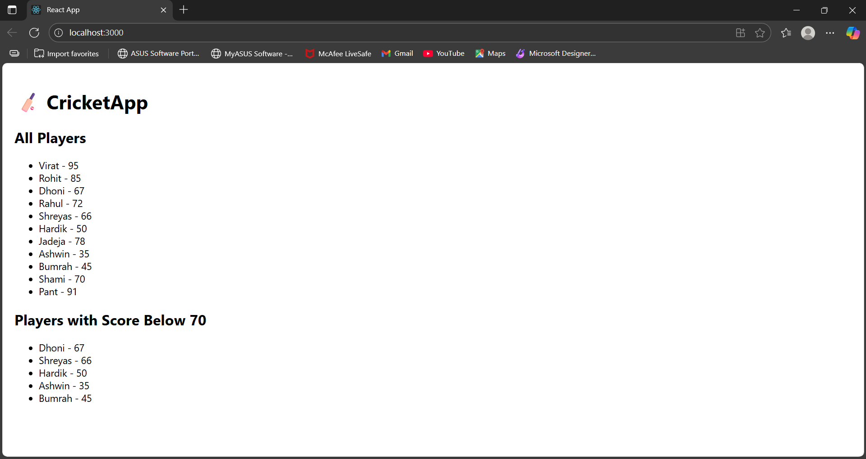

**EXERCISE : 10 Officeapp**

**OfficeList.jsx**

import React from 'react';

const OfficeList = () => {

  const offices = [

  {

    name: 'Tech Park',

    rent: 55000,

    address: 'Chennai',

    image: 'https://images.unsplash.com/photo-1590650046871-72f308b4b157?auto=format&fit=crop&w=800&q=60',

  },

  {

    name: 'Sky Towers',

    rent: 70000,

    address: 'Bangalore',

    image: 'https://images.unsplash.com/photo-1581092337425-81ab0b7c0843?auto=format&fit=crop&w=800&q=60',

  },

  {

    name: 'Green Valley',

    rent: 48000,

    address: 'Hyderabad',

    image: 'https://images.unsplash.com/photo-1600585154340-be6161a56a0c?auto=format&fit=crop&w=800&q=60',

  },

];

  return (

    <div style={{ padding: '20px' }}>

      <h1>🏢 Office Spaces for Rent</h1>

      {offices.map((office, index) => (

        <div key={index} style={{

          border: '1px solid #ddd',

          marginBottom: '20px',

          padding: '15px',

          maxWidth: '400px'

        }}>

          <img src={office.image} alt={office.name} style={{ width: '100%' }} />

          <h2>{office.name}</h2>

          <p><strong>Address:</strong> {office.address}</p>

          <p>

            <strong>Rent:</strong>{' '}

            <span style={{ color: office.rent < 60000 ? 'red' : 'green' }}>

              ₹{office.rent}

            </span>

          </p>

        </div>

      ))}

    </div>

  );

};

export default OfficeList;

**App.js:**

import React from 'react';

import OfficeList from './components/OfficeList';

function App() {

  return (

    <div>

      <OfficeList />

    </div>

  );

}

export default App;

**OUTPUT:**

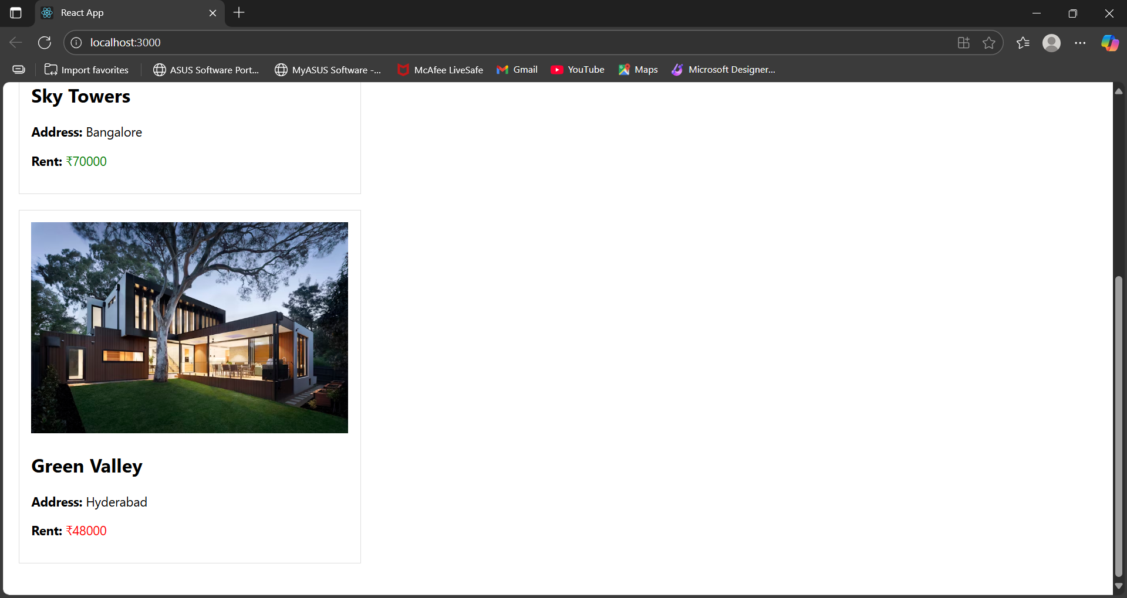

**EXERCISE 11 – eventexamplesapp**

**Counter.jsx:**

import React, { useState } from 'react';

function Counter() {

  const [count, setCount] = useState(0);

  const increment = () => {

    setCount(prev => prev + 1);

    sayHello();

  };

  const decrement = () => {

    setCount(prev => prev - 1);

  };

  const sayHello = () => {

    alert('Hello! Value increased.');

  };

  return (

    <div>

      <h2>Counter Value: {count}</h2>

      <button onClick={increment}>Increment</button>

      <button onClick={decrement}>Decrement</button>

    </div>

  );

}

export default Counter;

**WelcomeButton.jsx:**

import React from 'react';

function WelcomeButton() {

  const sayWelcome = (msg) => {

    alert(msg);

  };

  return (

    <div>

      <button onClick={() => sayWelcome("Welcome!")}>Say Welcome</button>

    </div>

  );

}

export default WelcomeButton;

**OnPressExample.jsx:**

import React from 'react';

function OnPressExample() {

  const handleClick = () => {

    alert("I was clicked");

  };

  return (

    <div>

      <button onClick={handleClick}>OnPress</button>

    </div>

  );

}

export default OnPressExample;

**CurrencyConvertor.jsx:**

import React, { useState } from 'react';

function CurrencyConvertor() {

  const [rupees, setRupees] = useState('');

  const [euro, setEuro] = useState(null);

  const handleSubmit = (e) => {

    e.preventDefault();

    const result = parseFloat(rupees) / 90;

    setEuro(result.toFixed(2));

  };

  return (

    <div>

      <h3>Convert Rupees to Euro</h3>

      <form onSubmit={handleSubmit}>

        <input

          type="number"

          placeholder="Enter in INR"

          value={rupees}

          onChange={(e) => setRupees(e.target.value)}

        />

        <button type="submit">Convert</button>

      </form>

      {euro && <p>Euro: €{euro}</p>}

    </div>

  );

}

export default CurrencyConvertor;

**OUTPUT:**

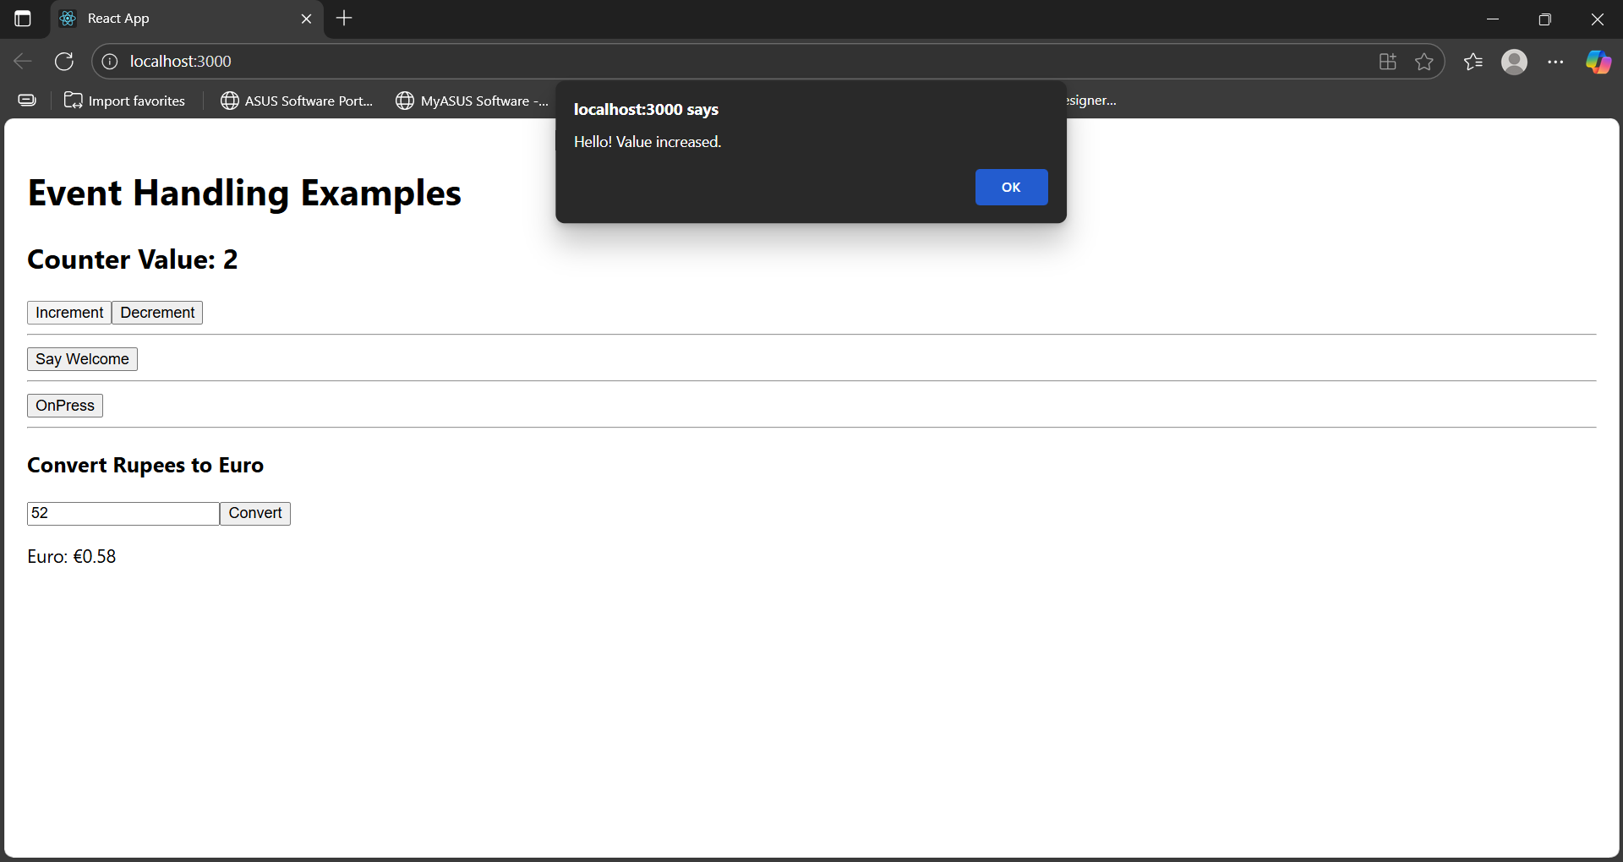

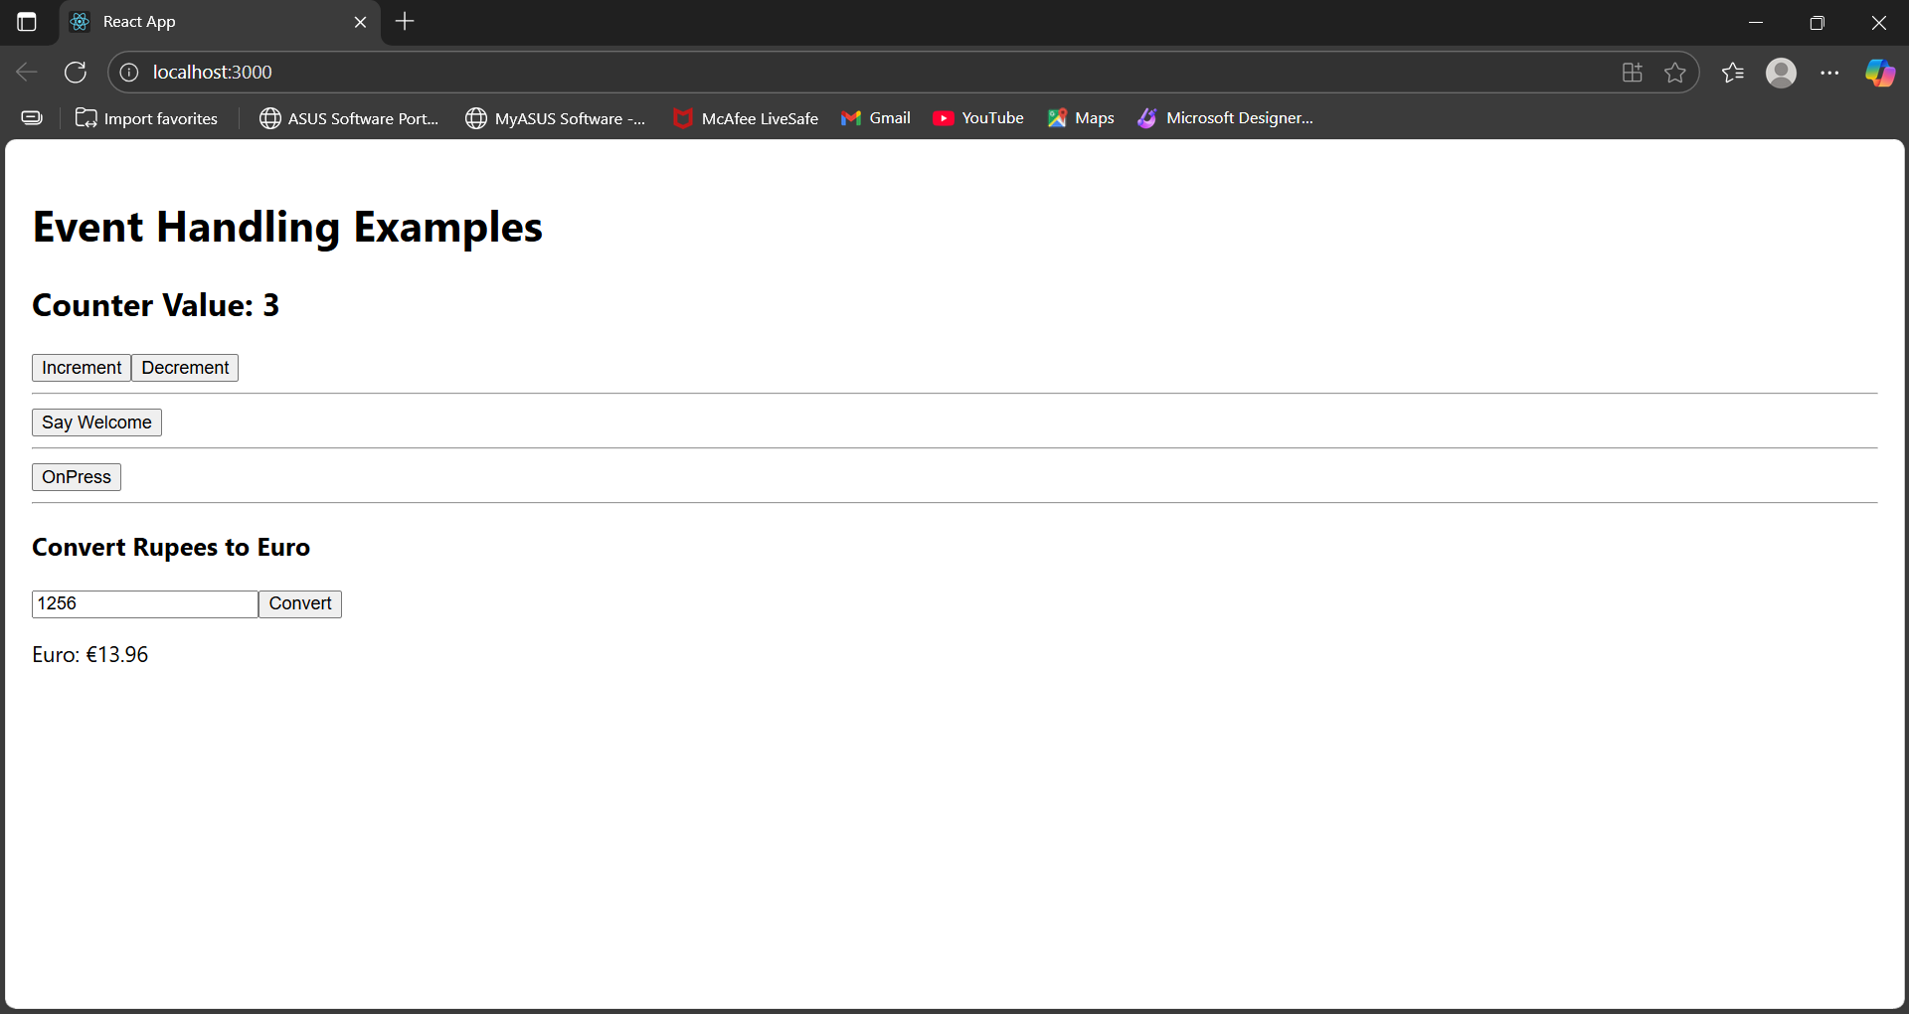

**EXERCISE 12 – TicketBookingApp**

**LoginPage.jsx:**

import React from 'react';

const LoginPage = ({ handleLogin }) => {

  return (

    <div style={{ textAlign: 'center' }}>

      <h2>Welcome to Ticket Booking App</h2>

      <button onClick={handleLogin}>Login</button>

    </div>

  );

};

export default LoginPage;

**UserPage.jsx:**

import React from 'react';

import FlightList from './FlightList';

const UserPage = ({ handleLogout }) => {

  return (

    <div style={{ textAlign: 'center' }}>

      <h2>Welcome, User!</h2>

      <FlightList />

      <button onClick={handleLogout} style={{ marginTop: '20px' }}>

        Logout

      </button>

    </div>

  );

};

export default UserPage;

**FlightList.jsx:**

import React from 'react';

const flights = [

  { id: 1, from: 'Chennai', to: 'Delhi', time: '10:00 AM' },

  { id: 2, from: 'Bangalore', to: 'Mumbai', time: '1:00 PM' },

  { id: 3, from: 'Kolkata', to: 'Hyderabad', time: '4:00 PM' },

];

const FlightList = () => {

  return (

    <div>

      <h3>Available Flights</h3>

      <ul>

        {flights.map(flight => (

          <li key={flight.id}>

            {flight.from} ➡ {flight.to} at {flight.time}

          </li>

        ))}

      </ul>

    </div>

  );

};

export default FlightList;

**OUTPUT:**

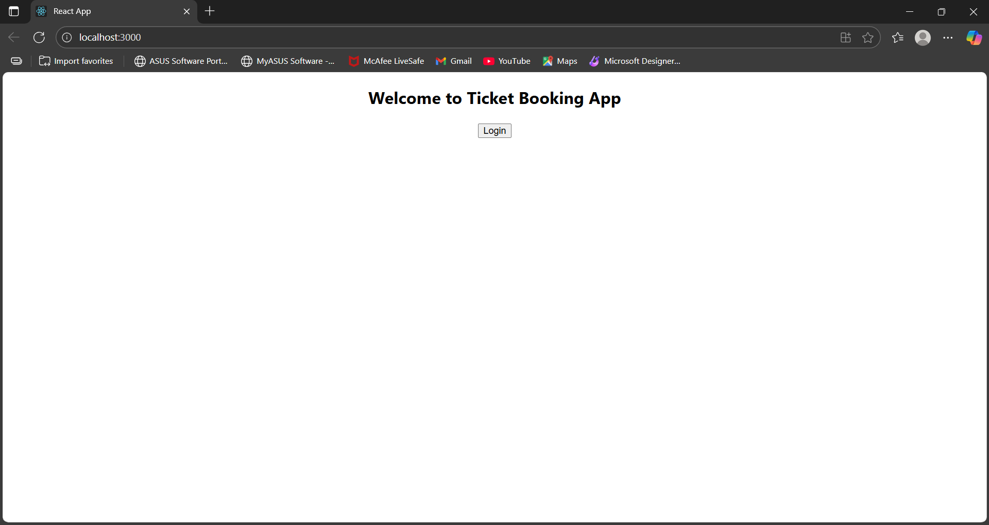

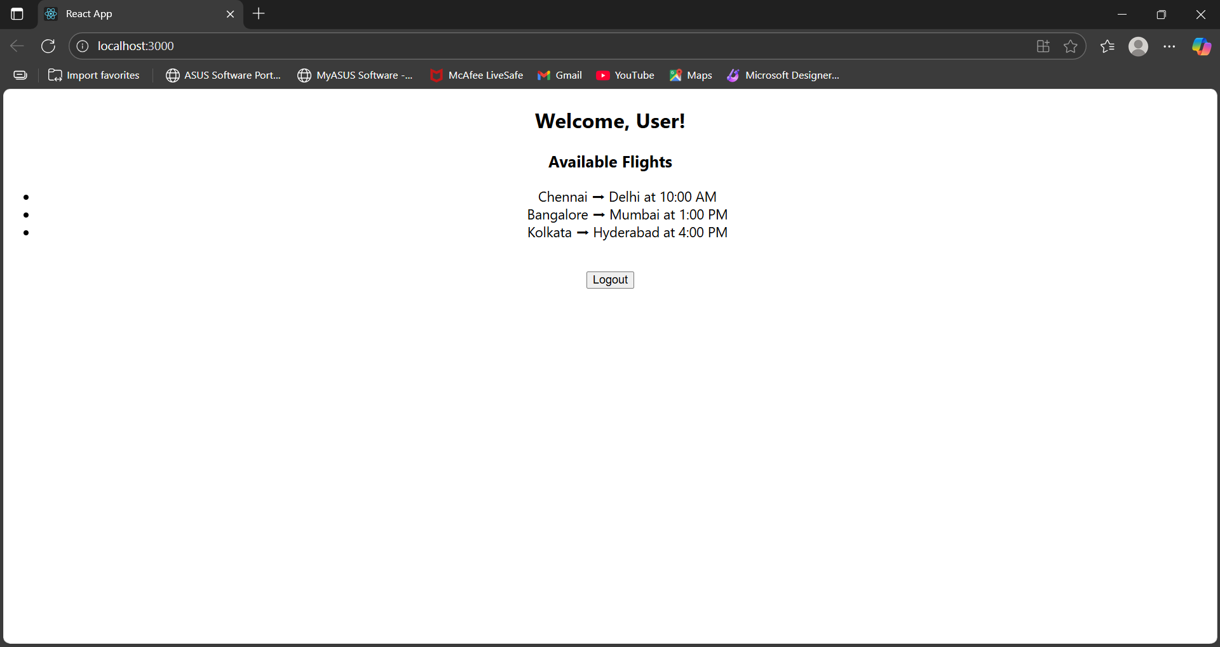

**EXERCISE 13 : bloggerapp**

**BookDetails.jsx**

import React from 'react';

const BookDetails = ({ display }) => {

  return display ? (

    <div>

      <h2>Book Details</h2>

      <div>Master React<br />670</div>

      <br />

      <div>Deep Dive into Angular 11<br />800</div>

      <br />

      <div>Mongo Essentials<br />450</div>

    </div>

  ) : null;

};

export default BookDetails;

**BlogDetails.jsx:**

import React from 'react';

const BlogDetails = ({ visible }) => (

  visible && (

    <div>

      <h2>Blog Details</h2>

      <h3>React Learning</h3>

      <strong>Stephen Biz</strong>

      <p>Welcome to learning React!</p>

      <h3>Installation</h3>

      <strong>Schwezdienier</strong>

      <p>You can install React from npm.</p>

    </div>

  )

);

export default BlogDetails;

**CourseDetails.jsx:**

import React from 'react';

const CourseDetails = ({ show }) => {

  if (!show) return null;

  const courses = [

    { name: 'Angular', date: '4/5/2021' },

    { name: 'React', date: '6/3/2021' },

  ];

  return (

    <div>

      <h2>Course Details</h2>

      {courses.map((c, i) => (

        <div key={i}>

          <strong>{c.name}</strong>

          <div>{c.date}</div>

        </div>

      ))}

    </div>

  );

};

export default CourseDetails;

**App.js:**

import React, { useState } from 'react';

import CourseDetails from './components/CourseDetails';

import BookDetails from './components/BookDetails';

import BlogDetails from './components/BlogDetails';

import './App.css';

function App() {

  const [view] = useState('all'); // switch-style condition

  const renderComponent = () => {

    switch (view) {

      case 'courses':

        return <CourseDetails show={true} />;

      case 'books':

        return <BookDetails display={true} />;

      case 'blogs':

        return <BlogDetails visible={true} />;

      case 'all':

        return (

          <>

            <CourseDetails show={true} />

            <BookDetails display={true} />

            <BlogDetails visible={true} />

          </>

        );

      default:

        return <p>No content to show.</p>;

    }

  };

  return (

    <div className="app">

      <div className="container">{renderComponent()}</div>

    </div>

  );

}

export default App;

**App.css:**

.app {

  padding: 20px;

  font-family: Arial;

}

.container {

  display: flex;

  justify-content: space-around;

  align-items: flex-start;

}

.container > div {

  padding: 10px;

  border-left: 4px solid green;

  margin: 10px;

}

**OUTPUT:**

